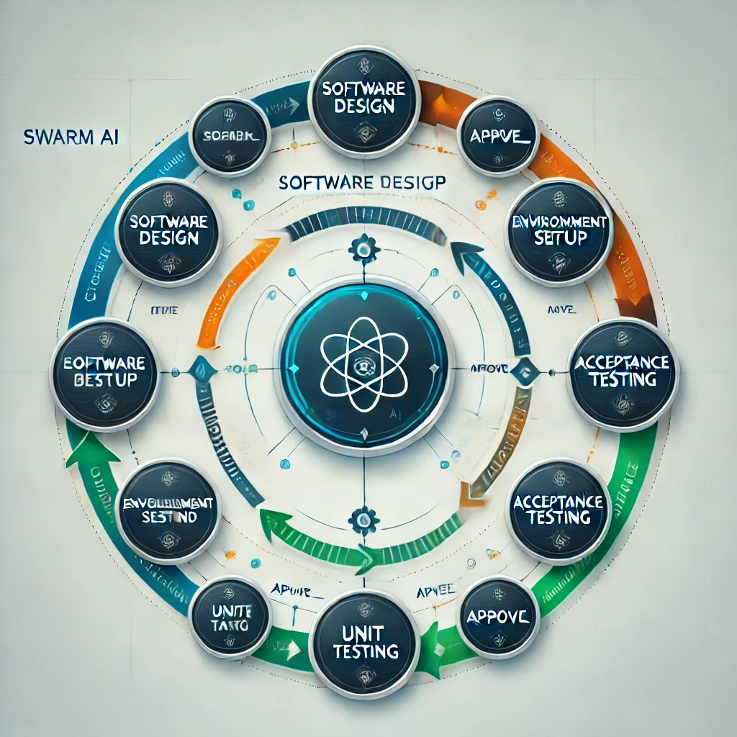
AutoSWE with SWARM
We are benchmarking the performance of automated software engineering against DevBench using SWARM AI for decision-making and task execution.
The 5 evaluations in DevBench serve as the primary nodes in the system. Progression to the next node is determined by hardcoded logic or SWARM AI agents in "approve_" prefixed nodes.
Tasks/Nodes
- Software Design
- Environment Setup
- Implementation
- Acceptance Testing
- Unit Testing
Control Flow.
In this system, SWARM AI handles the orchestration and decision-making at every stage of the software development cycle. Decision nodes, prefixed with approve_, are powered by SWARM agents to ensure context-aware and adaptive control flow.
Key Features:
- SWARM Decision Nodes: Multi-agent intelligence drives decisions at approved_ nodes, ensuring robust control flow.
- Dynamic Execution: Nodes are processed sequentially, with SWARM agents managing transitions based on task completion and input conditions.
- Output Aggregation: The system accumulates artifacts generated at each node into a final state for delivery.

Requirements
- Obtain access to SWARM AI and its API keys.
- Create a .env file to store your configuration (see .env.example).
The .env file should include the following:
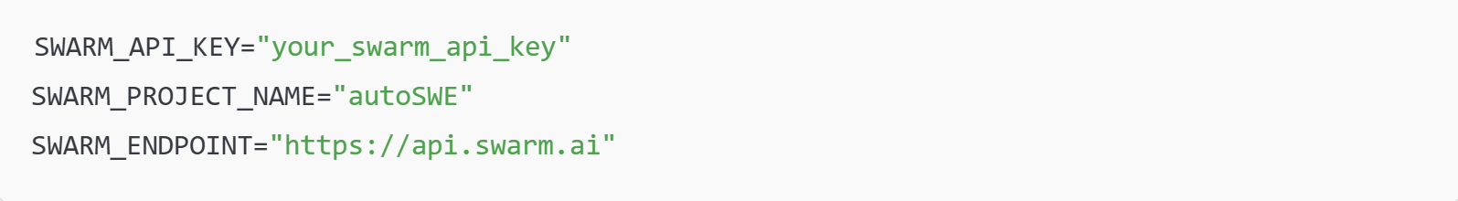
How to Use
Running a Custom PRD
To execute the program with a custom PRD.md file:
Running the Example PRD
To use the included example PRD.md file in the repo:

What is SWARM AI?
SWARM AI is a cutting-edge multi-agent framework designed for intelligent decision-making and task automation. In this project, SWARM agents:
- Analyze Tasks: Understand and process the requirements of each node.
- Drive Decisions: Use context and logic to determine the workflow at approve_ nodes.
- Adapt Dynamically: Respond to changes in input, task status, or conditions during execution.
This enables autoSWE to go beyond static workflows, providing adaptability and scalability in software engineering tasks.

Outputs
The final state of the system includes all artifacts produced during the process, such as:
- Design Documentation
- Environment Configuration Files (e.g., .env)
- Source Code
- Test Results (Unit and Acceptance Testing)
These outputs are saved in the specified output directory.

Advantages of Using SWARM AI
- Decentralized Decision-Making: SWARM agents collaborate to ensure robust, distributed task management.
- Dynamic Workflows: SWARM enables flexible transitions between nodes, eliminating rigid, predefined logic.
- Scalability: SWARM’s multi-agent architecture makes it ideal for handling complex and large-scale software engineering workflows.
- Efficiency: SWARM optimizes task execution by learning from context and improving with feedback.

Graph Visualization
Below is an example of how the control flow is managed by SWARM AI agents.

Future Directions
This implementation can be extended to:
- Incorporate advanced SWARM learning algorithms to improve decision-making.
- Enable real-time visualization of the SWARM decision flow.
- Optimize node execution using parallel processing with SWARM agents.
Contact the development team or consult SWARM AI's documentation for more information.

