A PROJECT REPORT ON

PRATICAL SESSION MONITORING SYSTEM
THIRD YEAR OF ENGINEERING
(Computer Engineering)
By

51. Krishna Kiran Aher

Under the Guidance of
Ms. P. R. Dholi



DEPARTMENT OF COMPUTER ENGINEERING

Matoshri Education Society’s,
Matoshri College of Engineering and Research Centre, Nashik Eklahare, Near Odha Gaon, Shambhajinagar Road, Nashik.
Affiliated to Savitribai Phule Pune University, Pune 2025-2026


Matoshri College of Engineering and Research Centre, Eklahare, Nashik
Department of Computer Engineering Year 2025-26

CERTIFICATE

This is to certify that

51. Krishna Kiran Aher

From Third year Computer Engineering has successfully completed his/ her Internship Project Work on “AI Colorization & Enhancement” at Matoshri College of Engineering and Research Centre, Nashik in partial fulfillment of the Bachelor of Computer Engineering.

Ms. P. R. Dholi | Dr. S. A. Bhavsar | Dr. G. K. Kharate
Guided By | Head of the Department | Principal

AKNOWLEDGEMENT

It is a great pleasure to acknowledge those who extended their support, and contributed time and psychic energy for the completion of this project work. At the outset, I would like to thank my project guide Ms.P.R.Dholi who served as sounding board for both contents and programming work.

His valuable and skillful guidance, assessment and suggestions from time to time improved the quality of work in all respects. We would like to take this opportunity to express our deep sense of gratitude towards his, for his invaluable contribution in completion of this Project Stage.

We are thankful to Dr. G. K. Kharate, Principal of Matoshri College of engineering, Nashik. We are also thankful to Dr. S. A. Bhavsar Head of Computer Department for their timely guidance, inspiration and administrative support without which our work would not have been completed.
We are also thankful to the all staff members of Computer Department Matoshri College of Engineering, Nashik. Also we would like to thank my colleagues and friends who helped us directly and indirectly to complete this project.

51. Krishna Kiran Aher

ABSTRACT

The AI Image Colorizer is a web-based application designed to automatically enhance and colorize grayscale or faded images using computer vision and machine learning techniques. Traditional methods of manually restoring or coloring old images are time-consuming, require artistic expertise, and are not easily scalable. This system aims to automate the colorization and enhancement process, providing users with multiple high-quality output variants quickly and efficiently.
The application allows users to upload an image and choose between different processing modes, including enhancement, colorization, or a combination of both. The backend processes the image using an OpenCV-based deep learning model and image enhancement techniques to generate multiple variants. Users can preview, compare, and download the generated results directly through the interface.
In addition to image processing, the system incorporates a feedback mechanism where users can rate the generated outputs and provide comments. This feedback is analyzed using Natural Language Processing (NLP) techniques such as TextBlob and NLTK, enabling the system to generate insights and visualize user satisfaction through graphical representations.
By integrating image processing, machine learning, and user feedback analytics, the AI Image Colorizer provides an efficient, user-friendly, and intelligent solution for restoring and enhancing images in a modern digital environment

Keywords: AI Image Colorizer, Image Enhancement, Image Colorization, OpenCV, Machine Learning, FastAPI, React, Natural Language Processing, TextBlob, NLTK, User Feedback Analysis.

INDEX

Chapter | Content | Page No
1 | Introduction | 2
2 | Significance and Background | 3
3 | Motivation | 5
4 | Problem Statement and Objectives | 6
5 | Related Work | 7
5.1 | Literature Study | 7
5.2 | Summary | 9
6 | Proposed System | 10
6.1 | System Architecture | 10
6.2 | UML Diagrams | 13
7 | Software and hardware requirements | 17
8 | Technologies used | 19
9 | Module description | 21
10 | Results and Analysis | 23
11 | Testing | 27
12 | Advantages and Disadvantages | 29
13 | Conclusion and Future Scope | 31
14 | References | 33

LIST OF FIGURES
FIG. NO | TITLE | PAGE NO
6.1 | System Architecture | 12
6.2.1 | Use case diagram | 13
6.2.2 | Class diagram | 14
6.2.3 | Activity diagram | 15
6.2.4 | Sequence diagram | 16
9.1.1 | User workflow | 22
10.1.1 | Image Upload | 23
10.1.2 | Mode Selection | 23
10.1.3 | Result Loading | 24
10.1.4 | Output Displayed | 24
10.1.5 | Output Variants and Reviews | 25
10.1.6 | User Review Report | 25
10.1.7 | Developer Dashboard | 26
10.1.8 | Example Carousel and User Preference Graph | 26

CHAPTER 1
INTRODUCTION
The AI Image Colorizer is a web-based application designed to automatically enhance and colorize grayscale or faded images using artificial intelligence and image processing techniques. Traditional methods of restoring or colorizing old images are time-consuming, require artistic expertise, and are not easily accessible to general users. This system replaces manual processes with an automated solution that generates multiple high-quality image variants quickly and efficiently. Users can upload images, choose processing modes, and download the results, making image restoration simple and accessible. The system improves efficiency, reduces manual effort, and provides a user-friendly approach to modern image enhancement.
  - Introduction
Image colorization and enhancement play a significant role in digital image processing, especially in restoring old photographs and improving visual quality. Many historical and personal images exist only in grayscale or have faded over time, making them less visually informative and appealing. Traditionally, restoring or colorizing such images required manual editing using advanced tools and artistic skills, which is both time-consuming and difficult for non-experts.
With advancements in artificial intelligence and computer vision, automated image colorization has become possible using pretrained models and image processing techniques. These technologies enable systems to predict realistic colors and enhance image quality with minimal user input. However, there is still a need for a simple, efficient, and accessible platform that allows users to easily apply these techniques without requiring technical expertise.
The AI Image Colorizer is a web-based application developed to address these challenges by providing an automated and user-friendly solution for image enhancement and colorization. The system allows users to upload images and select processing modes such as enhancement, colorization, or a combination of both. The backend processes the image using OpenCV-based techniques and generates multiple output variants, allowing users to preview and select their preferred results.

CHAPTER 2
SIGNIFICANCE AND BACKGROUND
The AI Image Colorizer is significant because it improves the efficiency and accessibility of image enhancement and colorization processes. Traditional methods of restoring grayscale or faded images require manual editing, specialized software, and artistic expertise, making them time-consuming and difficult for general users. This system eliminates these challenges by providing an automated and centralized platform for image processing.

Significance of the System
The AI Image Colorizer plays an important role in simplifying digital image restoration by combining artificial intelligence, image processing, and user interaction into a single platform. The system allows users to upload images and automatically generate enhanced and colorized versions without requiring technical knowledge or advanced tools.
Users can select different processing modes and receive multiple output variants, enabling them to compare results and choose the most suitable version. This approach improves flexibility and user satisfaction, as it provides alternatives instead of a single fixed output.
The system also incorporates a feedback mechanism, where users can rate the generated results and provide comments. This feedback is analyzed using Natural Language Processing (NLP) techniques to generate insights into user preferences and satisfaction levels. These insights are further visualized through graphical representations, helping evaluate the performance of the system.
By storing processed data and feedback in an organized manner, the system ensures efficient data management and easy retrieval when needed. Additionally, the application provides a user-friendly interface and supports real-time interaction between the user and the system.
Overall, the AI Image Colorizer enhances the process of image restoration by reducing manual effort, improving efficiency, and providing intelligent insights through feedback analysis. It offers a scalable and modern solution suitable for applications such as photo restoration, digital media enhancement, and content creation.

Background
In the field of digital image processing, image enhancement and colorization are important tasks used to improve the visual quality and interpretability of images. Many historical photographs, old records, and personal images exist in grayscale or have deteriorated over time, resulting in loss of detail and visual appeal. Traditionally, restoring and colorizing such images has been performed manually using professional editing tools, which requires significant time, effort, and artistic expertise.
Manual colorization involves carefully selecting colors for different regions of an image, which can be both complex and subjective. This process is not only time-consuming but also difficult to scale when dealing with large collections of images. Additionally, achieving consistent and realistic results across multiple images can be challenging without advanced knowledge and experience.
With the advancement of artificial intelligence and computer vision, automated image colorization techniques have been developed to simplify this process. Pretrained deep learning models can analyze grayscale images and predict suitable color distributions, significantly reducing the need for manual intervention. Similarly, image enhancement techniques can improve contrast, sharpness, and overall image quality, making images more visually appealing.
Despite these advancements, many existing solutions are either complex to use, require high computational resources, or do not provide flexibility in output selection. Users often receive a single processed image without the ability to compare multiple variations or provide feedback on the results.
To address these limitations, modern systems are being developed that combine automated image processing with user interaction. An AI-based Image Colorizer provides a platform where users can easily upload images, apply enhancement and colorization techniques, and receive multiple output variants. This approach not only improves usability but also allows users to select results based on their preference while enabling further analysis through feedback mechanisms.

CHAPTER 3

MOTIVATION
The AI Image Colorizer is developed to automate the process of image enhancement and colorization using artificial intelligence and image processing techniques. Traditional methods of restoring or colorizing images require manual editing, specialized tools, and artistic skills, making them time-consuming and inaccessible to many users. This system provides a simplified and automated solution that allows users to enhance and colorize images efficiently with minimal effort.

Motivation
The motivation behind developing the AI Image Colorizer arises from the challenges associated with traditional image restoration and colorization methods. Many old photographs and grayscale images lack visual clarity and appeal, but restoring them manually requires significant time, expertise, and precision. This creates a need for an automated system that can perform these tasks quickly and effectively.
Another key motivation is to make advanced image processing techniques accessible to general users. Existing tools often require technical knowledge or complex software, limiting their usability. By developing a web-based application, the system allows users to easily upload images, apply processing techniques, and obtain results without requiring any prior expertise.
Additionally, the project is motivated by the need to provide flexibility in output selection. Instead of generating a single result, the system produces multiple variants, allowing users to compare and choose the most suitable output based on their preference. This improves user experience and satisfaction.
Finally, the project aims to combine multiple domains, including artificial intelligence, full-stack development, and data analysis, into a single practical application. It was developed as part of internship training to gain hands-on experience in building intelligent systems that solve real-world problems efficiently.

CHAPTER 4
PROBLEM STATEMENT AND OBJECTIVES

Background
In today’s digital era, image processing plays a crucial role in various domains such as photography, media, historical preservation, and medical imaging. Many old photographs, grayscale images, and low-quality images lack proper color representation and visual clarity. Manual image restoration and colorization require expert knowledge, high effort, and significant time consumption. Traditional image editing tools also require skilled human intervention, making the process inefficient and inconsistent.
The developed system aims to provide a user-friendly platform where users can upload grayscale or low-quality images and receive enhanced and colorized outputs efficiently. The project focuses on reducing manual effort while improving the accuracy and quality of image restoration.

Objectives
- To develop an AI-based system that can automatically enhance and colorize grayscale or faded images.
- To design a user-friendly web-based interface for uploading, processing, previewing, and downloading images.
- To implement different processing modes such as enhancement, colorization, and combined processing.
- To implement different processing modes such as enhancement, colorization, and combined processing.
- To incorporate a feedback mechanism where users can rate generated outputs and provide comments.
- To analyze user feedback using Natural Language Processing (NLP) techniques to extract insights and measure user satisfaction.
- To generate graphical representations of feedback data for better visualization and analysis.
- To ensure efficient data handling, storage, and retrieval of processed images and feedback.
CHAPTER 5
RELATED WORK
This chapter reviews existing techniques, models, and systems related to image enhancement and colorization using computer vision and machine learning. Various traditional and modern approaches have been studied to understand how grayscale images can be restored and enhanced. Analyzing these existing methods helps in identifying their strengths and limitations, which provides a strong foundation for designing the proposed AI Image Colorizer system.

  - Literature Survey
The literature survey focuses on different image colorization and enhancement techniques developed over time. Traditional image processing methods relied on manual coloring or rule-based approaches, where colors were assigned to grayscale images based on human input. While these methods provided control over the output, they were time-consuming and required significant expertise.
With the advancement of deep learning, automated image colorization techniques have gained popularity. Research by Richard Zhang and others introduced convolutional neural network (CNN)-based models capable of predicting realistic colors for grayscale images. These models analyze image features and generate color distributions automatically, significantly reducing manual effort.
Several modern tools and systems have been developed using these techniques. Libraries such as OpenCV provide pretrained deep learning models for image colorization, allowing developers to integrate AI-based colorization into applications. Other approaches, such as GAN-based models (e.g., DeOldify), further improve realism but often require high computational resources and complex setup.
Existing systems provide automated colorization and enhancement but have certain limitations. Many applications generate only a single output, limiting user choice. Some systems require powerful hardware or are difficult to use for non-technical users. Additionally, most existing tools do not incorporate user feedback or analytical mechanisms to evaluate output quality.
The study of these existing techniques highlights the need for a system that is not only capable of performing automated image colorization and enhancement but also provides multiple output variants, user interaction, and feedback analysis. These insights have guided the development of the proposed AI Image Colorizer system, which aims to combine ease of use, efficient processing, and intelligent feedback-driven evaluation.
Sr. No. | Existing System / Study | Technology Used | Key Features | Advantages | Limitations | Relevance to Proposed System
1 | Traditional Manual Colorization | Image editing tools (Photoshop, GIMP) | Manual coloring, Layer-based editing | High control over output | Time consuming, requires experties | Highlighted need for automation
2 | OpenCV Colorization Model | Deep Learning (CNN), OpenCV | Automatic color prediction for grayscale images | Fast, easy integration, pretrained model | Limited accuracy, color bleeding issues | Core model used in proposed system
3 | DeOldify (AI Colorization Tool | GAN (Deep Learning), PyTorch | High-quality realistic colorization | Better visual results, advanced AI | Requires high computational power, complex setup | Inspired future improvements
4 | Basic Image Enhancement Tools | Image processing algorithms (contrast, sharpening | Improve brightness, contrast, clarity | Simple, fast processing | No colorization capability | No colorization capabilit
5 | Online Image Editing Tools (e.g., Canva, Fotor) | Web-based image processing tools | Basic enhancement, filters, simple color adjustments | Easy to use, no installation required, accessible to general users | Limited AI capabilities, lacks true colorization, no feedback analytics | Highlighted need for AI-based automation and intelligent feedback system

Summary

The literature survey includes various traditional and modern approaches to image enhancement and colorization, such as manual editing techniques, OpenCV-based colorization models, GAN-based systems like DeOldify, and web-based image editing tools. These systems provide features such as image enhancement, automatic colorization, and user-friendly interfaces for processing images.

These approaches offer advantages such as automation, improved visual quality, and ease of use. Deep learning-based models, in particular, enable efficient and fast colorization of grayscale images, reducing the need for manual effort. However, they also have certain limitations, including limited accuracy, color inconsistencies, high computational requirements, and lack of flexibility in output selection.

Additionally, most existing systems do not incorporate mechanisms for collecting and analyzing user feedback, which is important for evaluating the effectiveness of generated results. They often provide a single output without allowing users to compare multiple variations or contribute to system improvement.

The study of these existing techniques helped in identifying key features required for the proposed system, such as automated processing, multiple output generation, user-friendly interaction, and feedback-driven analysis. These insights have guided the development of the AI Image Colorizer, which aims to overcome the limitations of existing solutions by combining image processing, machine learning, and user feedback analytics into a unified system.

CHAPTER 6
PROPOSED SYSTEM
The proposed system is an AI Image Colorizer designed to automate the process of image enhancement and colorization using artificial intelligence and image processing techniques. It provides a web-based platform where users can upload grayscale or faded images and generate multiple enhanced and colorized outputs efficiently.
In this system, users can select different processing modes such as enhancement, colorization, or a combination of both. The backend processes the image using OpenCV-based techniques and pretrained deep learning models to generate multiple output variants. These variants allow users to compare results and choose the most suitable version based on their preference.
The system also includes a feedback mechanism where users can rate each generated variant and provide comments. This feedback is stored and analyzed using Natural Language Processing (NLP) techniques, enabling the system to evaluate user satisfaction and extract meaningful insights. The results of this analysis are visualized through graphical representations, providing an additional layer of evaluation.
The proposed system reduces the need for manual image editing, improves efficiency in image restoration, and provides an interactive and user-friendly experience. It also introduces a feedback-driven approach, making the system more adaptive and analytically useful. Overall, the system combines image processing, machine learning, and data analysis into a unified and efficient solution.

System Architecture
The system architecture of the AI Image Colorizer describes how different components interact to perform image processing, feedback collection, and analytics. The system follows a modular architecture consisting of the presentation layer (frontend), application layer (backend), and processing and analytics layer.
The presentation layer is developed using React (Vite), which provides an interactive user interface for uploading images, selecting processing modes, previewing generated variants, and submitting feedback. It also includes features for downloading images, viewing progress, and interacting with the system in real time.
The application layer is developed using FastAPI, which handles API requests, image uploads, processing logic, and communication between different components. It manages tasks such as file handling, routing, feedback submission, and interaction with the processing modules. The backend also ensures smooth communication between the frontend and the underlying processing system.
The processing layer is responsible for image enhancement and colorization. It uses OpenCV for image processing operations such as contrast adjustment, sharpening, and noise reduction. For colorization, a pretrained deep learning model is used through OpenCV’s DNN module to generate realistic color outputs from grayscale images. The system generates multiple variants by applying different processing parameters to improve output diversity.
The analytics layer handles user feedback and data analysis. Feedback submitted by users is processed using Natural Language Processing techniques with libraries such as TextBlob and NLTK. This layer extracts sentiment, keywords, and user preferences, which are then used to generate graphical representations such as pie charts using matplotlib.
The data layer stores uploaded images, processed outputs, and user feedback. Files are stored locally in structured directories, while feedback data is maintained in a structured format for analysis. The system also provides functionality to delete stored data to maintain privacy and reduce storage usage.
The frontend communicates with the backend through REST APIs, and the backend coordinates processing, storage, and analytics operations. This architecture ensures efficient processing, modular design, scalability, and smooth user interaction.

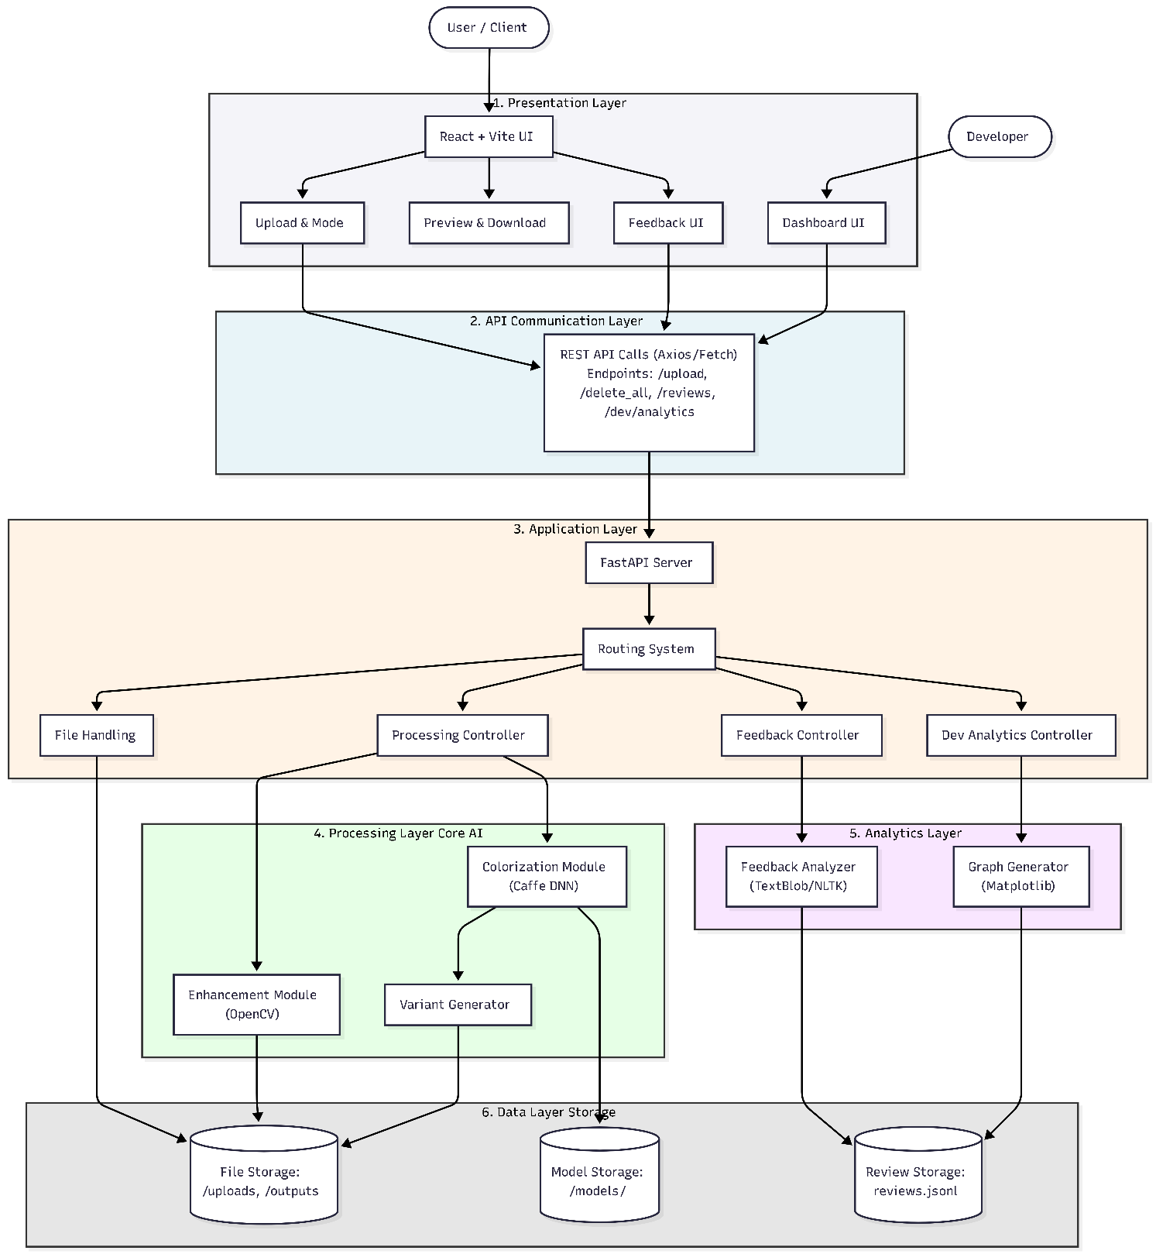

Figure 6.1 System Architecture of Image Colorization

UML Diagrams (Use case, Class, Activity and Sequence diagram)
UML (Unified Modeling Language) diagrams are used to visually represent the structure and behavior of the AI Image Colorizer system. These diagrams help in understanding how different components of the system interact with each other and how users engage with the application.

System Architecture UML (Unified Modeling Language) diagrams are used to visually represent the structure and behavior of the AI Image Colorizer system. These diagrams help in understanding how different components of the system interact with each other and how users engage with the application..
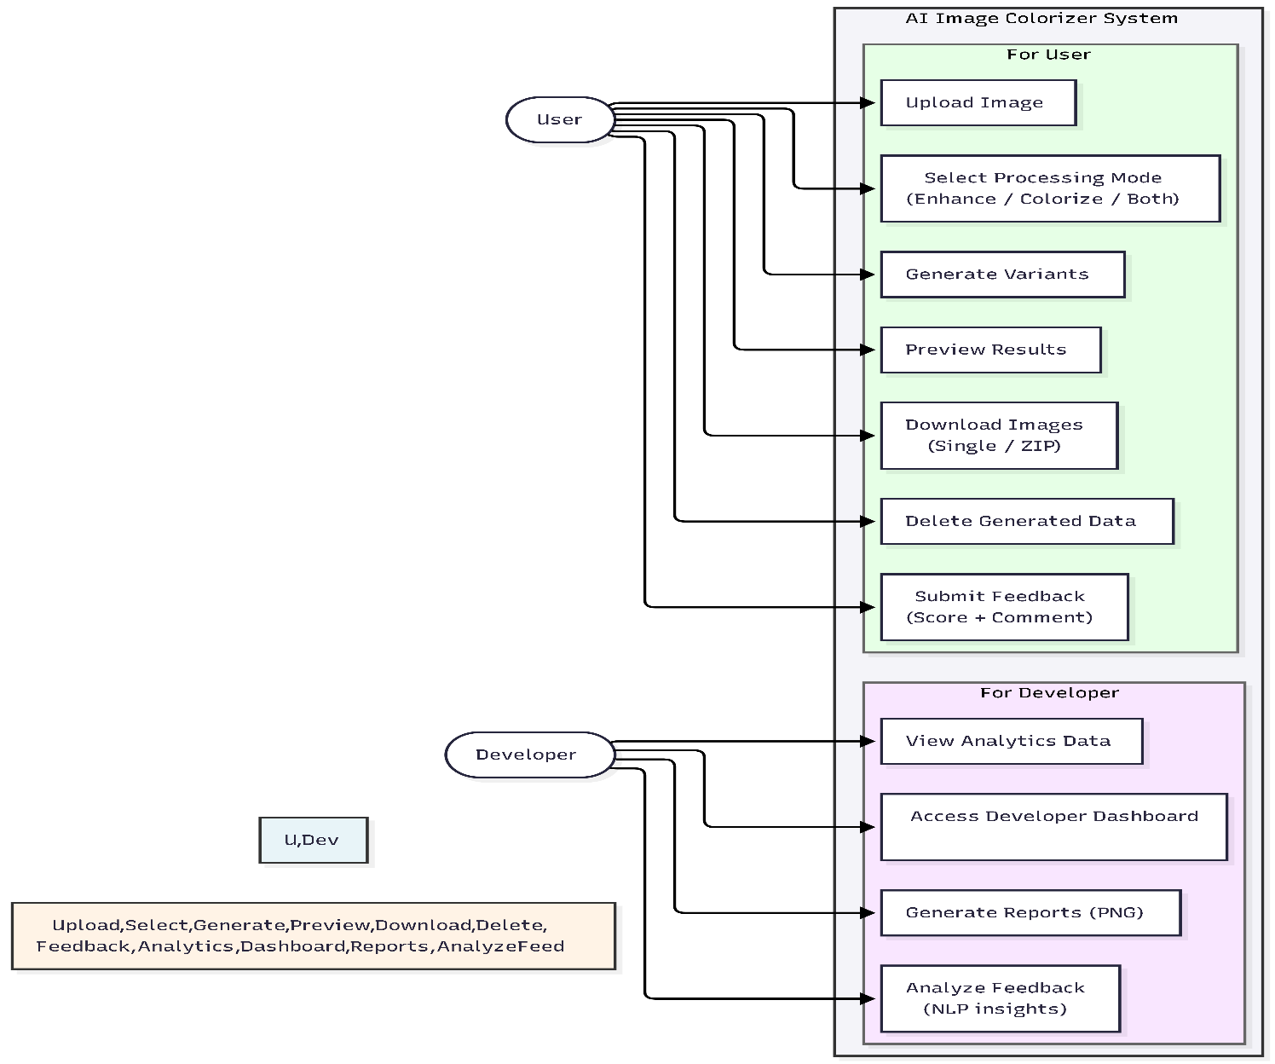
Figure 6.2.1 Use case diagram of User & Developer

6.2.2 Class Diagram

The Class Diagram represents the structure of the AI Image Colorizer system by showing the main classes, their attributes, and the relationships between them. It helps in understanding how different components of the system manage image processing, user interaction, and feedback analysis.
The system includes key classes such as Image, Variant, Review, FeedbackAnalysis, and ProcessingEngine. These classes work together to handle image uploads, processing, variant generation, and feedback analytics.
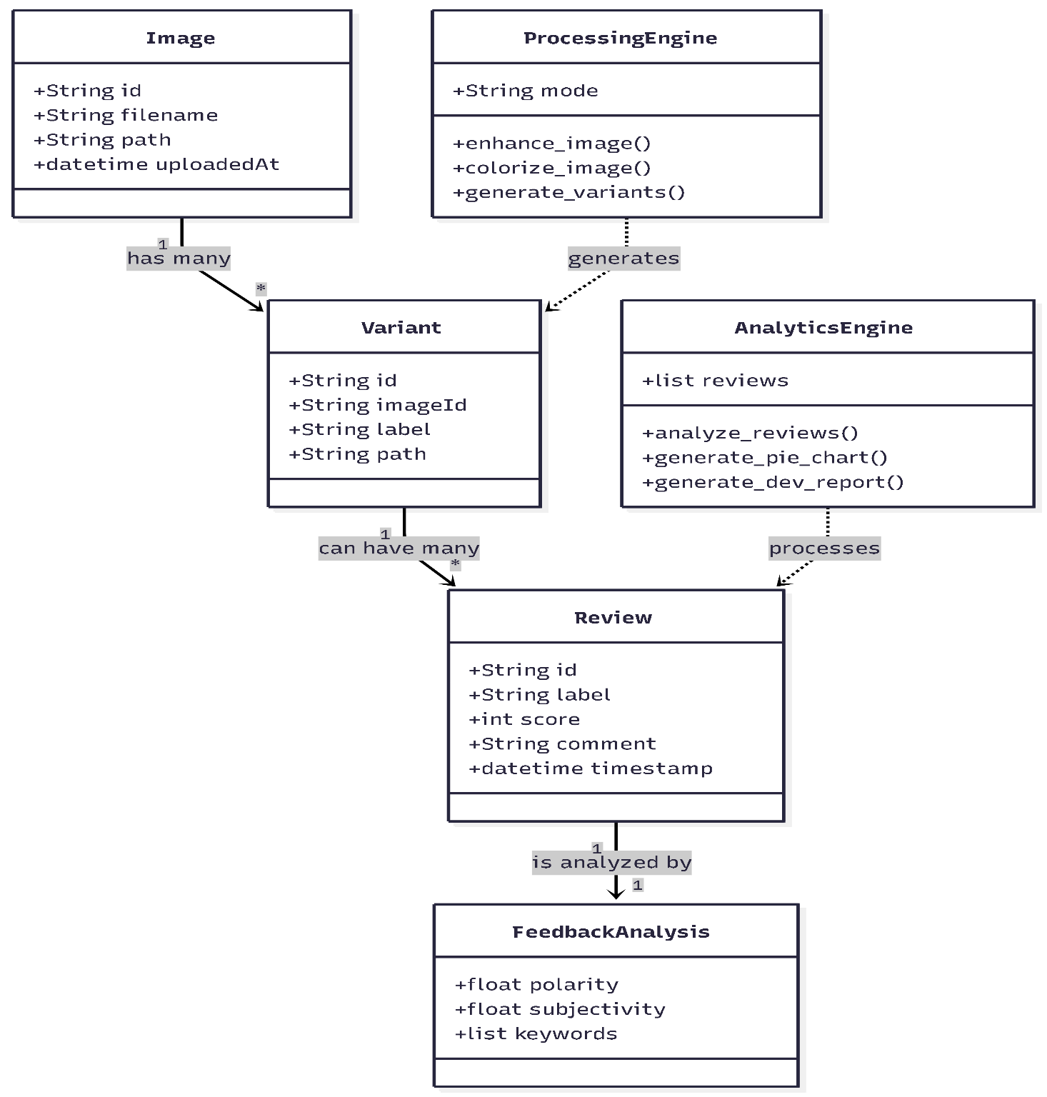
Figure 6.2.1 Use case diagram

6.2.3 Activity Diagram

The Activity Diagram represents the workflow of operations performed in the AI Image Colorizer system. It illustrates the sequence of steps from image upload to processing, feedback submission, and analytics generation. This diagram helps in understanding how the system processes user input and produces output while incorporating feedback for evaluation.

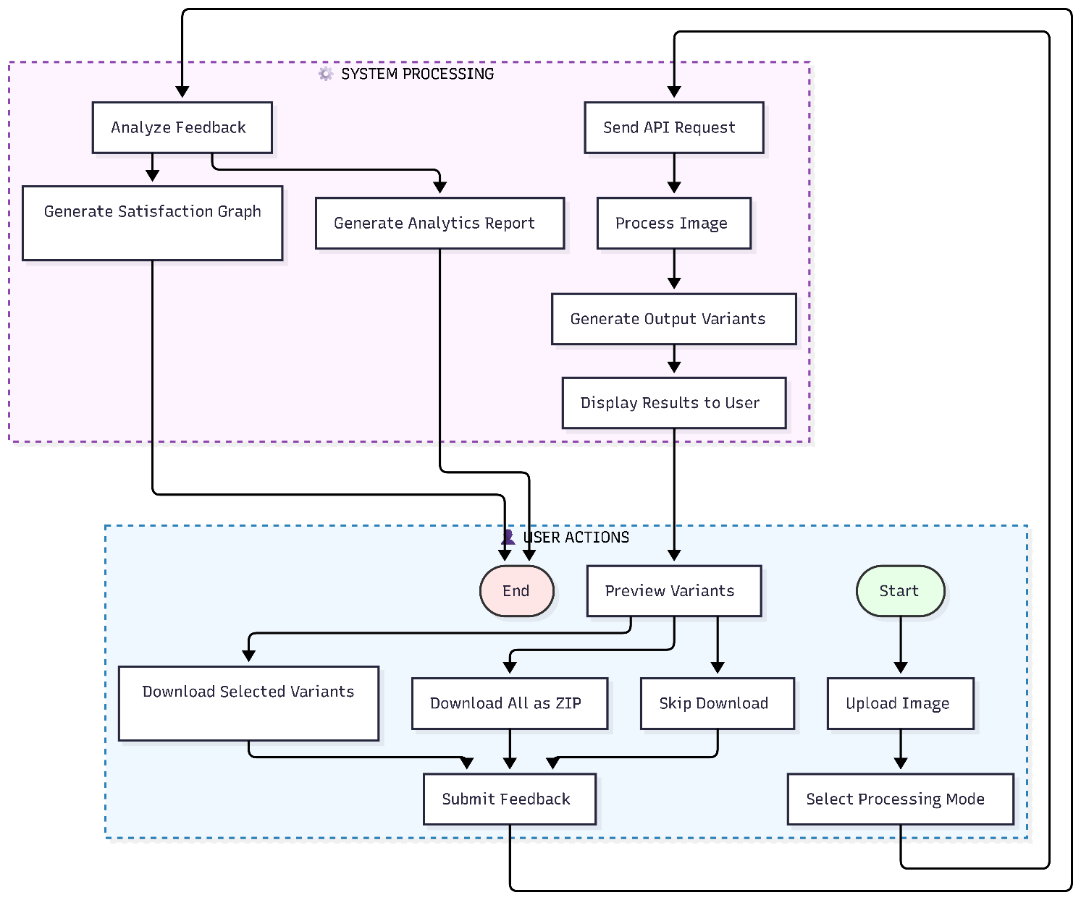

Figure 6.2.3 Activity diagram of Image Processing

6.2.4 Sequence Diagram

The Sequence Diagram illustrates the interaction between system components in a time sequence. It shows how messages are exchanged between the User Interface, Server (Node.js), and Database (MongoDB).
For example, when a student logs in, the request goes from the user interface to the server, the server checks the database, and then sends the response back to the user interface. This diagram helps visualize how system components communicate during operations.
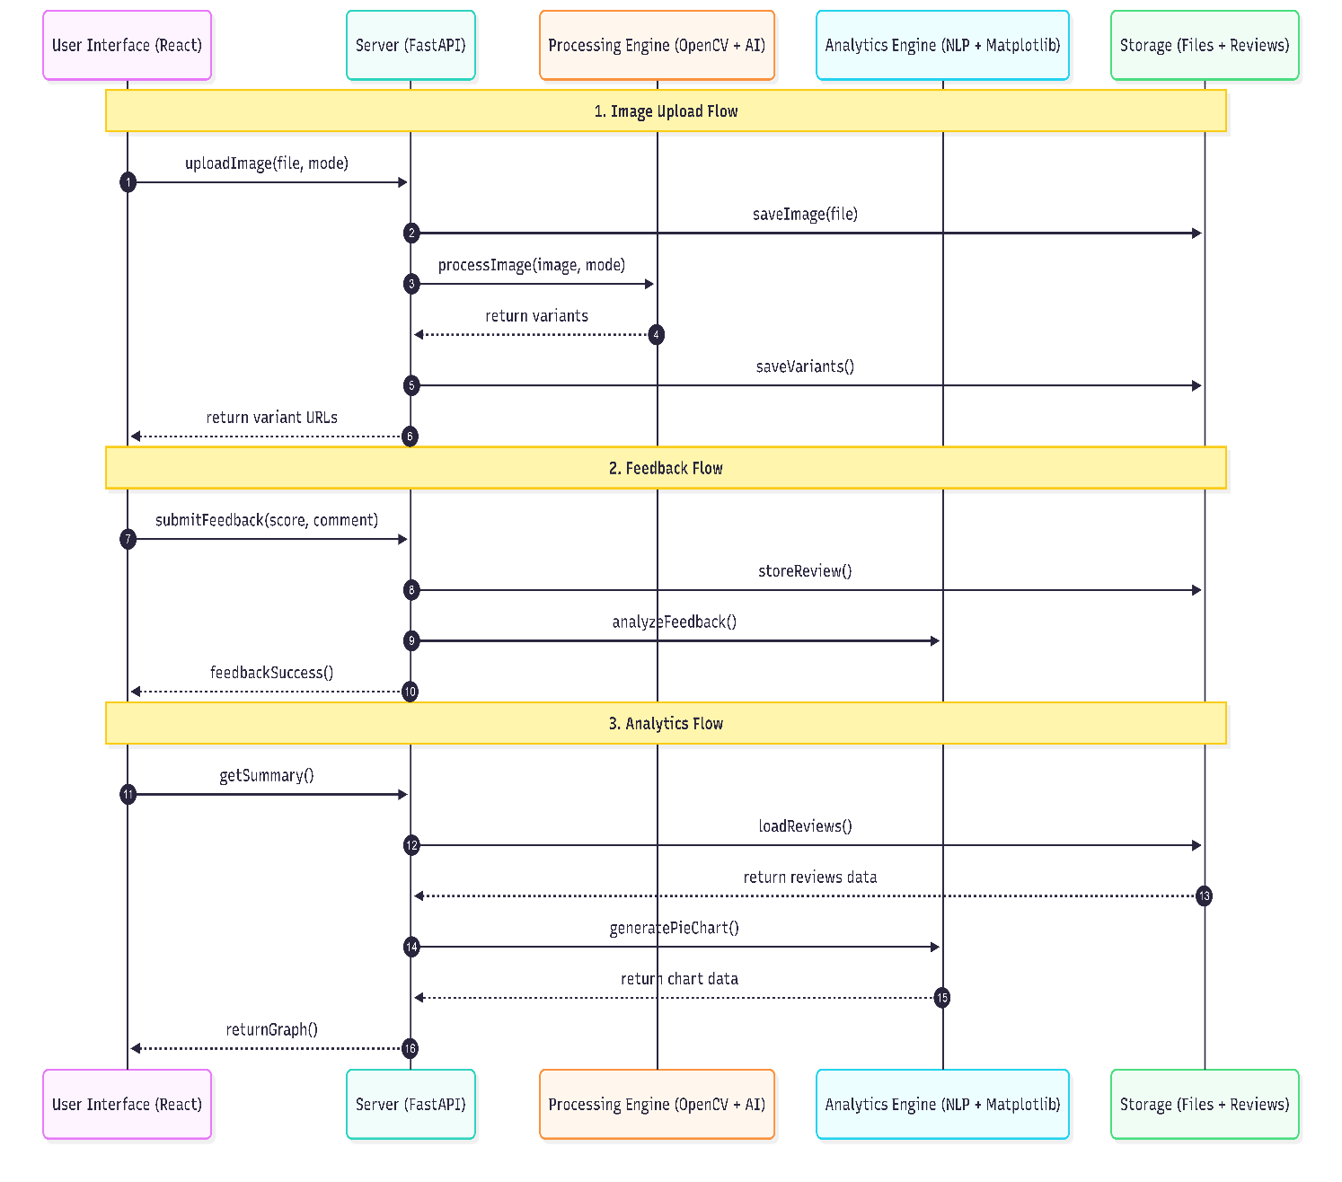

Figure No 6.2.4 Sequence Diagram of Image State
CHAPTER 7
SOFTWARE AND HARDWARE REQUIREMENTS
System requirements define the necessary software and hardware components required to develop, deploy, and run the AI Image Colorizer system efficiently. The analysis identifies the need for an automated system that performs image enhancement and colorization while also supporting feedback collection and analytics.
The system replaces manual image editing processes by providing an AI-based solution that is efficient, user-friendly, and scalable. It includes functional requirements such as image upload, processing, variant generation, and feedback submission, along with non-functional requirements such as performance, usability, and reliability.
7.1 Software Requirements

7.1.1 Operating System
- Windows 10 or higher / Linux / macOS
- Should support modern web browsers and database management software.
- Must support Python, Node.js (for frontend tooling), and modern browsers

7.1.2 Development Tools
- IDE / Code Editor: Visual Studio Code
- Programming Languages:
  - Python → Backend (FastAPI, image processing, NLP)PHP / Node.js / Python (for backend)
  - JavaScript → Frontend (React + Vite)
  - HTML, CSS → UI structure and styling

Frameworks & Libraries:

FastAPI → Backend API development

React (Vite) → Frontend development

OpenCV (cv2) → Image processing and colorization

NumPy, TextBlob & NLTK → Numerical operations, Sentiment analysis and NLP

Matplotlib → Graph generation (analytics)

7.1.3 Runtime Enviornments

Python 3.10+ (Recommended: 3.12)

Node.js 18+ (for frontend development)

Virtual Environment (venv) for dependency isolation

7.1.4 Server

Uvicorn → ASGI server for FastAPI

Runs locally on: http://127.0.0.1:8000

7.1.5 Storage

Local File Storage

/uploads → Original images

/outputs → Generated variants

Review Storage

JSONL file (Reviews/reviews.jsonl)

Model Storage

/models/colorization/ → AI model files

7.1.6 Browser

Google Chrome (Recommended)

Mozilla Firefox

Microsoft Edge

Must support:

HTML5

CSS3

Modern JavaScript (ES6+)

7.1.7 Additional Software

Git / GitHub → Version control

Python venv → Dependency management

npm → Frontend package manager

Git LFS (optional) → Handling large model files

7.2 Hardware Requirements

7.2.1 Server Requirements (for hosting the system)
- Processor: Intel Core i5 or higher / AMD Ryzen 5 or higher
- RAM: Minimum 4 GB (More recommended for better performance but unneeded)
- Storage: 5 to 10 GB HDD or SSD (SSD preferred for faster read/write operations)
- Network: Stable internet connection (minimum 10 Mbps for concurrent access)
- Power Backup: UPS to prevent data loss during power outages

7.2.2 Client Requirements (for students and faculty access)
- Processor: Intel Core i3 or higher / AMD equivalent
- RAM: Minimum 4 GB
- Storage: Minimal
- Input Devices: Keyboard and Mouse (or touchpad)
- Network: Internet connection (minimum 5 Mbps recommended)

CHAPTER 8

TECHNOLOGIES USED
The AI Image Colorizer system is developed using modern technologies that support image processing, artificial intelligence, web development, and data analysis. The system integrates a React-based frontend with a FastAPI backend, along with image processing libraries and Natural Language Processing (NLP) tools.
The frontend provides an interactive user interface for uploading images and viewing results, while the backend handles processing, storage, and analytics. Additional tools are used for visualization, version control, and development.

8.1 Frontend Technologies

HTML5
Used for structuring web pages and defining layout elements.

CSS3
Used for styling the interface and improving visual appearance.

JavaScript
Used for handling interactivity and dynamic content.

React-(Vite)
Used to build a fast, responsive, and component-based user interface.

Axios
Used for making API requests between frontend and backend

8.2. Backend Technologies
- Python
Core programming language used for backend development.
- FastAPI
Used to build RESTful APIs for handling image upload, processing, and feedback.
- Uvicorn
ASGI server used to run the FastAPI application.
- REST-API
Used for communication between frontend and backend 8.3. Database Technologies

8.3. Image Processing & AI Technologies
- OpenCV (cv2)
Used for image enhancement, filtering, and processing operations.
- OpenCV DNN Module
Used for AI-based image colorization using pretrained models.
- NumPy
Used for numerical operations and array manipulation.

8.4. NLP & Analytics Technologies
- TextBlob
Used for sentiment analysis of user feedback.
- NLTK (Natural Language Toolkit)
Used for tokenization and keyword extraction.
- Matplotlib
Used for generating graphical representations such as pie charts..

8.5. Storage & Data Handling

- TextBlob
Used for sentiment analysis of user feedback.
- NLTK (Natural Language Toolkit)
Used for tokenization and keyword extraction.
- Matplotlib
Used for generating graphical representations such as pie charts.

8.6. Development & Version Control Tools

- Local File System
Used to store uploaded images and processed outputs.
- JSONL (JSON Lines)
Used for storing user feedback data in a structured format.
- Model Files (Caffe / NumPy)
Used for AI colorization models.

CHAPTER 9

MODULE DESCRIPTION
The AI Image Colorizer system is divided into several functional modules that work together to perform image processing, user interaction, and feedback analysis. Each module is responsible for a specific task, ensuring efficient and organized system operation.
The main modules of the system include the Image Upload Module, Processing Module, Variant Generation Module, Feedback Module, and Analytics Module. These modules collectively enable the system to enhance and colorize images while incorporating user feedback for evaluation.
9.1 User Module
- Upload [Upload Original Image] --> Mode [Select Processing Mode]
- Mode --> Processing [AI Image Processing]
- Processing --> Preview [Preview Generated Variants]
- Preview --> Download[ Download (Single / ZIP)]
- Download --> Feedback [Submit Review & Feedback]
- Feedback --> Exit [Finish & Exit]
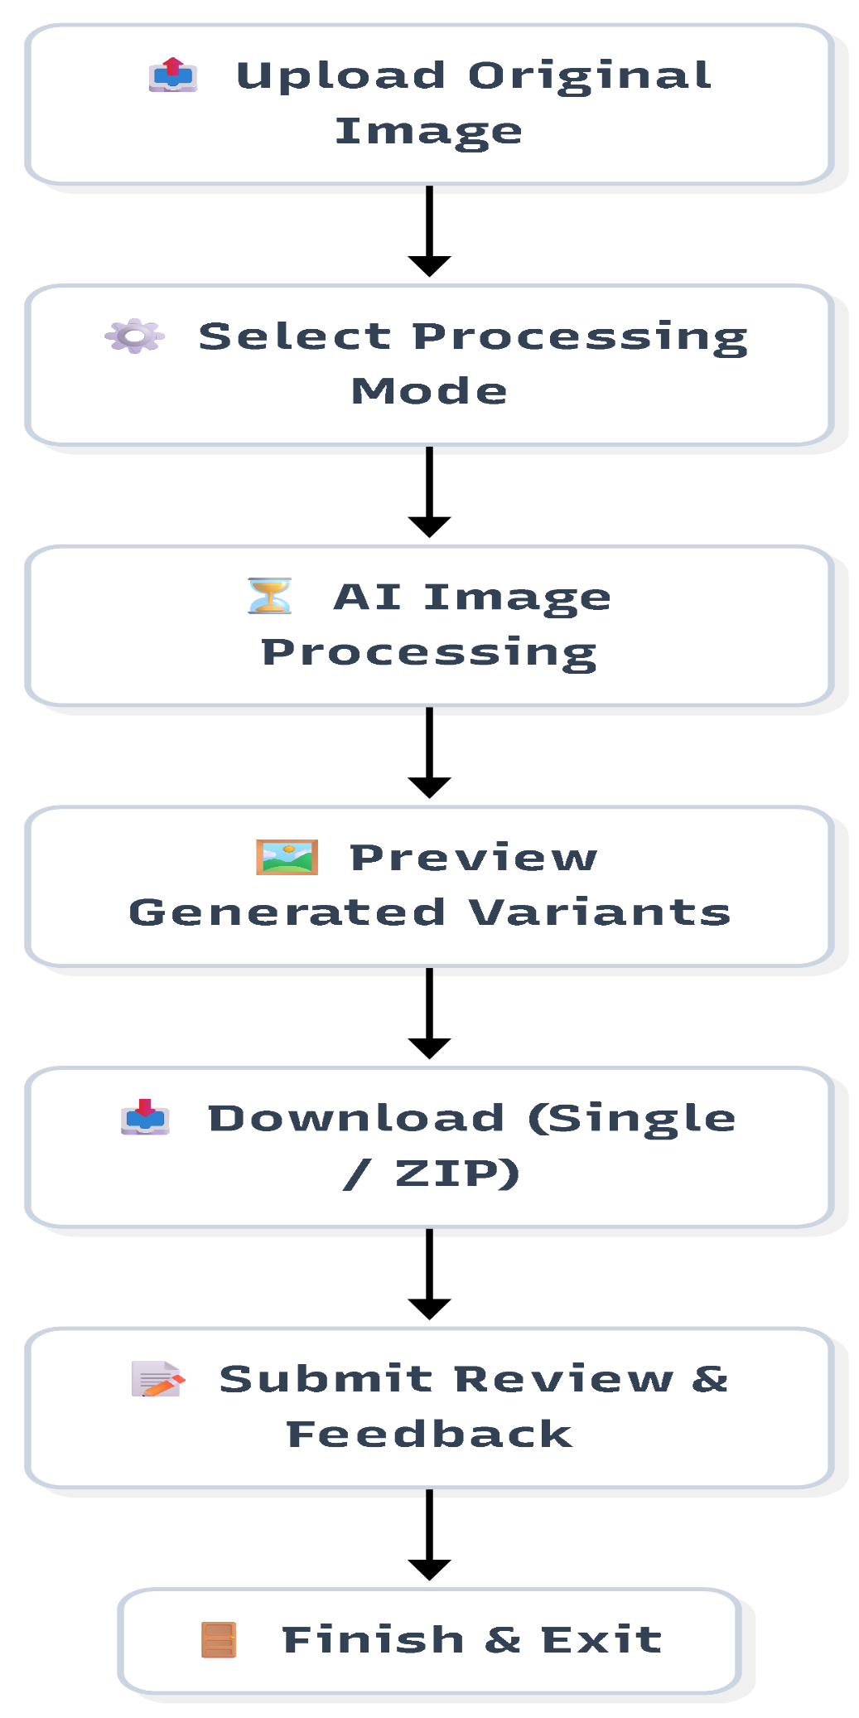
Figure 9.1.1 User Workflow

CHAPTER 10
RESULTS AND ANALYSIS
The AI Colorizer and Enhancer was successfully implemented and tested, and all modules worked as expected. The system reduces manual effort and improves accuracy in attendance and session management. It provides easy access to information for user. The performance is efficient under normal conditions with smooth data flow.
  - Screenshots
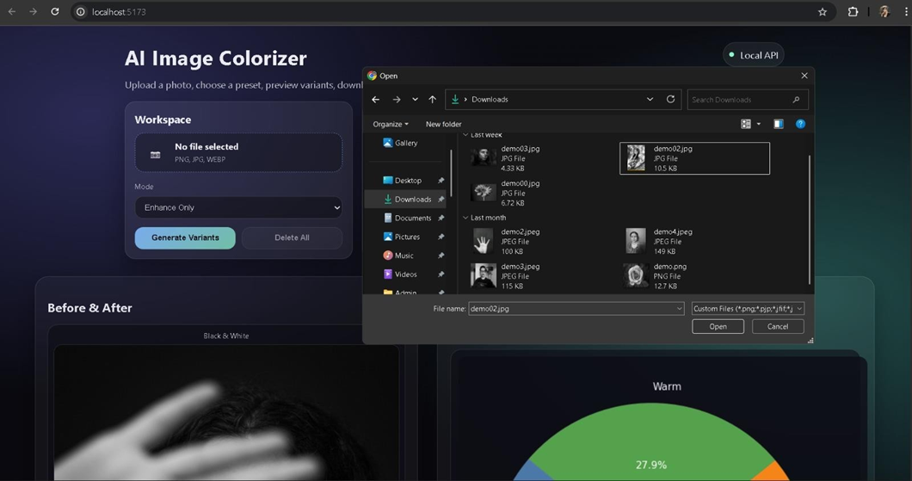
Figure 10.1.1 Image Upload
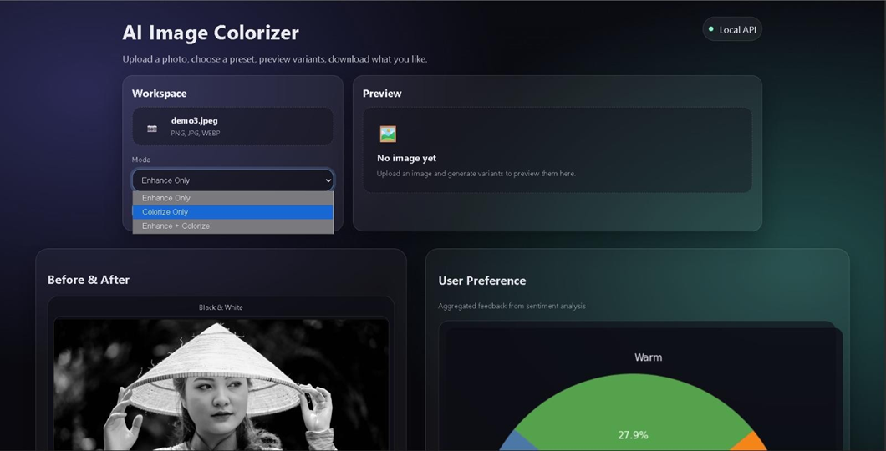
Figure 10.1.2 Mode Selection
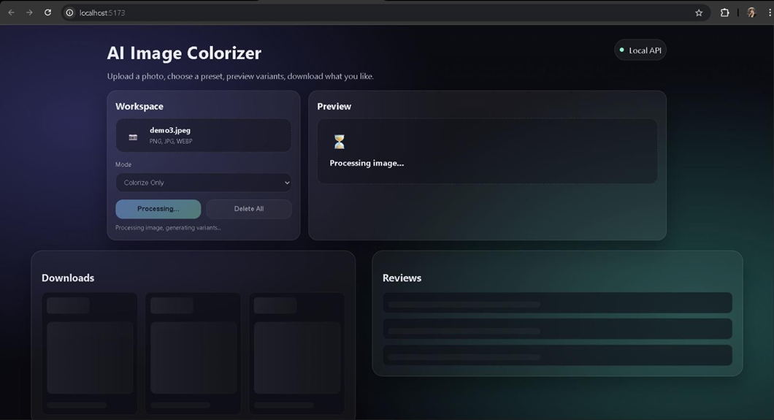

Figure 10.1.3 Result Loading

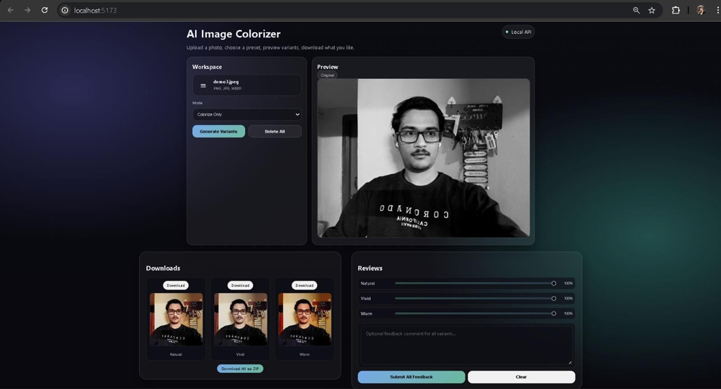

Figure.10.1.4 Output Displayed

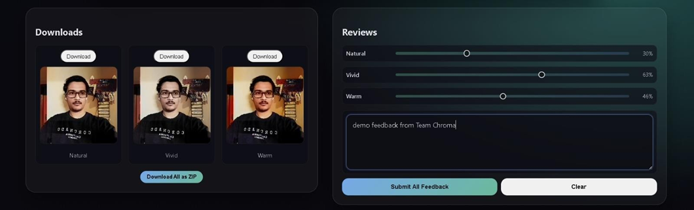

Figure.10.1.5 Output Variants and Review

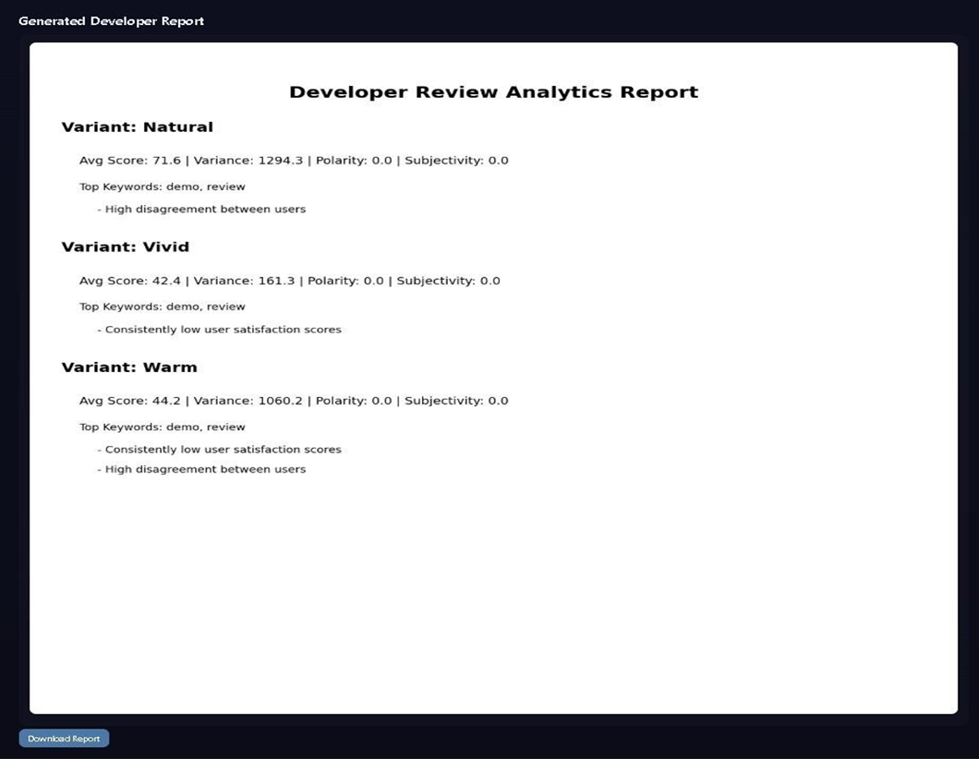

Figure.10.1.6 User Review Report

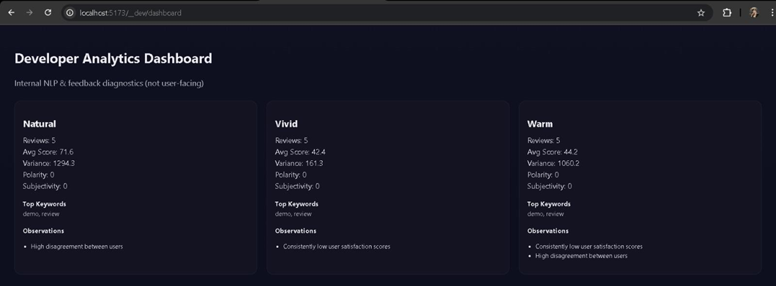

Figure.10.1.7 Developer Dashboard

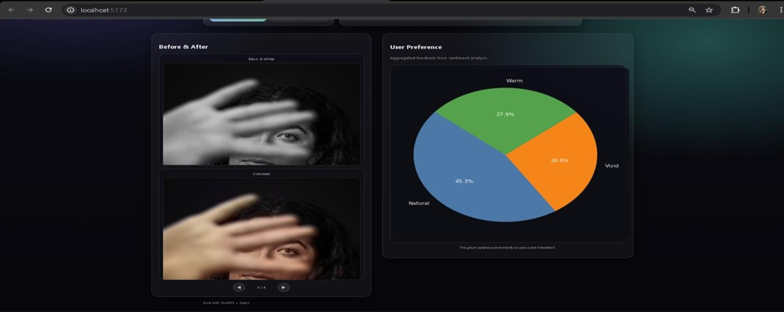

Figure.10.1.8 Example Carousel and User Preference Graph

CHAPTER 11

TESTING

Testing is performed to ensure that the AI Image Colorizer system functions correctly and meets all specified requirements. It verifies core functionalities such as image upload, processing, variant generation, feedback submission, and analytics generation.

Different types of testing are conducted, including unit testing, integration testing, system testing, and performance testing. The testing process ensures smooth communication between the frontend (React), backend (FastAPI), processing modules (OpenCV), and analytics components (NLP and visualization).

Testing also helps identify issues such as invalid inputs, processing errors, and feedback handling problems, ensuring that the system operates reliably before deployment.

11.3 Test Cases

Test Case ID | Test Case Description | Input | Expected Result | Status
TC01 | Image Upload | Valid image file (jpg/png/webp) | Image uploaded successfully | Pass
TC02 | Invalid File Upload | Unsupported file format | Error message displayed | Pass
TC03 | Image Processing (Enhance) | Valid image + enhance mode | Enhanced variants generated | Pass
TC04 | Image Processing (Colorize) | Valid image + colorize mode | Colorized variants generated | Pass
TC05 | Image Processing (Both) | Valid image + both mode | Enhanced + colorized variants generated | Pass
TC06 | View Variants | Generate available images | Variants displayed correctly | Pass
TC07 | Download image | Click Download button | Image downloaded correctly | Pass
TC08 | Download ZIP | Multiple Variants | ZIP file downloaded sucessfully | Pass
TC09 | Empty feedback | No comment/default score | Feedback handled without error | Pass
TC10 | Submit feedback | Score +comment | Feedback stored sucessfully | Pass

11.4 Testing Results
- All unit testing and integration testing were successfully executed for the core modules of the system, including image upload, processing, variant generation, and feedback handling.
- Integration between the frontend (React), backend (FastAPI), and processing modules (OpenCV and AI model) was tested and functioned correctly without data inconsistencies.
- Image enhancement and colorization features worked as expected across different modes (Enhance, Colorize, Both), producing valid output variants.
- Feedback submission system, including score input and optional comments, was verified and stored correctly in the system.
- Analytics generation, including sentiment analysis and pie chart visualization, worked correctly and updated dynamically based on user feedback.
- The system handled invalid inputs (unsupported file types, empty uploads) gracefully by displaying appropriate error messages.
CHAPTER 12

ADVANTAGES AND DISADVANTAGES

The AI Image Colorizer system is designed to automate image enhancement and colorization using artificial intelligence. It provides an efficient platform for processing images and collecting user feedback for analysis. Like any technological system, it offers several advantages in terms of performance and usability, while also having certain limitations related to processing and system design.

12.1 Advantages:

Automated Image Processing
The system automatically enhances and colorizes images using AI, reducing manual editing effort.

Multiple Output Variants
Generates different versions (Natural, Vivid, Warm), allowing users to choose preferred results.

User-Friendly Interface
Simple and intuitive frontend makes it easy for users to upload images and view results.

Integrated Feedback System
Users can provide ratings and comments, enabling continuous improvement and evaluation.

Real-Time Analytics
Generates visual insights (pie charts) based on user feedback for better understanding of preferences.

Lightweight and Local Execution
Can run on local systems without requiring heavy cloud infrastructure.

Modular Architecture
Separate modules for processing, feedback, and analytics make the system scalable and maintainable

12.2 Disadvantages
- Processing Time
Image processing and AI colorization may take time depending on image size and system performance.
- Limited Model Accuracy
AI-generated colorization may not always produce perfectly realistic results.
- No Cloud Storage
Data is stored locally, which may limit accessibility across multiple devices.
- Basic Analytics
Current analytics are limited to simple visualizations and sentiment analysis.
- Hardware Dependency
Performance depends on system specifications (CPU, RAM), especially during processing.
- Model Dependency
Requires external model files, which must be downloaded and configured manually.

CHAPTER 13

CONCLUSION AND FUTURE SCOPE
The AI Image Colorizer system successfully addresses the challenges of manual image enhancement and colorization by providing an automated and efficient solution using artificial intelligence. The system offers a centralized platform where users can upload images, generate multiple enhanced and colorized variants, and provide feedback for evaluation.
13.1 Conclusion
By integrating image processing techniques with AI-based colorization, the system reduces manual effort, improves processing efficiency, and delivers visually appealing results. The user-friendly interface ensures smooth interaction, while the feedback and analytics modules provide valuable insights into user preferences.
Testing results confirm that the system meets both functional and non-functional requirements, with reliable performance across image processing, feedback handling, and analytics generation. Although the system has certain limitations in terms of model accuracy and processing time, it provides a strong and scalable foundation for further development.
Overall, the AI Image Colorizer system is an effective and modern solution that combines computer vision, web development, and data analysis to enhance image processing workflows.

13.2 Future Scope
- Adaptive AI Based on User Feedback
Implement a feedback-driven optimization system where sentiment analysis and user scores dynamically influence image processing parameters. For example, if users indicate that a variant such as “Vivid is not bright enough”, the system can automatically adjust brightness, contrast, or saturation in future outputs. This creates a self-improving system that evolves based on user preferences.
- Advanced AI Models
Integrate more sophisticated deep learning or diffusion-based models to achieve higher accuracy and more realistic colorization results.
- Cloud Deployment
Deploy the system on cloud infrastructure to enable remote access, scalability, and multi-user support.
- User Authentication System
Introduce secure login functionality to manage user sessions and personalize feedback tracking.
- Enhanced Analytics Dashboard
Expand analytics with deeper insights such as trend analysis, variant performance comparison, and user behavior tracking.
- Batch Image Processing
Allow users to upload and process multiple images simultaneously to improve productivity.
- Mobile Application Support
Develop a mobile-friendly interface or dedicated mobile application for better accessibility.
- GPU Acceleration
Utilize GPU-based processing to significantly reduce processing time for large images or advanced models.
- Exportable Reports
Enable generation of downloadable reports (PDF/PNG) summarizing user feedback, analytics, and system performance.

CHAPTER 14

REFERENCES
- Sommerville, I., Software Engineering, 10th Edition, Pearson Education.
- Pressman, R. S., Software Engineering: A Practitioner’s Approach, McGraw-Hill.
- FastAPI Documentation, “FastAPI Framework,” Available at: https://fastapi.tiangolo.com
- React Documentation, “React Official Documentation,” Available at: https://react.dev
- OpenCV Documentation, “OpenCV Library,” Available at: https://docs.opencv.org
- NumPy Documentation, “NumPy Library,” Available at: https://numpy.org
- Matplotlib Documentation, “Matplotlib Library,” Available at: https://matplotlib.org
- TextBlob Documentation, “TextBlob Library,” Available at: https://textblob.readthedocs.io
- NLTK Documentation, “NLTK Library,” Available at: https://www.nltk.org
- Zhang, R., Isola, P., & Efros, A. A., “Colorful Image Colorization,” European Conference on Computer Vision (ECCV), 2016.
- Mozilla Developer Network (MDN), “Web Development Documentation,” Available at: https://developer.mozilla.org
- W3Schools, “HTML, CSS, JavaScript Tutorials,” Available at: https://www.w3schools.com
- GitHub Documentation, “Version Control and Collaboration,” Available at: https://docs.github.com

