SOAP (SOcialAirPollution)

Team: 10

Challenge: Air pollution

# Introduction

Air pollution is a major health risks and causes an estimation half a million premature deaths each year in Europe. Therefore, it is necessary to know the effects of air pollution on the health of people and which of these people are more at risk. This insight will help municipalities, consultancy firms and health insurance providers to strategically plan urban development to lower the health risk due to air pollution.

# Bottleneck

Currently there are different datasets and visualization tools available to view the state of air pollution, like data from the Sentinel 5 satellite, measurement stations from RIVM (Governmental agency of the Netherlands regarding environment) and the zip code view of the Lung fund. However, these products do not combine datasets like for example economic or social status within neighborhoods or are to coarse for drawing conclusions on neighborhood level. This neighborhood level is important for urban development. Another important problem is that these tools are not easily accessible for urban planners and health insurance providers.

# Our product

We addressed this issue by building an open tool where we visualize the map data of RIVM with other economic and social factors, called ‘SOAP’ (SOcialAirPollution ). We only focus in this prototype on combining air pollution map data with a factor that is a good indicator for the economic and social status of the people living in that neighborhood. Therefore, we choose to set the average WOZ-value (valuation of real estate) in the neighborhoods against the air pollution.

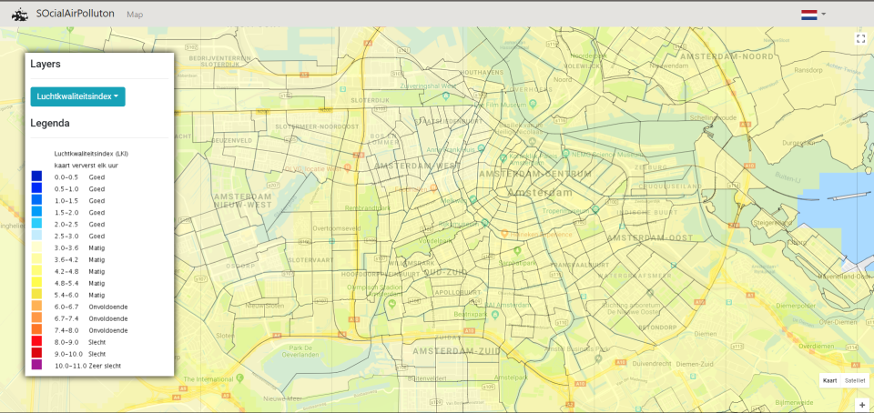

These datasets are visualized in an app where it is visualized on a map per type of air pollution (fine dust (PM10), nitrogen-dioxide (NO2), ozon (O3) and air quality index). You can click on a neighborhood to view a plot of the air pollution and view the WOZ-value.

# Our customers

Our product is aimed at urban planners from municipalities and consultancy firms and health insurance providers. Urban planners of municipalities can use our product to review the urban development of recent years against the air pollution. They can answer questions like whether people with a lower social status live or move to areas with larger air pollution, increasing the already larger health risk for these people. Urban planners of consultancy firms can use the tool to address the issues of increased health risk due to air pollution in areas to the municipalities and help planning new urban development in areas with low levels of air pollution but also areas with lower housing prices. Finally, health insurance providers can use the tool to review areas with larger health risks due to air pollution but with low economic and social status. With this information they can selectively make plans to prevent health issues of these people to ultimately lower the cost of treating the health problems.

# Future development

In our prototype we only addressed one factor (the WOZ-value) against the air pollution on a neighborhood level. However, economic and social status is not only reflected by one factor but multiple. Therefore, we want to address more factors which reflect economic and social status and get this data also visualized in our tool. Furthermore, the prototype now shows a real-time view. For our future customers it would be beneficial to also view the development of air pollution and several factors over the years. This will give an estimation whether the air pollution increases or decreases in an area. This information can help urban planners for selecting certain areas for future development and view whether areas in risk of too high levels of air pollution. Health insurance providers can also use this data to plan their activities more selectively to increase the effect of preventing health issues in certain neighborhoods.

# Conclusion

It is necessary to know the effects of air pollution on the health of people and which of these people are more at risk. This insight will help municipalities, consultancy firms and health insurance providers to strategically plan urban development to lower the health risk due to air pollution. Current products for viewing air pollution do not combine datasets like for example economic or social status within neighborhoods or are to coarse for drawing conclusions on neighborhood level. We addressed this issue by building an open tool where we visualize the map data of RIVM with other economic and social factors, called ‘SocialAirPollution’ (Soap for short). Our product is aimed at urban planners from municipalities and consultancy firms and health insurance providers. For future development we want to address more factors which reflect economic and social status.