For all the graphs, the red line shows the training errors. Blue line shows the testing errors. Green line shows the difference between training errors and testing errors.

Iris dataset using logistic regression

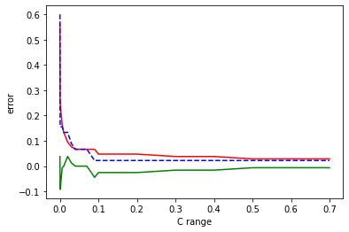

The best c value is 0.325. Underfitting occurs when c is below 0.04. It happens because c value is low.

Wine dataset using logistic regression

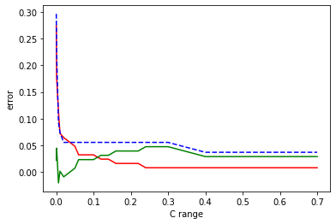

The best c value is 0.183.

Iris dataset using random forest model

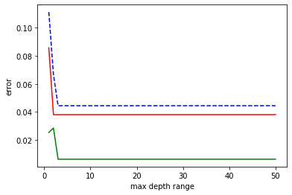

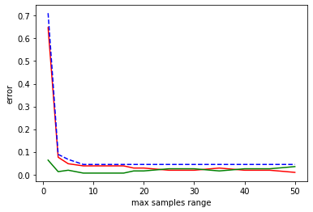

Best max depth value is 1. Best max sample value is 12. Underfitting occurs when max sample value is above 20. It happens because there is too much sample data.

Breast cancer dataset using random forest model

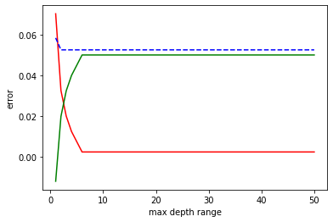

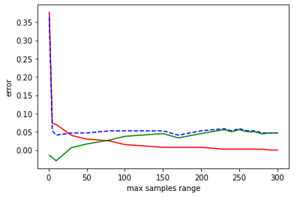

Best max depth value is 5. Best max sample value is 180. Underfitting occurs when max depth value is above 7 or max sample value is above 200. It happens because the model is not trained enough. Overfitting occurs when max depth is below 2 or max sample value is below 10. It happens because the sample size is not large enough so the model is tuned to fit closely to the training data.