Medimates

**Omniasanitas**

**Deepti Rathore**

**Krunal Solanki**

**Report**

**Introduction:**

The lack of accessibility and affordability of healthcare is a vice that has spread its cancerous tentacle all over the United States firmly. To battle this vice, we have come up with Omniasanitas. Omniasanitas is a once-stop shop for all your medical needs. It provides several features such as:

1. Looking up doctor for instant online consultation whether it be via text, call or video consultation.

2. Searching medicines and then subsequently getting them delivered to your house or being sent to a nearby pharmacy for pickup at your own convenience.

3. Looking up different types of laboratory tests and booking them while also getting test samples picked up at your home.

4. Providing personalized health insurance with customized coverage or full coverage.

**Problem Statement:**

The United States has long struggled with the issue of healthcare accessibility and affordability. Despite being one of the wealthiest nations in the world, millions of Americans struggle to access basic healthcare services due to the high cost of medical care. Many individuals simply cannot afford the exorbitant prices of medical treatments, leading to delayed or inadequate care that can have serious consequences. Furthermore, the lack of comprehensive healthcare coverage means that many individuals are forced to make difficult decisions between paying for healthcare and other necessities such as housing, food, and education. The result is a healthcare system that leaves many behind and perpetuates disparities in healthcare outcomes.

**The key barriers to access in healthcare are:**

* Financial Barriers - Currently, there are more than 40 million Americans with no health insurance. Additionally, at least 35 million more are denied care because their medical provider did not accept their insurance.
* General Accessibility and Availability Barriers - The issue of accessibility can also be threatened by obstacles that hinder availability. For example, patients who rely on public transportation, or who live in remote areas, may not be able or willing to travel long distances or catch the bus to visit a doctor. Conversely, patients who have a steady means of transportation may still experience a lack of access to healthcare services. This may simply be because the resources in their area do not support their condition.
* Logistical Barriers - Depending on the patient’s situation, lists of barriers to healthcare access can include many other logistical obstacles like:
* Inability to pause work or family obligations.
* Inconvenient facility hours.
* Long waiting periods (especially surgical consult).
* Uncertainty when transitioning from one provider to another.

**Lack of Affordability in Healthcare:**

The number and percentage of Americans lacking health insurance is falling to historic lows despite policy changes aimed at helping people get and stay covered during the COVID-19 pandemic, as well as the recent decision by several states to expand Medicaid eligibility under the Affordable Care Act. To further observe this issue, we look at a survey undertaken by the SSRS.

For the survey, SSRS interviewed a nationally representative sample of 8,022 adults aged 19 and older between March 28 and July 4, 2022. This analysis focuses on 6,301 respondents under age 65. The findings of the survey are as follows:

* Forty-three percent of working-age adults were inadequately insured in 2022. These individuals were uninsured (9%), had a gap in coverage over the past year (11%), or were insured all year but were underinsured, meaning that their coverage didn’t provide them with affordable access to health care (23%).

* Forty-six percent of respondents said they had skipped or delayed care because of the cost.

**Business Model Canvas:**

**Value Proposition Canvas:**

**Hypotheses:**

The two hypotheses we want to test are:

* In what states is healthcare more accessible?
* And if it is accessible, is it affordable and how much of that is covered by insurance?

**Methods:**

**Data Description:**

This dataset shows variation of hospital charges in the various hospitals in the US for the top 100 diagnoses. The dataset is owned by the US government. It is freely available on [data.gov](https://data.gov.). We can observe how price for the same diagnosis and the same treatment and in the same city can vary differently across different providers.

Link to dataset:

<https://www.kaggle.com/datasets/speedoheck/inpatient-hospital-charges?resource=download>

Data Dictionary:

|  |  |
| --- | --- |
| DRG Definition | Provides name of Procedure |
| Provider Name | Provides Hospital Name |
| Provider Street Address | Provides Hospital street address |
| Provider Id | Provides Hospital Id |
| Provider City | Provides the city in which the hospital is in |
| Provider State | Provides the state in which the hospital is in |
| Provider Zip Code | Provides the zipcode in which the hospital is |
| Hospital Referral Region Description | Provide information of Hospital referral region |
| Total Discharges | Provide information of how many patients got discharged |
| Average Covered Charges | Provide information of insurance average covered charges for the Procedure |
| Average Total Payments | Provide Information of how much the total payment is charged for the procedure, room and medicines |

**Data Cleaning:**

Cleaning Steps Undertaken:

* Firstly, we changed the data roles to geographic for all the columns including States, City and Zip code.
* Then we, excluded the cities which tableau didn’t recognize.
* Lastly, we added more filters for better visualizations.

**Visualizations:**

**Visualization of the whole dataset:**

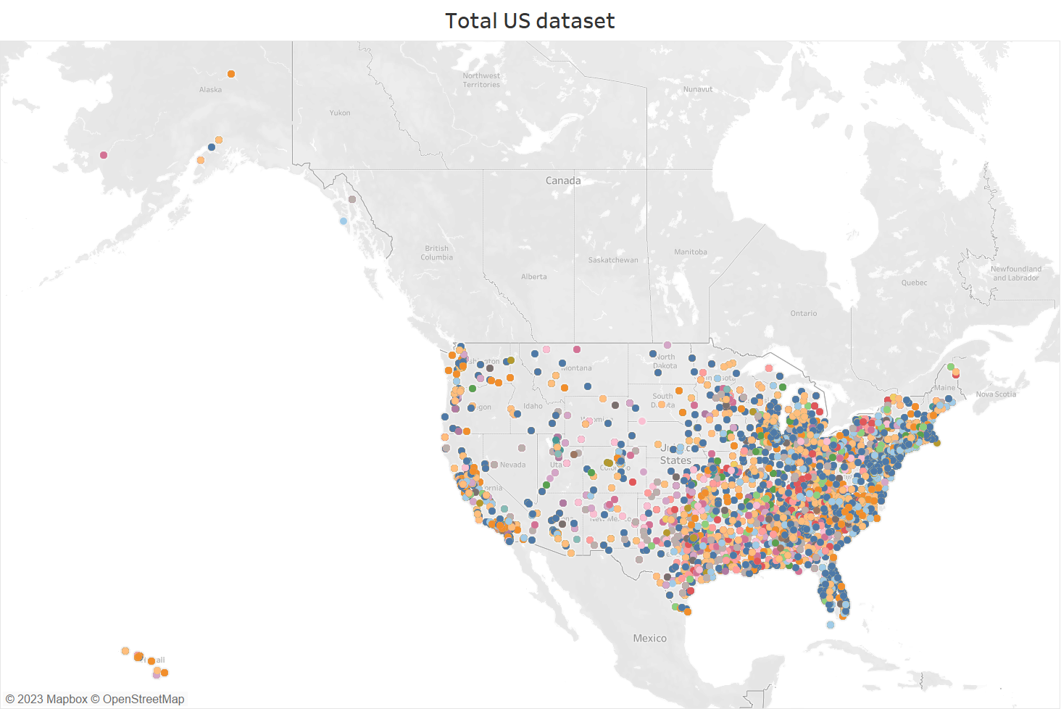

* It is giving the information for the hospitals which is providing the procedure at what price. But just by looking at it we can’t make out which state has a greater number of procedures or what is the overall cost there.

**Visualization according to State:**

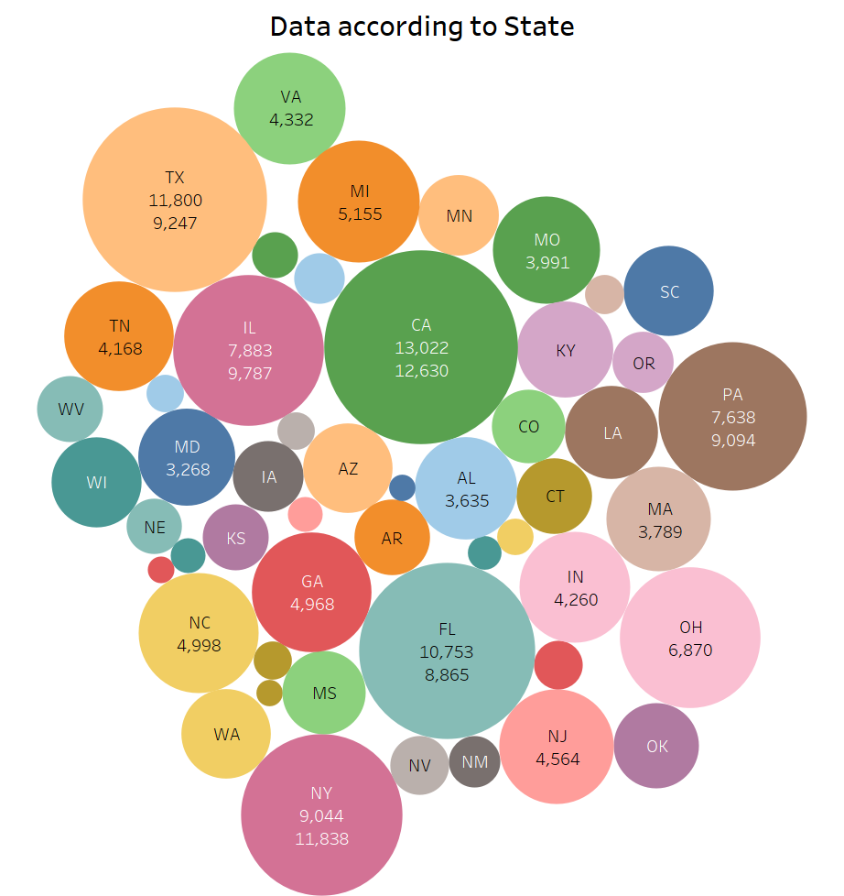

* This bubble graph basically shows which state has the highest number of procedures with their average cost.
* We can observe from the visualization that California, Taxes and Florida are the states where the frequency of the procedure is high. It is also observed that the overall cost of procedures in those states is also high.

**Visualization according to County:**

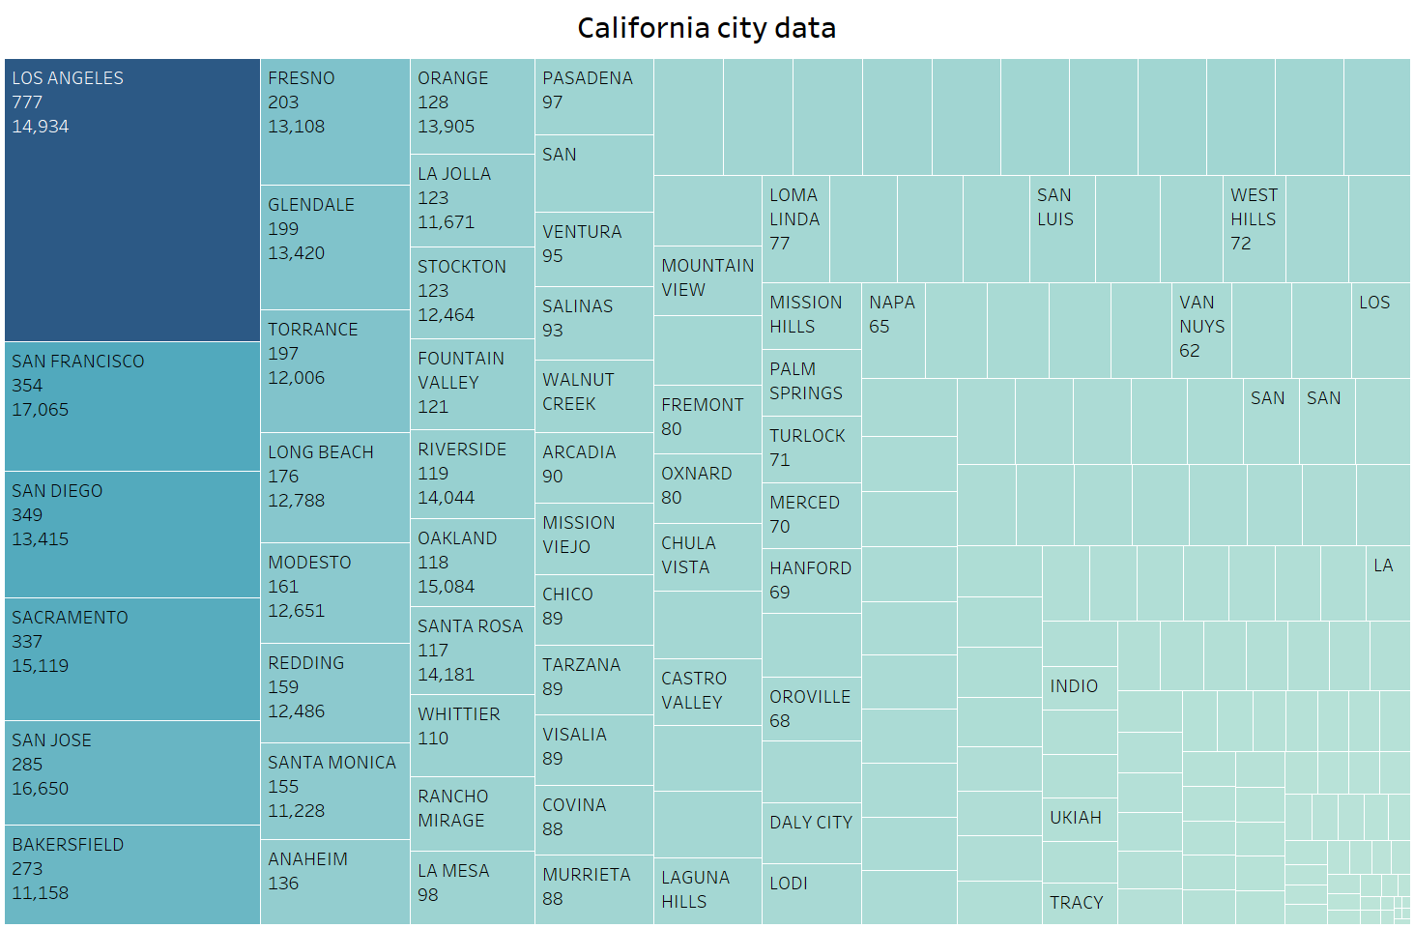

* When we filter the data according to cities in California, we found out that LA has the greatest number of procedures among all the cities in CA.
* We also noticed that average cost of treatment in San Francisco is more than any other county in California.
* So, we can infer that if there is accessibility doesn’t imply that it is affordable.

Visualizing the most expensive procedure:

* We are filtering based on the total payment being more than $50,000. By observing this visualization, we can say that code 853(Infectious and parasitic diseases and 870(septicemia or sever sepsis) are most common treatment.

Insurance Coverage Analysis:

* We are checking how much does the insurance cover for different treatments. We can notice that the coverage can be anywhere from 66% to 86%.

Price variation by provider:

* When we chose the 2 mostly used procedures and LA as the city for those. WE found out that the prices for the same procedure vary a lot between different providers.

**Monetization:**

**In-app purchases:** This involves offering digital products or services within a mobile app and generating revenue through user purchases.

**Subscription fees:** The platform charges users a subscription fee of $10 per year to access content or features on the platform.

**Revenue:**

* Consultancy commission: The platform charges a commission for connecting users with doctors or healthcare professionals who provide consultation services through the platform.
* Medicine vendor commission: The platform charges a commission for connecting users with vendors who sell medicines through the platform.
* Insurance commission: The platform charges a commission for connecting users with insurance providers and policies.
* Laboratories commission: The platform charges a commission for connecting users with the laboratories to book the medical tests.

**Prototype:**

The prototype file has been submitted to the beachboard in the same dropbox.