**Module–2(Manual Testing)**

* What is Exploratory Testing?

In Exploratory testing is a testing person will explore the Application without any documentation to look the system pattern. How it work and write is positive and negative scenarios.

It is not random testing but it is Adhoc testing with purpose of find bugs.

Exploratory testing is structured and rigorous.

* What is traceability matrix?

Traceability Matrix is Help for tracking Testing Software process.

There are two types of traceability Matrix

* Forward Traceability
* Backward Traceability

In Forward Traceability mapping of Requirements to Test Cases.

In Backward Traceability mapping of Test Cases to Requirements.

* What is Boundary value testing?

Boundary Value Testing is a methodology for designing test cases to set near the limits of valid ranges.

Boundary value testing is that highlight errors better than equivalence partitioning.

* What is Equivalence partitioning testing?

In Equivalence partitioning testing numbers fall into a partition where each would have the equivalent.

* What is Integration testing?

Integration testing is a level of the software testing process. Where individual units are combined and tested as a group.

Test drivers and test stubs are used to assist in integration testing

There are two types of integration testing

* Component integration testing
* System integration testing
* What determines the level of risk?

A factor that could results in future negative consequences usually express as impact and likelihood.

There are two types of risk

* Project risk
* Product risk
* What is Alpha testing?

Alpha testing is always performed by the developers at the software development site.

Sometimes it is performed by independent Testing team.

Alpha Testing is not open to the market and public

Alpha Testing is always performed in Virtual Environment.

It comes under the both of white box testing and Back box testing.

* What is beta testing?

Beta testing is always performed by the customers at their own site.

It is not performed by independent testing team.

Beta testing is always open for the market and public.

Beta testing is always performed in real time environment

It is only a kind black Box Testing.

* What is component testing?

Component Integration Testing is performed to expose defects in the interfaces and inraction between integrated components

Component testing is usually formal testing.

Thera are two types of component testing

* Functional testing
* Non-Functional Testing
* What is functional system testing?

A requirement that specifies a function that a system component must perform.

Manual Testing and Automation testing tools can be used for Functional testing

Easy to do manual testing

There are two types of test Approach

- requirement base Functional Testing

- Process base Functional Testing

* What is Non-Functional Testing?

In Non-Functional Testing is not related to Functionality example – usability, reliability and maintainability.

Tough to do manual testing

* What is GUI Testing?

GUI is Graphical User Interface.

GUI testing involves checking the screens with the controls like menu, buttons, icons and all types of bars, tool bar, menu bar, dialog Boxes and windows.

* What is Adhoc testing?

Adhoc testing is an informal testing type with an aim to brake the system.

It does not follow any design techniques to create test cases.

Tester randomly test the application without any test cases or Documentation.

Adhoc testing technique is called Error Guessing Technique.

There are three types of Adhoc testing

* Buddy Testing
* Pair Testing
* Monkey Testing
* What is load testing?

It’s a performance testing to check system behavior under load.

Load testing is a kind of performance testing which determines a system’s performance under real life load condition. How application behaves when multiple users access it simultaneously.

* What is stress Testing?

Stress testing is system is stress beyond its specification to check how and when is fails.

Stress testing is used to test the stability and reliability of the system.

Stress testing is done to make sure that the system would not crash under crunch situation.

Stress testing is also known as a endurance testing.

* What is white box testing and list the types of white box testing?

White Box testing is testing based on an analysis of the internal structure of the component or system.

White box testing is also known as a Glass Box testing or Open box testing.

In White Box testing The tester require knowledge of coding.

* What is black box testing? What are the different black box testing techniques?

Black box testing is testing either functional or non functional, without reference to the internal structure of component or system.

Black box testing is also known as a Specification based testing.

In Black box testing the tester have no knowledge of how the system is structured inside the box.

* Mention what are the categories of defects?

Defects is the variance from a desired product attributes

There are many types of defect

* Data quality/Database Defects
* Critical Functionality defects
* Functionality Defects
* Security Defects
* User interface Defects
* Mention what bigbang testing is?

In big bang integration testing all components or modules is integrated simultaneously, after which everything is tested as a whole.

Big Bang testing has the advantages that everything is finished before integration testing starts.

The major disadvantages is that in general it is time consuming and difficult to trace the cause of failures of this late integration.

In Big Bang testing all component are integrated together at once, and then tested.

* What is the purpose of exit criteria?

Exit criteria defines the items that must be completed before testing can be concluded.

* Successful Testing of Integrated Application.
* Executed Test Cases are documented.
* All High Prioritized bugs are Fixed and closed.
* Technical documents to be submitted followed by release notes.
* When should "Regression Testing" be performed?

Regression testing is performed when the software or its environment is changed.

Change in requirements and code is modified according to the requirement.  
New feature is added to the software, defect fixing, Performance issue fix.

* What is 7 key principles? Explain in detail?

1. Testing shows presence of defects
2. Exhaustive testing is impossible
3. Early Testing
4. Defect clustering
5. The Pesticide paradox
6. Testing is context dependency
7. Absence of error fallacy

* Difference between QA v/s QC v/s Tester

**QA**

* Activities which ensure the implementation of processes, procedures and standards in context to verification of developed software and intended requirements
* Focuses on processes and procedures rather than conducting actual testing on the system.
* Process oriented activities.
* Preventive activies.
* It is subset of Software Test Life Cycle.

**QC**

* Activities which ensure the verification of developed software respect to documented requirements.
* Focus on actual testing by executing Software with intend to identify bug/defect through implementation of procedures and process.
* Product oriented activities.
* It is a corrective process.
* QC can be considered as the subset of Quality Assurance.

**TESTER**

* Activities which ensure the identification of bugs/defects/error in the software.
* Focuses on actual testing
* Product oriented activities.
* It is a Preventive Process.
* Testing is a subset of QUALITY CONTROL
* Difference between Smoke and Sanity?

|  |  |
| --- | --- |
| **Smoke Testing** | **Sanity Testing** |
| It is Exercise entire Application or Software | It is exercise Particular Part of Application or software. |
| Requirement Documents Part | Does not required document Part |
| Test by tested and developer | Yest by only Tester |
| Objective – Stability of system | Objective – Rationality of system |
| Smoke testing is subset of regression testing | Sanity testing is subset of Acceptance testing |
| Smoke testing is also called ZERO level testing | Sanity testing is also called N level of testing |

* Difference between verification and Validation
* Explain types of Performance testing.

There are Six types of Performance testing

* Load testing
* Stress testing
* Endurance testing
* Spike testing
* Volume testing
* Scalability testing
* What is Error, Defect, Bug and failure?

A mistake in coding is called Error, error found by tester is called Defect, defect accepted by development team then is called bug, build does not meet the requirements then is called failure.

* Difference between Priority and Severity

|  |  |
| --- | --- |
| **Priority** | **Severity** |
| Priority is given by Test Lead or Project manager | Severity is given by QA testers |
|  |  |
|  |  |
|  |  |

* What is Bug Life Cycle?

The duration or time span between the first time defects is found and the time that it is called as Bug Life Cycle.

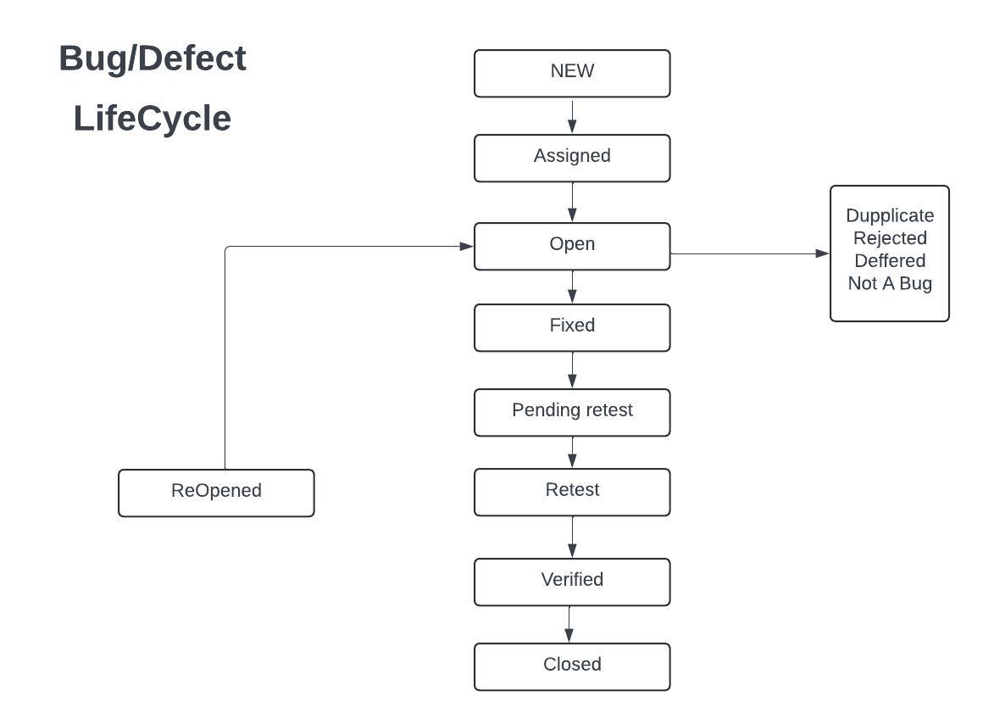

* Explain the difference between Functional testing and Non Functional testing

|  |  |
| --- | --- |
| **Functional Testing** | **Non- Function Testing** |
| Functional testing is executed first | Non-Functional testing should be performed after functional testing |
| Manual testing or automation tools can be used for functional testing | Using tools will be effective for this testing |
| Business requirements are the inputs to functional testing | Performers parameter like speed, scalability are inputs to non-functional testing |
| Easy to do manual | Tough to do manual |
| Types of Functional testing are:  Unit testing  Smoke testing  Sanity testing  Black-box testing  White-box testing  Integration Testing  Usar acceptance Testing  Regression Testing | Types of Non-Functional Testing are:  Performance Testing  Volume Testing  Load Testing  Stress Testing  Security Testing  Installation Testing  Penetration Testing  Compatibility Testing  Migration Testing |

* + To create HLR & TestCase of 1)(Instagram , Facebook) only first page

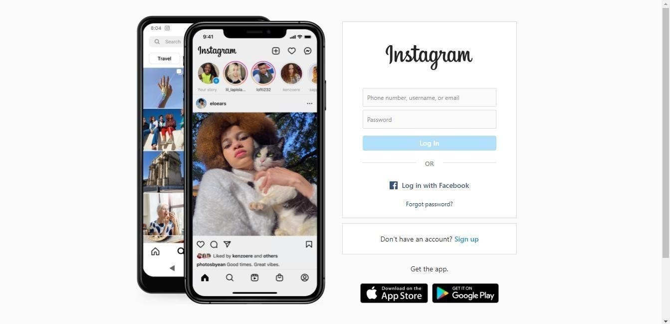

1. Facebook Login Page : <https://www.facebook.com/>

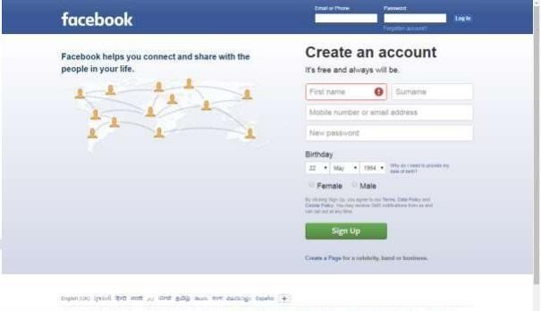

* + What is the difference between the STLC (Software Testing Life Cycle) and SDLC (Software Development Life Cycle)?

|  |  |
| --- | --- |
| SDLC | STLC |
| Process followed by development team within the software organization to develop a software product. | Process to carrying out various activities to ensure the quality of the software. |
| Stands for Software Development Life Cycle. | Stands for Software Testing Life Cycle. |
| Covers the entire life cycle of the software. | Limited only to the testing phase. |
|  |  |
|  |  |



* + What is the difference between test scenarios, test cases, and test script?

|  |  |  |
| --- | --- | --- |
| **TEST SCENARIO** | **TEST CASE** | **TEST SCRIPT** |
| Is any functionality that can be tested. | Is a set of actions executed to verify particular Functionality. | Is a set of instructions to test an app automatically. |
| Is derived from test artifacts like business Requirement Specification (BRS) and Software Requirement Specification (SRS). | Is mostly derived from test scenario. | Is mostly derived from test cases. |
| Heps test the end-to-end functionality in an Agile way. | Helps in exhaustive testing of an app. | Helps to test specific things repeatedly. |
| Is more focused on what to test. | Requires more resources and time. | Requires less time for testing but more resources for scripts creating anf updating. |
|  |  |  |

* + Explain what Test Plan is? What is the information that should be covered.

A test plan is a detailed document which describes software testing areas and activities.

* What is priority?

Priority Is Relative and Business-Focused. The priority status is set based on the customer requirements.

For Example :- If the company name is misspelled on the home page of the website, then the priority is high severity is low to fix it.

**Priority can be following types:-**

**LOW :-** The defect is an irritant which should be repaired, but repair can be deferred until after more serious defect has been fixed.

**Medium:**- The defect should be resolve in the normal course of development activities. It can wait until a new build or version is created.

**High :**- The defect must ben resolved as soon as possible because the defect is affecting the application or the product severely.

* What is severity?

Severity is absolute and customer-Focused. It is the extent to which the defect can affect the software.

For Example:- If an application or web page crashes when a remote link is clicked, in this case clicking the remote link by an user is rare but the impact of application crashing is severe.

**Severity can be following types:-**

**Blocked**

**Critical**

**Major**

**Minor**

* Bug categories are…
* Functional bugs
* Usability bugs
* Security
* Compatibility bugs
* Syntax
* Logical bugs
* Unit-level bugs
* System integration
* Functional errors
* Calculation Errors
* Performance Defects
* Communication
* Critical
* Software
* Out of bound bugs
* Advantage of Bugzilla .

Effective Bug Tracking. Bugzilla provides a centralizes platform for tracking and managing software defects.

Customization and Flexibility.

Bugzilla is highly customizable, allowing organizations to tailor it to their specific needs.

* What are the different Methodologies in Agile Development Model?
* Explain the difference between Authorization and Authentication in Web testing.What are the common problems faced in Web testing?

|  |  |
| --- | --- |
| **AUTHENTICATION** | **AUTHORIZATION** |
| It determines whether users are who they are claiming to be | It determines the access that should be given or denied to an employee/user |
| It is done before authorization | It is done after the users successfully authenticate themselves |
| The data is moved through data tokens | The data is moved through access tokens |
| Authentication is visible to the user | Authorization is not visible to the user |
| This process is changeable by the user | It is not changeable by the user |

To create HLR & TestCase of WebBased (WhatsApp web , Instagram) 1. WhatsApp Web : <https://web.whatsapp.com/>

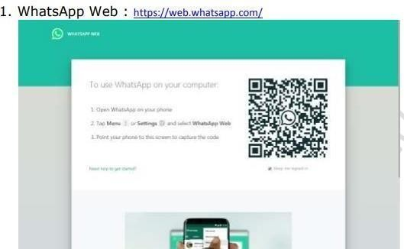



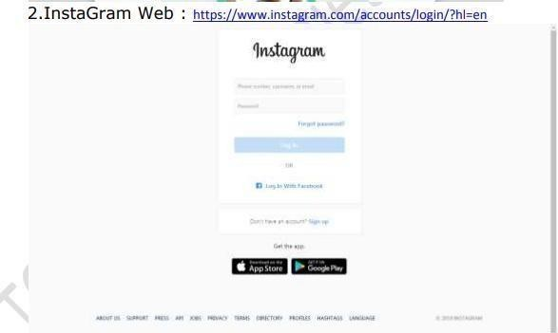

* + 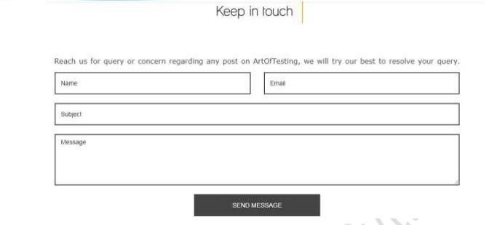To create HLR and TestCase on this Link. <https://artoftesting.com/>
  + Write a scenario of only Whatsapp chat messages

|  |  |
| --- | --- |
| **POSITIVE SCENARIO** | **NEGATIVE SCENARIO** |
| Verify the WhatsApp chat messages graphics is good to understand | While Verify the WhatsApp Chat Messages user can not use without Internet. |
| Verify the WhatsApp Chat new messages on top | While Verify the WhatsApp User can not take Screen Shot to another user’s photo |
| In whatsApp chat user can easily click to symbol of camera to Quickly click photo | While Verify the WhatsApp Camera is medium quality. |
| In WhatsApp Chat user can also show photo to click on another user’s DP |  |
| In WhatsApp chat user can easily scrolling chats |  |
| In WhatsApp chat user can search name to chatting. |  |
| In WhatsApp chat user can also do Voice Call & Video Call just one click on calling symbol |  |
| In WhatsApp chat user can also send voice messages. |  |

* + Write a Scenario of Pen

|  |  |
| --- | --- |
| **POSITIVE SCENARIO** | **NEGATIVE SCENARIO** |
| Verify the material of pen | While verifying the pen refill, Ink quality is not so good. |
| Verify the company name on the pen | While verifying the pen refill, refill should be reusable. |
| Verify the temperature of Ink in the pen | While verifying the pen, temperature of Ink should ne manageable. |
| Verify the height of the pen | While verifying the pen, company logo is not written properly. |
| Verify the width of the pen | While verifying the pen, cap is not properly. |
| Verify the grip of the pen | While verifying the pen, the grip of the pen is not proper. |
| Verify the cap of the pen | While verifying the pen, height of the pen is not suitable. |
| Verify the Ink quality of the pen | While verifying the pen, width of the pen is not suitable. |
| Verify the weight of the pen | While verifying the pen, it is not waterproof. |
|  | While verifying the pen, the quality used for the body of pen is not suitable. |
|  | While verifying the pen, it is not open from top side. |
|  | While verifying the pen, it is not open from bottom side to insert the refill. |
|  | While verifying the pen, the ink used in that not working for butter paper or transparent paper. |
|  | While verifying the pen, the body of pen is not transparent.  While verifying the pen, the label on pen is not visible. |

* + Write a Scenario of Pen Stand

|  |  |
| --- | --- |
| Verify the material of pen stand | While verifying the pen stand, the material is low quality |
| Verify the Company name of pen stand | While verifying the pen stand, company name is not readable |
| Verify the Height of the pen stand | While verifying the pen stand, height of pen stand is level of pen height |
| Verify the Width of the pen stand | While verifying the pen stand, maximum 3 pens are keep in pen stand |
| Verify the weight of the pend stand | While verifying the pen stand, weight is low |
|  |  |

* + Write a Scenario of Door

|  |  |
| --- | --- |
| Verify the material of door | While Verifying the door, material of door is very good. |
| Verify the Design of door | While Verifying the door, design is attractive. |
| Verify the handle are installed | While Verifying the door, Handle used are good Quality. |
| Verify the stopper installed | While Verifying the door, Stopper is not attached properly to the door. |
| Verify the close door is without noise | While Verifying the door, it is to noisy when open or close. |
| Verify the Quality of door | While Verifying the door, good Quality. |

* + Write a Scenario of ATM

|  |  |
| --- | --- |
| Verify the material of ATM | While Verifying the ATM, material is good. |
| Verify the company name and logo | While Verifying the ATM, Company name and logo is Clearly readable and Attractive |
| Verify the display of ATM | While Verifying the ATM, Display Brightness is low |
| Verify the Buttons of ATM | While Verifying the ATM, Button are Working Properly. |
| Verify the insert Debit card of ATM | While Verifying the ATM, Insert Debit Card Easily. |
| Verify the Printing Receipt of ATM | While Verifying the ATM, It is Lower Quality of page and printing ink. |
| Verify the Cash Out Roller of ATM | While Verifying the ATM, Roller Working Properly. |
|  |  |

* + When to used Usablity Testing?

Usability testing is use before any design decisions are made.

* + What is the procedure for GUI Testing?

Graphical User Interface (GUI) testing id a process of testing the system’s GUI of the system under Test. GUI testing Involves checking the screens with the controls like menus, buttons, icons and all types of bars- tool bar, menu bar, dialog boxes and windows etc.

* + Write a scenario of Microwave Owen

|  |  |
| --- | --- |
| Verify the material of Oven | While verifying the oven, material is mat finished and good. |
| Verify the buttons of oven | While verifying the oven, Buttons are working properly. |
| Verify the heat of oven | While verifying the oven, It is set manually. |
| Verify the Company name or logo of Oven. | While verifying the oven, It is attractive |
| Verify the Display of oven | While verifying the oven, It is working Properly. |
| Verify the handle of oven | While verifying the oven, Handle material is good |
| Verify the wire and Plug of oven | While verifying the oven, it is bad quality |
| Verify the symbols of oven | While verifying the oven, It is Clearly Readable. |

* + Write a scenario of Coffee vending Machine

|  |  |
| --- | --- |
| Verify the material of Coffee Machine | While verifying the Coffee Machine, Material is good |
| Verify the company name and logo of Coffee Machine | While verifying the Coffee Machine, company name and logo is readable. |
| Verify the display of Coffee Machine | While verifying the Coffee Machine, It is Show Timing of preparing coffee. |
| Verify the buttons of Coffee Machine | While verifying the Coffee Machine, it is easily working properly. |
| Verify the filters of Coffee Machine | While verifying the Coffee Machine, It is working properly. |
| Verify the set a limit of Coffee Machine | While verifying the Coffee Machine, It is manually set by user |
| Verify the symbol of Coffee Machine | While verifying the Coffee Machine, It is helpful for new user. |
| Verify the wire and plug of Coffee Machine | While verifying the Coffee Machine, Quality is good. |
| Verify the Quality of Coffee | While verifying the Coffee Machine, It is good but not testfull. |



* + Write a scenario of chair

|  |  |
| --- | --- |
| Verify the material of chair | While Verifying the chair, its material is good |
| Verify the company logo of chair | While verifying the chair, Company name is not readable. |
| Verify the width of chair | While verifying the chair, it is good |
| Verify the height of chair | While verifying the chair, height is normal |
| Verify the How much Carrying weight of chair | While verifying the chair, carrying 80 to 90kg of the chair. |
| Verify the design of chair | While verifying the chair, design is good. |
| Verify the Side handle of chair | While verifying the chair, side handle is not given. |
|  |  |

* + To Create Scenario (Positive & Negative)

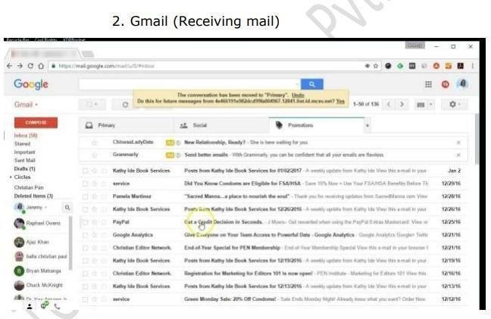

|  |  |
| --- | --- |
| **POSITIVE** | **NEGATIVE** |
| Verify the GUI of Gmail | While Verifying the Gmail, Gui is Attractive But Not Understandable to new user |
| Verify the logo of Gmail | While Verifying the Gmail, Logo is on top and readable But it is in Corner of top side |
| Verify the Search Bar of Gmail | While Verifying the Gmail, Search bar is working properly But Search Only Mail ID. |
| Verify the Details of Gmail | While Verifying the Gmail, mails details is given on left side inbox, starred Mails, Sent mails, Draft Mails Etc.. |
| Verify the Received Notification Of Gmail | While Verifying the Gmail, User get Quick notification on His Device. But Some times Mails are full then user can not fet notification. |
| Verify the Send New Gmail | While Verifying the Gmail, User Can Easily Send Mail to click Compose Button. But it is noy understand for new user. |
| Verify the Mail id Readable or not if Gmail | While Verifying the Gmail, It is Properly Readable name but not Mail id |
| Verify the Showing time of Gmail | While Verifying the Gmail, Timing Show in Right side of display. |
| Verify the Quick mail button of Gmail | While Verifying the Gmail, Quick Mail Button is not given. |



1. 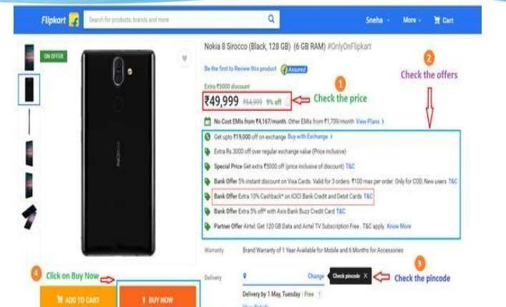Online shopping to buy product (flipkart)

|  |  |
| --- | --- |
| Verify the Gui Of Flipkart | While verifying the Flipkart, GUI is good and understandable. |
| Verify the company name and logo of Flipkart | While verifying the Flipkart, Logo and company name is readable. |
| Verify the price of Flipkart | While verifying the Flipkart, Price is low to compare other sites. |
| Verify the offers of Flipkart | While verifying the Flipkart, Offers are more to compare other sites. |
| Verify the check pin code on Flipkart | While verifying the Flipkart, It is check to parcel’s delivery is possible to your location or not. |
| Verify the buttons of Flipkart | While verifying the Flipkart, button or links working properly. |
|  |  |
|  |  |

* Write a Scenario of Wrist Watch

|  |  |
| --- | --- |
| Verify the Material of Wrist Watch | While verifying the Wrist Watch, it is good to look |
| Verify the shape of Wrist Watch | While verifying the Wrist Watch, It is round shape to good to look |
| Verify the Design of Wrist Watch | While verifying the Wrist Watch, It is Attractive Dial Design |
| Verify the price of Wrist Watch | While verifying the Wrist Watch, Price is high compere to Quality |
| Verify the width of Wrist Watch | While verifying the Wrist Watch, Complete to fit with hand width. |
| Verify the Weight Of Wrist Watch | While verifying the Wrist Watch, Heavy Weight. |
| Verify the Belt Quality of Wrist Watch | While verifying the Wrist Watch, Low Quality. |
|  |  |

* Write a Scenario of Lift(Elevator)

|  |  |
| --- | --- |
| Verify the Quality of Lift | While Verifying the Lift, It is good Quality |
| Verify the Capacity of Lift | While Verifying the Lift, It is 6 Members Capacity. |
| Verify the timing to up-down of Lift | While Verifying the Lift, It is More Timing Consuming |
| Verify the voice when door is open of lift | While Verifying the Lift, It is Continues Repeating Voice Message. |
| Verify the which floor voice message of lift | While Verifying the Lift, It is Updating |
| Verify the light quality of Lift | While Verifying the Lift, It is Low Quality of Light |
| Verify the Fan Quality of Lift | While Verifying the Lift, It is Low Quality of Fan |
| Verify the Fire Bell Of Lift | While Verifying the Lift, It is Not Given |
| Verify the buttons of Lift | While Verifying the Lift, It is working Properly. |
| Verify the Alarm Of Lift | While Verifying the Lift, It is Not Working Some times. |

* 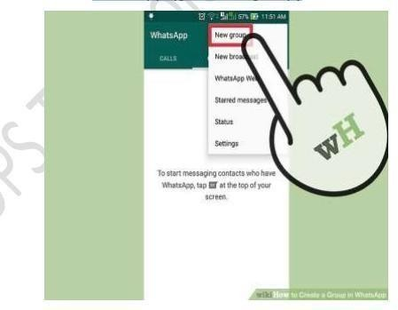Write a Scenario of whatsapp Group (generate group)

|  |  |
| --- | --- |
| Verify the Gui of Generate WhatsApp Group. | While Verifying the Creating WhatsApp Group, Gui Is Good to understand. |
| Verify the click buttons or link of Generate WhatsApp Group | While Verifying the Creating WhatsApp Group, It is Working Properly |
| Verify the Add Members Generate WhatsApp Group | While Verifying the Creating WhatsApp Group, It is Easy to add members. |
| Verify the click to add members Generate WhatsApp Group | While Verifying the Creating WhatsApp Group, It is click to which person you want to add in group. |
| Verify the Next Button Of Generate WhatsApp Group | While Verifying the Creating WhatsApp Group, It is Navigate to next page. |
| Verify the write a group name of Generate WhatsApp Group | While Verifying the Creating WhatsApp Group, It is Working Properly but characters are not allowed above 25 characters. |
| Verify the upload DP Of Generate WhatsApp Group | While Verifying the Creating WhatsApp Group, It is Upload in Minor time |
| Verify the Create group Button of Generate WhatsApp Group | While Verifying the Creating WhatsApp Group, It is Working Properly. |



* + 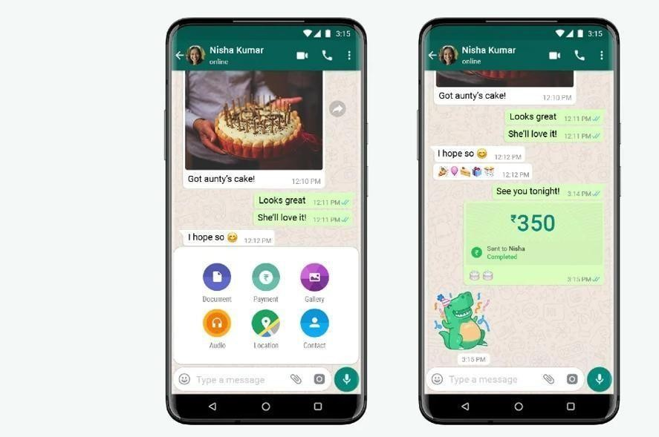Write a Scenario of Whatsapp payment

|  |  |
| --- | --- |
| Verify the Gui Of WhatsApp Payment | While Verifying the WhatsApp Payment, It is Good to understand. |
| Verify the Button or link of WhatsApp Payment | While Verifying the WhatsApp Payment, It is working Properly. |
| Verify the amount of WhatsApp Payment | While Verifying the WhatsApp Payment, It is Enter Easily. |
| Verify the Payment Method of WhatsApp Payment | While Verifying the WhatsApp Payment, It is Not Linked Properly to bank account. |
| Verify the T&C of WhatsApp Payment | While Verifying the WhatsApp Payment, It is Readable. |
| Verify the bank List of WhatsApp Payment | While Verifying the WhatsApp Payment, It is Popular bank given on top to quick add. |
| Verify the Search Bar of WhatsApp Payment | While Verifying the WhatsApp Payment, It is working properly. |
| Verify the confirm message of WhatsApp Payment | While Verifying the WhatsApp Payment, It is Notified to user. |