**Module–2(Manual Testing)**

* What is Exploratory Testing?

In Exploratory testing is a testing person will explore the Application without any documentation to look the system pattern. How it work and write is positive and negative scenarios.

It is not random testing but it is Adhoc testing with purpose of find bugs.

Exploratory testing is structured and rigorous.

* What is traceability matrix?

Traceability Matrix is Help for tracking Testing Software process.

There are two types of traceability Matrix

* Forward Traceability
* Backward Traceability

In Forward Traceability mapping of Requirements to Test Cases.

In Backward Traceability mapping of Test Cases to Requirements.

* What is Boundary value testing?

Boundary Value Testing is a methodology for designing test cases to set near the limits of valid ranges.

Boundary value testing is that highlight errors better than equivalence partitioning.

* What is Equivalence partitioning testing?

In Equivalence partitioning testing numbers fall into a partition where each would have the equivalent.

* What is Integration testing?

Integration testing is a level of the software testing process. Where individual units are combined and tested as a group.

Test drivers and test stubs are used to assist in integration testing

There are two types of integration testing

* Component integration testing
* System integration testing
* What determines the level of risk?

A factor that could results in future negative consequences usually express as impact and likelihood.

There are two types of risk

* Project risk
* Product risk
* What is Alpha testing?

Alpha testing is always performed by the developers at the software development site.

Sometimes it is performed by independent Testing team.

Alpha Testing is not open to the market and public

Alpha Testing is always performed in Virtual Environment.

It comes under the both of white box testing and Back box testing.

* What is beta testing?

Beta testing is always performed by the customers at their own site.

It is not performed by independent testing team.

Beta testing is always open for the market and public.

Beta testing is always performed in real time environment

It is only a kind black Box Testing.

* What is component testing?

Component Integration Testing is performed to expose defects in the interfaces and inraction between integrated components

Component testing is usually formal testing.

Thera are two types of component testing

* Functional testing
* Non-Functional Testing
* What is functional system testing?

A requirement that specifies a function that a system component must perform.

Manual Testing and Automation testing tools can be used for Functional testing

Easy to do manual testing

There are two types of test Approach

- requirement base Functional Testing

- Process base Functional Testing

* What is Non-Functional Testing?

In Non-Functional Testing is not related to Functionality example – usability, reliability and maintainability.

Tough to do manual testing

* What is GUI Testing?

GUI is Graphical User Interface.

GUI testing involves checking the screens with the controls like menu, buttons, icons and all types of bars, tool bar, menu bar, dialog Boxes and windows.

* What is Adhoc testing?

Adhoc testing is an informal testing type with an aim to brake the system.

It does not follow any design techniques to create test cases.

Tester randomly test the application without any test cases or Documentation.

Adhoc testing technique is called Error Guessing Technique.

There are three types of Adhoc testing

* Buddy Testing
* Pair Testing
* Monkey Testing
* What is load testing?

It’s a performance testing to check system behavior under load.

Load testing is a kind of performance testing which determines a system’s performance under real life load condition. How application behaves when multiple users access it simultaneously.

* What is stress Testing?

Stress testing is system is stress beyond its specification to check how and when is fails.

Stress testing is used to test the stability and reliability of the system.

Stress testing is done to make sure that the system would not crash under crunch situation.

Stress testing is also known as a endurance testing.

* What is white box testing and list the types of white box testing?

White Box testing is testing based on an analysis of the internal structure of the component or system.

White box testing is also known as a Glass Box testing or Open box testing.

In White Box testing The tester require knowledge of coding.

* What is black box testing? What are the different black box testing techniques?

Black box testing is testing either functional or non functional, without reference to the internal structure of component or system.

Black box testing is also known as a Specification based testing.

In Black box testing the tester have no knowledge of how the system is structured inside the box.

* Mention what are the categories of defects?

Defects is the variance from a desired product attributes

There are many types of defect

* Data quality/Database Defects
* Critical Functionality defects
* Functionality Defects
* Security Defects
* User interface Defects
* Mention what bigbang testing is?

In big bang integration testing all components or modules is integrated simultaneously, after which everything is tested as a whole.

Big Bang testing has the advantages that everything is finished before integration testing starts.

The major disadvantages is that in general it is time consuming and difficult to trace the cause of failures of this late integration.

In Big Bang testing all component are integrated together at once, and then tested.

* What is the purpose of exit criteria?

Exit criteria defines the items that must be completed before testing can be concluded.

* Successful Testing of Integrated Application.
* Executed Test Cases are documented.
* All High Prioritized bugs are Fixed and closed.
* Technical documents to be submitted followed by release notes.
* When should "Regression Testing" be performed?

Regression testing is performed when the software or its environment is changed.

Change in requirements and code is modified according to the requirement.  
New feature is added to the software, defect fixing, Performance issue fix.

* What is 7 key principles? Explain in detail?

1. Testing shows presence of defects
2. Exhaustive testing is impossible
3. Early Testing
4. Defect clustering
5. The Pesticide paradox
6. Testing is context dependency
7. Absence of error fallacy

* Difference between QA v/s QC v/s Tester

**QA**

* Activities which ensure the implementation of processes, procedures and standards in context to verification of developed software and intended requirements
* Focuses on processes and procedures rather than conducting actual testing on the system.
* Process oriented activities.
* Preventive activies.
* It is subset of Software Test Life Cycle.

**QC**

* Activities which ensure the verification of developed software respect to documented requirements.
* Focus on actual testing by executing Software with intend to identify bug/defect through implementation of procedures and process.
* Product oriented activities.
* It is a corrective process.
* QC can be considered as the subset of Quality Assurance.

**TESTER**

* Activities which ensure the identification of bugs/defects/error in the software.
* Focuses on actual testing
* Product oriented activities.
* It is a Preventive Process.
* Testing is a subset of QUALITY CONTROL
* Difference between Smoke and Sanity?

|  |  |
| --- | --- |
| **Smoke Testing** | **Sanity Testing** |
| It is Exercise entire Application or Software | It is exercise Particular Part of Application or software. |
| Requirement Documents Part | Does not required document Part |
| Test by tested and developer | Yest by only Tester |
| Objective – Stability of system | Objective – Rationality of system |
| Smoke testing is subset of regression testing | Sanity testing is subset of Acceptance testing |
| Smoke testing is also called ZERO level testing | Sanity testing is also called N level of testing |

* Difference between verification and Validation
* Explain types of Performance testing.

There are Six types of Performance testing

* Load testing
* Stress testing
* Endurance testing
* Spike testing
* Volume testing
* Scalability testing
* What is Error, Defect, Bug and failure?

A mistake in coding is called Error, error found by tester is called Defect, defect accepted by development team then is called bug, build does not meet the requirements then is called failure.

* Difference between Priority and Severity

|  |  |
| --- | --- |
| **Priority** | **Severity** |
| Priority is given by Test Lead or Project manager | Severity is given by QA testers |
|  |  |
|  |  |
|  |  |

* What is Bug Life Cycle?

The duration or time span between the first time defects is found and the time that it is called as Bug Life Cycle.

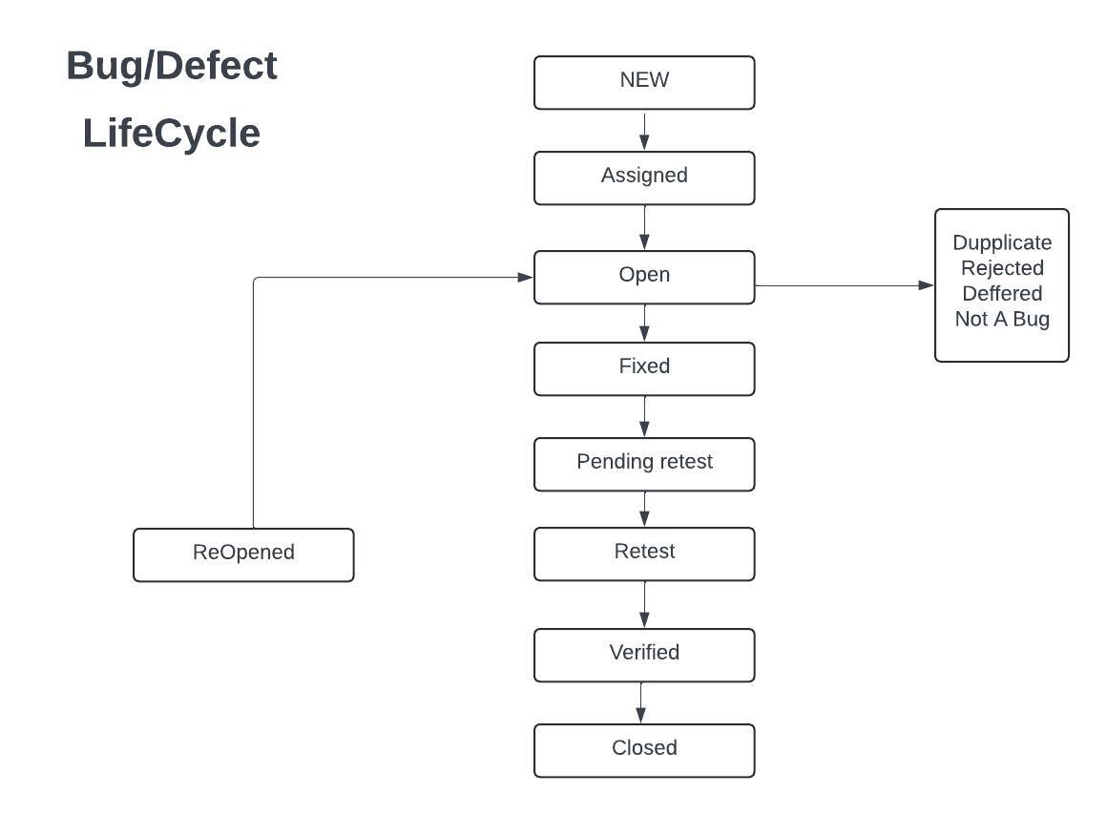

* Explain the difference between Functional testing and Non Functional testing

|  |  |
| --- | --- |
| **Functional Testing** | **Non- Function Testing** |
| Functional testing is executed first | Non-Functional testing should be performed after functional testing |
| Manual testing or automation tools can be used for functional testing | Using tools will be effective for this testing |
| Business requirements are the inputs to functional testing | Performers parameter like speed, scalability are inputs to non-functional testing |
| Easy to do manual | Tough to do manual |
| Types of Functional testing are:  Unit testing  Smoke testing  Sanity testing  Black-box testing  White-box testing  Integration Testing  Usar acceptance Testing  Regression Testing | Types of Non-Functional Testing are:  Performance Testing  Volume Testing  Load Testing  Stress Testing  Security Testing  Installation Testing  Penetration Testing  Compatibility Testing  Migration Testing |

* + To create HLR & TestCase of 1)(Instagram , Facebook) only first page

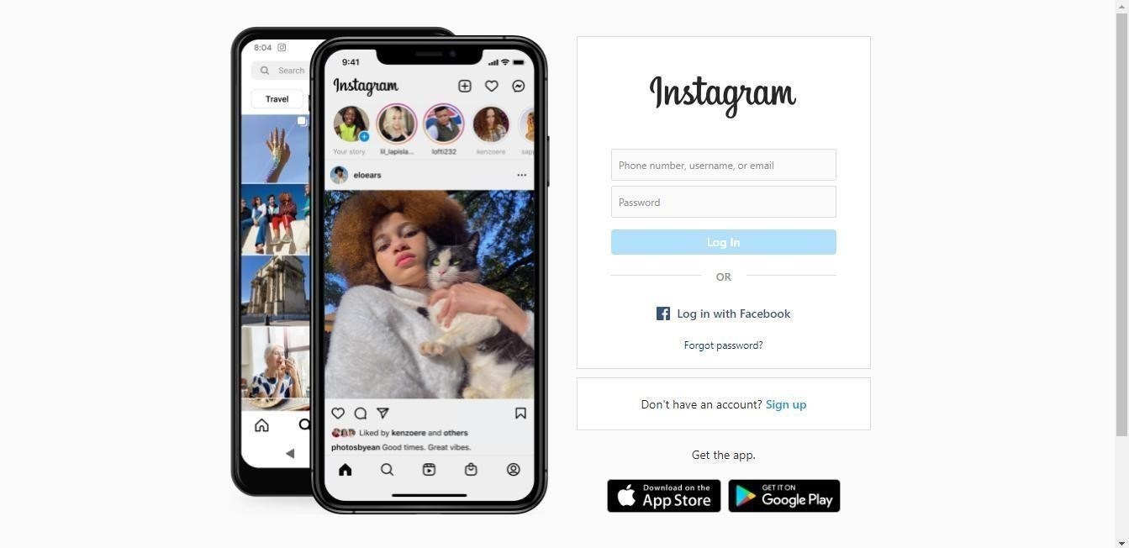

1. Facebook Login Page : <https://www.facebook.com/>

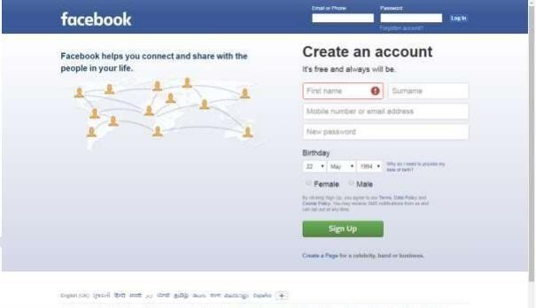

* + What is the difference between the STLC (Software Testing Life Cycle) and SDLC (Software Development Life Cycle)?



* + What is the difference between test scenarios, test cases, and test script?
  + Explain what Test Plan is? What is the information that should be covered.
* What is priority?
* What is severity?
* Bug categories are…
* Advantage of Bugzila .
* Difference between priority and severity
* What are the different Methodologies in Agile Development Model?
* Explain the difference between Authorization and Authentication in Web testing.What are the common problems faced in Web testing?

To create HLR & TestCase of WebBased (WhatsApp web , Instagram) 1. WhatsApp Web : <https://web.whatsapp.com/>

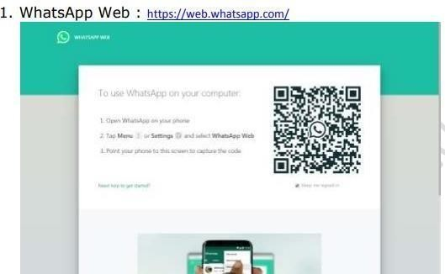



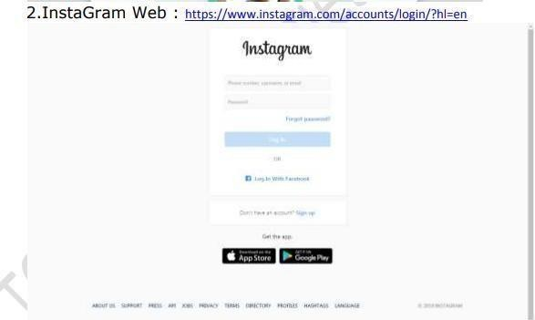

* + 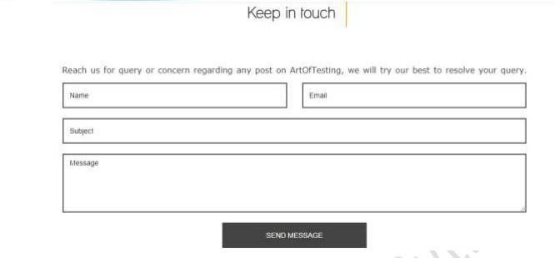To create HLR and TestCase on this Link. <https://artoftesting.com/>
  + Write a scenario of only Whatsapp chat messages
  + Write a Scenario of Pen
  + Write a Scenario of Pen Stand
  + Write a Scenario of Door
  + Write a Scenario of ATM
  + When to used Usablity Testing?
  + What is the procedure for GUI Testing?
  + Write a scenario of Microwave Owen
  + Write a scenario of Coffee vending Machine



* + Write a scenario of chair
  + To Create Scenario (Positive & Negative)

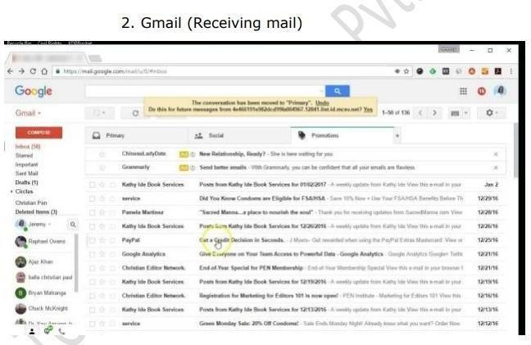



1. Online shopping to buy product (flipkart)

* Write a Scenario of Wrist Watch
* Write a Scenario of Lift(Elevator)
* 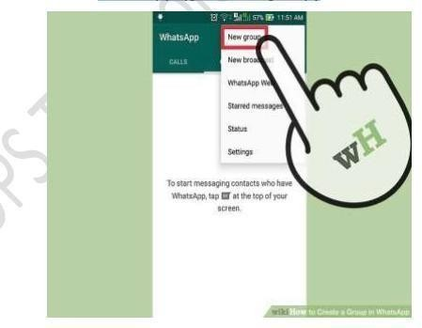Write a Scenario of whatsapp Group (generate group)



* + 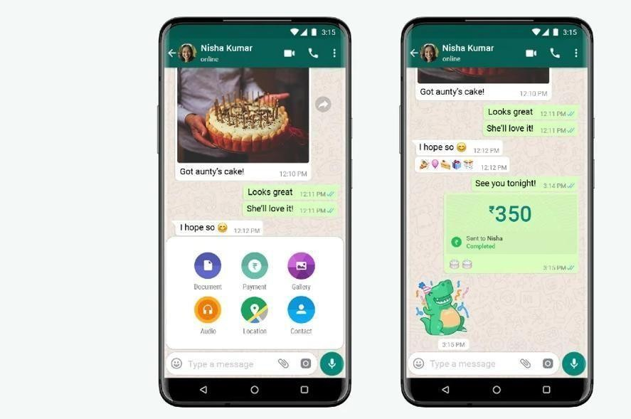Write a Scenario of Whatsapp payment