Assign Spoanor Manul admin sidebar click on Assign Sponsor or Click on header’s notifiation there Request for sposnor click so manul user page open.

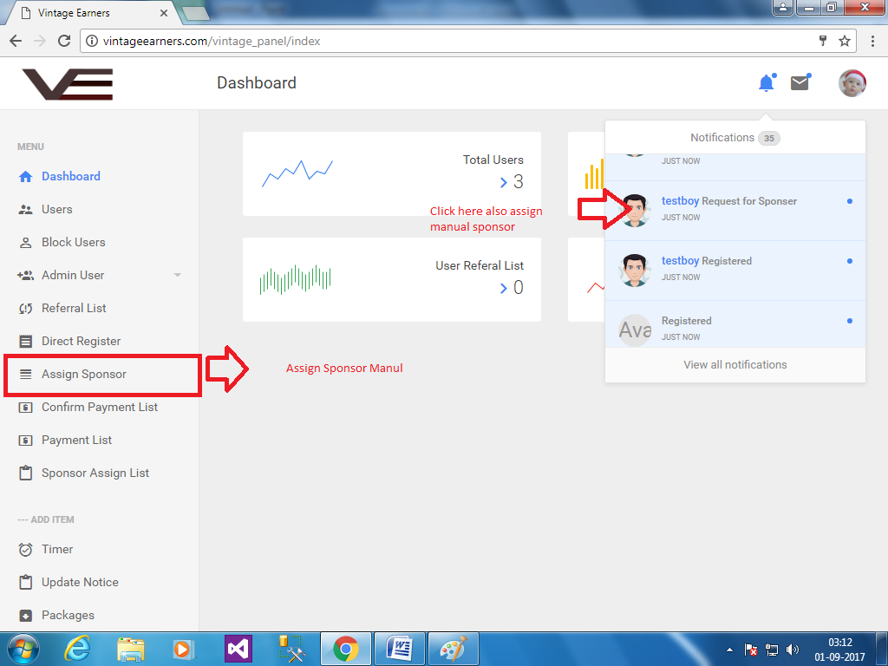

When you directly click open with notification for manual merged than Sponsor list page open who request for gh and them select anyone.In this also remaining amount and also assign remaining amount show,

1 remaining amount is for user remaining balance to get amount

2 assign remaining amount is for that he is waitng to merged with this amount after merged his assign remaining amount reduce user ph amount as example mr.a gh for 10k and merged with mr.b who ph for 5k but mr.b now not pay any amount to mr.a so mr.a remaining amount is 10k and assign remaining amount is 5k because mr.a merged to mr.b so its reduce and if mr.b not pay on time than 5k added into mr.a account

Now you click on notification and sponsor page open and select any one and click on Assign Sponsor button so user merged with sponsor

Ex testboy request for sposnor and admin click on notification than sposnor assign list open and admin choose one of them admin select willam and click on assign sponsor than testboy merged with willam to pay.

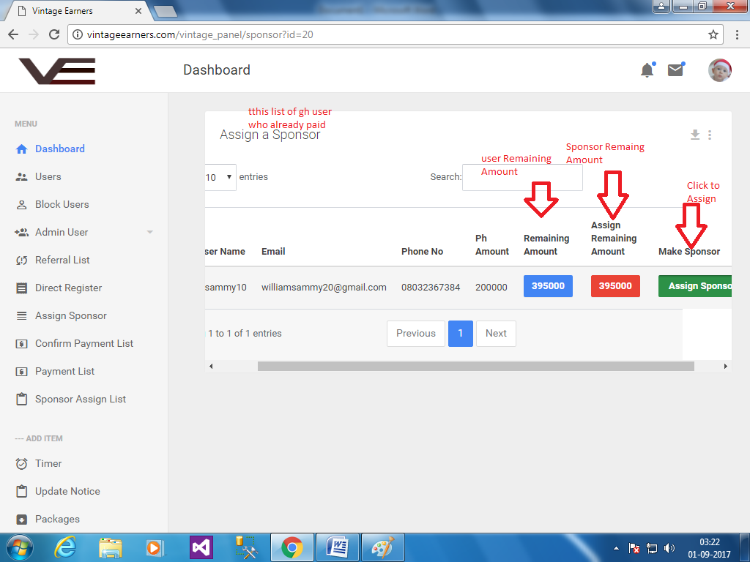

As the same merged functionality when admin click on left sidebar assign sposnor,

Than PH request user list open,there all user show request for sposnor and who not merged .

In table admin show their user name and ph amount and also a pay amount (20% , 80% or 50%)

And click on assign Sponsor than same as notification click after page open (as above megred work)

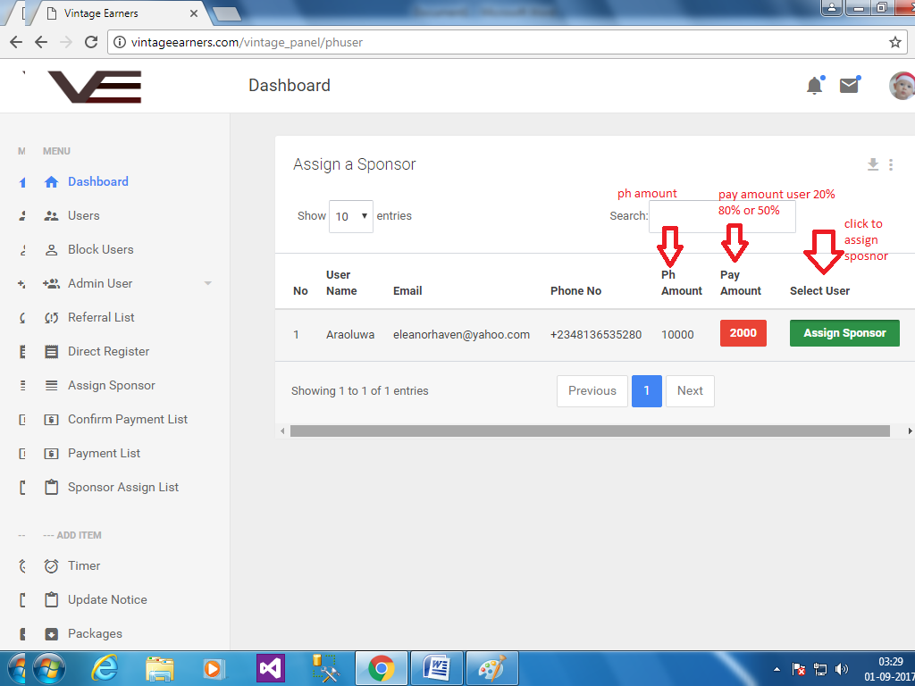

For timer

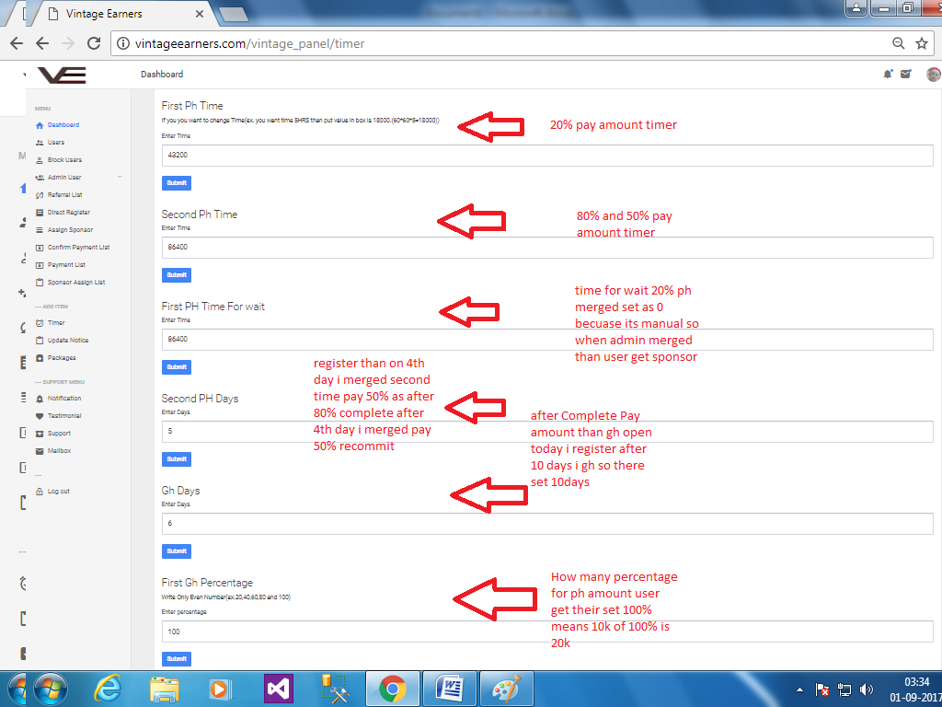

This script is fully manual merged....