
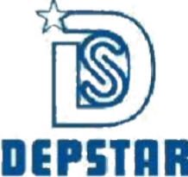
A
Project Report On
"TaskCraft (Project Management System)"
(CE451.01 - Software Project Major)


Prepared by
Krunal Gadhiya (22DCE030)

Under the Supervision of
Prof. Bhavika Patel

Submitted to
Charotar University of Science & Technology (CHARUSAT) for the Partial Fulfillment of the Requirements for the Degree of Bachelor of Technology (B.Tech.)
in Computer Engineering
for 8th semester
Submitted at

Accredited with Grade A+ by NAAC

DEPARTMENT OF COMPUTER ENGINEERING
Devang Patel Institute of Advance Technology and Research (DEPSTAR) Faculty of Technology & Engineering (FTE), CHARUSAT
At: Changa, Dist: Anand, Pin: 388421.

April, 2026


DECLARATION BY THE CANDIDATE

I hereby declare that the project report entitled “TaskCraft (Project Management System)” submitted by me to Devang Patel Institute of Advance Technology and Research, Changa in partial fulfilment of the requirement for the award of the degree of B.Tech in Computer Engineering, from Department of Computer Engineering, DEPSTAR-FTE, CHARUSAT, is a record of bonafide CE451.01 Software Project Major (project work) carried out by me under the guidance of Prof. Bhavika Patel. I further declare that the work carried out and documented in this project report has not been submitted anywhere else either in part or in full and it is the original work, for the award of any other degree or diploma in this institute or any other institute or university.

22DCE030
Krunal Gadhiya

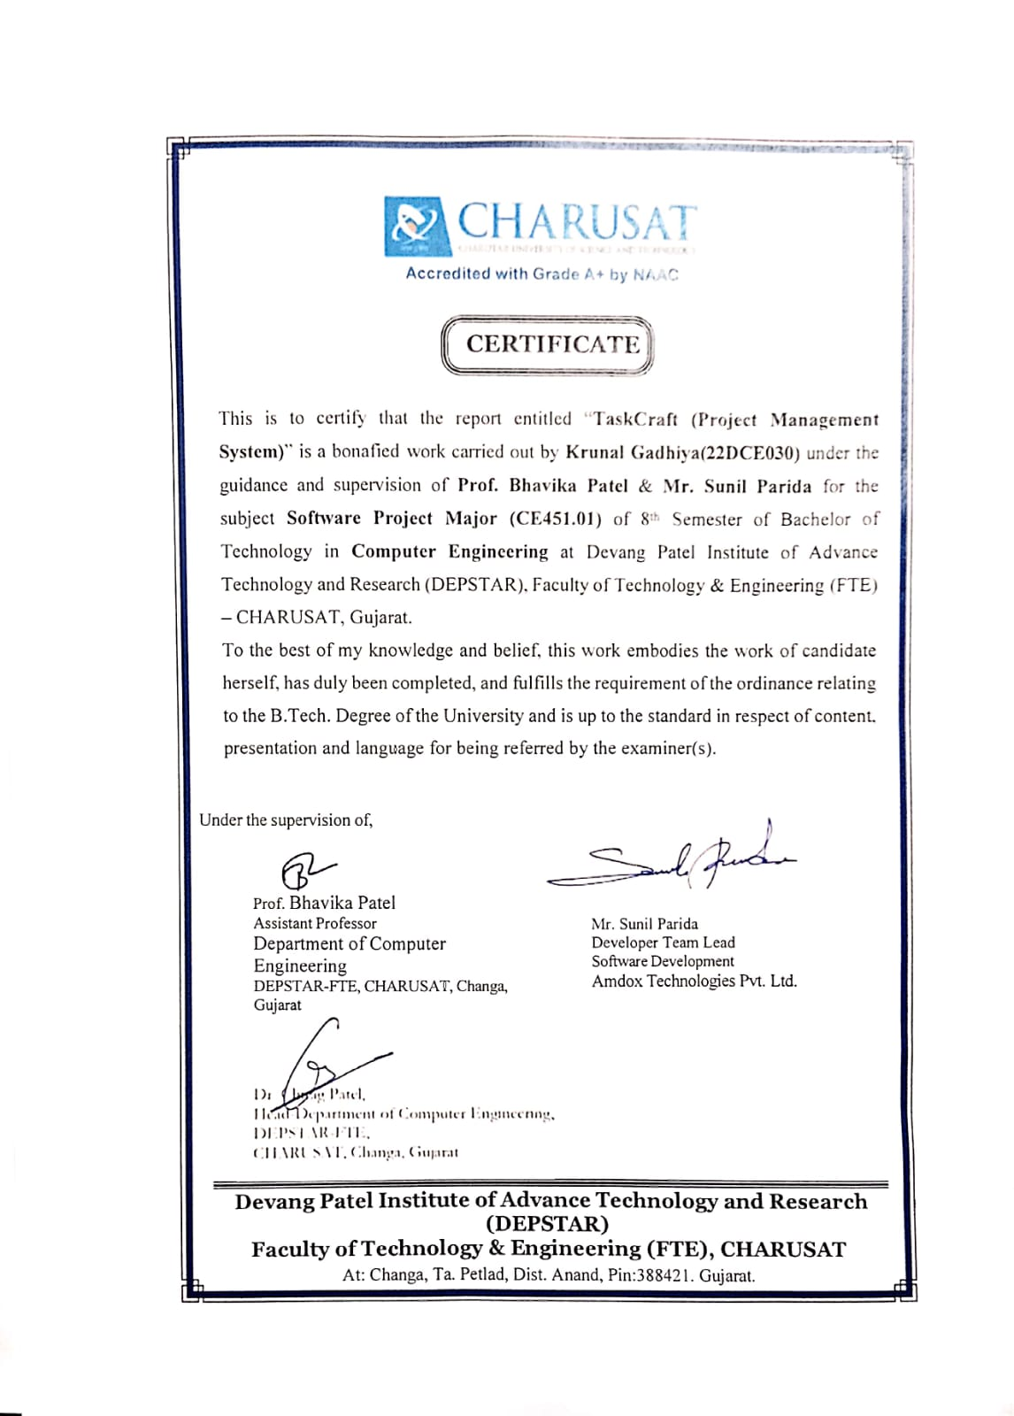


Accredited with Grade A+ by NAAC

CERTIFICATE

This is to certify that the report entitled “TaskCraft (Project Management System)” is a bonafied work carried out by Krunal Gadhiya(22DCE030) under the guidance and supervision of Prof. Bhavika Patel & Mr. Sunil Parida for the subject Software Project Major (CE451.01) of 8th Semester of Bachelor of Technology in Computer Engineering at Devang Patel Institute of Advance Technology and Research (DEPSTAR), Faculty of Technology & Engineering (FTE) – CHARUSAT, Gujarat.
To the best of my knowledge and belief, this work embodies the work of candidate herself, has duly been completed, and fulfills the requirement of the ordinance relating to the B.Tech. Degree of the University and is up to the standard in respect of content, presentation and language for being referred by the examiner(s).


Under the supervision of,



Prof. Bhavika Patel Assistant Professor
Department of Computer Engineering
DEPSTAR-FTE, CHARUSAT, Changa,
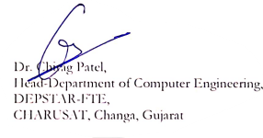
Gujarat

Mr. Sunil Parida
Developer Team Lead
Software Development
Amdox Technologies Pvt. Ltd.

Dr. Chirag Patel,
Head- Department of Computer engine
CHARUSAT, Changa, Gujarat

Devang Patel Institute of Advance Technology and Research (DEPSTAR)
Faculty of Technology & Engineering (FTE), CHARUSAT
At: Changa, Ta. Petlad, Dist. Anand, Pin:388421. Gujarat.

ABSTRACT

The TASKCRAFT is an enterprise-level web-based application designed to simplify and enhance compliance management and KYC processes within organizations. It provides a centralized and structured platform for managing customer data, monitoring transactions, and performing regulatory compliance checks efficiently. The system addresses the limitations of legacy compliance systems by reducing manual effort, improving data accessibility, and ensuring faster processing.
The system is divided into key modules such as Admin, Compliance Analyst, and Manager. The Admin module manages user roles, permissions, and configurable compliance workflows. It also maintains system configurations and ensures proper monitoring of activities. The Compliance Analyst module is responsible for handling customer data, performing KYC verification, and identifying suspicious transactions based on predefined rules and patterns. The Manager module reviews high- risk cases, makes approval or rejection decisions, and ensures compliance with regulatory standards. To enhance system performance, TASKCRAFT integrates advanced technologies such as Ehcache for caching frequently accessed data and Lucene indexing for fast and efficient search operations. The system also exposes RESTful APIs, enabling seamless communication between frontend and backend, as well as integration with external systems.
Developed using modern technologies like Spring Boot for the backend and Nuxt (Vue 3) for the frontend, the system ensures secure, scalable, and high-performance operations. TASKCRAFT ultimately helps organizations improve compliance efficiency, enhance decision-making, and maintain a transparent and reliable KYC process.

ACKNOWLEDGEMENT

We extend our heartfelt gratitude to our project mentor, Mr.Sunil Parida, for his invaluable guidance, support, and encouragement throughout our Java internship journey at Amdox Technologies Pvt. Ltd. His expertise, constructive feedback, and unwavering assistance have been instrumental in shaping our understanding of enterprise application development using Spring Boot, REST API, Spring Security-SSO and Stash technologies. We would like to express our sincere appreciation to Head of the Department for encouraging and allowing us to do internship for the partial fulfilment of the requirements leading to the award of BE degree. Additionally, we would like to acknowledge the entire team at Employee Evaluation for their collaboration, particularly our project mentors and colleagues at AMDOX Technologies. Their insights, cooperation, and camaraderie have enriched our learning experience and contributed significantly to our professional development. Finally, I am grateful my friends for their unwavering support and understanding during this internship period at AMDOX Technologies. Their encouragement has been a constant source of motivation for us.

TABLE OF CONTENTS

Abstarct iv
Acknowledgement v
List of Figure ix
List of Tables x
Chapter 1 Introduction 1
  - Project Summary 1
  - Purpose 1
  - Objective 2
  - Scope 2
  - Tools & Technology Used 3
Chapter 2 Project Management 4
  - Project Planning 4
    - Project Development Approach and Justification 4
    - Project Effort and Time, Cost Estimation 6
    - Roles and Responsibilities 7
    - Group Dependencies 9
  - Project Work Scheduling 10
Chapter 3 System Requirements Study 11
  - User Characteristics 11
  - Hardware and Software Requirement 11
  - Assumptions and Dependencies. 12
Chapter 4 System Analysis 13
  - Study of Current System 13
  - Problem and Weaknesses of Current System 13
  - Requirements of New System 14
    - Functional Requirements 14
    - Non-Functional Requirements 15
  - Feasibility Study 17
    - Contribution to Organizational Objectives 17
    - Technical and Schedule Feasibility 18
    - Integration Feasibility 19
  - Activity/Process In New System 19
  - Feature of New System 20
  - Use Case Diagram 22
  - Class Diagrram 23
  - Sequence Diagram 24
Chapter 5 System Design 25
  - System Application Design 25
    - Pseudo code 26
  - Input/Output and Interface Design 27
Chapter 6 Implementation Planning 28
  - Implementation Environment 28
  - Program/Modules Specification 28
  - Security Features 29
  - Coding Standards 30
Chapter 7 Testing 32
  - Testing Plan 32
  - Testing Strategy 32
  - Test Suites Design 33
    - Test Cases 33
Chapter 8 Conclusion and Discussion 35
  - Self Analysis of Project Viabilities 35
  - Problem Encountered and Possible Solutions 35
  - Summary of Project work 37
Chapter 9 Limitation and Future Enhancement 38
Bibliography 40

LIST OF FIGURES

Figure 2.1 Gantt Chart 10
Figure 4.1 Activity Diagram 20
Figure 4.2 Use Case Diagram 21
Figure 4.3 Class Diagram 23
Figure 4.4 Sequence Diagram 24

LIST OF TABLES
Table 7.1 Employee Test Cases 33
Table 7.2 Lead/Manager Test Cases 34
Table 7.3 Admin Test Cases 34

CHAPTER 1: INTRODUCTION

PROJECT SUMMARY:

In modern software development and organizational workflows, managing tasks efficiently is a critical factor for project success. Traditional methods such as spreadsheets, emails, and manual tracking systems often lead to inefficiencies, lack of transparency, and poor coordination among team members. As projects grow in complexity, the need for structured task management becomes increasingly important.
To address these challenges, project management tools like Jira have been widely adopted in the industry. These tools provide features such as task tracking, workflow management, and team collaboration. However, they are often complex, costly, and not suitable for small teams or academic environments.
This project introduces TaskCraft, a simplified yet powerful task management system inspired by Agile methodologies. It aims to provide essential project management functionalities in a user-friendly and efficient manner.

PURPOSE:

In many organizations and student project environments, there is no centralized system to manage tasks effectively. Teams rely on informal communication channels, which leads to:

- Lack of clarity in task ownership
- Difficulty in tracking project progress
- Missed deadlines and poor time management
- Inefficient collaboration among team members

Although existing tools are available, they often introduce complexity or require paid subscriptions, making them lessaccessible.

OBJECTIVE:
The primary objectives of TaskCraft are:
- To develop a centralized platform for managing projects and tasks
- To implement Agile workflow-based task tracking
- To enable role-based access control for secure operations
- To improve team collaboration and transparency
- To provide real-time updates and reporting mechanisms

SCOPE:
The scope of TaskCraft includes designing and developing a web-based application that supports project creation, task assignment, workflow tracking, and reporting.
The system is intended for:
- Student project teams
- Small software development teams
- Startups and organizations
The system can be extended in the future with advanced features such as AI-based recommendations and mobile applications.

TECHNOLOGY AND LITERATURE REVIEW:

The TASKCRAFT system is developed using modern technologies to ensure performance, scalability, and maintainability:
- Backend: Java 25, Spring Framework, Spring Boot
A powerful backend stack used to build scalable and secure RESTful services.
- Server: Apache Tomcat 11
Handles deployment and execution of backend services efficiently.
- Frontend: Nuxt v4.3.0 (Vue 3)
Provides a modern, responsive, and user-friendly interface.
- IDE: STS (Backend), VS Code (Frontend)
Used for efficient development and debugging.
- API: RESTful Services
Enables communication between frontend and backend systems.
- Database: Relational Database
Stores structured data like customer details, transactions, and compliance records.
- Version Control: Git
Used for code management and collaboration.
- Ehcache:
Improves performance by reducing database load through caching.
- Lucene Indexing:
Provides fast and efficient search capabilities for large datasets.

CHAPTER 2: PROJECT MANAGEMENT

PROJECT PLANNING:

Project Development Approach and Justification

The development of the TaskCraft follows an Agile Development methodology, which focuses on iterative development, flexibility, and continuous improvement. This approach is suitable for complex enterprise systems like TaskCraft, where compliance requirements and business needs evolve frequently.
The system is developed in smaller modules with continuous testing and feedback, ensuring scalability, performance, and adaptability.

Requirements Gathering & Analysis:
The initial phase focused on understanding compliance requirements, KYC workflows, and regulatory needs.
Activities:
- Understanding legacy system challenges (manual effort, complex configurations)
- Identifying system requirements for customer data, compliance workflows, and monitoring
- Defining API structure and data flow
- Documenting functional and non-functional requirements

System Design:
This phase involved designing a scalable and modular architecture. Activities:
- Designing system architecture (microservices + modular structure)
- Database schema design for customer and transaction data
- API design (RESTful services)
- UI/UX planning using Nuxt (Vue 3)

Development & Implementation:
Core system development was done using modern technologies. Activities:
- Backend development using Java 25, Spring Boot
- REST API development for frontend integration
- Frontend development using Nuxt (Vue 3)
- Integration with relational database
- Implementation of Ehcache (caching) and Lucene (indexing)

Testing & Iteration:
Regular testing cycles were followed as per Agile methodology.

Activities:
- Unit testing and integration testing
- Performance testing (API response, caching efficiency)
- Continuous improvements based on feedback
- Fixing bugs and optimizing queries

Deployment & Maintenance:
After development, the system is deployed and continuously maintained.

Activities:
- Deployment on Apache Tomcat 11
- Monitoring APIs and system performance
- Regular updates and optimizations
- Enhancing features based on business needs

Justification of Approach:
- Flexibility and Adaptability:
The system requirements were expected to evolve throughout the project based on feedback from various users (Admin, Employee, Manager, and COO). Agile’s iterative nature allowed for continuous adjustments and improvements.

User-Centered Design:
Regular feedback loops and testing from users (managers, employees) ensured that the system was aligned with the end-users' needs. Agile provided the necessary flexibility to address user concerns and adapt features accordingly.

Faster Time to Market:
By breaking the project into smaller deliverables, the Agile methodology allowed for the early release of key features, enabling users to interact with the system and provide valuable insights early in the process.

Risk Management:
The iterative approach allowed for early detection of issues, reducing the risk of major system failures later in the project. Continuous testing helped identify and resolve bugs and performance bottlenecks.

Enhanced Collaboration:
Agile encourages collaboration between developers, stakeholders, and end-users, which led to better communication and a higher-quality product.

Project Effort and Time, Cost Estimation

The development of the Employee Evaluation System involves multiple phases, each contributing to the overall time and effort. Below is the estimated breakdown of time and effort required for each phase:

Requirements Gathering & Analysis (1 Week)
Effort: 2 team members Activities:
- Meetings with stakeholders (Admin, Employees, Managers, COO)
- Documentation of functional and non-functional requirements
- Identifying user roles and workflows
- Preparing system specifications and user stories

- System Design (1 Week) Effort: 2 team members Activities:
- Designing the database schema (entity relationship diagrams, table structure)
- Defining system architecture (backend, frontend, security)
- UI/UX wireframing and prototyping
- Finalizing the technology stack (Spring Boot, Hibernate, MS SQL Server)

- Development & Implementation (2 Months) Effort: 3-4 developers, 1 frontend specialist Activities:
- Backend development using Spring Boot and Hibernate
- Frontend development with Thymeleaf, JavaScript, jQuery

- Database integration with MS SQL Server
- Role-based access control and user authentication
- Implementation of task submission, grievance handling, performance evaluations, etc.

Testing & Iteration (1 Month)
Effort: 2-3 team members (testers and developers) Activities:
- Unit testing, integration testing, and bug fixing
- User Acceptance Testing (UAT) with stakeholders
- Iterative improvements based on feedback
- Performance testing (load testing, database optimizations)

Bug Fixing (1 Week)
Effort: 2 team members (testers and developers) Activities:
- Addressing critical bugs identified during testing
- Performing regression testing to ensure that no new issues are introduced
- Ensuring that all feedback from UAT and previous testing phases has been implemented
- Final adjustments to improve the system's performance and stability

Deployment & Final Presentation (1 Weeks)
Effort: 2 team members (developer, system administrator) Activities:
- Deploying the application to a production environment
- Conducting final system checks and documentation
- Preparing the final project report and presentation for internship evaluation
- Post-deployment monitoring and support

Roles and Responsibilities
The project team consists of 4 members, each assigned specific roles and responsibilities to ensure effective coordination, timely delivery, and quality outcomes. The roles are distributed based on individual strengths, interest areas, and the project's requirements.

Project Manager / Team Lead
Assigned To: 1 Team Member
Responsibilities:
- Act as the central point of contact for all project-related communications
- Coordinate tasks among team members and monitor project progress
- Conduct weekly review meetings to track deadlines and deliverables
- Ensure that the project aligns with objectives and stakeholder expectations
- Handle risk management, task reassignment, and conflict resolution
- Oversee final documentation and presentation

- Backend Developer Assigned To: 1 Team Member Responsibilities:
- Develop the core application logic using Spring Boot and Hibernate
- Design and implement RESTful APIs for task submission, evaluations, and grievances
- Integrate and manage the MS SQL Server database with proper schema design
- Implement role-based access control and authentication
- Optimize backend performance and handle exceptions and validations

- Frontend Developer Assigned To: 1 Team Member Responsibilities:
- Design and implement interactive user interfaces using Thymeleaf and HTML/CSS
- Use JavaScript and jQuery to enhance responsiveness and interactivity
- Ensure cross-browser compatibility and mobile responsiveness
- Integrate frontend with backend APIs for dynamic data handling
- Maintain a user-friendly dashboard for each role: Admin, Employee, Manager, COO

- Quality Analyst / Tester Assigned To: 1 Team Member Responsibilities:
- Design and execute test cases for functionality, performance, and security
- Perform unit testing, integration testing, and system testing
- Identify bugs and collaborate with developers for fixes

- Coordinate User Acceptance Testing (UAT) and gather feedback
- Maintain a bug-tracking log and prepare test reports

Collaborative Responsibilities:

- Requirements gathering and brainstorming sessions
- Documentation (technical, design, and final report)
- Presenting the project to evaluators and stakeholders
- Continuous feedback and code reviews
- Post-deployment support and monitoring

Group Dependencies
Effective collaboration and dependency management were critical to the successful execution of the Employee Evaluation System project. With a 4-member team working simultaneously on various modules, certain tools and practices were adopted to maintain synchronization, prevent conflicts, and ensure smooth progress.

Version Control and Collaboration – Bitbucket (Stash)
The team used Bitbucket (previously known as Stash) as the central version control system based on Git. Bitbucket enabled the team to:

Maintain Code Integrity
Version control ensured that all code changes were tracked, and no work was lost due to overwrites or errors. Each member worked on separate branches, reducing the risk of merge conflicts.

Parallel Development
Team members could develop different features simultaneously, such as backend APIs, frontend templates, and testing modules, without interfering with each other's work.

Pull Requests and Code Review
Before merging any code into the main branch, team members submitted pull requests. This allowed others to review code, suggest improvements, and ensure quality standards were met.

Issue Tracking and Task Management
Bitbucket was integrated with project management tools to track bugs, features, and tasks. This helped the team coordinate responsibilities and monitor progress.

Continuous Integration Support
Although not fully automated in this project, Bitbucket provided the foundation for future CI/CD pipelines if needed.

Team Dependency Management:
The project followed a modular development structure, where each member was responsible for specific components. This created dependencies such as:

- The frontend developer relied on APIs provided by the backend developer.
- The tester depended on completed features to begin testing and report bugs.
- The team lead coordinated integration and ensured that all modules aligned with the goals.

PROJECT SCHEDULING:

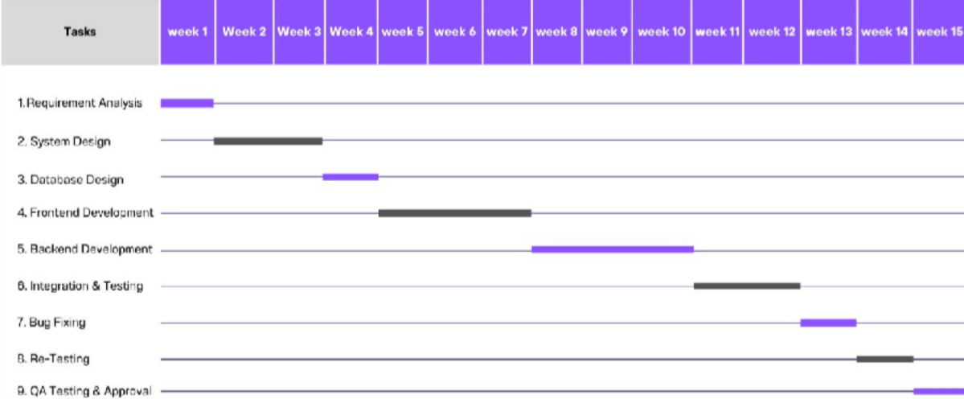
Fig 2.1 Gantt Chart

CHAPTER 3: SYSTEM REQUIREMENTS STUDY

USER CHARACTERISTICS

Admins
Admins are technically skilled users responsible for configuring and managing the TASKCRAFT system. They handle system setup, define compliance workflows, manage user roles and permissions, and monitor system activities. They also oversee audit logs, reports, and system configurations. Since they work with advanced features, the interface provides structured dashboards, data tables, and configurable forms for efficient management.

Compliance Officers / Analysts
These users are responsible for reviewing customer data, performing KYC verification, and monitoring compliance workflows. They have moderate technical knowledge and interact with the system regularly to analyze customer profiles, transaction history, and screening results. The interface provides detailed views, filters, and search capabilities (enhanced using Lucene indexing) for faster data analysis.

Managers / Supervisors
Managers oversee compliance operations and ensure that workflows are executed correctly. They monitor alerts, review flagged transactions, and make decisions based on system-generated insights. They require dashboards showing summaries, pending actions, and performance indicators. The system provides quick access to approvals, monitoring tools, and reporting features.

Top-Level Management / Executives
Executives use the system for strategic decision-making. They analyze aggregated data, trends, and compliance reports. Their interaction is limited but critical, focusing on dashboards, visualizations, and reports. The interface emphasizes charts, summaries, and exportable reports for business insights.

HARDWARE AND SOFTWARE REQUIREMENTS
The TASKCRAFT system is built on modern enterprise technologies designed for efficient performance. The server infrastructure requires a minimum Intel i5 processor, 8 GB RAM (16 GB recommended), and 250 GB storage. Client systems need only standard configurations with

modern browsers. The backend is powered by Java 25, Spring Framework, and Spring Boot, running on Apache Tomcat 11, with a relational database (MySQL/PostgreSQL). The frontend leverages Nuxt v4.3.0 (Vue 3) for dynamic user interfaces, while communication occurs through RESTful APIs. Development is facilitated using STS for backend development, VS Code for frontend work, and Git for version control.

ASSUMPTIONS AND DEPENDENCIES

Assumption:
- The organization has a clearly defined hierarchy with Admin, Manager, Employee, and COO roles.
- Users are expected to have basic familiarity with web applications and internet usage.
- The system will be deployed in a secure and stable environment, either on-premises or cloud- based.
- Stakeholders such as Managers and Admins are available to perform role-based actions and provide timely responses.
- Users will access the system using updated web browsers such as Chrome, Firefox, or Edge.

Dependencies:
Technical Tools:
- Java Development Kit (JDK), Spring Boot, Thymeleaf, and a relational database (MySQL/PostgreSQL) are required for development and deployment.
- jQuery and Bootstrap are used to enhance frontend interactivity and responsiveness.

- Maven or Gradle is used for dependency management and building the project.

External Inputs and Decision-Making:
- Certain modules such as task approvals, grievance resolutions, and evaluation feedback rely on timely input or decisions from other individuals (e.g., Managers or Admins).
- The project may require guidance or suggestions from mentors, team leads, or domain experts during development or enhancement phases.
- System enhancements or policy updates depend on organizational leadership for approval and direction.

CHAPTER 4: SYSTEM ANALYSIS

STUDY OF CURRENT SYSTEM
- TASKCRAFT is an advanced enterprise compliance platform developed to streamline KYC processes, customer data handling, and regulatory monitoring in financial systems. It integrates multiple functionalities into a single centralized platform, reducing dependency on multiple legacy systems.
- The system combines capabilities from existing systems like Sunflower CIP, which provides a
complete 360-degree view of customer profiles and transactions, and Fluorescent, which performs high-value transaction screening and risk detection. This integration helps organizations achieve better compliance and faster decision-making.
- The platform is designed using a modular architecture, allowing easy maintenance and
scalability. It supports modern UI interaction and backend services through REST APIs, ensuring seamless communication between components.

Admin Module:
Manages user roles, permissions, compliance rules, and system configurations. Admins also monitor system activities and maintain audit logs for transparency and control.

Compliance Module:
Handles KYC verification, customer screening, and transaction monitoring. It helps identify suspicious activities and ensures regulatory compliance.

Manager Module:
Responsible for reviewing alerts, approving or rejecting flagged cases, and making compliance decisions based on system insights.

Dashboard Module:
Provides analytics, reports, and visual insights such as trends, summaries, and performance metrics for better decision-making.

PROBLEM AND WEAKNESSES OF CURRENT SYSTEM
Existing compliance systems face several limitations, especially as organizations grow and data volume increases.

Complex Legacy Systems:
Older systems require high manual effort, frequent updates, and complex configurations, making them difficult to maintain and scale.

Scattered Data:
Customer information and transaction records are often stored in multiple systems, making it hard to retrieve and analyze data quickly.

Slow Processing:
Without caching mechanisms, systems rely heavily on databases, resulting in slower performance and delays in processing.

Limited Search Capability:
Lack of indexing results in slow search operations, especially when dealing with large datasets.

Low Scalability:
Traditional systems struggle to handle increasing users and data efficiently.

Poor User Experience:
Outdated interfaces and complex workflows reduce usability and increase training requirements.

REQUIREMENTS OF NEW SYSTEM

Functional Requirements:
- User Authentication and Role Management
The system provides a secure login mechanism to ensure that only authorized users can access the platform. It supports role-based access control, where different users such as Admins, Analysts, and Managers have different permissions. Each role has access to specific modules and functionalities, ensuring data security and controlled operations. This also helps in maintaining accountability and tracking user activities within the system.

Task Management

The system allows storing and managing detailed customer profiles, including personal details, transaction history, and relationships with other entities. It ensures that data is organized and easily accessible whenever required. Efficient data retrieval mechanisms are implemented to

quickly fetch customer information, which is critical for compliance checks and decision- making. The system also supports updates and modifications in real time.

Evaluation Process
TASKCRAFT provides configurable workflows for KYC verification and compliance processes. Organizations can define rules and steps according to their regulatory requirements. The system automates various stages such as verification, monitoring, and approval, reducing manual intervention. This improves efficiency and ensures consistency in compliance operations across the organization.

Grievance Handling

The platform includes an advanced screening system that detects high-value and suspicious transactions. It analyzes transaction patterns and assigns risk levels to customers based on predefined rules. This helps in identifying potential fraud or compliance risks at an early stage. The system enhances decision-making by providing alerts and insights to managers and analysts.

Admin Functions

The system uses RESTful APIs for communication between the frontend and backend. These APIs enable smooth data exchange and allow integration with external systems such as banking platforms or regulatory tools. This makes the system flexible and extendable, supporting future enhancements and third-party integrations without major changes.

Dashboards and Reporting
TASKCRAFT provides real-time dashboards and reporting features that display key performance indicators, compliance status, and system activities. Users can view graphical reports, summaries, and trends to understand data easily. These dashboards help management in making informed decisions and monitoring system performance effectively.

Non-Functional Requirements:
Non-functional requirements define the overall quality and behavior of the system. These ensur
the system operates effectively, securely, and efficiently in a real-world environment:

Security
The system implements strong security mechanisms, including authentication, authorization, and role-based access control. Sensitive financial and customer data is protected using secure protocols and encryption techniques. The system also prevents unauthorized access and protects against common security threats, ensuring safe data handling.

Scalability
The system should be capable of scaling to support an increasing number of users and data over time. Whether accessed by 10 or 10,000 employees, performance should remain stable. Database design and server infrastructure should allow for horizontal and vertical scaling without major redesign.

Performance
The application is optimized to respond swiftly to user actions, with operations such as login, task submission, and dashboard loading completing in under 2 seconds. Performance has been improved by approximately 80% through several key enhancements:
- Caching frequently accessed data (such as role permissions, user lists, and task categories) using Spring Cache, reducing redundant database hits.
- SQL query optimization, including the use of indexed columns, joins, and limiting nested subqueries, ensures faster data retrieval and processing.
- Pagination is implemented for task lists, grievance records, and user management tables, minimizing data load and improving frontend rendering performance.
These measures collectively ensure that the system maintains responsiveness even under high concurrent user loads.

Usability
The user interface should be intuitive, consistent, and simple to navigate for users with different technical backgrounds. Each user role should have a clear and focused dashboard. Icons, colors, and form layouts must contribute to ease of use. Minimal training or documentation should be required for users to interact with the system effectively.

Reliability
The system should perform consistently and without failure across all its modules. It must handle unexpected errors gracefully, with fallback mechanisms where necessary. Scheduled backups and error logging should be implemented to ensure data integrity and assist in troubleshooting.

Maintainability
The system follows a modular architecture, where each component can be updated or modified independently. The code is well-structured and easy to understand, making debugging and future enhancements simpler. Version control tools like Git are used to manage changes efficiently.

FEASIBILITY STUDY

Contribution to Organizational Objectives:

TASKCRAFT plays an important role in improving overall organizational efficiency and compliance management. It automates complex KYC processes, reducing manual work and human errors. This leads to faster processing and better accuracy in compliance checks.
The system provides real-time monitoring of customer activities, allowing organizations to identify risks and take timely actions. It also improves transparency by maintaining proper records and audit logs. With data-driven insights and reports, management can make better decisions and improve operational performance. Overall, it enhances productivity and ensures regulatory compliance.

Technical and Schedule Feasibility:
The system is built using modern and reliable technologies such as Spring Boot and Nuxt, which are widely used in enterprise applications. These technologies provide strong support, scalability, and ease of development, making the system technically feasible.
The project does not require expensive infrastructure and can run on standard servers or cloud platforms. Proper planning and Agile methodology helped in completing the project within the defined timeline. This shows that the system is feasible in terms of both technical implementation and project scheduling.

Integration Feasibility

TASKCRAFT is designed with integration capabilities using REST APIs, allowing it to connect easily with external systems such as banking platforms, compliance tools, and third-party services. This ensures smooth data exchange and interoperability.

The system supports future integrations, making it flexible and adaptable to new requirements. Organizations can extend its functionality without major modifications, which makes it highly sustainable for long-term use.

Real-Time Performance Tracking:
The system allows managers to monitor team progress in real-time, making it easier to identify high performers and areas that require improvement. This contributes to better decision-making regarding employee development and team management.

Fair and Transparent Evaluation Process:
By automating the evaluation process, the system minimizes biases and ensures that performance reviews are based on objective metrics, which increases trust and satisfaction among employees.

Reduced Administrative Burden:
The system automates the tasks of assigning, reviewing, and scoring tasks, significantly reducing the administrative overhead for both employees and managers. This leads to more efficient use of time and resources.

Data-Driven Insights:
The system’s reporting capabilities provide valuable insights into overall team performance, helping leadership make informed decisions about resource allocation, training needs, and strategic direction.

Employee Engagement and Motivation:
The ability to track task completion, receive immediate feedback, and be recognized for achievements boosts employee morale and engagement. The system provides an avenue for employees to voice concerns through grievance handling, further contributing to a positive work environment.

Technical and Schedule Feasibility:
The system can be successfully implemented using the current technology and within the given cost and schedule constraints.
The Employee Evaluation System was developed using robust, industry-proven technologies such as Spring Boot, Hibernate, Java, and Thymeleaf. These technologies are widely supported, well-documented, and offer a stable and scalable foundation for enterprise-level applications.

Their compatibility and maturity helped streamline the development process and minimize technical risks.
In terms of scheduling, the project was completed ahead of the defined timeline, demonstrating the team's effective planning, time management, and technical proficiency. The early completion further validates the system's feasibility in terms of development scope and resource availability.

Key Points:
- Utilized stable and mature technologies (Spring Boot, Hibernate, NuxtJs, Java)
- No need for specialized or costly infrastructure
- Compatible with existing systems and deployment environments
- Project completed within budget and ahead of schedule

Integration Feasibility:

The system can be successfully integrated with other systems already in place.

To enhance interoperability and streamline task management workflows, the Employee Evaluation System exposes secure APIs for external systems to fetch existing tasks and add new tasks programmatically. This ensures seamless integration with external tools and platforms used within the organization.
Additionally, a custom Chrome Extension has been developed and deployed, specifically designed to integrate with Jira, the organization’s existing issue tracking system. This extension automatically detects the currently opened Jira ticket and allows employees to add tasks directly from the Jira interface, without needing to log in to the main evaluation system. This improves user convenience and productivity by embedding task submission into their existing workflow.

Key Integration Highlights:
- public APIs exposed for task fetch and creation
- Chrome Extension developed for seamless Jira integration
- Auto-fetches active Jira issue and submits it as a task
- No need to manually switch between systems

ACTIVITY/PROCESS IN NEW SYSTEM

The system follows a structured workflow starting from user authentication to final decision- making. First, the user logs into the system and accesses customer data. The system then performs KYC screening and evaluates the risk level based on transaction data.
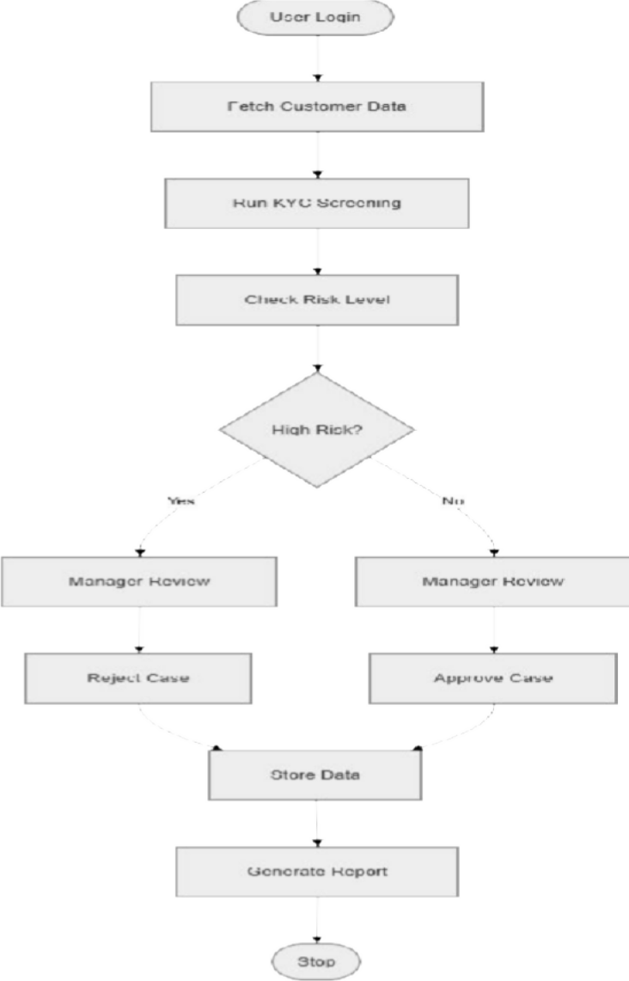

Fig 4.1 Activity Diagram

FEATURES OF NEW SYSTEM

Single Sign-On (SSO) Integration
- Seamless login experience using SAML-based Single Sign-On.
- Users authenticate once to access all modules securely.

Customizable Task Categories
- Admins can create task categories dynamically.
- Supports weightage assignment per category for precise scoring.

Chrome Extension for Quick Task Logging
- Employees can log tasks directly from Jira using a custom Chrome extension.
- Automatically fetches the currently open Jira ticket for faster submissions.

Audit Logging
- All critical actions (task submission, evaluation, grievances) are logged.
- Helps maintain a record for transparency and compliance.

Deadline and Reminder System
- Tasks come with optional due dates.
- Automated email or in-system reminders to ensure timely review and submission.

Advanced Filtering & Search
- Filter tasks by date, status, employee, or category.
- Helps users quickly navigate large task lists.

Data Export & Reporting Tools
- Export task and evaluation data in Excel or PDF format.
- Useful for HR reviews, appraisals, and audits.

USE CASE DIAGRAM

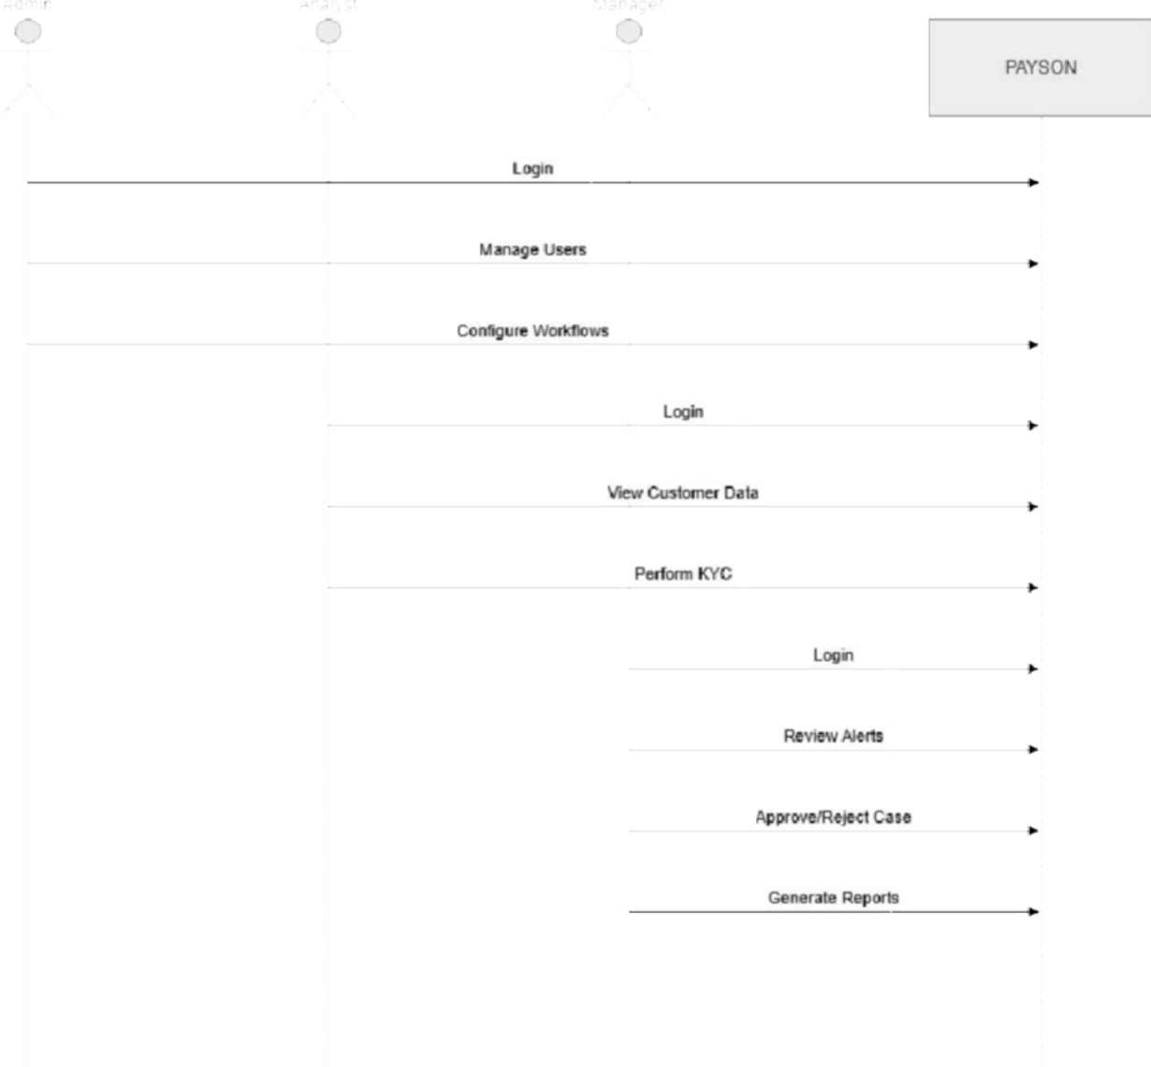

Fig 4.2 Use Case Diagram

CLASS DIAGRAM
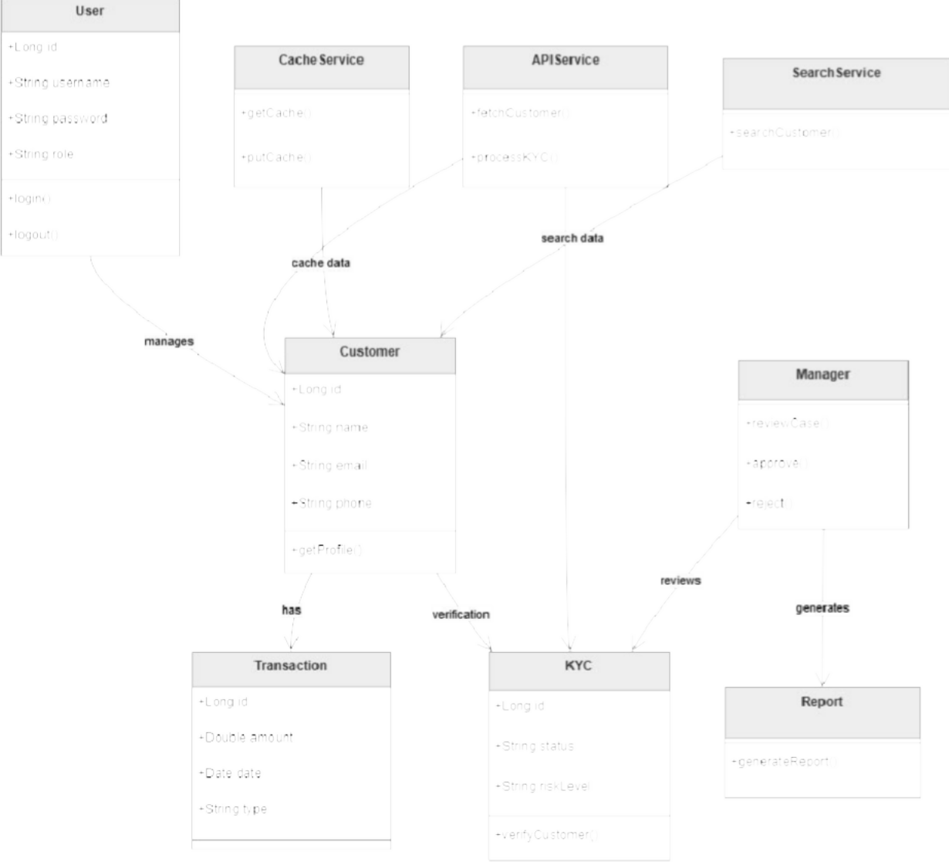

Fig 4.3 Class Diagram

SEQUENCE DIAGRAM

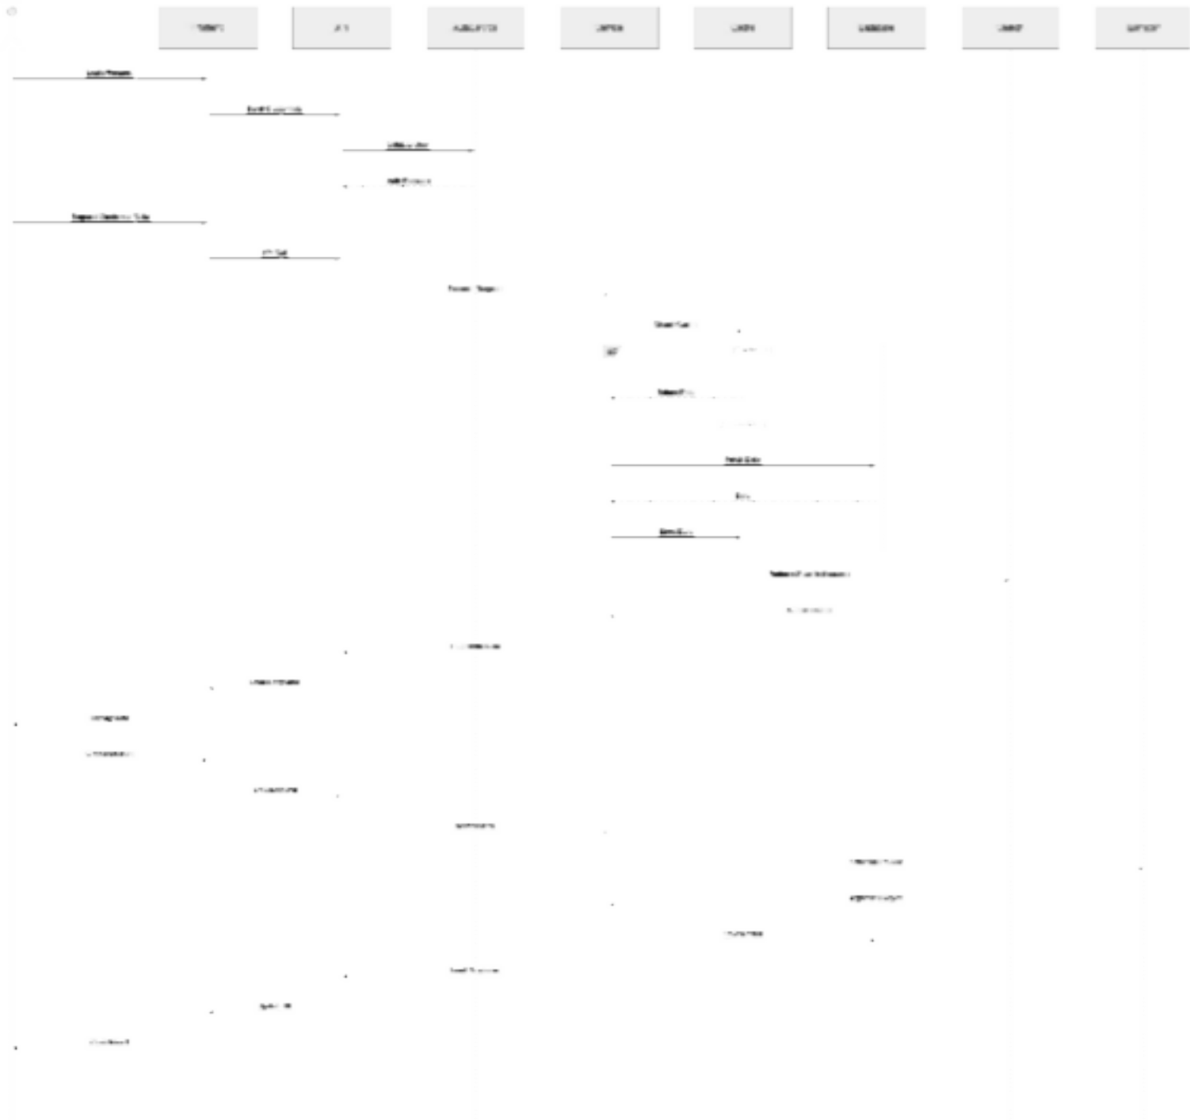

Fig 4.4 Sequence Diagram

CHAPTER 5: SYSTEM APPLICATION DESIGN

SYSTEM APPLICATION DESIGN
The TASKCRAFT follows a clean and modular 3-tier architecture, which separates the system into different layers. This design improves scalability, maintainability, and
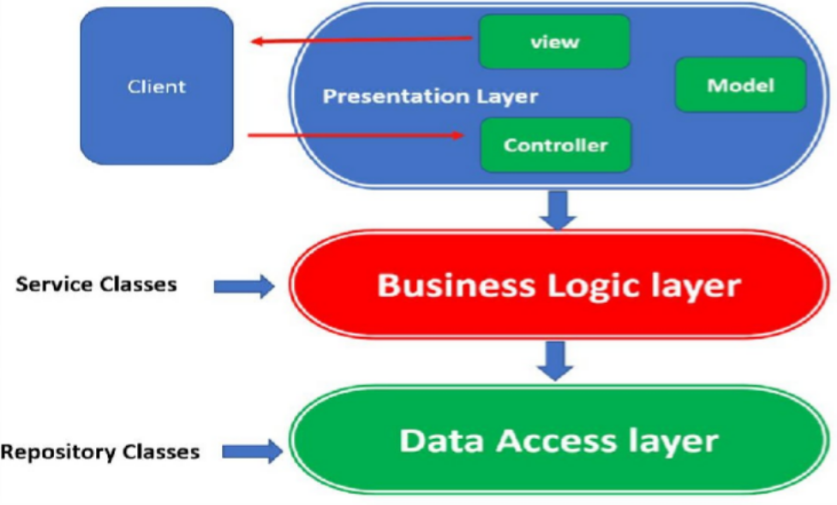
Fig. 5.1 Three Tier Architecture

Presentation Layer (Controller Layer)
- This layer handles all incoming HTTP requests from users and sends responses back to the frontend (Nuxt UI).
- It acts as an entry point for all API calls and user interactions.
- Uses Thymeleaf templates to render dynamic HTML pages in your project.
- Controllers communicate with the service layer to process requests and return results.
- It uses REST APIs to exchange data in JSON format.
- Example: CustomerController.java, KYCController.java, AuthController.java

Business Logic Layer (Service Layer)
- Contains all the core logic and rules of the application.
- Coordinates between the controller and data layers.
- Enforces business validations like role-based task evaluation or grievance resolution rules.
- Example: EmployeeService.java, TaskService.java, GrievanceService.java

Data Access Layer (Repository Layer)
- Directly communicates with the database using Spring Data JPA and Hibernate.
- Contains repository interfaces that perform CRUD operations on entities.
- Example: EmployeeRepository.java, TaskRepository.java

Method Pseudo Code
Method ManageKYCSystem(Input: UserDetails, ActionType, CustomerData, TransactionData)

Step 1: Authenticate User
If UserDetails is invalid OR role not in [Admin, Analyst, Manager] Return "Access Denied"

Step 2: Fetch Customer Data
If ActionType == "FetchCustomer": Validate CustomerData
Retrieve customer profile and transaction history Return Customer Data

Step 3: Perform KYC Screening (Analyst Role) If ActionType == "PerformKYC":
Validate CustomerData and TransactionData Analyze transaction patterns
Assign Risk Level (Low / Medium / High) Save KYC status
Return "KYC Completed"

Step 4: Risk Evaluation (System Logic) If Risk Level == High:
Flag customer for review Notify Manager
Else:
Mark as Verified

Step 5: Manager Review (Manager Role) If ActionType == "ReviewCase":
Fetch flagged customer Validate Manager authority Approve or Reject case Update KYC status
Save decision
Return "Case Reviewed"

Step 6: Search Operation (Lucene)
If ActionType == "SearchCustomer": Perform indexed search
Return fast results

Step 7: Caching Mechanism (Ehcache) If frequently accessed data:
Store in cache
Retrieve from cache for faster response

Step 8: Admin Configuration
If ActionType == "AdminOperation": Manage users, roles, workflows Return "Configuration Updated"

Step 9: Generate Reports
If ActionType == "GenerateReport": Aggregate data
Return analytics and reports

Step 10: Final Response
Return "Operation Completed Successfully"

CHAPTER 6: IMPLEMENTATION PLANNING

IMPLEMENTATION ENVIRONMENT
The implementation environment of the TASKCRAFT defines how the system is deployed, accessed, and interacted with by different users. The system is designed to support enterprise-level operations with high performance, scalability, and security.

Single vs Multiuser
    - TASKCRAFT is implemented as a multiuser web-based application, allowing multiple users such as Admins, Compliance Analysts, and Managers to access the system simultaneously.
    - Each user interacts with the system based on their assigned roles and permissions, ensuring secure and controlled access to sensitive data.
    - The system is capable of handling concurrent users without affecting performance, thanks to its scalable backend architecture.
    - Role-based access control (RBAC) ensures that users can only access the features and data relevant to their responsibilities.

GUI vs Non-GUI
    - TASKCRAFT provides a Graphical User Interface (GUI) built using Nuxt (Vue 3), offering a modern, responsive, and user-friendly experience.
    - The interface includes dashboards, forms, and reports that help users easily interact with the system.
    - Users can perform operations such as customer search, KYC verification, and monitoring through intuitive UI components.
    - In addition to GUI, the system also supports API-based (Non-GUI) interactions, allowing integration with external systems like banking platforms.
    - REST APIs enable seamless communication between systems and support automation of workflows.

PROGRAM/MODULES SPECIFICATION
The TASKCRAFT system is divided into multiple modules based on user roles and functionalities. Each module is designed to handle specific responsibilities efficiently.

Admin Module
    - Manages user roles and permissions (Admin, Analyst, Manager)
    - Configures compliance workflows and system rules
    - Monitors system activities, logs, and audit records

    - Controls system configurations and ensures proper functioning
    - Handles system-level operations such as user management and workflow updates

Compliance Analyst Module
    - Performs KYC verification and customer screening
    - Analyzes customer profiles and transaction patterns
    - Identifies suspicious activities and assigns risk levels
    - Uses Lucene-based search for quick data retrieval
    - Works on flagged cases and prepares them for managerial review

Manager Module
    - Reviews high-risk or flagged customer cases
    - Approves or rejects cases based on compliance analysis
    - Monitors overall compliance activities and system alerts
    - Ensures proper execution of workflows and regulatory policies
    - Generates reports and insights for decision-making

Reporting & Dashboard Module
    - Provides real-time analytics and visual dashboards
    - Displays key performance indicators and compliance metrics
    - Helps management understand trends and system performance
    - Supports export of reports for audits and decision-making
    - Offers summarized and detailed views of system data

SECURITY FEATURES
The TASKCRAFT system implements multiple layers of security to protect sensitive financial and customer data. Security is considered a critical aspect of the system.

Role-Based Access Control (RBAC)
    - Access to system features is controlled based on user roles
    - Ensures that users can only access authorized data and functionalities
    - Prevents unauthorized operations and enhances data security

Spring Security Integration
    - Used for authentication and authorization
    - Secures all API endpoints and system resources
    - Ensures that only authenticated users can access protected services
    - Provides session management and security filters

Data Security and Protection
    - Sensitive data is handled securely using encryption and secure protocols
    - Protects against common vulnerabilities such as SQL Injection and XSS
    - Ensures data integrity and confidentiality
    - Implements proper validation and sanitization of inputs

Audit Logging
    - Records all critical actions such as KYC verification, approvals, and updates
    - Helps in tracking system activity and identifying suspicious behavior
    - Supports compliance requirements and auditing processes
    - Provides transparency and accountability within the system

CODING STANDARD
To ensure code quality, maintainability, and team collaboration, the Employee Evaluation System follows industry-standard coding practices. These standards improve readability, reduce errors, and promote efficient development.

Naming Conventions
Classes: PascalCase (e.g., TaskController, UserService)
Methods and Variables: camelCase (e.g., submitTask(), taskList)
Constants: UPPER_SNAKE_CASE (e.g., MAX_TASK_POINTS)

Code Structure and Modularity
Follows three-layer architecture: Controller, Service, Repository Uses modular classes and services for separation of concerns Each class focuses on a single responsibility (SOLID principles)

Commenting and Documentation
Proper inline comments added for complex logic Javadoc used for public methods and classes
Functions include descriptions of parameters and return values

Exception Handling and Logging
All critical operations are enclosed in try-catch blocks.
Uses SLF4J Logger (e.g., private static final Logger logger = LoggerFactory.getLogger(ClassName.class);) for error tracking and debugging.

CHAPTER 7: TESTING

TESTING PLAN
The Employee Evaluation System follows a structured testing approach to ensure high reliability and functionality. Testing began with unit tests using JUnit and Mockito to validate individual services and controllers. Integration testing ensured proper communication between system layers such as Controller, Service, and Repository. Functional testing verified that task submission, evaluation, and grievance features worked as expected. The user interface, built with Thymeleaf, was tested for responsiveness and input validation. Security testing confirmed role- based access control and SAML-based SSO authentication were functioning correctly. After each development cycle, bugs were fixed and retested to maintain stability. Final rounds included regression testing to ensure new updates didn't break existing features and User Acceptance Testing (UAT) with real users to validate the system in a practical environment.

TESTING STRATEGY
The Employee Evaluation System undergoes a comprehensive testing lifecycle to ensure functionality, reliability, performance, and security. The testing process is structured to validate each module and its integration with the complete system.

Unit Testing
  - Conducted on individual components like services, controllers, and repositories.
  - Ensures each function performs correctly in isolation.
  - Tools Used: JUnit 5, Mockito
  - Example: Testing TaskService.submitTask() logic with mock repositories.

Integration Testing
  - Verifies the interaction between components (e.g., Controller → Service → Repository).
  - Ensures end-to-end data flow and logic are consistent.
  - Tools Used: Spring Boot Test, TestRestTemplate

Functional Testing
  - Validates that all system functions meet the defined requirements.

  - Tested features: Task submission, evaluations, grievance handling, role-based access, etc.

Security Testing
  - Verifies role-based access control and authentication mechanisms.
  - Confirms that unauthorized users cannot access restricted modules.

Bug Fixing and QA Testing
  - Bugs identified during testing are documented, fixed, and retested.
  - A QA pass is performed post-fix to ensure no new issues are introduced.

Retesting and Regression Testing
  - Retesting ensures resolved issues do not reappear.
  - Regression testing confirms that new changes don’t break existing features.

TEST SUITES DESIGN

Test Cases:
Employee Module Test Cases

ID | Test condition | Expected output | Actual Output | Remark
TC001 | Employee logs in with valid credentials | Redirect to Employee Dashboard | Redirect to  Employee Dashboard | Pass
TC002 | Employee logs in with  invalid credentials | Show "Invalid username  or password" message | Show error  message | Pass
TC003 | Employee submits a task  with all required fields | Task successfully created  and assigned | Task created and  assigned | Pass
TC004 | Employee submits a task  without required fields | Show validation error | Validation error  shown | Pass
TC005 | Employee views assigned  tasks | Display a list of assigned  tasks | Correct tasks  displayed | Pass
TC006 | Employee raises  grievance on evaluation | Grievance saved and  visible to Manager | Grievance recorded  and visible | Pass
Table 7.1 Employee Test Cases

Manager (Lead) Module Test Cases

ID | Test condition | Expected output | Actual Output | Remark
TC001 | Manager logs in with valid  credentials | Redirect to Manager  Dashboard | Redirect to Manager  Dashboard | Pass
TC002 | Manager reviews and updates  task status | Task status updated  to "Reviewed" | Status updated  correctly | Pass
TC003 | Manager provides feedback  on a task | Feedback  successfully saved | Feedback saved  successfully | Pass
TC004 | Manager assigns points to a  task | Points assigned  successfully | Points assigned  correctly | Pass
TC005 | Manager rejects task  submission | Task status updated  to "Rejected" | Status updated to  "Rejected" | Pass
TC006 | Manager views list of all  tasks submitted by employees | Display list of all tasks submitted | List of tasks shown | Pass
Table 7.2 Lead/Manager Module Test Cases

Admin Module Test Cases

ID | Test condition | Expected output | Actual Output | Remark
TC001 | Admin logs in with  valid credentials | Redirect to Admin  Dashboard | Redirect to Admin  Dashboard | Pass
TC002 | Admin creates a new  user and assigns a role | New user created and  assigned role | User created and role  assigned | Pass
TC003 | Admin creates a new  task category | Task category  successfully created | Task category created  successfully | Pass
TC004 | Admin assigns  managers to employees | Managers successfully  assigned to employees | Managers assigned to  employees correctly | Pass
TC005 | Admin views a list of  all users | Display list of all users  in the system | List of users displayed | Pass
TC006 | Admin updates user  role | User role updated  successfully | User role updated  correctly | Pass
Table 7.3 Admin Module Test Cases

CHAPTER 8: CONCLUSION AND DISCUSSION

SELF ANALYSIS OF PROJECT VIABILITIES
The TASKCRAFT is highly viable in terms of both technical implementation and organizational benefits. The system is developed using modern and stable technologies such as Spring Boot, Nuxt (Vue 3), and relational databases, ensuring scalability, maintainability, and flexibility for future enhancements. It is designed to handle complex compliance workflows, customer data management, and regulatory requirements efficiently.
The system addresses major challenges of legacy compliance systems, such as high manual effort, scattered data, and poor performance. By introducing a centralized platform with configurable workflows, TASKCRAFT improves operational efficiency and reduces complexity. The integration of Ehcache (for caching) and Lucene indexing (for fast search) further enhances system performance and responsiveness.

Technological Viability:
The system uses robust technologies like Java, Spring Boot, and Nuxt, which are widely used in enterprise applications. Features such as caching (Ehcache), indexing (Lucene), and REST APIs ensure high performance, scalability, and easy integration with other systems.

Organizational Viability:
TASKCRAFT streamlines KYC processes, compliance workflows, and customer monitoring. It improves transparency, reduces manual workload, and enhances decision-making through real- time analytics and reports.
The successful implementation of the project is the result of proper planning, modular architecture, and effective use of modern technologies. The system not only fulfills current business requirements but is also capable of adapting to future regulatory changes and system expansions.

PROBLEM ENCOUNTERED AND POSSIBLE SOLUTIONS

Module Integration Conflicts

Problem: Integrating functionalities from systems like Sunflower CIP and Fluorescent created challenges in maintaining consistent data flow and structure.
Solution: Standardized API structures and implemented a centralized service layer to handle data transformation and communication

Delayed Email Notifications
Problem: Handling large volumes of customer and transaction data caused slower response times.
Solution: Implemented Ehcache for caching frequently accessed data and Lucene indexing for faster search operations, significantly improving performance.

Grievance Status Not Updating Properly
Problem: Searching customer data without indexing was time-consuming and inefficient. Solution: Integrated Lucene indexing to enable fast and optimized search functionality across large datasets.

Workflow Complexity in Compliance Processes
Problem: Managing multiple KYC workflows and compliance rules became complex and difficult to maintain.
Solution: Designed configurable and modular workflows, allowing flexibility and easier updates.

Dashboard Performance for COO Module
Problem: Handling sensitive financial data required strong security mechanisms.
Solution: Implemented role-based access control, secure authentication, and proper validation to ensure data protection.

SAML Authentication Integration Challenges
Problem: Inconsistent API responses caused issues in frontend-backend communication. Solution: Standardized API responses and implemented proper exception handling and logging mechanisms.

SUMMARY OF PROJECT WORK

The TASKCRAFT is an enterprise-level web application designed to simplify and enhance compliance and KYC processes. The system integrates customer data management, transaction monitoring, and risk assessment into a single centralized platform.
The project includes multiple modules such as Admin, Compliance Analyst, and Manager, each responsible for specific functionalities. The Admin module manages users and system configurations, the Analyst module handles KYC verification and screening, and the Manager module reviews and approves high-risk cases. The system also provides dashboards and reports for better decision-making.
Key features of the system include configurable workflows, REST API integration, fast search using Lucene, and high performance through Ehcache caching. The system ensures secure handling of sensitive data and supports scalability for future growth.
The project successfully meets both functional and non-functional requirements, improving system efficiency, performance, and usability. Various testing methods such as unit testing, integration testing, and performance testing were conducted to ensure system reliability.
Overall, TASKCRAFT provides a modern, scalable, and efficient solution for compliance management, helping organizations handle complex regulatory requirements with ease while maintaining high performance and security.

CHAPTER 9: FUTURE ENHANCEMENTS

While the Employee Evaluation System is fully functional and meets the current needs of the organization, there are several opportunities for future enhancements to further improve its capabilities and adapt to evolving requirements:

AI-Powered Analytics and Insights:
Integrating machine learning algorithms to analyze employee performance trends and provide data-driven insights, helping managers make more informed decisions about employee development and task assignments.

Mobile Application:
Developing a mobile application to provide employees and managers with access to the system on-the-go, enabling task submissions, evaluations, and grievances from smartphones or tablets.

Automated Feedback System:
Implementing an automated feedback loop, where the system can suggest improvements based on past evaluations and performance trends, helping employees grow and develop continuously.

Advanced Reporting Features:
Expanding reporting capabilities with customizable, detailed performance dashboards and reports for management, enabling them to track team progress, identify bottlenecks, and plan resource allocation.

Integration with More External Tools:
Integrating the system with additional tools and platforms such as Slack, Microsoft Teams, or Google Workspace, to facilitate communication, task tracking, and reporting directly within commonly used collaboration tools.

Gamification of Performance:
Introducing gamification elements like leaderboards, achievements, and badges to increase employee engagement and motivation in completing tasks and receiving evaluations.

Enhanced Grievance Management:
Building a more robust grievance management system with automated workflows, escalation procedures, and tracking to ensure timely resolution and feedback on raised concerns.

Voice Command Features:
Adding voice-command capabilities for hands-free task management and performance tracking, improving accessibility for users with disabilities or those preferring voice interactions.

Multi-Language Support:
Introducing multi-language support to cater to a global workforce, enabling users from different regions to use the system in their preferred language.

BIBLIOGRAPHY

  - Spring Boot Documentation
https://docs.spring.io/spring-boot/docs/current/reference/htmlsingle/

  - Hibernate ORM Documentation https://hibernate.org/orm/documentation/

  - Thymeleaf Documentation https://www.thymeleaf.org/documentation.html

  - Spring Security with SAML
https://docs.spring.io/spring-security-saml/docs/current/reference/html/

  - Gradle Build Tool Documentation https://docs.gradle.org/current/userguide/userguide.html

  - PostgreSQL Documentation https://www.postgresql.org/docs/

  - Jira Software API Documentation https://developer.atlassian.com/cloud/jira/platform/rest/v3/intro/

  - Chrome Extension Developer Guide https://developer.chrome.com/docs/extensions/mv3/

  - Java SE 17 API Documentation https://docs.oracle.com/en/java/javase/17/docs/api/index.html

  - Bootstrap Documentation (used for styling UI in Thymeleaf templates)
https://getbootstrap.com/docs/5.0/getting-started/introduction/

  - REST API Design Best Practices https://restfulapi.net/rest-api-design-best-practices/

  - OWASP Security Guidelines (for implementing secure authentication and access control)
https://owasp.org/www-project-top-ten/

  - Maven Repository (for dependency management references) https://mvnrepository.com/

