Moseley’s law: how X-rays revealed the atomic number
  - Session 001 · Phase 4 · curriculum node D2 · levels L1..L4
Socratic Mastery Tutor
2026-10-18
Table of Contents

Session map
Outcome of this session
After this session you can:
- explain why atomic weight cannot be the true ordering variable of the periodic table (Ar/K, Co/Ni, Te/I);
- derive Moseley’s law $\sqrt{ν}=a(Z−1)$ for the K-alpha line from the Bohr model, including the value of $a$;
- read an unknown element’s atomic number off its K-alpha energy;
- say where the law bends (Z up to 92) and what physics takes over;
- reproduce Figures 1 to 3 from codes/xray/moseley.
- Prerequisites: the Bohr model of hydrogen and $E=hν$ (known at L3). The first three “puzzles” of the in-chat overview (triads, Mendeleev’s gaps, the inversions) are recapped in Section 2; they become sessions A1 to C4 later.
- Depth levels taught: L1..L4 (L0 intuition · L1 school · L2 advanced school · L3 college · L4 master’s · L5 PhD · L6 frontier; levels outside the range get one line in Section 3.6)
- Difficulty ladder used: easy → medium → medium-hard → hard → hardest (all five tiers, Sections 3.1 to 3.5)
- Deliverables: this document, 3 figures, code module codes/xray/moseley (with README, example and tests)
- Source anchors: H. G. J. Moseley, The high-frequency spectra of the elements, Phil. Mag. 26, 1024 (1913), and Part II, Phil. Mag. 27, 703 (1914). Measured K-alpha$​_{1}$ energies: X-ray Data Booklet (LBNL), Table 1-2, https://xdb.lbl.gov/Section1/Table_1-2.pdf. History: E. Scerri, The Periodic Table: Its Story and Its Significance (Oxford; chapter and page numbers to be confirmed against your copy). The dates of element discoveries in Section 3.4 are quoted from general knowledge and should be checked against Scerri before they are used in teaching material.

1. Terms: the term tree
Term | Symbol | One-line meaning | Where it appears | New / known
atomic weight | $A_{r}$ | mass of an average atom relative to $​^{12}$C/12 | 2, 3.1 | known
atomic number | $Z$ | number of protons in the nucleus (nuclear charge in units of $e$) | everywhere | new
characteristic X-ray |  | X-ray photon of a sharp energy that depends only on the element | 3.1 | new
K-alpha line | K$α$ | photon emitted when an $n=2$ electron falls into a hole in the $n=1$ (K) shell | 3.1, 3.3 | new
X-ray tube |  | evacuated tube that fires electrons at a metal target | 3.1 | known
Bragg’s law | $nλ=2dsinθ$ | a crystal reflects X-rays only at angles set by wavelength | 3.2 | new
electron-volt | eV | $1.602×{10}^{−19}$ J; energy gained by one electron across 1 V | 3.2 | new
Rydberg energy | $Ry$ | 13.6057 eV, the ionization energy of hydrogen | 3.3 | new
screening constant | $σ$ | how many units of nuclear charge the other electrons cancel | 3.3, 3.4 | new
fine-structure constant | $α$ | $≈1/137$; sets the size of relativistic corrections | 3.5 | new
relativistic correction |  | change in atomic energy levels because the electron’s $v/c$ is not small | 3.5 | new
K$α_{1}$, K$α_{2}$ |  | the two close components of K-alpha (spin-orbit split $2p_{3/2}$, $2p_{1/2}$) | 3.5 | fwd
Bohr model |  | electron on a quantized circular orbit, $E_{n}=−Ry Z^{2}/n^{2}$ | 3.3 | known
photon energy and frequency | $E,ν$ | $E=hν=hc/λ$ | 3.3 | known
New terms found while explaining: screening constant needed the idea of an inner electron shielding the nucleus, taken care of in 3.3. K$α_{1}$/K$α_{2}$ is registered as a forward node; the first-order Dirac factor in 3.5 uses only the K$α_{1}$ line.

2. Remember
The story so far, in five lines. By 1869 Mendeleev had ordered the elements by atomic weight but broke that rule where chemistry demanded: tellurium (127.6) sits before iodine (126.9). Later the same happened for argon (39.95) before potassium (39.10), and cobalt (58.93) before nickel (58.69). Everyone said “weight is the order, chemistry is a little off”. Moseley asked what physical quantity increases by exactly one for every step along the table.
Atomic number
$Z$ is the number of protons in the nucleus, equivalently the nuclear charge in units of $e$. It fixes the number of electrons in a neutral atom, hence the chemistry. The periodic table is ordered by $Z$.
Moseley’s law (K-alpha)
$$\sqrt{ν_{Kα}}=a (Z−1), a=\sqrt{3/4 Rc}=4.97×{10}^{7} {\text{Hz}}^{1/2} (1)$$
Memory hook: “square-root of the X-ray colour counts the protons”. Plot $\sqrt{ν}$ against position in the table and you get a ruler with one tick per element.
Recall quiz (answers in Section 10):
- What does $Z$ count?
- Which three pairs does atomic weight put in the wrong order?
- In the K-alpha transition, which shell does the electron leave and which does it enter?
- Why is the nuclear charge seen by the transitioning electron $Z−1$ and not $Z$?
- Roughly how large is $a$, in Hz$​^{1/2}$?

3. Understand: the derivation

3.1 Tier 1 (easy): intuition and a picture
Fire fast electrons at a metal. A few of them knock an electron out of the innermost shell. An electron from the next shell drops into the hole and a single X-ray photon leaves with an energy equal to the energy difference. Because the two energies are set by the atom’s own nuclear charge, the photon colour is a fingerprint: a characteristic X-ray. For each element there is one sharp bright line that comes from the $n=2→n=1$ jump, the K-alpha line.
Moseley collected these lines for a few dozen elements in 1913 and 1914 and plotted the square root of the frequency against the element’s position number. The points fell on a straight line, with no swaps (Figure 2, right). Atomic weight puts three pairs out of order (Figure 2, left); the X-ray line puts all of them in the chemists’ order.
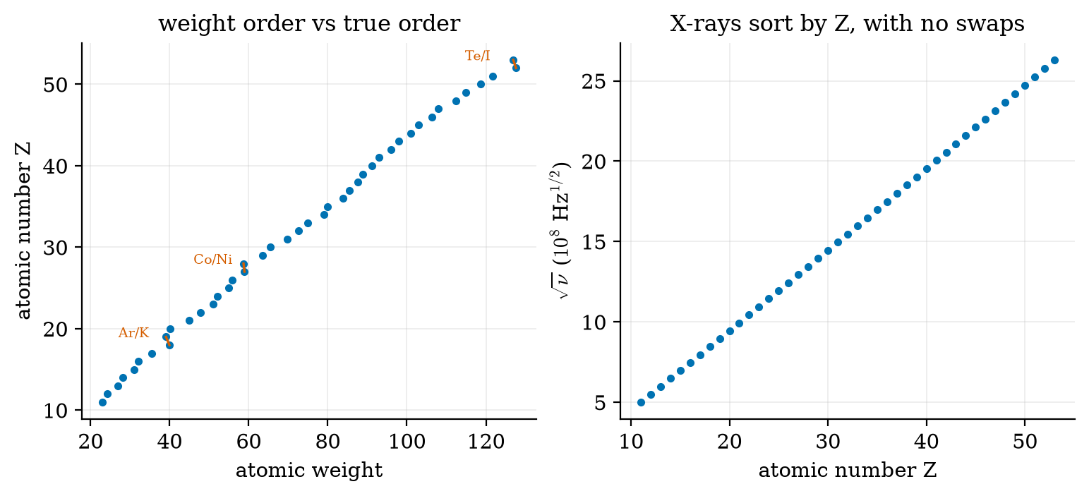
Left: sorting by atomic weight swaps Ar/K, Co/Ni and Te/I (red links). Right: the square root of the K-alpha$​_{1}$ frequency rises smoothly with $Z$ with no swaps. Data from the X-ray Data Booklet; plotted by fig02_weight_vs_Z.py.

3.2 Tier 2 (medium): the definitions made precise
How the line was measured. Moseley’s electrons struck samples mounted on a movable carriage inside a tube. The emitted X-rays were reflected from a crystal and recorded on film. A crystal reflects only at angles obeying Bragg’s law
$$nλ=2dsinθ, (2)$$
where $d$ is the spacing between crystal planes (known), $θ$ the glancing angle, $n$ an integer. Measuring $θ$ gives $λ$, then $ν=c/λ$, or the photon energy $E=hc/λ$.
Units: X-ray photon energies are quoted in electron-volts: $1 \text{eV}=1.602×{10}^{−19}$ J, and $hc=12 398.4$ eV$⋅$Å, so a 1.54 Å photon has about 8050 eV. Check with copper, the most common laboratory target: K$α_{1}$ is 8047.78 eV, so
$$λ=\frac{12 398.4}{8047.78} \text{Å}=1.5406 \text{Å}.$$

3.3 Tier 3 (medium-hard): the main derivation
Bohr energy for a hydrogen-like atom of charge $Z_{\text{eff}}$:
$$E_{n}=− Ry \frac{Z_{\text{eff}}^{2}}{n^{2}}, Ry=13.6057 \text{eV}. (3)$$
Step 1: what charge does the jumping electron feel? When the K-shell loses one electron, one 1s electron is left. As the $n=2$ electron falls, it sees the nucleus (charge $+Z$) partly cancelled by that remaining 1s electron (charge $−1$, sitting inside its orbit). So $Z_{\text{eff}}=Z−σ$ with $σ≈1$. (The other $n=2$ electrons are mostly outside it and cancel little; that is the origin of the small corrections in 3.4.)
Step 2: the photon energy is the difference of two levels, treating the final $n=1$ and initial $n=2$ levels with the same $Z_{\text{eff}}$:
$$\begin{aligned}E_{Kα}&=E_{2}−E_{1} \\ &=− Ry (Z−σ)^{2}\left(\frac{1}{2^{2}}−\frac{1}{1^{2}}\right)&&\text{(by @eq:bohr)} \\ &=3/4 Ry (Z−σ)^{2}.\end{aligned} (4)$$
Step 3: convert energy to frequency with $E=hν$ and use $Ry/h=Rc=3.2898×{10}^{15}$ Hz:
$$\begin{aligned}ν_{Kα}&=3/4 Rc (Z−σ)^{2} \\ \sqrt{ν_{Kα}}&=\sqrt{3/4Rc} (Z−σ)\end{aligned} (5)$$
With $σ=1$ this is (1), and numerically $a=\sqrt{0.75×3.2898×{10}^{15}}=4.967×{10}^{7}$ Hz$​^{1/2}$. Moseley found that his fitted constant for the K series agreed with $3/4$ of the Rydberg frequency, an early and striking confirmation that Bohr’s 1913 model works for atoms heavier than hydrogen.
What each term means. $3/4=1−1/4$ is the geometry of the $2→1$ jump; $Rc$ is the hydrogen scale of frequency; $(Z−σ)$ is the nuclear charge as seen from inside the atom.
Test against data (Figure 1). For the 43 elements from Na to I the fitted line deviates from Bohr by a few percent at most. Over $Z=13$ to $30$ (a range like Moseley’s own) the fitted slope is $4.976×{10}^{7}$ Hz$​^{1/2}$ against the predicted $4.967×{10}^{7}$ (0.2% apart) and the fitted $σ$ is $0.99$.
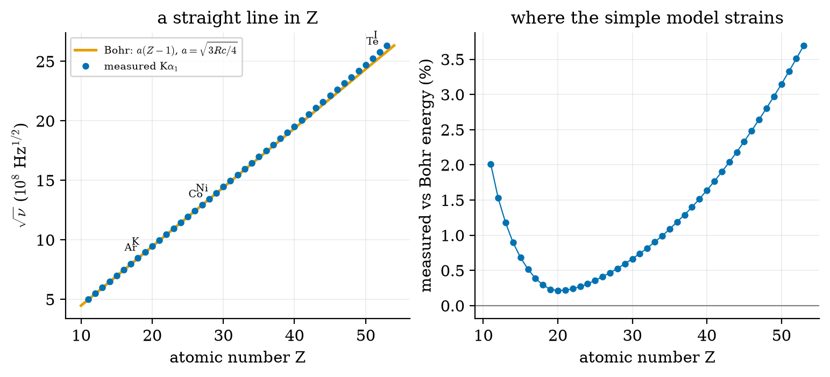
Left: square root of the measured K-alpha$​_{1}$ frequency (dots) against the Bohr line with $σ=1$. Right: the measured photon energy relative to the Bohr prediction. The line is excellent over $Z=13$ to $30$ and drifts up to $+3.7\%$ at iodine. Plotted by fig01_moseley_law.py.

3.4 Tier 4 (hard): generalisation, edge cases, what the textbook glosses over
Edge 1: the fitted $σ$ is not exactly 1. A free straight-line fit over $Z=31$ to $53$ gives slope $5.15×{10}^{7}$ (3.8% above Bohr) and an intercept equivalent to $σ=2.07$; the slope and intercept trade off against each other, so $σ$ from a free fit is not meaningful at high $Z$. Taking the slope as fixed at Bohr’s value and solving element by element, $σ_{\text{eff}}=Z−\sqrt{E/(3/4Ry)}$ is $0.93$ for Al, $0.92$ for Cu and $0.11$ for Te. It falls with $Z$ because the true energy is raised by the relativistic effects of 3.5 and by $n=2$ screening effects, and a smaller $σ_{\text{eff}}$ absorbs them. So $σ≈1$ is a statement about the light and middle elements.
Edge 2: a missing-element detector. A step of one in $Z$ changes $\sqrt{ν}$ by one tick of size $a$. So a double tick between neighbours means an element is missing. Moseley’s 1914 paper pointed to three gaps between Al ($Z=13$) and Au ($Z=79$), at $Z=43,61$ and $75$; they were filled later by technetium, promethium and rhenium. Element 72 was settled in 1923 when X-ray spectroscopy showed that hafnium, not “celtium”, occupies that place, a direct use of this session’s method.
Edge 3: why weights misordered. Atomic weight is the isotope-averaged mass, and the mass per proton depends on the neutron count and the isotope mix. Cobalt is a single isotope, $​^{59}$Co (58.93). Nickel is mostly $​^{58}$Ni (about two thirds) with heavier isotopes making up the rest, giving an average of 58.69. So Co with one proton fewer is heavier than Ni. The X-ray energy knows nothing about neutrons.
Do not over-read the straight line
Moseley’s law says the K-alpha energy is a smooth, monotonic function of $Z$. It does not by itself explain why the elements repeat chemically every 8, 18, 32; that comes from electron shell filling (sessions E1 to E5).

3.5 Tier 5 (hardest): the open question or research-level connection
The relativistic correction, to first order. For a hydrogen-like atom the Dirac energy of level $(n,j)$ is
$$E_{n,j}=−\frac{Ry Z^{2}}{n^{2}}\left[1+\frac{(Zα)^{2}}{n^{2}}\left(\frac{n}{j+1/2}−\frac{3}{4}\right)\right]+… (6)$$
Apply it to the K$α_{1}$ line, $2p_{3/2}→1s_{1/2}$. Ground state: $n=1$, $j=1/2$, bracket $1+1/4(Zα)^{2}$. Upper state: $n=2$, $j=3/2$, bracket $1+1/{16}(Zα)^{2}$. The photon energy is the difference, with the energy scale $(Z−σ)^{2}$ as before:
$$\begin{aligned}E_{Kα_{1}}&=Ry (Z−σ)^{2}\left[(1+{(Zα)^{2}}/4)−1/4(1+{(Zα)^{2}}/{16})\right] \\ &=3/4 Ry (Z−σ)^{2}\left[1+5/{16}(Zα)^{2}\right].\end{aligned} (7)$$
The correction grows as $Z^{2}$ and always raises the energy, as the data demand. Numbers (code: ka_energy_rel):
relative deviation of the measured K$α_{1}$ energy from two predictions with $σ=1$.
Element | $Z$ | $Zα$ | Measured vs Bohr | Measured vs Bohr + (7)
Cu | 29 | 0.21 | +0.6% | $−0.8$%
I | 53 | 0.39 | +3.7% | $−0.9$%
Au | 79 | 0.58 | +10.8% | +0.4%
U | 92 | 0.67 | +16.5% | +2.1%
First-order relativity removes about 90% of the gap at U. What remains is screening by the other electrons, higher powers of $(Zα)$, and the finite size of the nucleus; each is real and none is computed here.
Open threads at this depth. Real multi-electron relativistic atomic structure is computed with Dirac-Hartree-Fock-type methods. For the heaviest atoms the same relativistic contraction of inner orbitals reaches the valence shells and changes chemistry (session G2: gold’s colour, mercury’s liquidity).

3.6 Level ladder: the same idea from intuition to the frontier
Level | Audience | The idea at this level | Key equation / tool | What the next level corrects
L0 | intuition | Each element glows with its own X-ray colour; the colour steps up smoothly along the table. | picture | No numbers yet.
L1 | school | $\sqrt{\text{frequency}}$ is proportional to the number of protons less one; this fixes each element’s place. | $\sqrt{ν}=a(Z−1)$ | Where does $a$ come from?
L2 | advanced school | The line comes from an $n=2→1$ jump in an atom whose nuclear charge is reduced by one inner electron. | $E=3/4Ry(Z−1)^{2}$ | The model is Bohr’s, ad hoc.
L3 | college | Derived from quantized hydrogen-like levels, with a screening constant $σ$; Bragg’s law gives the measurement. | (4), (2) | $σ$ is not exactly 1, and the Bohr levels ignore relativity.
L4 | master’s | Dirac fine structure gives the $[1+5/{16}(Zα)^{2}]$ correction and splits K$α_{1}$/K$α_{2}$. | (7) | Many-electron screening is only approximated.
L5 | PhD | K-line energies are computed by relativistic many-body methods (Dirac-Hartree-Fock plus QED corrections). | Dirac-Fock | Precision at high $Z$ needs these.
L6 | frontier | Do the K-lines of the heaviest known and hypothetical elements follow this pattern? Open.

3.7 Regime ladder: push every parameter to its extremes
Parameter | Regime | Signal (dimensionless number) | What changes | Theory that takes over
nuclear charge | $Z≲10$ | few electrons | K lines are soft X-rays whose energy is shifted by the chemical environment | molecular and band structure
nuclear charge | $10≲Z≲30$ | $Zα≲0.2$ | Moseley’s law with $σ≈1$ to about 1% | Bohr model
nuclear charge | $Z∼50$ | $Zα≈0.4$ | +4% over Bohr | first-order Dirac
nuclear charge | $Z∼80$ to $92$ | $Zα≈0.6$ to $0.7$ | +11% to +17% over Bohr (Figure 3) | Dirac plus many-body screening, QED
nuclear charge | $Zα→1$ ($Z→137$) | $Zα→1$ | point-nucleus Dirac 1s energy collapses; nucleus size matters | finite-nucleus Dirac, strong-field QED
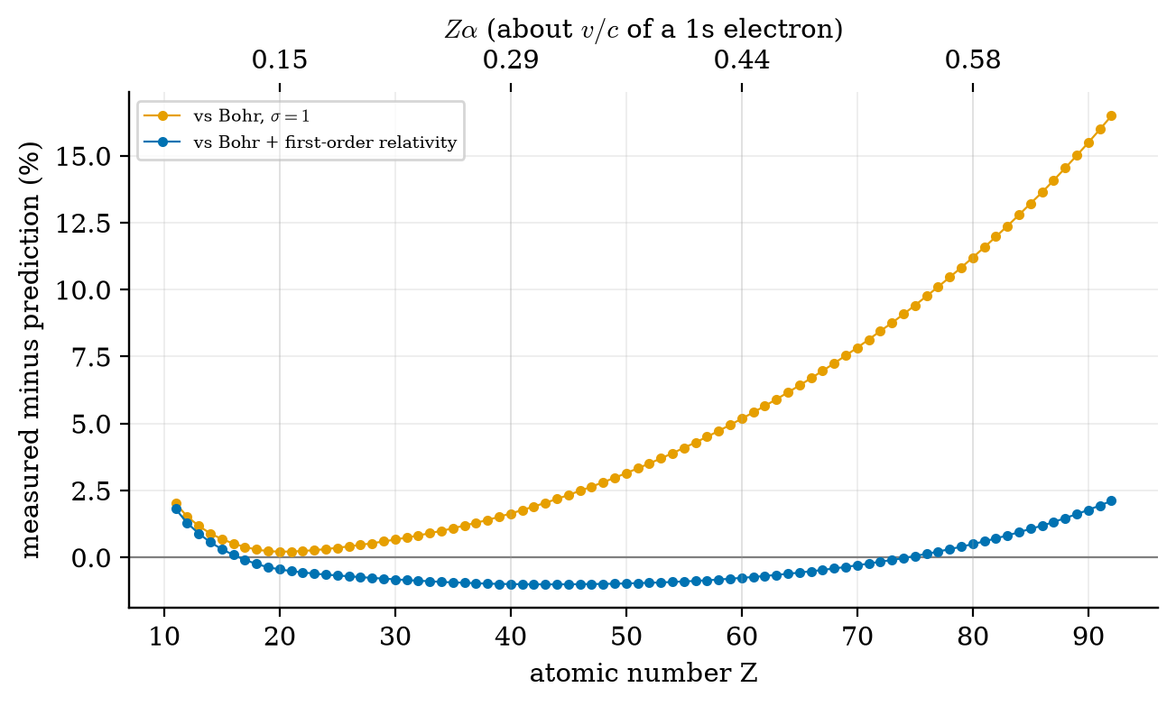
Measured K$α_{1}$ energy relative to prediction, $Z=11$ to $92$. Orange: Bohr line, which drifts to $+16.5\%$ at uranium. Blue: with the first-order Dirac factor, which stays within about $±2\%$. The top axis is $Zα$, the 1s electron’s speed as a fraction of the speed of light. Plotted by fig03_regimes.py.

4. Apply

4.1 Worked problem(s)
W1 (easy). Identify an unknown. A sample emits K$α_{1}$ at 6403.84 eV. Which element? Invert (4) with $σ=1$:
$$Z=1+\sqrt{\frac{6403.84}{0.75×13.6057}}=1+\sqrt{627.6}=26.05.$$
The nearest integer is $Z=26$: iron. The data table confirms Fe K$α_{1}$ = 6403.84 eV.
W2 (medium). Predict copper. $E=0.75×13.6057×{28}^{2}=8000$ eV against the measured 8047.78 eV (0.6% low).
W3 (medium-hard). Tell Co from Ni. Co is $Z=27$, Ni is $Z=28$. The step in $E$ between them is $7478.15−6930.32=547.8$ eV, about 8% of the line itself and easily resolved by a crystal spectrometer; the weights (58.93 and 58.69) differ the other way. Which would a weight-ordered table put first? Nickel, wrongly.
W4 (hard). Is the drift predicted? At iodine, with $σ=1$, the measured energy is $+3.7\%$ above Bohr. Equation (7) predicts $5/{16}(0.387)^{2}=+4.7\%$. The $−0.9\%$ left over (Table in 3.5) means other effects, mainly the screening of the $2p$ electron by the other $n=2$ electrons, act in the opposite direction and are about a fifth the size of the relativistic term.

4.2 Code and figures
import moseley as ms
d = ms.load_kalpha1()
Z, E = d["Z"], d["E_eV"]
m = (Z >= 13) & (Z <= 30) # a range like Moseley's own
a, sigma, rms = ms.fit_line(Z[m], ms.sqrt_nu(E[m]))
print(a, sigma) # 4.976e7 Hz^(1/2), sigma = 0.99
print(ms.moseley_slope()) # 4.967e7: the Bohr prediction
The full module, its README, tests and the data source are in codes/xray/moseley/. Figures: figures/fig01_moseley_law.py (law and deviation), fig02_weight_vs_Z.py (inversions), fig03_regimes.py (to uranium).
What to look at, what it proves, what would differ. Figure 1 (left): dots on a line prove $\sqrt{ν}∝Z$; if the true variable were atomic weight the dots would zigzag at the three pairs. Figure 2: the right panel is monotonic where the left is not. Figure 3: if the Bohr model were complete, the orange curve would be flat.

5. Analyze
Which term dominates where. The relativistic factor $1+5/{16}(Zα)^{2}$ exceeds 1% when $(Zα)^{2}>0.032$, i.e. $Zα>0.18$, or $Z≳25$. Below that the Bohr model is a 1% model; above $Z≈60$ it is wrong by more than 5%.
Sensitivity to $σ$. $dE/E=2 dσ/(Z−σ)$. At $Z=30$ an error of $Δσ=0.3$ shifts $E$ by 2%; at $Z=90$ only 0.7%. The line is therefore less sensitive to screening at high $Z$, so the identification of $Z$ is robust across the whole table.
Resolving power needed. Neighbouring elements differ by $dE/E=2/(Z−1)$. At $Z=50$ that is 4%, so even a modest spectrometer separates neighbours across the table.

6. Evaluate
- Versus chemistry: chemical ordering needed judgement (put I after Te “because it looks like Cl”). The X-ray ordering needs a measurement and one integer.
- Versus mass spectrometry: mass spectra give isotope masses, not $Z$; X-ray lines give $Z$ regardless of isotope. X-ray fluorescence (XRF) analysers use exactly this law to identify alloys and pigments.
- History and philosophy: a periodic table ordered by an observable physical integer turned “element” from a chemical idea into a nuclear one: an element is its $Z$. Moseley was killed at Gallipoli in August 1915, aged 27; his death is often cited as a reason Britain later kept scientists out of front-line service.
- When not to use it: for $Z<10$ the K line is too soft and entangled with chemistry; for $Z>60$ use the relativistic form or tabulated data; never use it to infer neutron number.

7. Create
What you can build from this
- Mystery-element game: give a student three K$α$ energies and have them identify the elements with W1’s formula. Add Co/Ni and Te/I as traps.
- Reproduce Moseley’s 1913 plot from the first rows of kalpha1_xdb.csv and mark which elements he could not have had (Tc, Pm).
- Extend the module to L-lines ($3→2$ jumps, screening constant much larger than 1) and compare screening constants.
- Combine with later sessions: after E4 (Madelung rule) predict from shell filling which elements have partly filled $3d$ shells whose K$α$ lines shift with chemical state.
- A package module: atomic/xray_lines.py with measured lines for $Z=3..92$ and both predictions; the module here is the seed.

8. Visualization lesson
Chart type | Best for | How it misleads | matplotlib call
scatter plot with fitted line | showing that $y$ is a linear function of $x$ | a good line over a short range hides the curvature (Fig. 1 right) | ax.plot(x, y, "o"), ax.plot(x, fit)
deviation (residual) plot | revealing structure a fit hides | percent scale depends on the reference model chosen (Bohr vs Dirac) | ax.plot(Z, (meas/pred - 1)*100)
twin-axis plot | two scales for the same $x$ ($Z$ and $Zα$) | a second axis can suggest two variables | ax.twiny()
Each chart was read in Section 4.2 by asking what the picture proves and what would look different if the theory were wrong.

9. Problem set
Graded exercises
- (easy) The K$α_{1}$ energy of an unknown is 4510.84 eV. Which element is it? (Use $Z=1+\sqrt{E/(0.75 Ry)}$.)
- (medium) Compute the Bohr K-alpha wavelength for silver ($Z=47$); compare with the measured 22 162.92 eV.
- (medium-hard) Derive (5) from (3) without looking, and state which approximation fixes $σ=1$.
- (hard) Using (7), find the $Z$ at which the first-order correction reaches 5%. Compare with Fig. 3.
- (hardest) Take the point-nucleus Dirac 1s energy $∝\sqrt{1−(Zα)^{2}}$. At what $Z$ does it vanish, and why must a real calculation include the finite size of the nucleus there?

10. Retrieval practice and recap
Answers to the Section 2 quiz.
- The number of protons (the nuclear charge in units of $e$).
- Ar/K, Co/Ni, Te/I.
- It leaves $n=2$ (L shell) and enters the hole in $n=1$ (K shell).
- One 1s electron remains and cancels one unit of nuclear charge.
- About $5×{10}^{7}$ Hz$​^{1/2}$ ($4.97×{10}^{7}$).
Answers to Section 9 (short). (1) $Z=22$, titanium. (2) $λ_{Bohr}=12398.4/(0.75×13.6057×{46}^{2})=0.574$ Å against 0.5594 Å measured. (4) $5/{16}(Zα)^{2}=0.05⇒Zα=0.40$, $Z≈55$. (5) $Zα=1⇒Z≈137$; there the point-nucleus formula goes to zero, so the electron is so close to the nucleus that the finite nuclear radius changes the answer.
Explain it to a friend.
- Why would a table ordered by weight put tellurium before iodine, and why does that bother a chemist?
- Why does an inner electron cancel exactly one unit of nuclear charge for the K$α$ jump?
- If you only had a straight-line plot of $\sqrt{ν}$ against position, how would you spot a missing element?
Re-derive by hand tomorrow: (4) from (3); the $1+5/{16}(Zα)^{2}$ factor from (6); the unknown-element inversion of W1.

11. Where next
- Next node: A1 (what counts as an element, Lavoisier), then the story forward through Mendeleev (C1 to C4); or if you want to follow the physics, E1 (Bohr shells and why spectra are lines).
- Terms discovered here but not yet taught: K$α_{1}$/K$α_{2}$ fine structure, Dirac-Hartree-Fock, X-ray fluorescence.
- Open threads for the learner: Why exactly does $σ_{\text{eff}}$ fall with $Z$ in the per-element estimate? How does an isotope mix, rather than a proton count, decide the Co/Ni weight order?

