What counts as an element: Lavoisier’s working definition
  - Session 002 · Phase 1 · curriculum node A1 · levels L1..L3
Socratic Mastery Tutor
2026-10-18
Table of Contents

Session map
Outcome of this session
After this session you can:
- state Lavoisier’s working definition of an element and say why it is operational and provisional;
- use conservation of mass in a closed vessel to show that a decomposition has happened (worked example: mercury(II) oxide);
- explain why Lavoisier’s list of 33 “simple substances” held 23 plain elements, 3 elements in disguise, 5 earths that are oxides and 2 things that are not matter;
- say how the definition changed in 1913 (from “cannot be decomposed” to “has atomic number $Z$”) and what that fixed;
- reproduce Figures 1 to 3 from codes/chemistry/lavoisier.
- Prerequisites: none for the chemistry; the contrast with the session 001 definition of $Z$ is made in Section 3.5.
- Depth levels taught: L1..L3 (L0 intuition · L1 school · L2 advanced school · L3 college · L4 master’s · L5 PhD · L6 frontier; others get one line in Section 3.6)
- Difficulty ladder used: easy → medium → medium-hard → hard → hardest; this node is mostly tiers 1 to 3, tiers 4 and 5 are short and point forward.
- Deliverables: this document, 3 figures, code module codes/chemistry/lavoisier (with README, example and tests), and the data behind stage 1 of the course app.
- Source anchors: A.-L. Lavoisier, Traité élémentaire de chimie (Paris, 1789), the table of simple substances; English translation by R. Kerr, Elements of Chemistry in a New Systematic Order (1790). The list of 33 entries was checked against the Wikipedia article on the Traité, which also states that 23 of the 33 are elements in the modern sense. The years and the people who resolved each entry (lavoisier33.csv) are from general knowledge and must be checked against E. Scerri, The Periodic Table: Its Story and Its Significance (Oxford) or a facsimile before they are used in published teaching material.

1. Terms: the term tree
Term | Symbol | One-line meaning | Where it appears | New / known
chemical element (operational) |  | a substance that no known chemical method can split into simpler substances | 3.1, 3.2 | new
simple substance |  | Lavoisier’s name for a substance in his table, i.e. one he could not decompose | 3.1 | new
compound |  | a substance that can be decomposed into simpler ones, in fixed proportions by mass | 3.2 | new
decomposition (analysis) |  | splitting a substance into simpler substances | 3.2, 3.3 | new
calx / oxide |  | what a metal turns into when heated in air; we now say metal oxide | 3.3 | new
conservation of mass |  | in a closed vessel the total mass does not change in a chemical reaction | 3.3 | new
radical (Lavoisier) |  | the unknown base that combines with oxygen to make an acid | 3.4 | new
earth (Lavoisier) |  | a non-metallic, non-melting, nearly insoluble solid such as lime or silica | 3.4 | new
atomic number | $Z$ | number of protons; the modern defining property of an element | 3.5 | known (session 001)
isotope |  | atoms with the same $Z$ and different neutron number | 3.5 | fwd
transmutation |  | change of one element into another by a nuclear reaction | 3.7 | fwd
molar mass | $M$ | mass of one mole of a substance, in g/mol | 3.3, 4.1 | known
New terms found while explaining: calx needed oxide, which is the same idea in the modern name. Isotope and transmutation are registered as forward nodes because the modern definition in 3.5 depends on them.

2. Remember
Element, Lavoisier’s way (1789)
If “element” means the last point that analysis can reach, then every substance that we cannot decompose by any means is, for now, an element. (A paraphrase of the passage in the Traité; see the translation by Kerr for the exact wording.)
Conservation of mass
In a closed vessel the total mass before a chemical change equals the total mass after it:
$$∑m_{\text{reactants}}=∑m_{\text{products}}. (1)$$
Memory hook: “Element = not split yet.” The word “yet” carries the whole lesson of the session.
The 33 in four groups (Figure 1): 23 plain elements (the gases oxygen, nitrogen, hydrogen; sulfur, phosphorus, carbon; and 17 metals), 3 “radicals” (muriatic, fluoric, boracic), 5 earths (lime, magnesia, barytes, argill, silex), and 2 imponderables (light, caloric).
Recall quiz (answers in Section 10):
- What did Lavoisier mean by an element?
- Why does the definition contain the word “yet”?
- Which two entries on his list are not matter at all?
- Name the five earths and say what they really are.
- What is the modern defining property of an element?

3. Understand: the derivation

3.1 Tier 1 (easy): intuition and a picture
Before Lavoisier “element” meant something like a philosophical ingredient: earth, air, fire, water. Lavoisier replaced that with a procedure. Take any substance and try every method you have to split it into simpler ones. If you succeed, it is a compound. If you fail, you may call it an element, until somebody succeeds. So an element is defined by the limits of the laboratory, not by a theory of what matter is made of.
The table in his Traité lists 33 such “simple substances”. Figure 1 shows what they turned out to be: 23 are still elements today, and three more (the radicals) are elements that he had not yet seen in pure form. The other seven are the interesting failures.
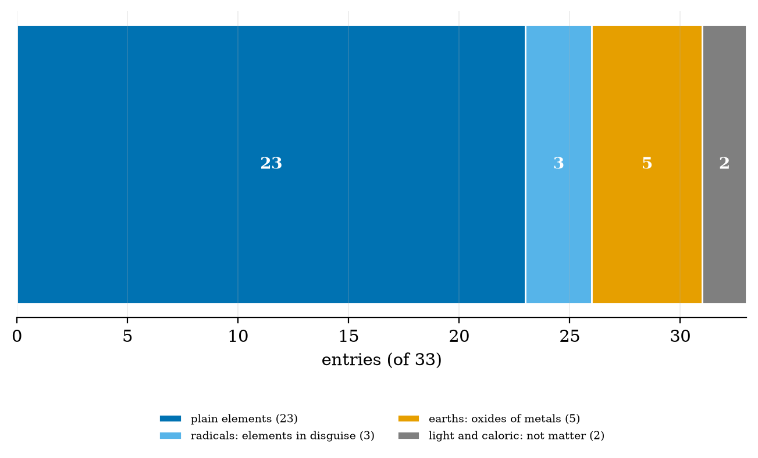
What Lavoisier’s 33 simple substances turned out to be: 23 plain elements, 3 radicals that were elements in disguise (26 modern elements in all), 5 earths that are oxides of metals and 2 imponderables that are not matter. Plotted by fig01_fate_of_33.py.

3.2 Tier 2 (medium): the definitions made precise
Three words need exact meaning.
- Decomposition: a chemical process that turns one substance into two or more substances, each with different properties from the original.
- Compound: a substance that can be decomposed. Its parts appear in fixed proportions by mass.
- Element (operational): a substance for which every known decomposition has failed.
The definition has two weaknesses and both are deliberate. It depends on the methods available. And it can only fail in one direction: a compound is shown to be a compound by one successful decomposition, but an element is never proved to be an element, only not yet disproved.
Water is the first test. In the 1780s water was widely regarded as an element. Cavendish had made water by burning “inflammable air” (hydrogen), and Lavoisier and Meusnier in 1783 to 1784 split water by passing steam over red-hot iron, collecting hydrogen and leaving iron oxide. One successful decomposition was enough to move water from the element list to the compound list.

3.3 Tier 3 (medium-hard): the main derivation, the balance as proof
Lavoisier’s real contribution was a way to prove that a decomposition took place: weigh everything, in a closed vessel.
Take mercury(II) oxide, the red “calx of mercury”. Heated to about 500 °C it gives liquid mercury and a gas. In modern notation
$$2 \text{HgO}→2 \text{Hg}+{\text{O}}_{2}. (2)$$
Step 1: moles. With molar masses $M_{\text{Hg}}=200.592$ g/mol and $M_{\text{O}}=15.999$ g/mol, we have $M_{\text{HgO}}=216.591$ g/mol, so a mass $m$ of HgO is $n=m/M_{\text{HgO}}$ moles.
Step 2: products by the coefficients of (2). Each mole of HgO gives one mole of Hg and half a mole of O$​_{2}$:
$$\begin{aligned}m_{\text{Hg}}&=n M_{\text{Hg}}=m \frac{200.592}{216.591}=0.9261 m \\ m_{{\text{O}}_{2}}&=n/2⋅2M_{\text{O}}=m \frac{15.999}{216.591}=0.0739 m\end{aligned} (3)$$
Step 3: check (1). $0.9261 m+0.0739 m=m$. For $m=100$ g: 92.613 g of mercury and 7.387 g of oxygen, imbalance 0.000 g (code: mass_balance).
Why it proves decomposition. If HgO were an element, heating it could not produce two substances with different properties. If the vessel is sealed and the total mass is unchanged, nothing escaped and nothing was added, so the two products came from the original: it was a compound of mercury and the gas. Lavoisier ran the reverse too, heating mercury in a measured volume of air until a red calx formed, and recovered the original mercury and the original gas by heating the calx. Synthesis and analysis agree, so the claim is secure.
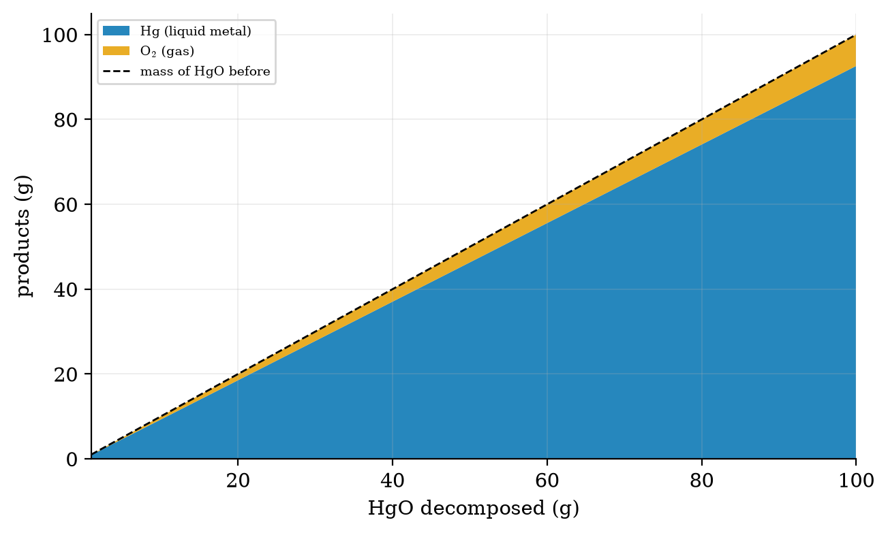
Closed-vessel mass balance for the decomposition of HgO from 1 to 100 g. The mercury and oxygen layers stack exactly to the dashed line, the mass of HgO before heating. Plotted by fig03_mass_balance.py.

3.4 Tier 4 (hard): what went wrong on the list
The 33 contain four kinds of entry. Figure 2 shows when each of the ten non-elements was finally resolved.
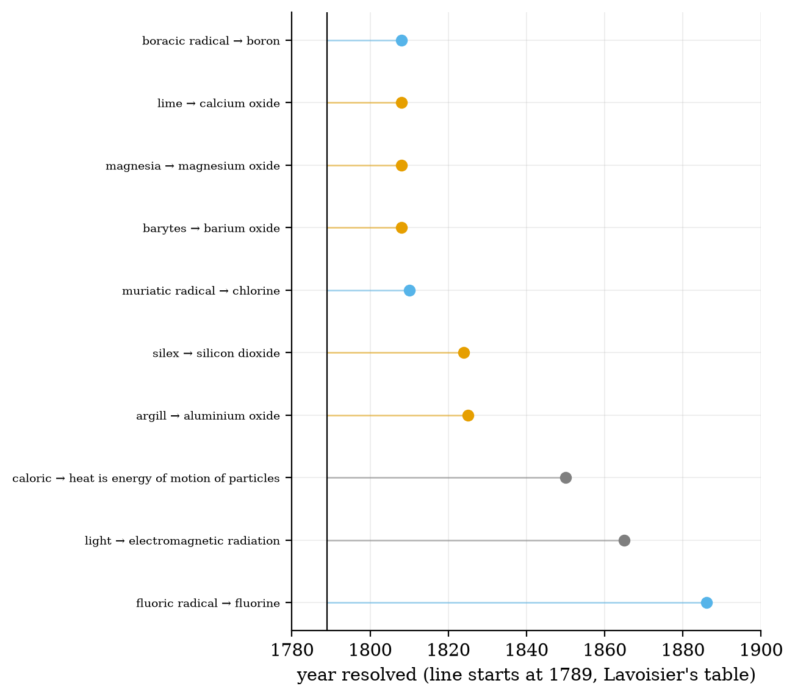
Years in which the ten entries that were not plain elements were resolved. The vertical line is 1789. Colours as in Figure 1. The earths fell in the years 1808 to 1825 to electrolysis and to reduction with reactive metals. Plotted by fig02_when_resolved.py.
- Earths (5). Lime, magnesia, barytes, argill (alumina) and silex (silica) resisted every decomposition Lavoisier could try, because the methods of his day were not energetic enough. He suspected they were oxides of metals he could not isolate. Electrolysis settled the first three in 1808 (Davy), silicon in 1824 (Berzelius) and aluminium in 1825 to 1827 (Ørsted, then Wöhler).
- Radicals (3). For Lavoisier an acid was a combination of oxygen with a radical. The muriatic radical would be the base of hydrochloric acid, and so on. He turned out to be partly right: chlorine, fluorine and boron are real elements. But the logic “all acids contain oxygen” was wrong, since hydrochloric acid (HCl) contains none. This is why the name “oxygen” (“acid-former”) is a historical slip that stayed.
- Light and caloric (2). Lavoisier counted light and heat as weightless substances. Heat was recognised as a form of energy in the nineteenth century and light as an electromagnetic wave in the 1860s. They were never decomposable because they were not substances.
- The 23. Oxygen, nitrogen, hydrogen, sulfur, phosphorus, carbon and 17 metals. All still elements.
The point is that the method kept working: every error on the list was found and corrected by the same procedure that created it.

3.5 Tier 5 (hardest): the open question, from “not yet split” to “has $Z$ protons”
An operational definition is only as good as the best laboratory. Two later developments forced a replacement.
- Isotopes (1913). Soddy showed that one chemical element can be a mixture of atoms of different masses. “Simple substance” no longer means “all atoms identical”, so the definition by mass or by chemical behaviour alone is not enough.
- The atomic number (1913, session 001). Moseley’s X-ray law gave an integer $Z$ that orders the elements with no swaps. The modern definition follows.
Chemical element, modern (IUPAC)
A chemical element is a species of atoms all having the same number of protons in the nucleus: the same $Z$.
Under this definition an element is no longer “what has not yet been split”. It is a class of atoms, and the question “how many elements are there?” has a precise answer: the number of allowed values of $Z$, currently 118 named elements. Whether a nucleus with a given new $Z$ lived long enough to count as a discovery is itself decided by convention (the joint IUPAC and IUPAP working groups use a minimum lifetime of the order of ${10}^{−14}$ s, long enough for an electron cloud to form; check the current criteria before quoting).

3.6 Level ladder: the same idea from intuition to the frontier
Level | Audience | The idea at this level | Key equation / tool | What the next level corrects
L0 | intuition | Things that cannot be broken down into simpler things are the basic ingredients. | picture | “Cannot be broken down” depends on how hard you try.
L1 | school | An element is a substance with only one kind of atom; a compound has more than one kind. | symbols | Why is “one kind of atom” meaningful?
L2 | advanced school | An element is defined by its atomic number; the 118 known elements fill the periodic table. | $Z$ | How was this defined before atoms were known?
L3 | college | Lavoisier’s operational definition: whatever cannot be decomposed by available methods; proved by weighing. | (1), (2) | The definition is provisional; $Z$ replaced it.
L4 | master’s | Elements as classes of nuclides, with isotopes; the identity of an element is a nuclear, not a chemical, property. | nuclide chart | What lifetime counts as “existing”?
L5 | PhD | Element status of superheavy nuclei is set by lifetime criteria and by chemistry done on a handful of atoms. | decay chains
L6 | frontier | Is there a last element? Where does the nuclear stability limit sit (island of stability)? Open.

3.7 Regime ladder: push every parameter to its extremes
Parameter | Regime | Signal (dimensionless number) | What changes | Theory that takes over
energy per atom in the experiment | chemical, $∼$ 1 eV | $E/\text{(bond energy)}$ | compounds split into elements; elements stay | chemistry
energy per atom | electrolysis, high temperature |  | earths split into metal and oxygen (1807 to 1825) | thermochemistry
energy per atom | nuclear, $∼$ MeV | $E/(\text{nuclear binding})$ | one element turns into another (transmutation, Rutherford 1919) | nuclear physics
number of atoms available | ${10}^{23}$ (a gram) | $N$ | weighing works | chemistry
number of atoms available | a handful | $N∼1$ | superheavy elements are identified atom by atom from decay chains | nuclear physics
The lesson of the table: “cannot be decomposed” always carries an unwritten phrase, “at this energy”. Lavoisier’s operational definition is a statement about the first row of the table.

4. Apply

4.1 Worked problem(s)
W1 (easy). Compound or element? A red powder heated in a sealed tube gives a silvery liquid and a gas, with a total mass equal to that of the powder. Which words fit: compound or element? Compound: it was decomposed, and the balance shows nothing was lost.
W2 (medium). Predict the products. Heating 25.0 g of HgO: $m_{\text{Hg}}=0.9261×25.0=23.15$ g and $m_{{\text{O}}_{2}}=0.0739×25.0=1.85$ g. Check: $23.15+1.85=25.0$ g.
W3 (medium-hard). What mass of gas would fill a 1 L vessel? Oxygen is 1.85 g in W2. At room temperature and pressure one mole of gas is about 24 L, so 1.85 g is $1.85/31.998=0.058$ mol or about 1.4 L. A 1 L closed vessel would burst or leak, which is why Lavoisier used a bell jar over mercury and measured volumes carefully.
W4 (hard). Count. From the data table: how many of the 33 entries correspond to modern elements, and which are the extra three compared with the number quoted in the Wikipedia article (23)? 26 correspond to modern elements; the three extra are the radicals (chlorine, fluorine, boron), which the source’s figure of 23 does not count because Lavoisier believed them to be oxygen compounds.

4.2 Code and figures
import lavoisier as lv
rows = lv.load_table()
print(lv.counts(rows)) # {'imponderable': 2, 'element': 23, 'radical': 3, 'earth': 5}
print(lv.mass_balance(100.0)) # (92.613..., 7.386..., 0.0)
The full module, README, tests and data file are in codes/chemistry/lavoisier/. Figures: fig01_fate_of_33.py, fig02_when_resolved.py, fig03_mass_balance.py.
What to look at, what it proves, what would differ. Figure 1: most of the list survived, which is why the method was good. Figure 2: every error was corrected by a later successful decomposition; if the definition were wrong in kind, the points would not have a decomposition behind them. Figure 3: the layers match the dashed line to machine precision; a leak would put the stack below it.

5. Analyze
- Error rate of the method. 7 of the 33 entries (5 earths, 2 imponderables) were wrong, 21%; the 3 radicals were elements the method had not isolated. So about 79% of the entries had the right identity, a strong result for a provisional method.
- Which energy decided each error. Earths needed high-temperature electrolysis; light and caloric needed a change of concept, not a better experiment. This is why the two groups are drawn in different colours.
- Sensitivity of the balance. To detect a 0.1% mass loss in a 100 g sample a balance needs 0.1 g resolution, which any modern laboratory balance exceeds easily. How precise Lavoisier’s own balances were is a historical fact to look up before quoting.

6. Evaluate
- Strength. The operational definition does not need atoms. It worked for 100 years before atoms were accepted.
- Weakness. It cannot say what an element is, only what has not been split; it cannot see isotopes; and it gives no way to know how many elements there are. Mendeleev later separated the simple body (what you can hold) from the element (the abstract thing that survives in compounds), a distinction that the modern $Z$ definition makes precise.
- Philosophy of science. The definition is falsifiable in one direction only. It is a useful template: “X is the current best explanation until a successful test shows otherwise”.
- When not to use it. Never use “has not been decomposed” to claim that something is an element today; use $Z$.

7. Create
What you can build from this
- Stage 1 of the course app: an “element or not?” sort of Lavoisier’s 33, with the real fate shown after each guess (the data is lavoisier33.csv).
- A mass-balance calculator for any one-step decomposition, extending mass_balance to other reactions.
- Timeline poster: when each of the first 60 elements was isolated, using the year_resolved field, and where Lavoisier’s list sits in it.
- Combine with session 001: compare the two definitions side by side: what Lavoisier needed (a successful decomposition) and what Moseley needs (a K-alpha line and one integer).
- A package module: history/elements.py with the 1789, 1869 and 1913 data used by the app.

8. Visualization lesson
Chart type | Best for | How it misleads | matplotlib call
single stacked bar (part-to-whole) | one total split into a few categories | hard to compare unless the segments are labelled with their values | ax.barh([0], [v], left=left)
lollipop (dot-and-stem) timeline | many events on one time axis, each with a start and an end | the stem length reads as duration even when only the end matters | ax.plot([x0, x1], [i, i]), ax.plot(x1, i, "o")
stacked area | showing how a total splits as a variable changes | upper layers inherit the wiggles of the lower ones | ax.stackplot(x, y1, y2)

9. Problem set
Graded exercises
- (easy) Is “air” an element in Lavoisier’s sense? In the modern sense? Explain in two sentences.
- (medium) Heating 50.0 g of HgO gives how many grams of mercury and of oxygen?
- (medium-hard) A student heats 10.00 g of a red powder in a sealed tube and finds 9.98 g afterwards. List two possible reasons and one check for each.
- (hard) Using year_resolved, find the mean gap between 1789 and the resolution year for the five earths, and explain why it is short compared with that for light and caloric.
- (hardest) A nucleus with a new $Z$ lives for ${10}^{−3}$ s. Does Lavoisier’s definition, the IUPAC definition, or neither tell us whether a new element exists? Argue both sides.

10. Retrieval practice and recap
Answers to the Section 2 quiz.
- A substance that cannot be decomposed by any known method.
- Because a later method may succeed; the definition is provisional.
- Light and caloric.
- Lime (calcium oxide), magnesia (magnesium oxide), barytes (barium oxide), argill (aluminium oxide), silex (silicon dioxide).
- The atomic number $Z$ (the number of protons).
Answers to Section 9 (short). (1) No, air is a mixture, not an element, in either sense. (2) 46.3 g Hg, 3.69 g O$​_{2}$. (4) The five earths had resolution years 1808, 1808, 1808, 1824 and 1825 (mean 1814.6), a gap of about 25.6 years; light and caloric took 76 and 61 years because a new concept, not a better experiment, was needed. (5) Lavoisier’s definition cannot decide it: no decomposition test is possible on a few atoms. The IUPAC definition by $Z$ can, and a lifetime of ${10}^{−3}$ s is far above the ${10}^{−14}$ s criterion, so the nucleus would count as an element once its $Z$ was demonstrated.
Explain it to a friend.
- Why does a good definition of “element” include the word “yet”?
- How does weighing a closed vessel prove that something was decomposed?
- What replaced Lavoisier’s definition, and what problem did it solve?
Re-derive by hand tomorrow: (3) from (2); the 26 versus 23 count.

11. Where next
- Next node: A2 (atomic weights: Dalton to Cannizzaro 1860), then A3 (valence). The course app’s stage 1 uses this session’s data.
- Terms discovered here but not yet taught: isotope and transmutation.
- Open threads for the learner: What exactly was the experiment that moved water from the element list to the compound list, and who first did it? Which of the 17 metals took longest to isolate?

