Evaluation, Safety and Responsible AI: Measuring What Matters
  - Unit 9 of the Generative AI and LLM crash course
GenAI crash course
2026-10-09
Table of Contents

Session map
Outcome of this session
After this session you can:
- compute BLEU, ROUGE, token F1 and exact match by hand, and say exactly when they mislead;
- explain LLM-as-judge evaluation, its position bias and how swapping orders reduces it, and why raw agreement can mislead (kappa);
- check an answer for groundedness and catch altered numbers;
- measure fairness (demographic parity, equal opportunity, equalized odds) and say why one cannot always have all three, and why small groups give uncertain audits;
- explain privacy risks (memorisation, PII) and the differential-privacy noise mechanism, and write an evaluation report for a RAG application with honest intervals.
- Prerequisites: Unit 1 (perplexity, memorisation), Unit 4 (paired comparison, Wilson-type intervals), Unit 5 (the RAG system and its question set), Unit 8 (prompt injection and defences). Elementary probability (the normal distribution, the logistic function).
- Difficulty ladder used: easy → medium → medium-hard → hard (Sections 3.1 to 3.4); the hardest tier is posed as open questions in Section 3.5.
- Deliverables: this document (.tex, .pdf, .docx), 6 figures, the module codes/evaluation/evaluation_np/ (BLEU, ROUGE, F1, judge bias and kappa, groundedness checks, fairness metrics, Laplace noise, PII detection, RAG evaluation helpers; 12 tests whose expected values were computed by hand), the Metric lab and Fairness explorer widgets, and a Colab notebook for the practical “evaluate a RAG/LLM application”.
- Source anchors: Papineni et al. 2002 (BLEU) and Lin 2004 (ROUGE), both journal or conference papers without arXiv versions, cited from the original definitions and checked here by hand-computed test cases; Zheng et al. 2023, arXiv:2306.05685 (LLM-as-a-judge: examines “position bias, verbosity bias, self-enhancement bias, and limited reasoning ability”; strong judges reach “over 80% agreement” with human preferences, “the same level of agreement between humans”); Hardt et al. 2016, arXiv:1610.02413 (equalized odds and equality of opportunity); Carlini et al. 2020, arXiv:2012.07805 (an adversary can recover individual training examples, “hundreds of verbatim text sequences”, from GPT-2 by querying it); Dwork et al. 2006 (the Laplace mechanism for differential privacy, derived here). arXiv IDs and quoted statements were checked in the PDFs on the day of writing.
- What is measured here, and what is not. There is no language model on the machine that built this course. The metrics, the fairness model, the privacy mechanism and the PII detector are exact or measured on real text; the judge-bias results use a stated simulation model; the RAG evaluation uses the course’s own RAG system (BM25 or LSA retrieval and an extractive answerer that can only quote). Statements about real LLMs are cited. The practical with a real model and a model judge is a Colab notebook that was not executed while writing this document.

1. Terms: the term tree
Term | Symbol | One-line meaning | Where it appears | New / known
evaluation set, benchmark |  | fixed questions with reference answers | 3.1 | new
exact match, token F1 |  | strict or bag-of-words agreement with a reference | 3.2 | new
BLEU |  | geometric mean of n-gram precisions times a brevity penalty | 3.2 | new
ROUGE-N, ROUGE-L |  | n-gram or longest-common-subsequence overlap with a reference | 3.2 | new
LLM-as-judge |  | a model grades or compares answers | 3.3 | new
position bias | $β$ | a judge’s preference for the answer shown first | 3.3 | new
Cohen’s kappa | $κ$ | agreement between two raters corrected for chance | 3.3 | new
groundedness |  | every claim is supported by the provided sources | 3.3 | new
demographic parity, equal opportunity, equalized odds |  | fairness criteria on selection rates and error rates | 3.4 | new
differential privacy | $ε$ | a guarantee that one person’s data barely changes the output | 3.4 | new
PII |  | personally identifiable information | 3.4 | new
red teaming |  | deliberate attempts to make a system fail | 3.4 | new
responsible AI |  | fairness, safety, privacy, transparency and accountability practices | 3.4 | new
perplexity, memorisation |  | model’s average surprise; reproducing training text | 3.1 | known
prompt injection |  | instructions hidden in data | 3.4 | known
paired comparison, Wilson interval |  | compare on the same items; interval for a rate | 3.3 | known
Terms used but not taught here: embedding-based metrics such as BERTScore, human-evaluation protocols in detail, legal frameworks and regulation, watermarking of generated text.

2. Remember
Why evaluate, and the three ways
Evaluation answers “is this system good enough for this use?” There are three ways: automatic metrics against reference answers (BLEU, ROUGE, F1, exact match, perplexity), model judges (an LLM grades answers), and human evaluation. Each is a proxy for what you care about.
Overlap metrics
With a reference $r$ and a candidate $c$ (lower-cased words): exact match is 1 if they are the same word sequence. Token F1 is the harmonic mean of precision and recall of shared words. ROUGE-N counts shared $n$-grams (recall, precision, F1); ROUGE-L uses the longest common subsequence (LCS). BLEU is
$$BLEU=BP⋅exp\left(1/N\sum_{n=1}^{N}{ln}p_{n}\right), BP=\left\{\begin{matrix}1 & |c|>|r| \\ e^{ 1−|r|/|c|} & \text{otherwise,}\end{matrix}\right. (1)$$
where $p_{n}$ is the modified $n$-gram precision (each candidate $n$-gram counts at most as often as it occurs in the reference) and BP is the brevity penalty.
Fairness criteria
For a classifier with prediction $\hat{Y}$, truth $Y$ and a group attribute $A$ (Hardt et al. 2016): demographic parity compares selection rates $P(\hat{Y}=1∣A)$; equal opportunity compares true positive rates $P(\hat{Y}=1∣Y=1,A)$; equalized odds requires both true and false positive rates to be equal across groups.
Differential privacy (Laplace mechanism)
A count query changes by at most 1 when one person is added or removed (its sensitivity $Δ=1$). Releasing the count plus Laplace noise of scale $Δ/ε$ is $ε$-differentially private: smaller $ε$ means more noise and more privacy.
Memory hooks.
- A metric is a ruler for something you cannot see. Check that the ruler measures the right thing.
- Overlap is not meaning: “does not” flips the meaning and barely moves the score.
- An audit is only as good as its smallest group.
- Privacy is a budget, not a switch: every released number spends some of it.
Recall quiz (answers in Section 10).
- What is the BLEU-2 score of the candidate “the cat” against the reference “the cat sat on the mat”?
- Why can two raters who agree 82% of the time have a kappa of about 0?
- Name one thing a fairness audit cannot equalise at the same time as equal opportunity when base rates differ.
- What is the mean absolute error of a Laplace-noised count at $ε=1$?
- Why is a regular-expression PII detector not enough?

3. Understand: the derivation

3.1 Tier 1 (easy): why LLM evaluation is hard, and a picture
For a classifier, evaluation is easy: compare predicted and true labels. For a language model there are many correct outputs (“each token can attend to all the other tokens” and “attention lets every word look at every other word” say the same), and some wrong ones look very similar to correct ones. Perplexity (Unit 1) measures how well a model predicts text, not whether its answers are useful or true. Other difficulties: the model may have seen the test set during training (contamination), results change with the prompt, and the quality you care about (helpful, honest, safe) is not one number.
The first picture shows what the standard automatic metrics do on five candidate answers to one reference.
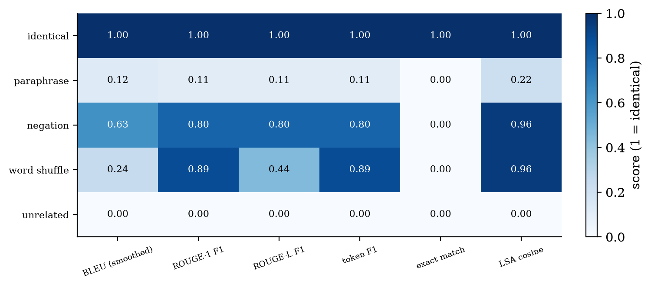
Scores of five candidate answers against the reference “attention lets every word look at every other word”: BLEU (smoothed), ROUGE-1 F1, ROUGE-L F1, token F1, exact match, and the cosine similarity of a classical embedding (LSA trained on the course text). The paraphrase scores about 0.11 to 0.22 even though it means the same. The negation (“attention does not let every word look at every other word”) scores 0.63 (BLEU), 0.80 (ROUGE) and 0.96 (embedding cosine) although it means the opposite. The word shuffle keeps ROUGE-1 at 0.89 but drops ROUGE-L to 0.44 and BLEU to 0.24.
Read Figure 1 as the unit’s main warning: overlap metrics reward the same words, not the same meaning. A paraphrase is under-scored, a negation is over-scored, and even an embedding similarity (LSA) rated the negation at 0.956. Metrics are useful for tracking change on a fixed task with fixed references; they are not evidence that an answer is right.

3.2 Tier 2 (medium): the metrics, computed by hand
Modified precision and BLEU. Take the reference “the cat is on the mat” and the degenerate candidate “the the the the the the the” (7 words). The candidate’s unigram “the” occurs 7 times but the reference has it only twice, so only 2 count: the modified unigram precision is $2/7=0.286$, not $7/7$. For BLEU-2 of the candidate “the cat” against the reference “the cat sat on the mat”: $p_{1}=2/2$, $p_{2}=1/1$, $|c|=2<|r|=6$, so $BP=e^{1−6/2}=e^{−2}=0.1353$ and BLEU-2 $=0.1353⋅e^{0}=0.1353$ (the module returns exactly this). Without smoothing BLEU is zero whenever the candidate has no matching $n$-gram of some length $n≤N$, which happens constantly for short sentences; the smoothed version adds 1 to numerator and denominator for $n>1$.
ROUGE. Reference “the cat sat on the mat” (6 words), candidate “the cat sit on mat” (5 words). Shared unigrams: the, cat, on, mat = 4, so ROUGE-1 precision $=4/5$, recall $=4/6$, F1 $=0.727$. Bigrams: the reference has 5 (the cat, cat sat, sat on, on the, the mat), the candidate 4 (the cat, cat sit, sit on, on mat); only the cat is shared: precision $1/4$, recall $1/5$, F1 $=0.222$. ROUGE-L uses the longest common subsequence the cat on mat of length 4: precision $4/5$, recall $4/6$, F1 $0.727$. A reversed candidate “d c b a” for “a b c d” has the same words but an LCS of 1, so ROUGE-L recall is $1/4$.
Token F1 and exact match. For the reference “the cat sat” and the candidate “the cat”: shared 2, precision 1, recall $2/3$, F1 $=0.8$. Exact match is 1 only if the (normalised) word sequences are identical: it is strict and suits short factual answers.
The failure patterns, in numbers (Figure 1).
five candidates against the same reference. Only the unrelated candidate is handled correctly by every metric.
candidate | meaning | BLEU (smoothed) | ROUGE-L F1 | LSA cosine
identical | same | 1.00 | 1.00 | 1.00
paraphrase | same | 0.12 | 0.11 | 0.22
negation | opposite | 0.63 | 0.80 | 0.96
word shuffle | gibberish | 0.24 | 0.44 | 0.96
unrelated | different | 0.00 | 0.00 | 0.00
Rules that follow. Use several metrics; look at examples, not only averages; use references written by people who know the task; do not compare metric values across tasks; and pair a metric with a check that can see meaning (a judge, a human, a task-specific test).

3.3 Tier 3 (medium-hard): judges, agreement, groundedness, and honest evaluation sets

3.3.1 LLM-as-judge and position bias
A judge is a model asked to grade an answer or to say which of two answers is better. Zheng et al. (2023) examine its limitations: position bias (preferring an answer by where it is shown), verbosity bias, self-enhancement bias (favouring its own outputs) and limited reasoning ability; they report that strong judges achieve “over 80% agreement” with human preferences, “the same level of agreement between humans”. I cannot run a judge here, so I show the mathematics of one stated bias with a simulation model: the judge’s chance of choosing $X$ over $Y$ is logistic in the true quality advantage $Δ$ plus a bias $β$ toward the first slot,
$$P(\text{judge says }X\text{ wins}∣X\text{ first})=σ​\left(\frac{Δ+β}{s}\right), P(…∣X\text{ second})=σ​\left(\frac{Δ−β}{s}\right), (2)$$
with $σ(x)=1/(1+e^{−x})$ and $s$ the judge’s noise scale. Always showing $X$ first inflates its win rate. Swapping the order and averaging gives $1/2[σ(\frac{Δ+β}{s})+σ(\frac{Δ−β}{s})]$, which equals exactly $1/2$ when $Δ=0$ for any $β$ (a true tie is judged a tie). Worked numbers with $β=1$, $s=1$: for equal answers ($Δ=0$) the fixed-order win rate is $σ(1)=0.731$ against $0.5$ after swapping. For $Δ=0.5$: fixed order $0.818$, swapped average $0.598$, unbiased $σ(0.5)=0.622$. For $Δ=1$: $0.881$, $0.690$ and $0.731$. Swapping removes most of the bias but not all, because the logistic function is not linear (the swapped average slightly under-states real differences). The test test_judge_bias_and_swapping checks the formulas against a Monte-Carlo simulation.
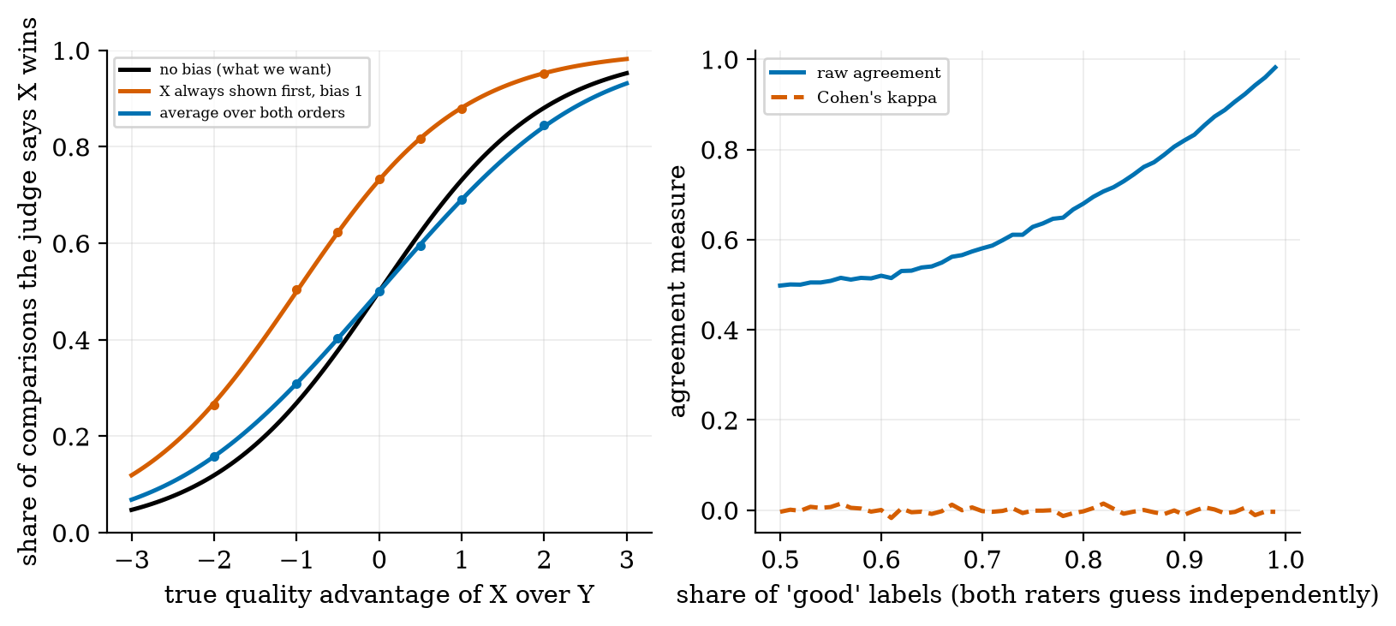
Left: the judge’s win rate for $X$ against the true quality advantage (simulation of Equation (2) with $β=1$, $s=1$): unbiased (black), $X$ always first (red) and averaged over both orders (blue); dots are Monte-Carlo estimates. Right: raw agreement (blue) and Cohen’s kappa (red) between two raters who guess “good” independently with the same probability.

3.3.2 Agreement, and why kappa
To trust a judge, compare it with humans on a labelled sample. Raw agreement (the share of identical labels) misleads when one label dominates. Cohen’s kappa corrects for the agreement expected by chance: $κ=(p_{o}−p_{e})/(1−p_{e})$, where $p_{o}$ is the observed agreement and pe=ℓ​PA(ℓ)PB(ℓ) is the chance agreement from each rater’s label frequencies. Worked example: $A=(1,1,0,0)$, $B=(1,0,0,0)$: $p_{o}=0.75$; $P_{A}(1)=0.5$, $P_{B}(1)=0.25$, so $p_{e}=0.5⋅0.25+0.5⋅0.75=0.5$ and $κ=0.25/0.5=0.5$. Figure 2 (right) shows why it matters: two raters who each say “good” 90% of the time independently (no information at all) agree ${0.9}^{2}+{0.1}^{2}=0.82$ of the time (measured $0.82$), yet their kappa is $−0.01≈0$.

3.3.3 Hallucination and groundedness
A hallucination is content that is not supported by the sources or by reality. For RAG (Unit 5) a practical check is groundedness: is each sentence of the answer supported by the retrieved text? A crude lexical test: the support score is the share of the sentence’s content words that occur in the context. It misses a dangerous case: the same wording with a changed number (“24 layers” for “12 layers”), so I add a number check (every number in the sentence must occur in the context).
I tested both on the course corpus. For each of the 30 questions the reference is the corpus sentence containing the answer and the context is the chunk containing it; the unsupported answers are (a) a random sentence from elsewhere in the course, and (b) the reference sentence with its numbers changed (28 of the 30 contain a number).
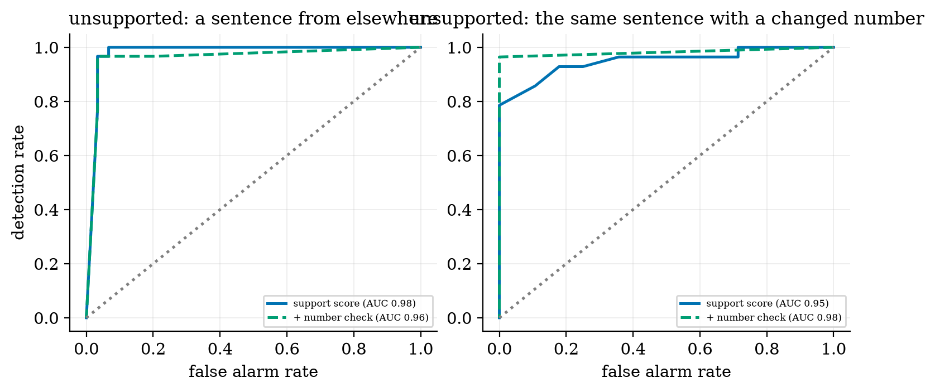
Detection of unsupported answers: ROC curves of the lexical support score (blue) and the support score with a number check (green). Left: unsupported sentence from elsewhere (AUC 0.978 and 0.961). Right: the same sentence with changed numbers (AUC 0.952 and 0.982).
Results: the mean support score is $0.959$ for supported sentences, $0.151$ for sentences from elsewhere and $0.743$ for number-altered sentences. A random unsupported sentence is easy to catch (AUC $0.978$). A number-altered sentence is harder with words alone ($0.952$), and the number check raises it to $0.982$. The number check lowered the first case slightly ($0.961$ against $0.978$), because a correct sentence that runs beyond its chunk can contain numbers the chunk does not: a check can add false alarms. And all this only tests lexical support; a sentence can use the right words and still say something the source does not (the negation of Figure 1), which needs a judge or a person.

3.3.4 An honest evaluation set
Four rules from earlier units apply directly. Size: with $n$ items a success rate has a Wilson interval (Unit 8); 21 successes in 30 give $[0.52,0.83]$. Paired comparison: compare two systems on the same items with a paired bootstrap (Unit 4). Fixed before tuning: the test set must not guide design (the winner’s curse of Unit 4). No contamination: reference answers must not be in the model’s training data; for LLMs this is often impossible to verify, so prefer questions written after the model’s training date or private ones.

3.4 Tier 4 (hard): fairness, privacy, security, responsibility

3.4.1 Fairness
Consider a classifier that flags people (loan approved, résumé shortlisted) and two groups. Hardt et al. define criteria on error rates. I use an exact model so that the numbers are not noisy: scores are Gaussian, $N(μ_{1},1)$ for true positives and $N(μ_{0},1)$ for true negatives, and the classifier flags a person if the score exceeds a threshold. Then for a group with base rate $π$,
$$\begin{aligned}TPR&=1−Φ(θ−μ_{1}),&FPR&=1−Φ(θ−μ_{0}), \\ \text{selection}&=π TPR+(1−π) FPR,&\text{accuracy}&=π TPR+(1−π)(1−FPR).\end{aligned} (3)$$
Group A (900 people, base rate $0.5$, positives and negatives two units apart) and group B (100 people, base rate $0.2$, noisier signal: $1.2$ apart), with one shared threshold $θ=0$:
exact metrics. The overall accuracy of the shared-threshold classifier is $0.830$ and looks fine; the gaps are demographic parity $0.135$ and equal opportunity $0.116$. Lowering group B’s threshold to $−0.40$ equalises the true positive rates (gap $0.000$) and nearly the selection rates ($0.005$), but then group B’s false positive rate is $0.421$ against $0.159$ (the equalized-odds gap becomes $0.262$) and its precision falls from $0.398$ to $0.333$.
 | accuracy | true positive rate | false positive rate | selection rate | precision
group A | 0.841 | 0.841 | 0.159 | 0.500 | 0.841
group B, shared threshold | 0.726 | 0.726 | 0.274 | 0.365 | 0.398
group B, own threshold $−0.40$ | 0.632 | 0.841 | 0.421 | 0.505 | 0.333
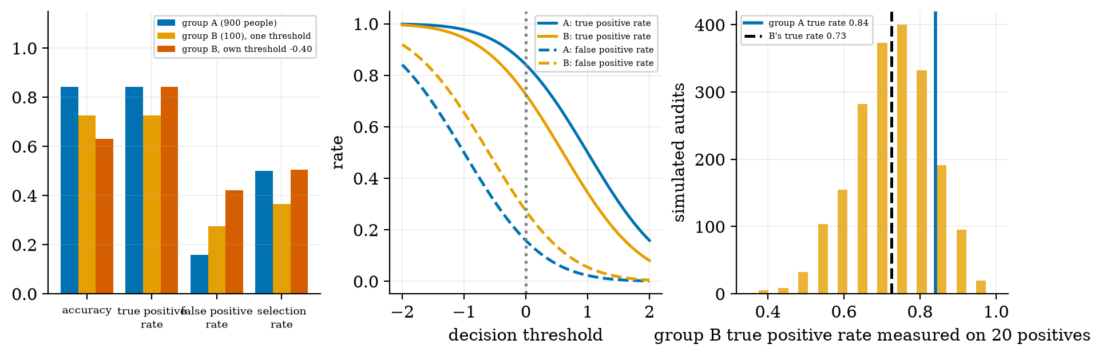
Left: accuracy, true positive rate, false positive rate and selection rate for group A (blue), group B with the shared threshold (orange) and group B with its own threshold (red). Middle: true and false positive rates of both groups against the threshold. Right: how a group B audit with only 20 positives could scatter: simulated estimates of group B’s true positive rate (true value 0.726) with their 95% range of $[0.55,0.90]$.
Three lessons. (1) Overall accuracy hides group gaps. (2) You generally cannot equalise everything: when the base rates differ and the classifier is imperfect, making true positive rates equal leaves false positive rates (or selection rates) unequal (Hardt et al. discuss what can be achieved by adjusting thresholds); which criterion to prefer is a value judgement, not a calculation. (3) Small groups give uncertain audits: group B has 100 people and only 20 true positives; a measured true positive rate of $0.726$ has a Wilson interval of $[0.53,0.89]$, wide enough to hide the whole gap, as the simulated audits (right panel) show. Report intervals per group, and collect more data on small groups before concluding that they are treated equally.
For language models, bias appears as stereotyped completions, uneven quality across languages and dialects, and unequal refusal rates; the same method applies: define a measurable criterion, split by group, report intervals.

3.4.2 Privacy
Memorisation. Unit 1 measured it on the character model: at memory order 6, 60% of the generated 12-character windows occurred verbatim in the training text. Carlini et al. (2020) showed the same risk for GPT-2: an adversary could recover “hundreds of verbatim text sequences” by querying the model. Private text in training data can come back out.
PII detection. A first defence is to find and remove personally identifiable information. The module’s regex detector looks for e-mail addresses, phone numbers and US-style social security numbers. On 20 synthetic snippets (not a benchmark) the results were: e-mail recall $1.0$, precision $1.0$; social security numbers $1.0$ and $1.0$; phone numbers recall $0.6$ (it missed an international number “+44 20 7946 0958” and the dotted form “555.123.4567”), precision $1.0$; and 0 of 5 names and addresses were found. It raised no false alarm on five look-alike strings (versions, invoice numbers, “pi is 3.14159”). Lesson: patterns catch what has a fixed format and miss names, addresses and free-form details; real systems add learned detectors and human review, and still miss some.
Differential privacy. Releasing a count with Laplace noise of scale $b=Δ/ε$ is $ε$-private because for two neighbouring true counts $a$ and $a^{′}$ with $|a−a^{′}|≤Δ$ the density ratio of any output $x$ is
$$\frac{p(x∣a)}{p(x∣a^{′})}=exp​\left(\frac{|x−a^{′}|−|x−a|}{b}\right)≤exp​\left(\frac{|a−a^{′}|}{b}\right)≤e^{ε}, (4)$$
using the triangle inequality $|x−a^{′}|−|x−a|≤|a−a^{′}|$. An observer therefore learns almost nothing about whether any one person is in the data. The price is accuracy: the expected absolute error of the noise is exactly $b=Δ/ε$. Measured on 200,000 draws for a true count of 1000: mean absolute error $10.0$ at $ε=0.1$, $1.00$ at $ε=1$ and $0.20$ at $ε=5$ (theory $10$, $1$, $0.2$). The tests check both the error and that the density ratio never exceeds $e^{ε}$.
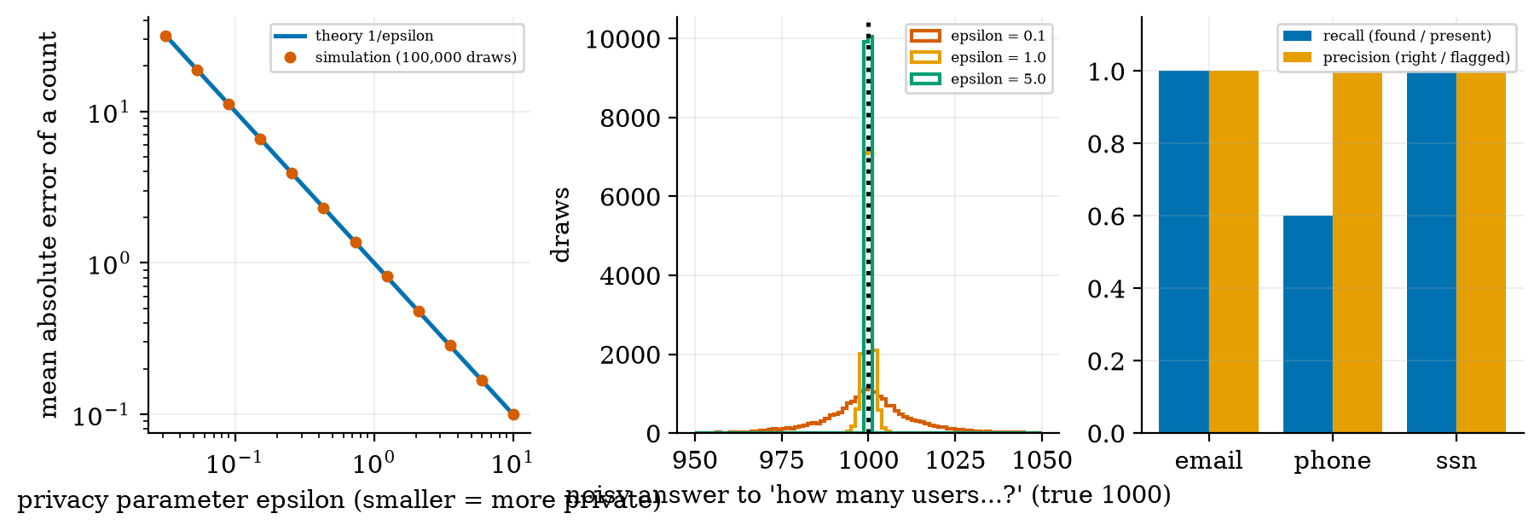
Left: mean absolute error of a Laplace-noised count against the privacy parameter $ε$: theory $1/ε$ (blue) and simulation (red dots). Middle: histograms of noisy answers for a true count of 1000 at $ε=0.1,1,5$. Right: recall and precision of the regex PII detector by type on 20 synthetic snippets.

3.4.3 Security, copyright, misinformation, and responsible practice
Security. Prompt injection and agent attacks were measured in Unit 8; the principle (enforce rules in code outside the model, least privilege, approval for sensitive actions) is the core security practice. Red teaming, deliberate attempts to make the system fail with attack phrasings the designers did not anticipate, is how defences are tested; the harness of Unit 8 is the smallest version of it. Copyright: memorisation is also the mechanism by which a model can reproduce copyrighted text (Unit 1); measure verbatim overlap with a source, as in that unit. Misinformation: fluent text can be false; groundedness checks, citations and human review reduce the risk but do not remove it.
Responsible AI practice is a set of habits more than a theory: state the intended use and out-of-scope uses; document the data and the model (a “model card” lists the training data, metrics by group, limits and known failures); measure harms with the methods above before deployment; keep a human in the loop for consequential decisions; provide a way to contest outcomes; log, monitor and have an incident process; and re-evaluate when the model, data or users change.

3.5 Tier 5 (hardest): open questions
- Can a model judge be trusted? Strong judges agree with humans about as much as humans agree with each other (Zheng et al.), but biases (position, length, self-preference) mean that a judge’s score must be validated against human labels on your task, and re-validated when the judge changes.
- Which fairness criterion is right? The criteria conflict (Section 3.4.1); the choice depends on the harm, the law and the people affected.
- How private is “private enough”? Smaller $ε$ means more privacy and less accuracy; there is no universal choice, and applying differential privacy to training a large model is much harder than to a count.
- Contamination. For models trained on web-scale text it is usually impossible to be sure a benchmark was not seen; the field lacks a reliable fix.

4. Apply

4.1 Worked problems
Problem 1 (BLEU). Candidate “the cat” against reference “the cat sat on the mat”, $N=2$: $p_{1}=p_{2}=1$, $BP=e^{1−6/2}$, BLEU-2 $=0.1353$.
Problem 2 (ROUGE-L). Reference “the cat sat on the mat”, candidate “the cat sit on mat”: LCS 4, precision $0.8$, recall $0.667$, F1 $0.727$.
Problem 3 (kappa). $A=(1,1,0,0)$, $B=(1,0,0,0)$: $p_{o}=0.75$, $p_{e}=0.5$, $κ=0.5$.
Problem 4 (judge). $Δ=0$, $β=1$, $s=1$: $X$ shown first wins $σ(1)=0.731$; averaged over both orders $0.5$.
Problem 5 (Laplace). A count of 250 is released with $ε=0.5$ and $Δ=1$: the noise scale is $2$ and the expected absolute error is $2$ (a typical answer lies within about $250±4$).
Problem 6 (small group). 14 successes of 20 positives: rate $0.70$; Wilson interval $[0.48,0.86]$.

4.2 Code and figures: evaluate a RAG application
Everything is in codes/evaluation/evaluation_np/ (see its README). The practical of this unit, “evaluate a RAG/LLM application using a defined evaluation data set and metrics”, is done here on the course’s own RAG system (Unit 5): 30 questions, each with a reference sentence taken from the corpus, answered by the extractive generator from the top 3 retrieved chunks. The metrics: whether the answer chunk was retrieved; whether the answer sentence contains the gold phrase; token F1 and ROUGE-L against the reference sentence; groundedness of the answer; and, for abstention, the answer rate on answerable, near-miss and off-topic questions.
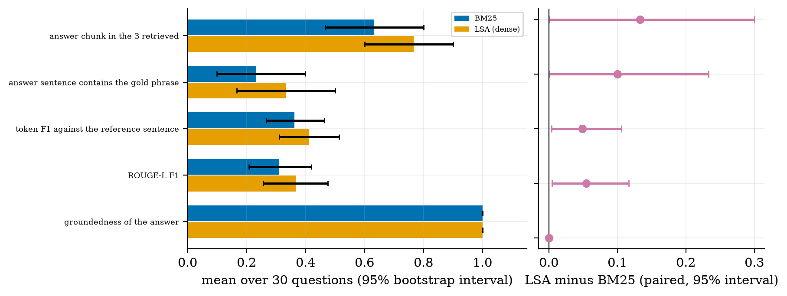
The evaluation report. Left: mean of each metric over the 30 questions for BM25 (blue) and the LSA dense retriever (orange) with 95% bootstrap intervals. Right: the paired difference LSA minus BM25 on the same questions with its 95% interval.
the report. Groundedness is 1.000 for both because an extractive answerer can only quote its context; it would not be 1 for a language model. Wilson intervals for BM25: “answer chunk retrieved” $0.633$ (19 of 30) has $[0.455,0.781]$ and “contains the gold phrase” $0.233$ has $[0.118,0.409]$.
metric (30 questions) | BM25 | LSA | LSA minus BM25 (paired 95% interval)
answer chunk among the 3 retrieved | 0.633 | 0.767 | $+0.133 [0.000, +0.300]$
answer sentence contains the gold phrase | 0.233 | 0.333 | $+0.100 [0.000, +0.233]$
token F1 against the reference sentence | 0.363 | 0.412 | $+0.049 [+0.004, +0.106]$
ROUGE-L F1 | 0.311 | 0.366 | $+0.055 [+0.005, +0.117]$
groundedness of the answer | 1.000 | 1.000 | $0.000$
How to read the report. The retriever comparison is borderline: the intervals for the two overlap-based answer metrics (token F1, ROUGE-L) exclude 0 by a small margin, those for retrieval and for containing the gold phrase touch 0, and the metrics themselves are crude (an answer sentence that is correct but worded differently scores low, Figure 1). With 30 questions I would not claim that the dense retriever is better; I would say the evidence leans that way and collect more questions. At the abstention threshold of Unit 5 (coverage $≥0.5$) the system answered 0.833 of answerable questions, 0.4 of the near-miss unanswerable ones and 0.0 of the off-topic ones: the 0.4 is the safety problem, not the accuracy.
For a real model, the notebook u9_evaluate_rag_real_model.ipynb generates answers with a small chat model, scores them with the same overlap metrics, asks the model itself to judge groundedness in both orders (Section 3.3.1) and compares with your own labels on 20 answers using kappa. It was not executed while writing this document.
Try it in the playground
The Metric lab scores any reference and candidate with BLEU, ROUGE, F1 and exact match (try “Negation” and “Paraphrase”). The Fairness explorer computes the exact group metrics of Equation (3) for your base rates, signal quality and thresholds.

5. Analyze
Checklist items used: limits (5.1), dominance (5.2), sensitivity (5.3), failure modes (5.4), uncertainty (5.5).

5.1 Limits
- Identical texts: every overlap metric is 1; no shared words: all are 0.
- A candidate of length 1: BLEU with $N≥2$ is 0 unless smoothed.
- Perfect classifier ($μ_{1}−μ_{0}→∞$): TPR $→1$, FPR $→0$ for every threshold in between: all fairness gaps vanish.
- $ε→∞$: no noise, no privacy; $ε→0$: pure noise.

5.2 Which term dominates
For short answers the brevity penalty and the missing higher-order $n$-grams dominate BLEU; for fairness audits the smallest group’s sample size dominates the uncertainty; for privacy the noise scale $1/ε$ dominates the error.

5.3 Sensitivity
Judge results are sensitive to the bias $β$ and to whether orders are swapped (Section 3.3.1); fairness gaps to the threshold and to the signal quality of the worse-served group; PII recall to the formats covered by the patterns.

5.4 Failure modes
- Metrics rewarding wording over meaning (Figure 1).
- Judge bias and raw agreement mistaken for reliability (Figure 2).
- Altered facts that pass lexical checks (Figure 3).
- Aggregate accuracy hiding group harm, and small-group audits too noisy to see it (Figure 4).
- Patterns missing free-form PII (Figure 5).
- Evaluation sets too small to separate systems (Figure 6).
- Contamination and tuning on the test set.

5.5 Uncertainty
The fairness model is idealised (Gaussian scores). The PII test has 20 snippets. The groundedness test uses 30 questions and one corpus. The judge results are a simulation of a stated model, not measurements of any real judge. The RAG report has 30 questions, so differences below about 0.1 are within noise.

6. Evaluate
Choosing methods. Automatic overlap metrics: cheap, repeatable, shallow. Model judges: cheap and closer to meaning, but biased and in need of validation. Human review: the standard, slow and costly; use it on a sample to validate the other two. Use all three, with intervals.
Fairness and privacy are trade-offs, not boxes to tick. Each criterion or privacy level costs something elsewhere; document the choice and the reason.
When not to trust an evaluation. A single metric; a benchmark the model may have seen; fewer than a few hundred items for small effects; an audit with a tiny group; a “safe” verdict from the same model that wrote the answer.
Wider context. Evaluation is where engineering meets ethics: what you choose to measure, and for whom, decides what the system will be good at. Responsible practice means measuring harms before deployment, publishing limits, and keeping people accountable.

7. Create
What you can build from this
- Metric audit: collect 20 pairs of answers (including paraphrases and negations) and compute BLEU, ROUGE and an embedding similarity; list where each fails.
- Judge validation: label 30 answer pairs yourself, run a judge in both orders, and report agreement and kappa with an interval.
- Groundedness checker v2: add a check that every named entity in the answer occurs in the sources, and measure on number-altered and entity-altered sentences.
- Fairness audit: pick a classifier you have trained, split by a group attribute, and report the three gaps with intervals and the smallest group’s size.
- Privacy budget: release five different counts with Laplace noise and compute the total $ε$ spent (it adds up, by composition).
- Evaluation report for your own RAG: reproduce Figure 6 on your documents and questions.

8. Visualization lesson
charts taught here. How to read the right panel of Figure 6: a whisker that crosses the vertical line at 0 means the difference is not established.
Chart type | Best for | How it misleads | matplotlib call
annotated heatmap (metrics by candidate) | many metrics on few examples (Fig. 1) | colour hides small differences: print the numbers | ax.imshow(M); ax.text(j, i, f"{M[i,j]:.2f}")
formula curve with simulation dots | verifying a model of bias (Fig. 2) | too few draws look like a different curve | ax.plot(d, f(d)); ax.plot(dd, sim, "o")
ROC curve per detector | a score that separates two groups (Fig. 3) | AUC depends on how hard the negatives are | ax.plot(fpr, tpr)
grouped bars by group and policy | fairness outcomes (Fig. 4) | bars hide sample sizes: add the group sizes | ax.bar(x + (i-1)*w, vals, w)
theory-versus-simulation on log axes | noise scaling laws (Fig. 5) | log axes hide constant factors | ax.loglog(eps, 1/eps)
bars with interval whiskers and a paired-difference panel | honest comparison (Fig. 6) | intervals from 30 items are wide | ax.barh(y, m, xerr=...); ax.errorbar(d, y, xerr=...)

9. Problem set
Graded exercises
- (easy) Compute ROUGE-1 precision, recall and F1 for reference “a b c d” and candidate “a b x”.
- (medium) Compute BLEU-2 for candidate “the cat sat” against reference “the cat sat on the mat” (include the brevity penalty).
- (medium-hard) With $β=1.5$, $s=1$, $Δ=0.5$ compute the win probability of $X$ when shown first and the swapped average, and compare with the unbiased $σ(Δ/s)$.
- (hard) Two raters label 100 items. Both say “positive” 95 times; they agree on 91 items. Compute $p_{o}$, $p_{e}$ and $κ$.
- (hardest) Show that the Laplace mechanism with scale $Δ/ε$ satisfies Equation (4), and compute the noise scale needed for $ε=0.2$ and $Δ=1$. Then explain why releasing 10 such counts about the same person costs a total privacy loss of up to $10ε$.

10. Retrieval practice and recap
Answers to the Section 2 quiz.
- $e^{−2}=0.1353$ (modified precisions 1 and 1, brevity penalty $e^{1−6/2}$).
- If both guess “good” 90% of the time independently, they agree 82% of the time by chance alone; kappa subtracts that chance agreement and is about 0.
- The false positive rates (or the selection rates): equalising true positive rates leaves them unequal when base rates differ and the classifier is imperfect (Section 3.4.1).
- About 1.0 (the noise scale is $Δ/ε=1$).
- It finds fixed formats only: it missed international and dotted phone formats and found no names or addresses.
Explain it to a friend.
- Why can an answer that means the opposite get a high ROUGE score?
- Why does swapping the order of two answers make an AI judge fairer?
- Why can a model with 83% overall accuracy still treat one group much worse?
Re-derive tomorrow without looking: (a) BLEU-2 of “the cat” against “the cat sat on the mat”; (b) kappa from $p_{o}$ and $p_{e}$; (c) the Laplace density-ratio bound (4).

11. Where next
- Next: Unit 10 (deployment and industry applications), which turns to cost, latency, memory and the operations needed to run these systems, including monitoring the metrics of this unit in production.
- Terms met but not taught: BERTScore, human-evaluation protocols, regulation, text watermarking.
- Open threads: how a real model judge behaves on the course’s questions (the Colab notebook); which fairness criterion fits a given application (Section 3.5).

