LLM Deployment and Industry Applications: Memory, Latency, Cost and Operations
  - Unit 10 of the Generative AI and LLM crash course
GenAI crash course
2026-10-09
Table of Contents

Session map
Outcome of this session
After this session you can:
- compute a model’s parameter count, weight memory and KV-cache memory from its configuration file, and check the result against an independent source;
- explain why decoding is memory-bound and prefill compute-bound, find the batch size where the limit changes, and say what quantization and grouped-query attention buy;
- compare static and continuous batching and read latency percentiles and throughput;
- estimate cost per token, the break-even between a rented GPU and a pay-per-token service, and the effect of a model cascade;
- deploy an LLM/RAG application as a web service with validation and monitoring, measure it, and describe the LLMOps and industry issues around it.
- Prerequisites: Unit 2 (the Transformer block, attention and the quadratic cost, $12d^{2}$ parameters per block), Unit 3 (next-token decoding, the context window), Unit 4 (cost of conversation history), Unit 5 (the RAG system), Unit 6 (quantization and its memory arithmetic), Unit 9 (evaluation and drift of metrics).
- Difficulty ladder used: easy → medium → medium-hard → hard (Sections 3.1 to 3.4); the hardest tier is posed as open questions in Section 3.5.
- Deliverables: this document (.tex, .pdf, .docx), 6 figures, the module codes/serving/serving_np/ (parameter and KV-cache arithmetic from a real model configuration, a roofline latency model, a batching simulation, cost formulas, drift monitoring, a FastAPI RAG web service and a benchmark that starts it; 9 tests), the LLM serving calculator and Serving simulator widgets, and a Colab notebook for serving a real model.
- Source anchors: the configuration of Qwen/Qwen2.5-0.5B-Instruct and the parameter count the hub reports for it (494,032,768), both fetched from the Hugging Face hub on the day of writing and stored in the module; Kwon et al. 2023, arXiv:2309.06180 (PagedAttention and vLLM: “the key-value cache (KV cache) memory for each request is huge and grows and shrinks dynamically”, wasted by “fragmentation and redundant duplication, limiting the batch size”; vLLM “improves the throughput of popular LLMs by 2-4× with the same level of latency” over the systems they compare with); Vaswani et al. 2017, arXiv:1706.03762 (Unit 2). The arXiv ID and the quoted statements were checked in the PDF.
- What is measured here, and what is not. The counts (parameters, memory, KV cache) are exact arithmetic from a real configuration and are verified against the hub. The web-service latency and throughput are real measurements, but of a toy retrieval service on this machine’s CPU, and are machine-specific. The GPU speed, batching and cost results use a stated model (a roofline model with illustrative hardware numbers, a queue simulation, and illustrative prices); they show how the quantities relate, not the performance or price of any product. No language model was served on the machine that built this course; the notebook that serves one is not executed.

1. Terms: the term tree
Term | Symbol | One-line meaning | Where it appears | New / known
inference, serving |  | running a trained model to answer requests | 3.1 | new
prefill and decode |  | process the prompt at once / generate one token at a time | 3.1 | new
KV cache |  | stored keys and values of all earlier tokens | 3.2 | new
grouped-query attention (GQA) | $n_{kv}$ | several query heads share one key-value head | 3.2 | new
memory-bound, compute-bound |  | limited by reading memory / by arithmetic | 3.3 | new
roofline model |  | time = larger of memory time and compute time | 3.3 | new
batching (static, continuous) | $B$ | decode several requests together; fixed batch vs slots that refill | 3.3 | new
latency, throughput, p95 |  | time per request; tokens per second; the value 95% of requests beat | 3.3 | new
service-level objective (SLO) |  | a target such as “p95 below 2 s” | 3.3 | new
model cascade, routing |  | try a small model first, escalate hard cases | 3.4 | new
LLMOps, drift (PSI) |  | operating LLM systems; detecting a shift in inputs | 3.4 | new
quantization |  | store weights in fewer bits | 3.2 | known
context window, tokens |  | the text the model reads at once | 3.2 | known
Terms used but not taught here: tensor and pipeline parallelism, speculative decoding, prefix caching, specific serving frameworks other than naming vLLM, container orchestration.

2. Remember
Two phases of inference
Prefill processes the whole prompt in one parallel pass and builds the KV cache: the keys and values of every prompt token, so that later tokens need not recompute them. Decode then generates tokens one at a time; each step reads all the weights and the whole KV cache, adds one token’s keys and values, and outputs one token.
Memory counts
Weights take (parameters $×$ bytes per parameter). The KV cache takes, per token,
$$\text{KV bytes per token}=2×L×n_{kv}×d_{h}×b, (1)$$
where $2$ is for keys and values, $L$ the number of layers, $n_{kv}$ the number of key-value heads, $d_{h}$ the head width and $b$ the bytes per number.
Latency, throughput, percentiles, SLO
Latency is the time one request takes; throughput is the work done per second (requests or tokens). The 95th percentile (p95) is the latency that 95% of requests are below; averages hide the slow tail that users notice. A service-level objective states a target such as “p95 under 2 seconds”.
Memory hooks.
- Decoding is reading, not thinking: every token requires reading the whole model from memory.
- The cache is the hidden bill: weights are paid once, the KV cache is paid by every user and every token.
- Batching is a bus: one trip of the weights can carry many passengers.
- Measure the tail, not the average.
Recall quiz (answers in Section 10).
- What are the two phases of inference, and which one limits the speed at which a chat reply appears word by word?
- How many bytes of KV cache does one token need for a model with 24 layers, 2 KV heads, head width 64, in 16-bit numbers?
- Why does batching raise throughput almost for free at small batch sizes?
- What does the 95th-percentile latency tell you that the average does not?
- What was the first thing you check when a measured parameter count disagrees with a published one?

3. Understand: the derivation

3.1 Tier 1 (easy): what deployment is about, and a real model
Training a model is done once; serving it happens for every user, all day, and it is where most of the money and most of the failures are. Three resources decide whether a deployment works: memory (does it fit, and how many users?), time (how long does a reply take?) and money (what does a million tokens cost?). A fourth, operations, keeps it working: monitoring, updating, and handling the unexpected.
To make this concrete I use one real model: Qwen/Qwen2.5-0.5B-Instruct, whose config.json I fetched from the Hugging Face hub. Its numbers are: hidden width 896, 24 layers, 14 attention heads of width 64, 2 key-value heads, feed-forward width 4864, vocabulary 151,936, tied input and output embeddings, 16-bit (bfloat16) weights, and a maximum context of 32,768 tokens.
From these alone I can compute how many parameters it has, following the architecture of Unit 2 (with a gated feed-forward layer of three matrices and attention biases on the query, key and value projections, which this model family uses):
the parameter count computed from the configuration (per layer: 14,912,384). The Hugging Face hub reports exactly 494,032,768 parameters for this model: the difference is 0. Checking a computation against an independent source is the habit to keep: if the numbers had disagreed, I would have looked first for a missing bias, an untied embedding or a different feed-forward shape. The size of the weights file agrees too: it is 988,097,824 bytes, which is $2×494,032,768$ (two bytes per 16-bit weight) plus 32,288 bytes of file header.
part | formula | parameters | share
token embedding (tied with the output layer) | $V⋅d=151936⋅896$ | 136,134,656 | 27.6%
attention, 24 layers | $L [ dhd_{h}+hd_{h}+2(d n_{kv}d_{h}+n_{kv}d_{h})+hd_{h}d ]$ | 44,067,840 | 8.9%
feed-forward (MLP), 24 layers | $L⋅3 d d_{ff}$ | 313,786,368 | 63.5%
normalisation weights | $L⋅2d+d$ | 43,904 | 0.0%
total |  | 494,032,768
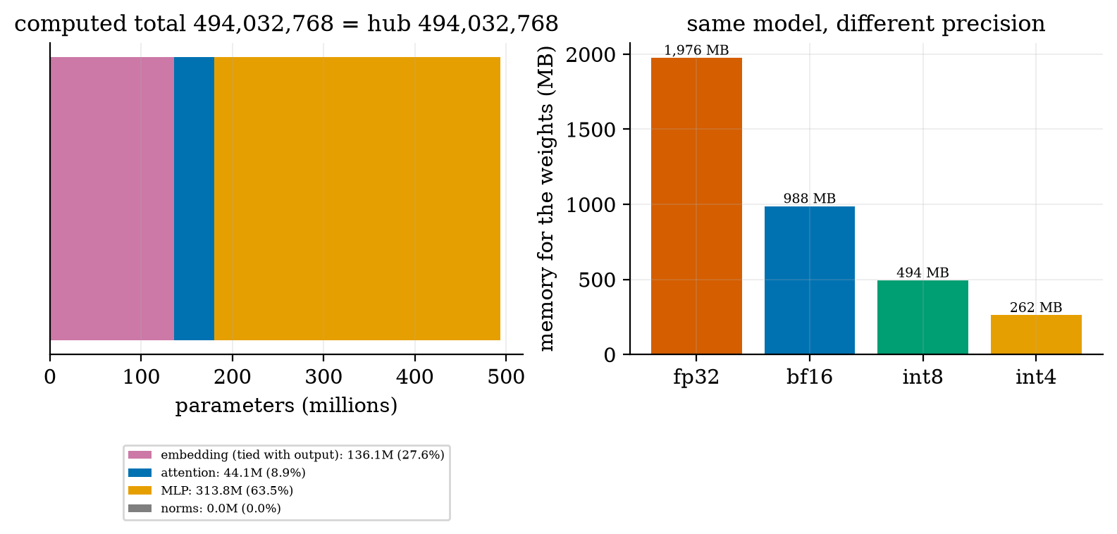
Left: where the 494 million parameters of Qwen2.5-0.5B are (embedding 27.6%, attention 8.9%, MLP 63.5%, norms 0.01%), with the computed total equal to the hub’s. Right: the memory for the weights at 32-bit (1976 MB), 16-bit (988 MB), 8-bit (494 MB) and 4-bit with one 16-bit scale per 64 weights (262.5 MB, $0.53125$ bytes per weight, Unit 6).
Notice that for this small model the embedding table is over a quarter of everything (the vocabulary is large); for large models the feed-forward layers dominate even more (the $12Ld^{2}$ of Unit 3).

3.2 Tier 2 (medium): the KV cache and grouped-query attention
At each decode step, the new token attends to all earlier tokens (Unit 2). Recomputing their keys and values every time would cost the whole prompt again, so they are cached. Per token, (1) gives for this model $2⋅24⋅2⋅64⋅2=12,288$ bytes ($12$ KiB). Multiply by the context length and the number of users to get the cache.
Grouped-query attention. The model has 14 query heads but only 2 key-value heads: several query heads share one key-value head. If it had one key-value head per query head (standard multi-head attention) the cache per token would be $2⋅24⋅14⋅64⋅2=86,016$ bytes: 7 times larger. A single sequence of the full 32,768 tokens needs $402.7$ MB of cache with grouped-query attention, against $2.82$ GB without it.
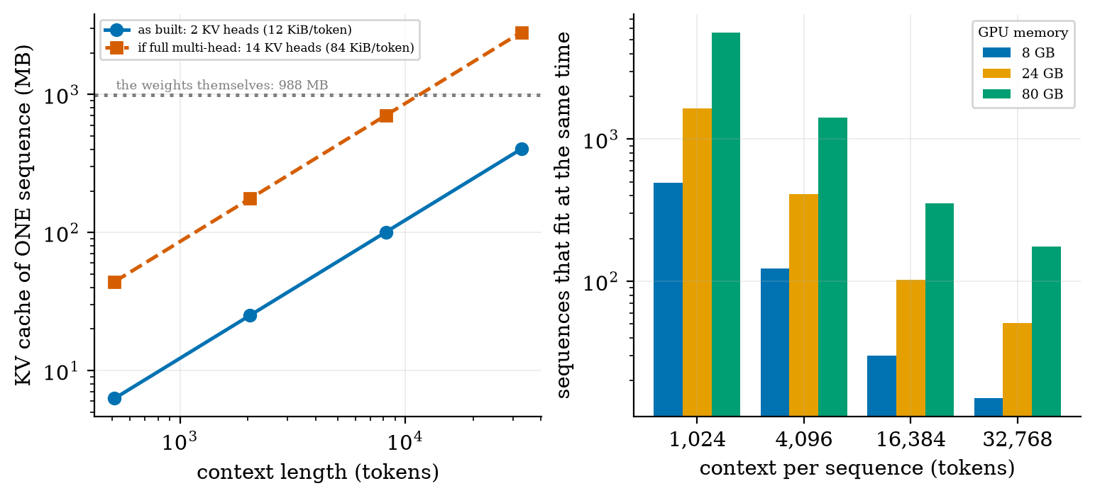
Left: KV cache of one sequence against its context length (log-log), as built (2 KV heads, 12 KiB per token, blue) and if it had one KV head per query head (14 heads, 84 KiB per token, red). The dotted line is the 988 MB of the weights: the full multi-head cache would exceed it after about 11,500 tokens, the grouped-query cache only after about 80,000 tokens ($988×{10}^{6}/12288$), beyond this model’s limit of 32,768. Right: how many sequences fit in 8, 24 and 80 GB of GPU memory (after the weights and a 10% overhead) at several context lengths.
How many users fit? With 16-bit weights and 10% of memory kept as overhead, an 8 GB GPU holds 493 sequences of 1024 tokens, 123 of 4096, 30 of 16,384 and 15 of 32,768 (without grouped-query attention: 70, 17, 4 and 2). On 24 GB: 1638, 409, 102 and 51; on 80 GB: 5643, 1410, 352 and 176. Memory, not arithmetic, usually limits how many users a GPU can serve, and the cache grows with every user and every token. Kwon et al. (2023) state the problem plainly: the KV cache memory “for each request is huge and grows and shrinks dynamically”, wasted by “fragmentation and redundant duplication, limiting the batch size”; their PagedAttention stores the cache in fixed-size blocks like virtual-memory pages, and vLLM “improves the throughput of popular LLMs by 2-4× with the same level of latency” compared with the systems they evaluated.

3.3 Tier 3 (medium-hard): speed, batching, percentiles

3.3.1 Decoding is memory-bound: the roofline model
One decode step must (a) read every weight and every cached key and value from memory, and (b) compute about $2N$ floating-point operations per sequence for $N$ parameters (one multiply and one add per weight). The step takes at least the longer of the two:
$$t_{\text{step}}(B)=max\left(\underset{\text{memory time}}{\underset{⏟}{\frac{W+B K}{BW}}}, \underset{\text{compute time}}{\underset{⏟}{\frac{B⋅2N}{F}}}\right), (2)$$
for a batch of $B$ sequences, $W$ bytes of weights, $K$ bytes of cache per sequence, memory bandwidth $BW$ (bytes/s) and peak arithmetic rate $F$ (FLOP/s). The memory term contains the weights once, whatever $B$ is: that is why batching is almost free. I evaluate it with illustrative hardware: $BW=1$ TB/s and $F=100$ TFLOP/s (round numbers chosen to show the pattern; they are not a product specification).
For the real model: $W=988$ MB gives a memory time of $0.988$ ms per step, so at $B=1$ about 1000 tokens/s. Compute per token is $2N/F=9.88 μ$s. The cache read per sequence is $1.23 μ$s for a 100-token context and $12.3 μ$s for 1000 tokens. Setting the two terms equal gives the critical batch size
$$B^{*}=\frac{W/BW}{2N/F−K/BW} (\text{infinite if the denominator is}≤0). (3)$$
For a 100-token context $B^{*}=0.988 \text{ms}/(9.88−1.23) μ\text{s}=114$: below it decoding is memory-bound and the throughput grows almost linearly with the batch; above it, compute-bound at the ceiling $F/(2N)=101,208$ tokens/s. For a 1000-token context the cache read per sequence (12.3 $μ$s) is larger than the compute per token (9.9 $μ$s), so $B^{*}=∞$: decoding stays memory-bound at every batch size.
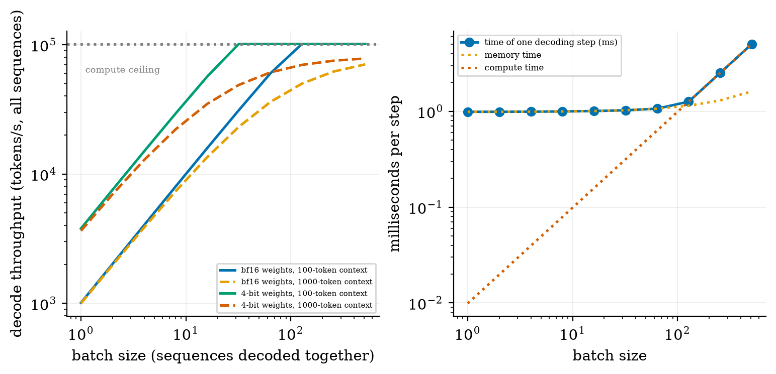
Left: decode throughput (tokens/s summed over the batch) against batch size for the real model on illustrative hardware (1 TB/s, 100 TFLOP/s): 16-bit weights with 100-token contexts (solid blue; 1011, 8017, 31,147, 101,208 tokens/s at batches 1, 8, 32, 128, then the compute ceiling), 16-bit with 1000-token contexts (orange dashed; 1000, 7364, 23,167, 49,982), and 4-bit weights (green and red; 3792 tokens/s at batch 1). Right: the memory time, compute time and their maximum (the step time) against batch size for 100-token contexts.
Four consequences:
- Quantization speeds up decoding, not only shrinks it. With 4-bit weights (262.5 MB) the memory time is $0.263$ ms: $3792$ tokens/s at batch 1, 3.75 times the 16-bit speed (Unit 6’s arithmetic, now seen as speed).
- Prefill is different. It processes many tokens at once, so it is compute-bound: a 1000-token prompt costs about $2N⋅1000/(0.5F)=19.8$ ms at an assumed 50% of peak arithmetic, against $0.99$ ms for one decode step. This is why the time to the first token depends on the prompt length and the speed afterwards on the memory.
- Long contexts hurt twice: they enlarge the cache (Figure 2) and keep decoding memory-bound.
- CPU inference is the same equation with a smaller bandwidth: at an assumed 50 GB/s the 16-bit model needs $988 \text{MB}/50 \text{GB/s}=19.8$ ms per token (about 50 tokens/s) and the 4-bit one $5.2$ ms (about 190 tokens/s): usable for a 0.5B model, hopeless for a 70B one.

3.3.2 Batching policies
If requests are processed one at a time the weights are re-read for each token. Static batching gathers up to $B_{max}$ requests, runs them together until the longest finishes, then starts the next batch: short requests wait for long ones, and the GPU idles on finished slots. Continuous batching (iteration-level scheduling, used by systems such as vLLM) removes a finished request at once and lets a waiting one take its slot at the next step.
I simulated one replica of the real model: requests arrive as a Poisson process, each needs a random number of output tokens (geometric, mean 60), the step time is (2) with the real model’s numbers (0.994 ms at batch 1, 1.037 at batch 8, 1.185 at batch 32), the largest batch is 32, and a static batch waits at most 50 ms to fill. (Prefill and KV memory limits are not simulated.)
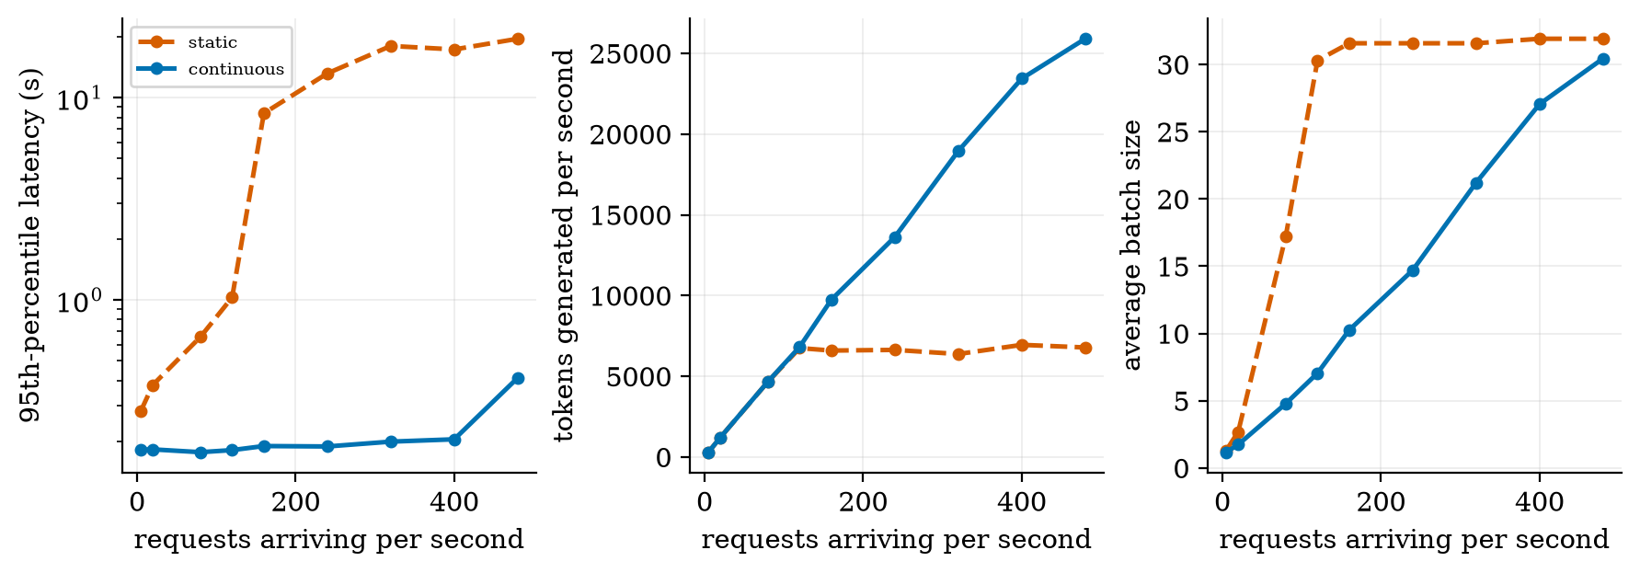
Simulation of static (red dashed) and continuous (blue) batching against the number of requests arriving per second: 95th-percentile latency (left, log scale), tokens generated per second (middle) and average batch size (right).
selected points of the simulation. Static batching reaches its capacity at about 6700 tokens/s (from 120 requests per second on, extra load only lengthens the queue: p95 goes from 1.0 s to 8.4 s at 160 requests per second); continuous batching keeps the p95 near 0.18 to 0.20 s up to 400 requests per second and still produces more tokens as load rises (25,902 tokens/s at 480), because a batch is only as slow as its longest member for static batching. The median (typical) wait is 0.04 s for continuous batching at all loads up to 400 requests/s against 0.11 to 9.5 s for static. These numbers come from a model with illustrative hardware; the direction (continuous batching is far better at high load, equal at low load) agrees with the 2-4 times throughput improvement that Kwon et al. report for their system, which also manages memory better.
requests per second | 5 | 20 | 80 | 120 | 160 | 320 | 480
static: p95 latency (s) | 0.28 | 0.38 | 0.66 | 1.03 | 8.38 | 18.0 | 19.6
continuous: p95 latency (s) | 0.18 | 0.18 | 0.18 | 0.18 | 0.19 | 0.20 | 0.41
static: tokens/s | 300 | 1212 | 4660 | 6747 | 6594 | 6379 | 6785
continuous: tokens/s | 300 | 1212 | 4667 | 6821 | 9744 | 18,952 | 25,902

3.3.3 Latency percentiles and a real service
I deployed the course’s RAG system (Unit 5: BM25 retrieval and an extractive answerer, with the abstention rule of Unit 5) as a web service with FastAPI, and benchmarked it by starting the server in a subprocess. The service has a health check, validates input before doing any work (a question must have 3 to 500 characters and $k$ must be 1 to 8) and logs every request.
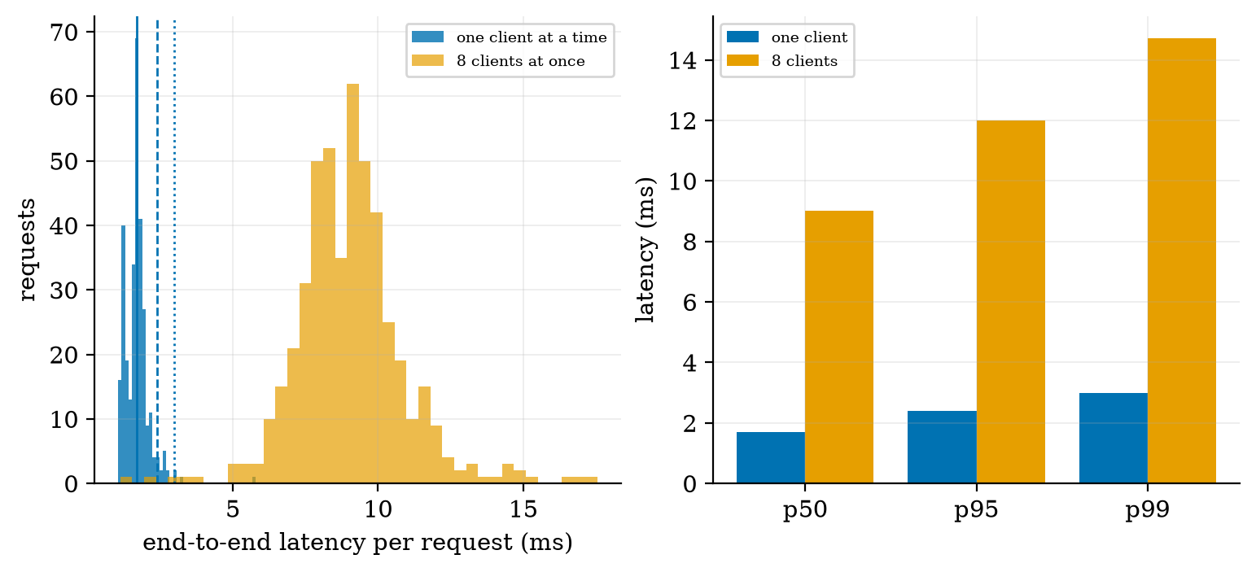
The real RAG web service on this machine’s CPU. Left: histogram of end-to-end latency for 300 sequential requests (blue) and 480 requests from 8 concurrent clients (orange); vertical lines mark the sequential p50, p95 and p99. Right: the percentiles for both cases.
Measured: with one client at a time, p50 $1.70$ ms, p95 $2.39$ ms, p99 $2.99$ ms and 588 requests per second. With 8 clients at once the throughput rose only to 864 requests per second (1.5 times) while the latency rose about 5 times (p50 $9.0$ ms, p95 $12.0$ ms, p99 $14.7$ ms): the single worker process is already busy, so extra clients queue. The three invalid requests (too short, too long, $k=99$) were all rejected with HTTP status 422 before any retrieval. Of the 50 questions cycled (30 answerable, 10 off-topic, 10 near-miss), 70% were answered and the rest abstained. Time spent inside the handler was about $0.4$ to $3$ ms (from the service log) against $1.7$ ms end to end for a typical request: the web layer adds its own overhead, so measure from the client. These numbers belong to this machine and this toy service.
An SLO turns such measurements into a promise: for example “p95 below 5 ms at 500 requests per second”. slo_violations(latencies, 1.0) returns the share of requests above a limit; tracking it over time is the first monitoring metric.

3.4 Tier 4 (hard): cost, operations, industry

3.4.1 Cost per token, rent or pay per token, cascades
With a GPU that costs $c$ dollars per hour and produces $τ$ tokens per second while busy a fraction $u$ of the time, the cost of a million tokens is
$$\text{cost per }{10}^{6}\text{ tokens}=\frac{c}{τ u⋅3600}×{10}^{6}. (4)$$
I use illustrative numbers: $c=\$2$ per hour and the batch-32 decode speed of the model on the illustrative hardware, $τ=27,012$ tokens/s. Then a million tokens cost $0.021 at 100% busy, $0.041 at 50%, $0.103 at 20%: utilisation is the lever, and an idle GPU costs the same as a busy one. Against an illustrative pay-per-token price of $0.50 per million tokens, renting the GPU is cheaper once it is busy more than $4.1\%$ of the time; with a fixed monthly GPU cost of $1460, the break-even volume is $1460/0.50×{10}^{6}=2.92$ billion tokens per month. These numbers ignore prefill, engineering time, redundancy for failures and the hours when traffic is low, so real costs are higher; use them to see the structure (fixed cost against usage), not as a quote.
A model cascade sends every request to a small model and escalates a fraction $p$ to a large one: expected cost $c_{s}+p c_{l}$. If the large model costs 10 times the small one: $p=10\%$ gives $2.0$, $20\%$ gives $3.0$, $50\%$ gives $6.0$ (relative to the small model alone), against $10$ for always using the large one. It pays only if the escalation rule is good (it must detect the hard cases), which has to be measured with the methods of Unit 9. Caching (reusing the answer or the computation for repeated prefixes) and quantization (Section 3.3.1) are the other main cost levers.
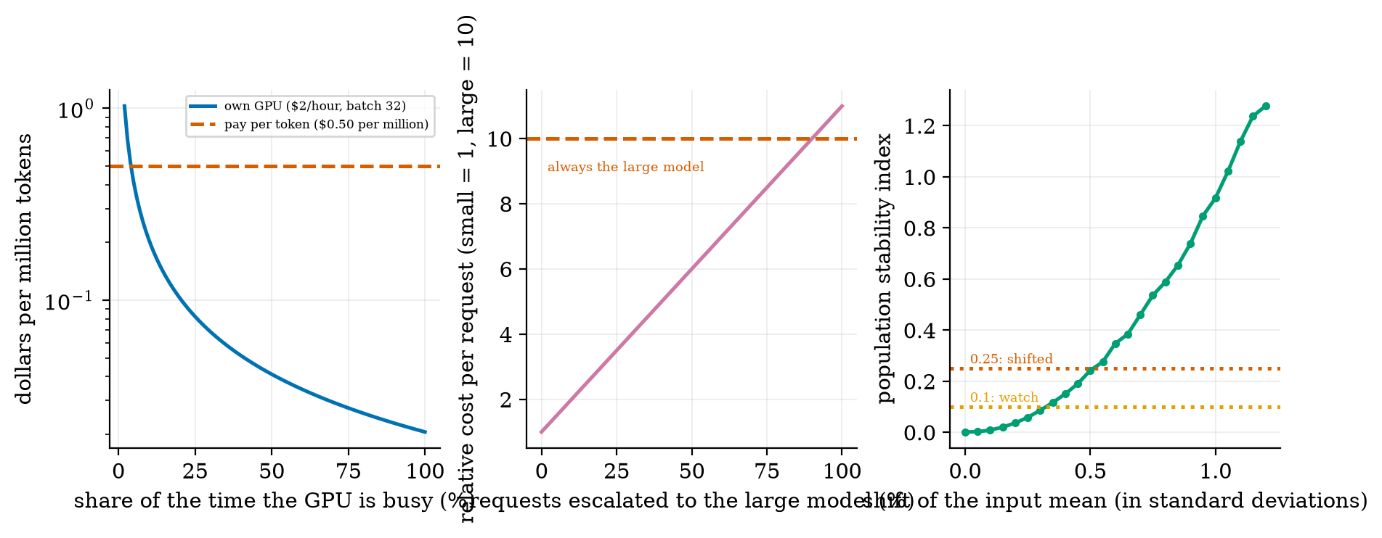
Left: cost per million tokens against the share of time the GPU is busy (illustrative: $2 per hour, batch-32 decoding) and an illustrative $0.50 pay-per-token price. Middle: relative cost of a cascade against the share of requests escalated to a model 10 times more expensive. Right: the population stability index against the shift of the input mean (in standard deviations), with the rule-of-thumb levels 0.1 and 0.25.

3.4.2 LLMOps: monitoring and drift
A deployed system must be watched. Useful signals: latency percentiles and error rates (the SLO); token and cost counters per request; quality signals (Unit 9’s metrics on a sample of real requests, user feedback, abstention rate, groundedness); and input drift: a change in what users ask. The population stability index compares a reference distribution with a new one using bins from the reference quantiles: PSI=i​(ai−ei)ln(ai/ei). On Gaussian data it was $0.001$ for no shift, $0.085$ for a shift of the mean by $0.3$ standard deviations, $0.237$ for $0.5$ and $0.931$ for a full standard deviation. The reading “below 0.1 stable, 0.1 to 0.25 shifting, above 0.25 shifted” is a common rule of thumb, not a law. Other LLMOps practice: versioning of the model, the prompt template, the index and the evaluation set; gated releases (a new version must pass the evaluation of Unit 9 before it serves traffic, then a canary share of users); rollback; and logging with privacy controls (Unit 9: logs may contain personal data).

3.4.3 Scaling and cloud versus local
To serve more traffic: add replicas behind a load balancer (the web service above shows why: one worker saturates), scale them automatically with the queue length, and use batching inside each replica. Cloud services need no hardware and scale instantly but cost per token, send data off-site and depend on the vendor. Local or private deployment keeps data in-house and gives control, at the price of hardware, operations skills and low utilisation at night (the cost lesson above). Models small enough to run on a laptop (the 0.5B model needs 0.99 GB, or 0.26 GB at 4 bits) make a local option real for many tasks. The choice is about data sensitivity, volume, latency needs and skills, not only price.

3.4.4 Industry applications
where the earlier units apply. I list risks and controls, not statistics: the benefits and failure rates depend on the model and the task and are not measured here. In every row the pattern is the one of this course: retrieve evidence (Unit 5), keep the model’s actions limited and validated (Unit 8), evaluate on your own data with intervals (Unit 9), and keep a person accountable.
field | typical use | main risk | what to measure and control
healthcare | summarising notes, drafting letters, literature search | wrong or invented clinical facts; privacy | groundedness against the record, human sign-off, privacy controls, no autonomous advice
finance | document analysis, report drafting, customer questions | wrong numbers; regulation; leakage | number checks (Unit 9), audit logs, approval for actions, access control
education | tutoring, practice questions, feedback | wrong explanations; over-reliance; fairness across students | accuracy on a reference set, per-group quality, teacher oversight
software engineering | code completion, review, test generation | insecure or wrong code; leaking secrets | tests that run, security review, no secrets in prompts
customer support | answering from a knowledge base, routing tickets | hallucinated policy; tone; escalation failures | groundedness, abstention and escalation rate, satisfaction, SLOs
legal and knowledge systems | search over contracts and case law, drafting | invented citations; confidentiality | citations that resolve, retrieval recall (Unit 5), confidentiality, lawyer review

3.5 Tier 5 (hardest): open questions
- How should capacity be planned for unpredictable demand? Traffic is bursty; headroom costs money and queues cost users. Autoscaling reacts with a delay (starting a model takes time to load weights, see the 988 MB above).
- How much quality is lost by cheaper serving? Quantization, smaller models and cascades save money; their effect on your task must be measured, and the loss can be uneven across inputs and groups (Unit 9).
- How to evaluate and monitor open-ended outputs in production? Drift in inputs is easy to measure (PSI); drift in quality needs labelled samples or model judges whose own bias must be controlled (Unit 9).
- Efficiency research. Faster decoding (speculative decoding, better cache layouts) and smaller caches are active areas; I did not test them.

4. Apply

4.1 Worked problems
Problem 1 (KV cache). 24 layers, 2 KV heads, head width 64, 16-bit: $2⋅24⋅2⋅64⋅2=12,288$ bytes per token; a 4096-token sequence: $50.3$ MB.
Problem 2 (memory). A 6-billion-parameter model in 16-bit needs $12$ GB for weights; in 4-bit with a scale per 64 weights, $6×{10}^{9}×0.53125=3.19$ GB. On an 8 GB GPU the first does not fit; the second leaves room for the cache.
Problem 3 (decode speed). Weights of $988$ MB at $1$ TB/s: $0.988$ ms per step, about $1012$ tokens/s at batch 1 (the roofline gives 1011 with the small cache read included).
Problem 4 (critical batch). $W=988$ MB, $2N/F=9.88 μ$s, cache read $1.23 μ$s per sequence: $B^{*}=988/(9.88−1.23)=114$.
Problem 5 (cost). $2 per hour, 27,012 tokens/s, 20% busy: $2/(27012⋅0.2⋅3600)×{10}^{6}=\$0.103$ per million tokens.
Problem 6 (SLO). If the p95 is 12.0 ms and the target is 10 ms, more than 5% of requests violate it.

4.2 Code and figures: deploy a RAG application as a web service
Everything is in codes/serving/serving_np/ (see its README). The service (app_fastapi.py):
class Ask(BaseModel):
question: str = Field(min_length=3, max_length=500) # validated before any work is done
k: int = Field(default=3, ge=1, le=8)
@app.post("/ask")
def ask(req: Ask):
order = R.rank(_bm25.scores(req.question))[: req.k] # retrieve (Unit 5)
ctx = [_chunks[int(i)]["text"] for i in order]
cov = R.query_coverage(req.question, ctx[0]) # abstain when the evidence is weak
answer = R.extractive_answer(req.question, ctx, n=2) if cov >= MIN_COVERAGE else None
log.info("ask k=%d coverage=%.2f answered=%s latency_ms=%.2f", ...) # monitoring
return {"answer": answer or "I don't know ...", "sources": [...], "latency_ms": ...}
Run it with uvicorn app_fastapi:app --port 8000 and measure it with python bench_service.py. To serve a real language model instead of the extractive answerer, replace answer_fn by a call to your model, keep the validation, the abstention rule and the logging, and re-measure p50, p95 and throughput. The Colab notebook u10_serve_real_model.ipynb loads Qwen2.5-0.5B-Instruct, recomputes its parameter count and KV cache from the loaded configuration, measures tokens per second at several batch sizes and compares them with the roofline prediction. It was not executed while writing this document.
Try it in the playground
The LLM serving calculator computes memory, users that fit, decode speed and cost for the real Qwen configuration or an illustrative 6B shape (JavaScript checked to give the same counts as the Python code). The Serving simulator runs the static versus continuous batching comparison of Section 3.3.2 with your load, maximum batch and reply length.

5. Analyze
Checklist items used: limits (5.1), dominance (5.2), sensitivity (5.3), failure modes (5.4), uncertainty (5.5).

5.1 Limits
- $B=1$: decode time is $W/BW$: about $1$ ms for the 16-bit model on 1 TB/s.
- $B→∞$: throughput approaches $F/(2N)$ if the cache read per sequence is smaller than the compute per token; otherwise the memory-bound limit $BW/K$ tokens/s.
- Utilisation $u→0$: cost per token $→∞$.
- All requests of equal length: static batching loses its disadvantage.

5.2 Which term dominates
For short contexts and small batches the weights dominate memory time; for long contexts and many users the KV cache does (at 1000 tokens the cache read per sequence exceeds the compute per token). For cost, utilisation dominates the price per token.

5.3 Sensitivity
Decode speed is directly proportional to bandwidth and inversely to bytes per weight (quantization: $3.75×$). Memory capacity in users is proportional to $1/(\text{context}⋅n_{kv})$. Latency percentiles under load are very sensitive to the batching policy (Figure 4) and to the number of worker processes (Figure 5).

5.4 Failure modes
- Out of memory when the cache of all users exceeds the GPU.
- Queues and a bad tail under bursty load.
- Silent quality loss after quantization or a model swap.
- Drift in inputs or data after launch.
- Unvalidated input reaching the model or tools.
- Logs with personal data.
- Cost surprises from low utilisation or long contexts.

5.5 Uncertainty
The parameter and memory counts are exact and verified. The service numbers are one machine and one toy workload. The roofline, batching and cost numbers depend entirely on the illustrative hardware and prices (1 TB/s, 100 TFLOP/s, $2 per hour, $0.50 per million tokens): change them and the numbers change, though the relationships (memory-bound decoding, the batching gap, utilisation as the cost lever) do not.

6. Evaluate
Options compared. Hosted API: no operations, pay per token, data leaves your control. Rented GPU with an open model: control and low cost per token at high utilisation, but you operate it. On-device or CPU: private and offline, limited to small or quantized models (Section 3.3.1). Cascades and caching: the cheapest to run but need a reliable decision rule.
Cost against quality. Every saving in Section 3.4.1 must be paid back by an evaluation that shows quality is preserved on your task.
When not to self-host. Low or highly variable volume (utilisation below about 5% in the illustrative numbers), no operations skills, or no data restrictions that justify the effort.
Wider context. Deployment turns a model into a service with obligations: uptime, privacy, fairness over time, accountability. The engineering of this unit (measure, validate, monitor, version, roll back) and the evaluation of Unit 9 belong together.

7. Create
What you can build from this
- Config calculator: fetch the config.json of another open model and compute its parameters and KV cache with param_breakdown (check against the hub’s count; if it disagrees, find out why).
- Capacity planner: given a GPU memory, a model, a context and a target number of users, report whether it fits, and the decode speed per user.
- Latency lab: add a second worker process to the service and measure how p95 changes with 8 clients.
- Cascade study: build a small-then-large pipeline for the course RAG (extractive then a real model) and choose an escalation rule using the coverage score of Unit 5; report cost and quality with intervals.
- Drift monitor: log the length of incoming questions, compare a day with a reference using psi, and alert above 0.25.
- Combine with Unit 9: add the groundedness and abstention metrics of Unit 9 to the service log, and track them over time.

8. Visualization lesson
charts taught here. How to read a latency histogram: the mass near the left is the typical request; the right tail is what users complain about; compare percentile lines, not a mean.
Chart type | Best for | How it misleads | matplotlib call
stacked horizontal bar of parts | where a total comes from (Fig. 1) | tiny parts vanish: label the numbers | ax.barh(0, v, left=left)
log-log line with reference lines | quantities spanning orders of magnitude (Fig. 2, 3) | straight lines can hide constant factors | ax.loglog(x, y); ax.axhline(...)
three curves on one axis (memory, compute, maximum) | which limit applies (Fig. 3 right) | the crossover depends on the assumed hardware | ax.loglog(b, mem); ax.loglog(b, comp)
paired policy comparison across load | system behaviour under load (Fig. 4) | simulation, not measurement: state the model | ax.semilogy(rate, p95)
latency histogram with percentile lines | the shape of the tail (Fig. 5) | an average line would hide it | ax.hist(...); ax.axvline(np.percentile(a, 95))
cost curve with a price line | break-even (Fig. 6) | the assumptions are in the axes: print them | ax.semilogy(u, cost); ax.axhline(price)

9. Problem set
Graded exercises
- (easy) A model has 32 layers, 8 key-value heads of width 128, 16-bit cache. Bytes of KV cache per token, and for a 2000-token sequence?
- (medium) The same model has 7 billion parameters in 16-bit on a 24 GB GPU with 10% overhead: how many 2000-token sequences fit?
- (medium-hard) Derive (3) from the two terms of (2). Evaluate it for $W=14$ GB, $N=7×{10}^{9}$, $K=0.26$ GB, $BW=2$ TB/s, $F=300$ TFLOP/s.
- (hard) A rented GPU costs $1500 per month. A provider charges $0.80 per million tokens. Find the monthly volume at which they cost the same, and the average number of tokens per second this is.
- (hardest) A cascade sends all requests to a small model (cost 1, accuracy 0.80) and escalates when a confidence score is below a threshold to a large model (cost 12, accuracy 0.95). Suppose the escalation rule sends 30% of requests, and among them the small model would have been right 40% of the time. Compute the expected cost and the expected accuracy, and compare with always using the large model.

10. Retrieval practice and recap
Answers to the Section 2 quiz.
- Prefill (the whole prompt at once) and decode (one token at a time); decode limits how fast the reply appears word by word.
- $2⋅24⋅2⋅64⋅2=12,288$ bytes.
- The weights are read once per step whatever the batch, so adding sequences to the batch adds little time until compute becomes the limit.
- How slow the slowest 5% are: the tail users experience; an average hides it.
- Look for a missing or extra component in your own count (biases, tied embeddings, feed-forward shape), then check the source.
Explain it to a friend.
- Why does a long chat make a GPU serve fewer people?
- Why is a 4-bit model not only smaller but faster at generating text?
- Why can a rented GPU be a worse deal than paying per token?
Re-derive tomorrow without looking: (a) KV bytes per token; (b) the critical batch (3); (c) the cost per million tokens (4).

11. Where next
This is the last unit of the syllabus; Unit 11 is the capstone. The units fit together as one progression: models (Units 1 to 3), using them (Units 4 to 6), extending them (Units 7 and 8), trusting them (Unit 9) and running them (this unit). The next step is the capstone (Unit 11): build a retrieval-based assistant over your own documents (Units 5, 9, 10), evaluate it with intervals, deploy it as a validated service, and write down the limits of the system. The lab track on the course site maps the syllabus’s fourteen laboratory exercises to the code of all units.
- Terms met but not taught: speculative decoding, prefix caching, parallelism for very large models.
- Open threads: how real GPU measurements compare with the roofline predictions (the Colab notebook); how much quality quantization costs on your task.

