1. **Explore one open-source data generator tool.**

**Tool Name : Mockaroo Data Generator**

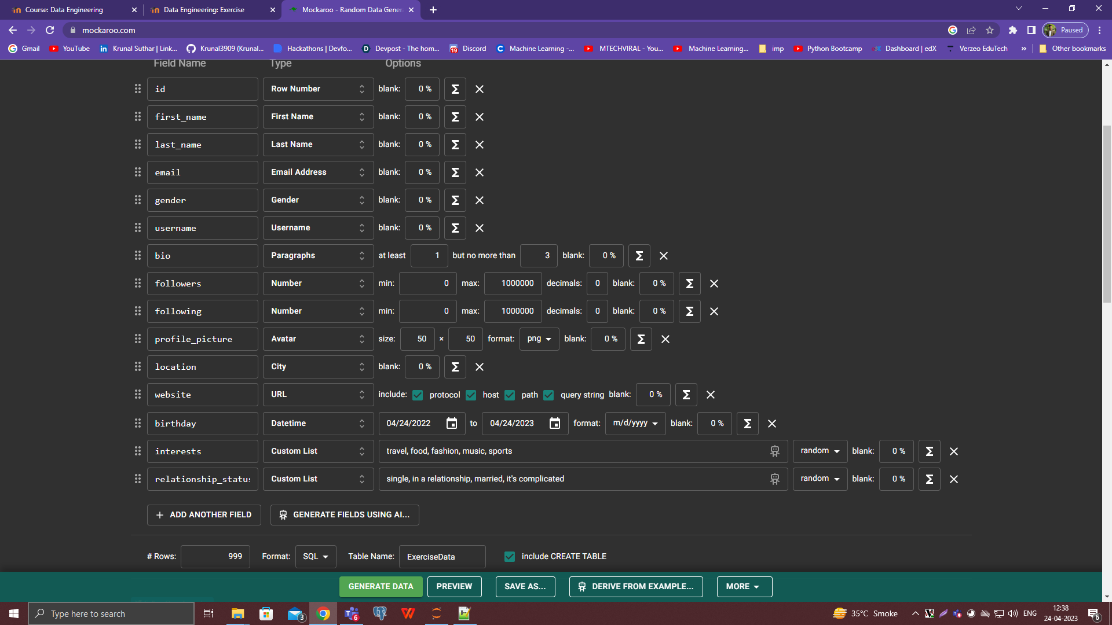

**Generated Table ( SQL ):**

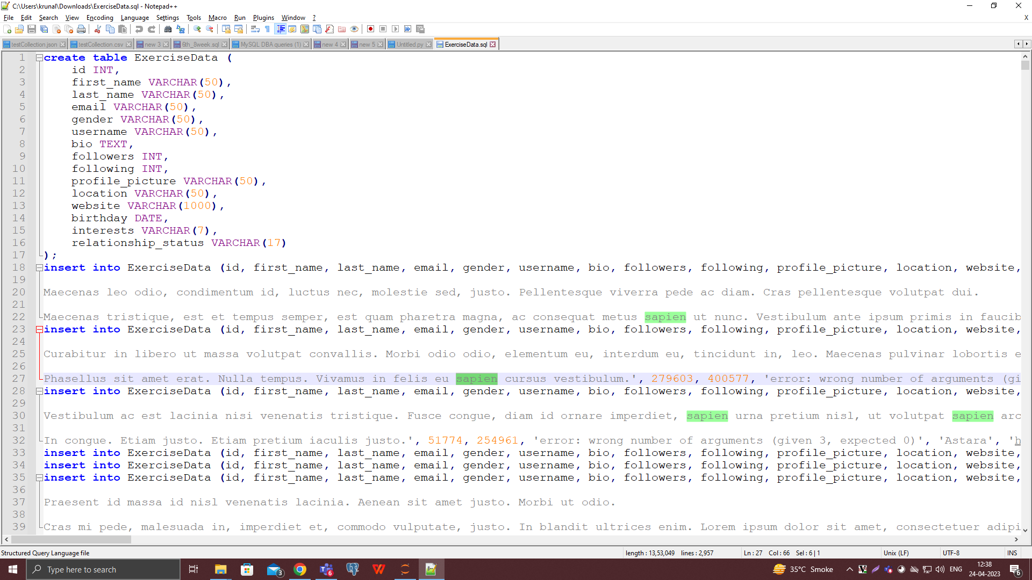

1. **Migrate Postgres database to SQL database (only 10 tables with all the constraints and data)**

**Tool : ESF Database Migration Tool**

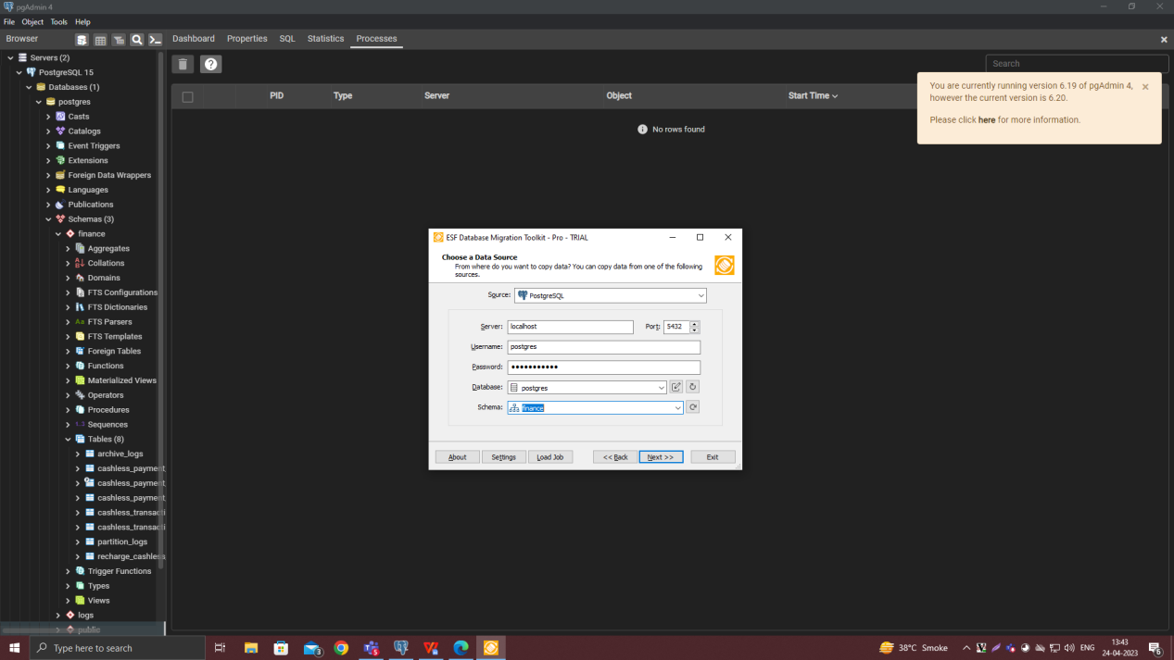

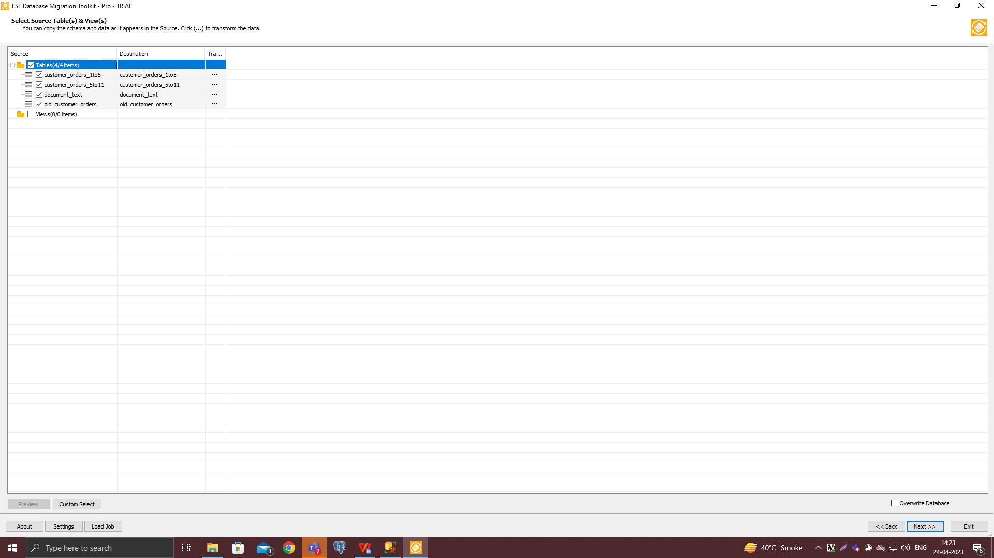

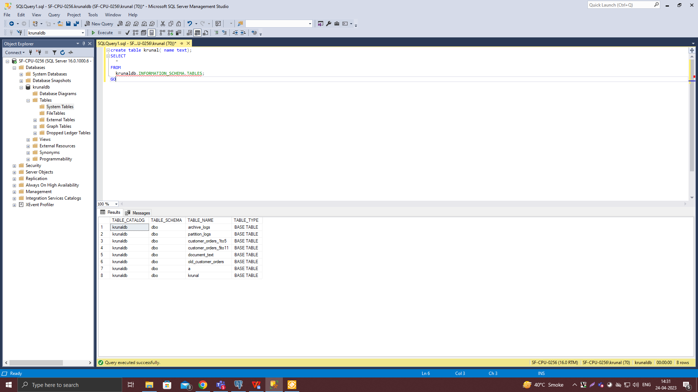

1. **Create table with partition and add data into it**

