**GIT Course Assignment**

1. Pull and Merge difference

- Make example of pull request and two branch merge events.

First we have to fork the repository in which we have to make changes and contribute back.

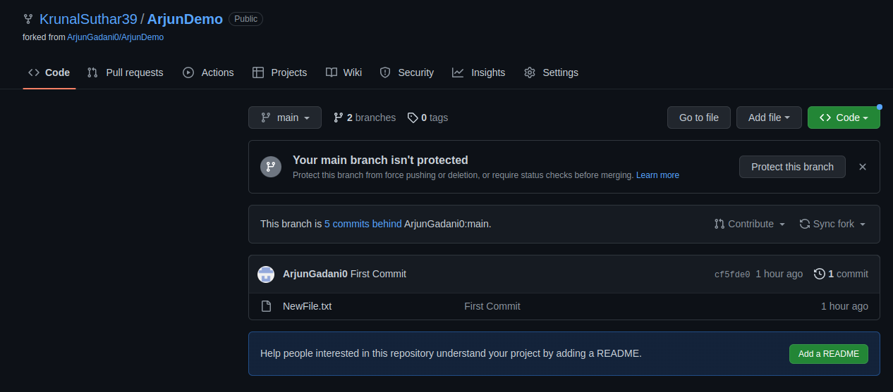

After forking we have to clone the repo in local folder using,

Git clone <https://github.com/KrunalSuthar39/ArjunDemo>

After that we can change the file and run following commands to commit change;

git add .

Git commit –m"commit message”

Then we make a new branch named ‘Krunal’ on which we will send pull request for verification of our code changes.

For this,

* For creating new branch: git branch krunal
* Change head pointer to krunal branch : git checkout krunal (by default head pointer points master/main branch)
* Then for push : git push origin krunal
* And using GitHub we can Compare and raise a PR to respective repository as shown below.
* After sending PR , reviewer will confirm and merge our PR and our code changes will reflect in main repository.

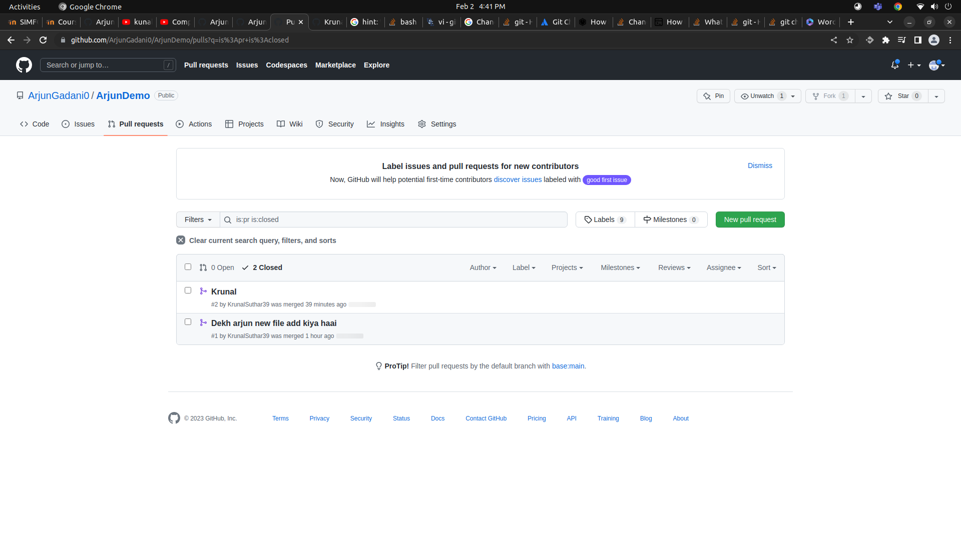

2. Rebase

- Try to rebase feature branch with master branch

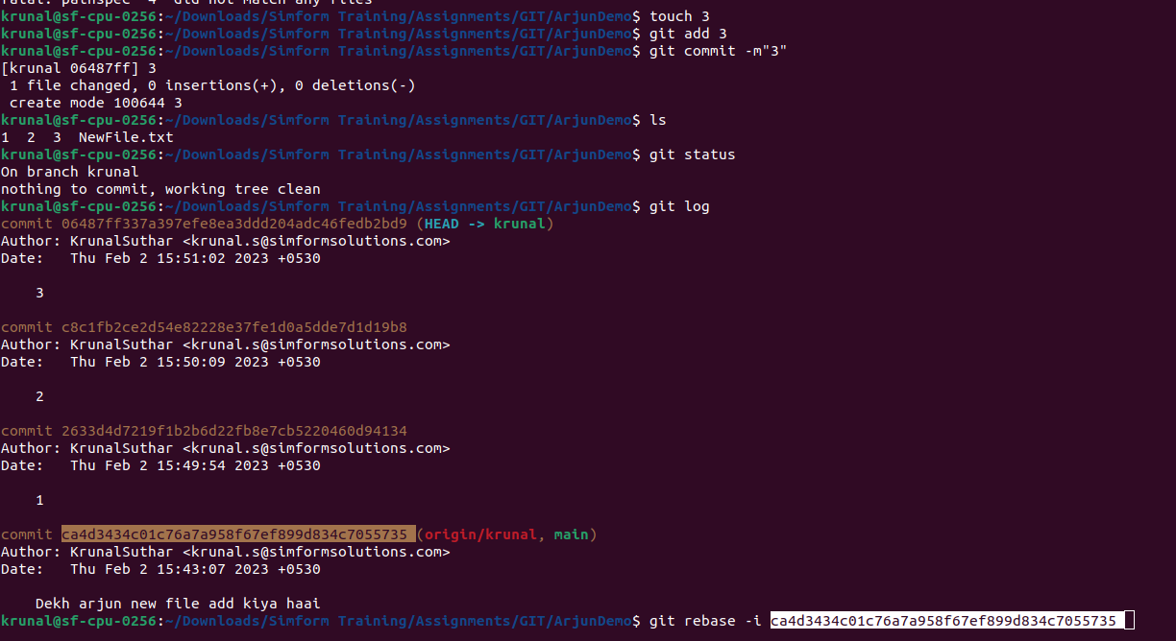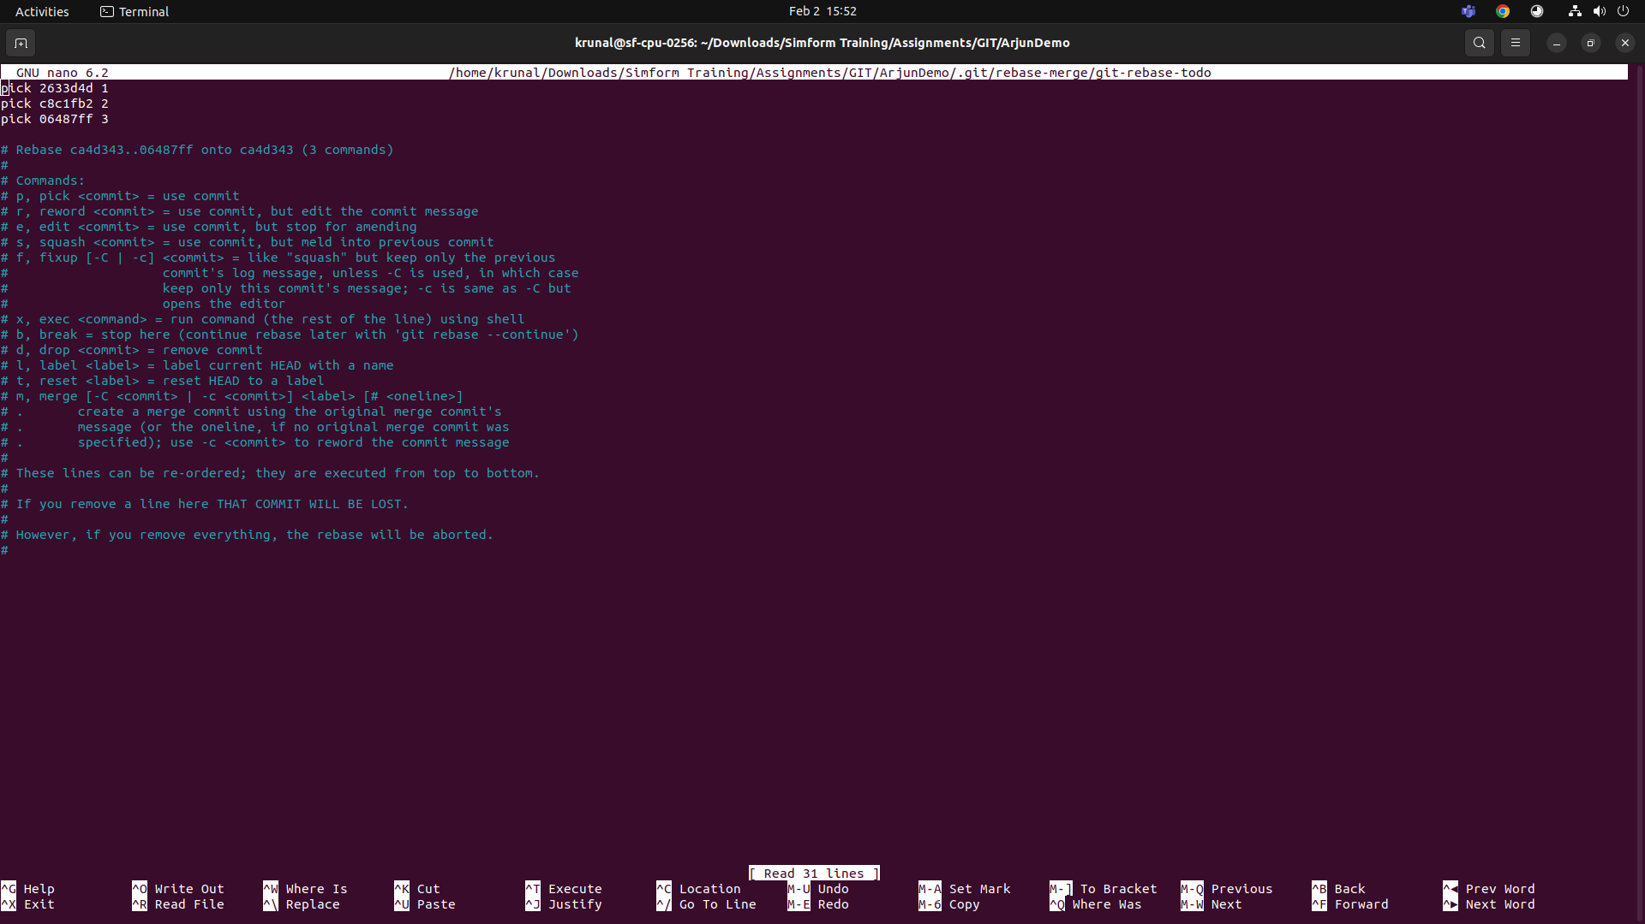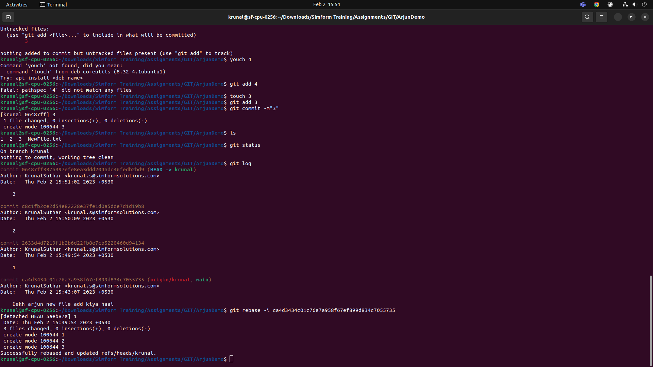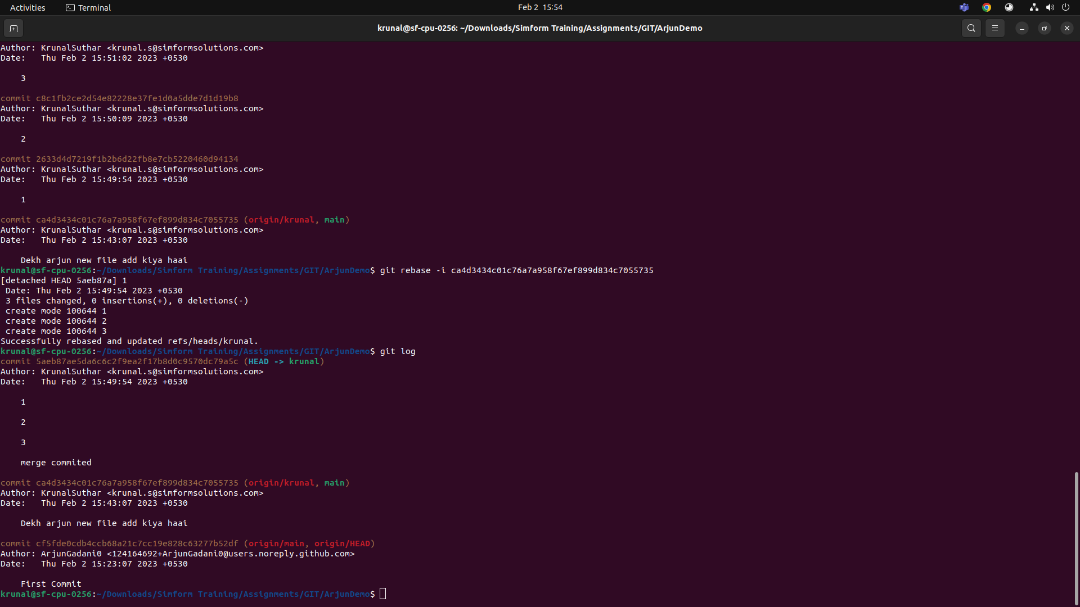

3. Change commit message

- Commit push on commit in feature branch and then change commit message

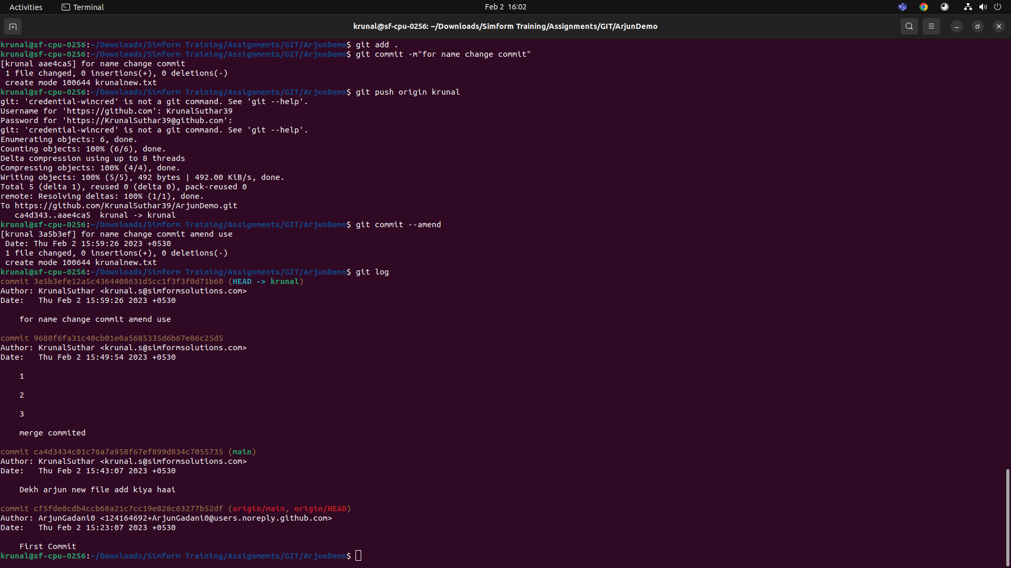

4. Cherry pick

- Pick some commits from feature branch to master branch

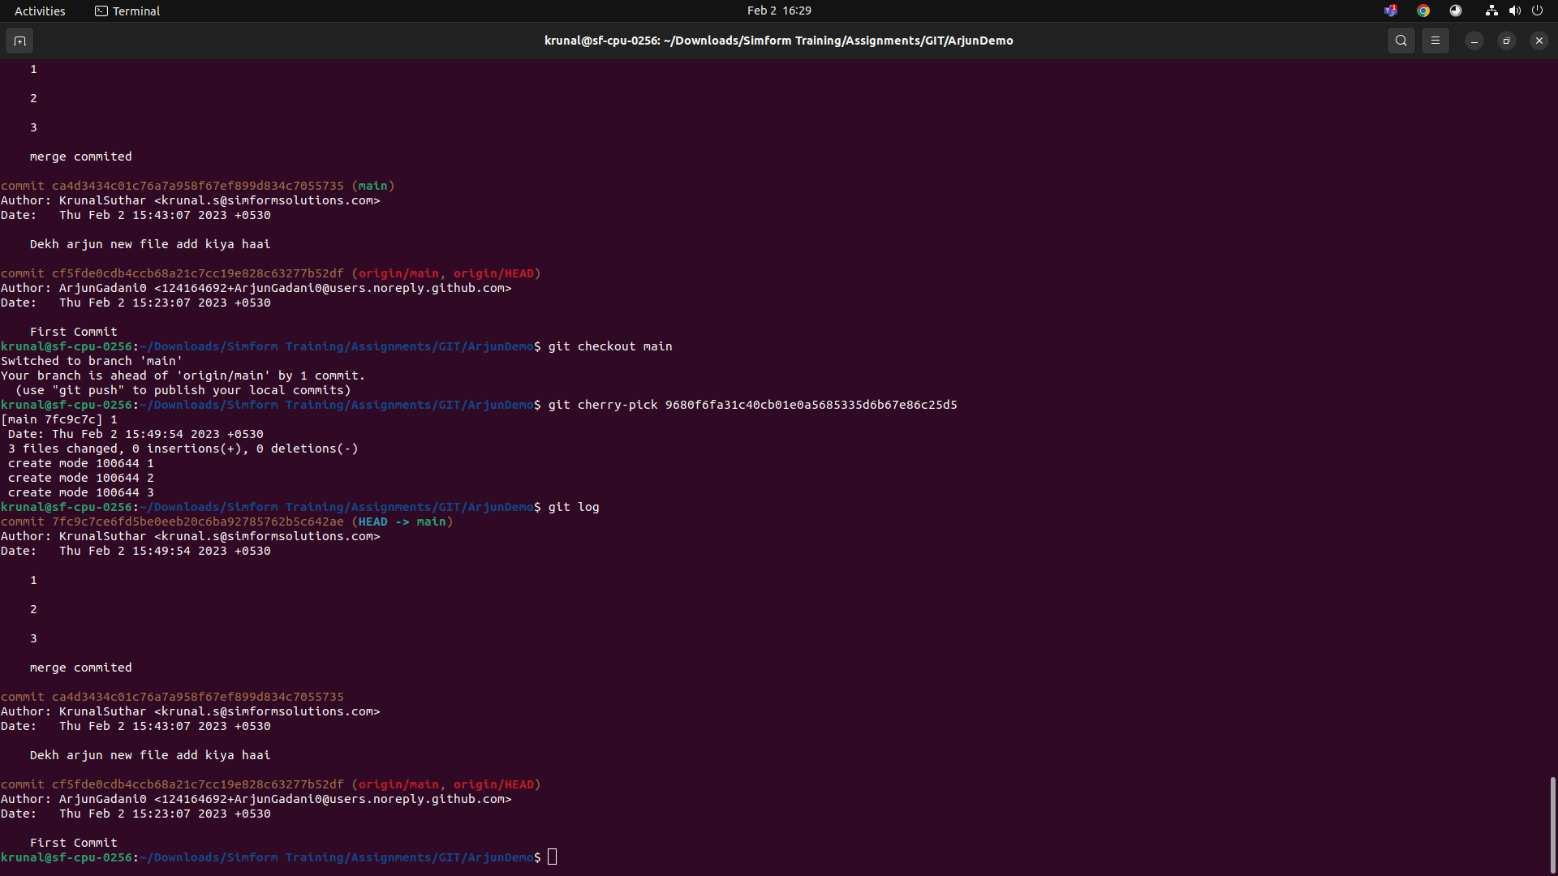

5. Drop commit

- Remove some commit from feature branch.

