**Hive Mini Project-1**

**This is a real time dataset of the I-neuron technical consultant team. You have to perform hive analysis on this given dataset.**

**Download Dataset 1 - https://drive.google.com/file/d/1WrG-9qv6atP-W3P_-gYln1hHyFKRKMHP/view**

**Download Dataset 2 -** [**https://drive.google.com/file/d/1-JIPCZ34dyN6k9CqJa-Y8yxIGq6vTVXU/view**](https://drive.google.com/file/d/1-JIPCZ34dyN6k9CqJa-Y8yxIGq6vTVXU/view)

**Note: both files are csv files.**

1. **Create a schema based on the given dataset.**

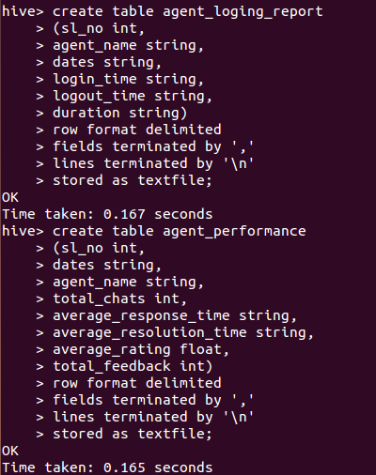

See below the directory created in HDFS.

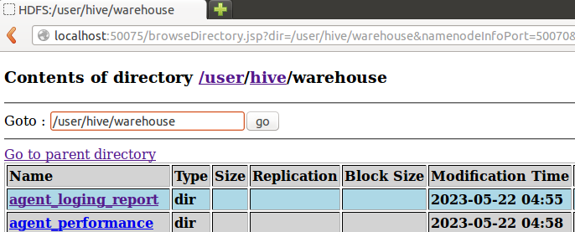

1. **Dump the data inside the hdfs in the given schema location.**

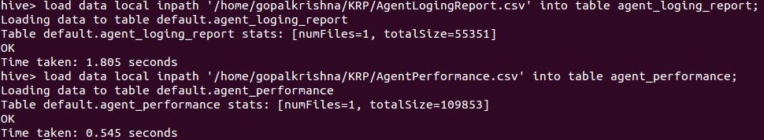

See below the data is loaded to HDFS.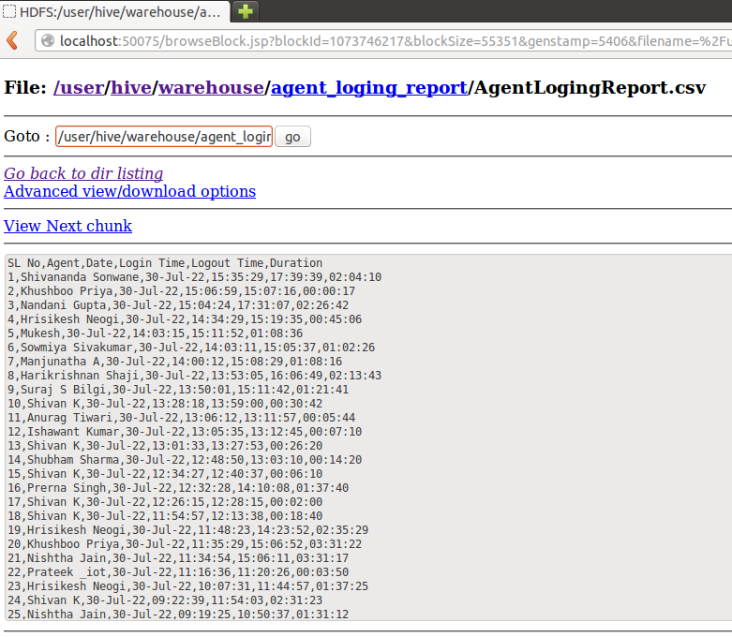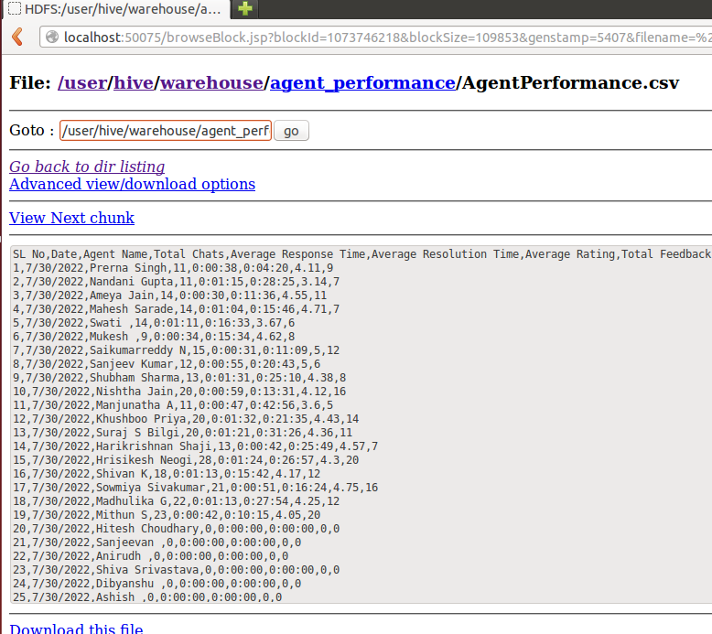

1. **List of all agents' name**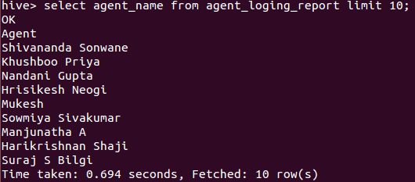
2. **Find out agent average rating.**

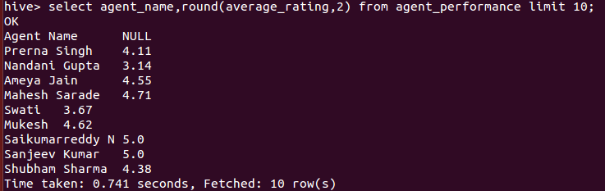

1. **Total working days for each agents.**

hive> select agent_name,count(dates) as Total_working_days from agent_loging_report group by agent_name order by Total_working_days desc limit 10;

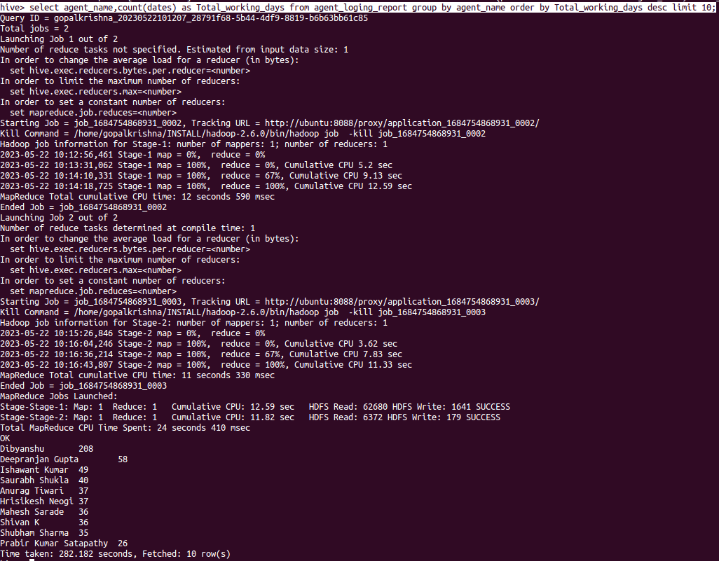

1. **Total query that each agent have taken.**

hive> select agent_name, sum(total_chats) as total_query from agent_performance group by agent_name order by total_query desc limit 15;

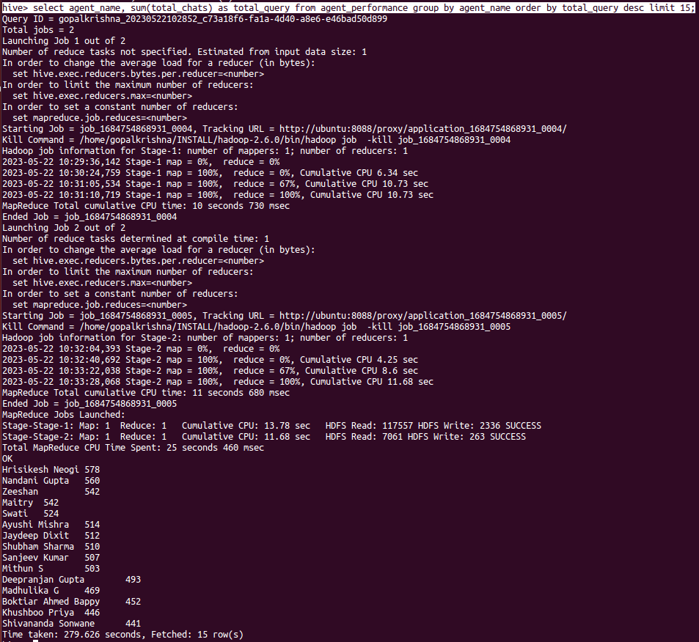

1. **Total Feedback that each agent have received.**

hive> select agent_name, sum(total_feedback) as total_feedback_agent from agent_performance group by agent_name order by total_feedback_agent desc limit 15;

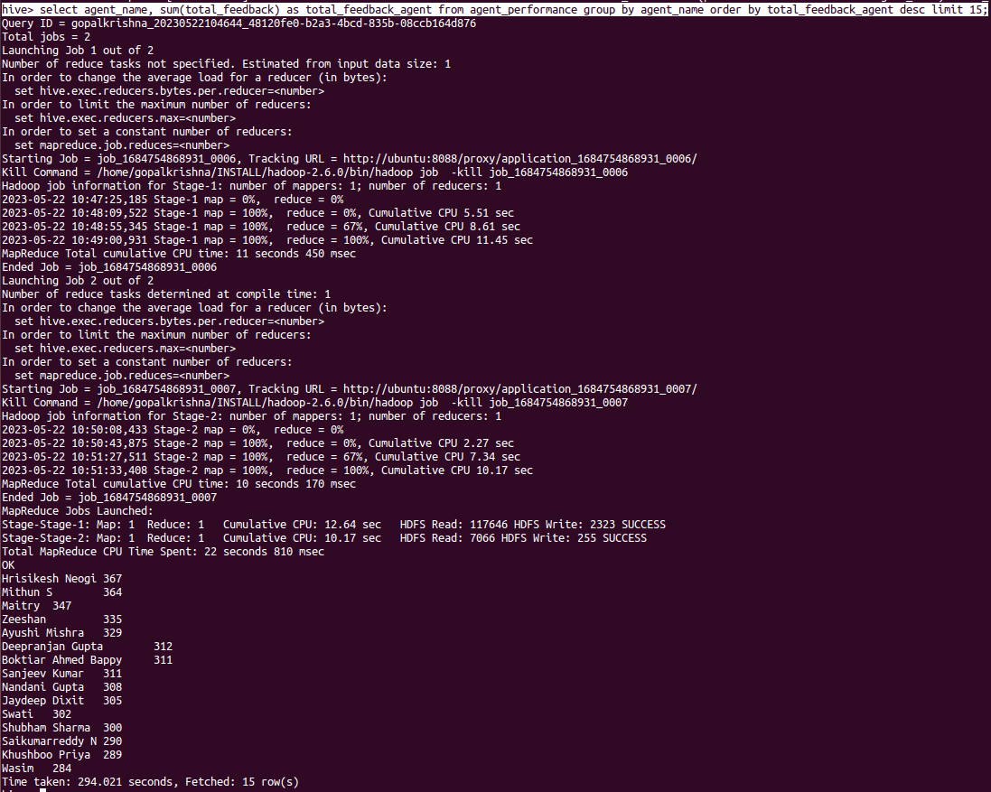

1. **Agent name who have average rating between 3.5 to 4.**

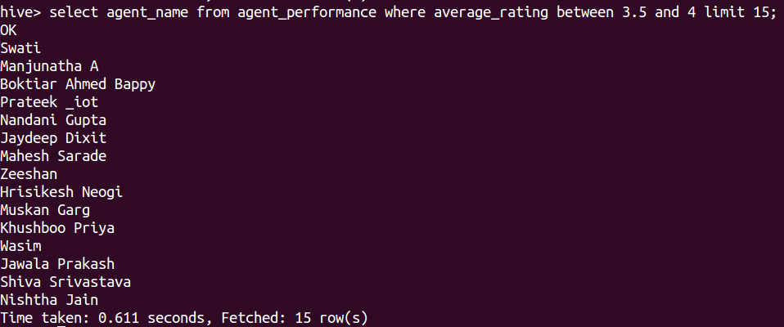

1. **Agent name who have rating less than 3.5.**

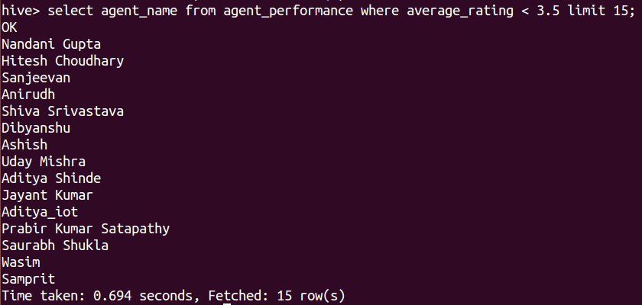

1. **Agent name who have rating more than 4.5.**

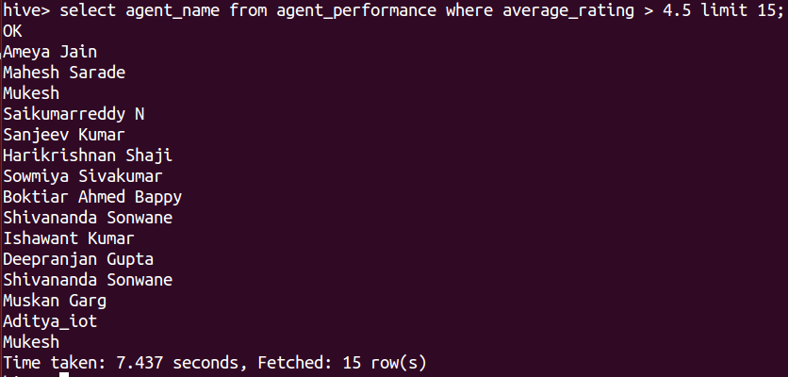

1. **How many feedback agents have received more than 4.5 average.**

hive> select agent_name,round(avg(total_feedback),2) from agent_performance group by agent_name having round(avg(total_feedback),2) > 4.5 limit 15;

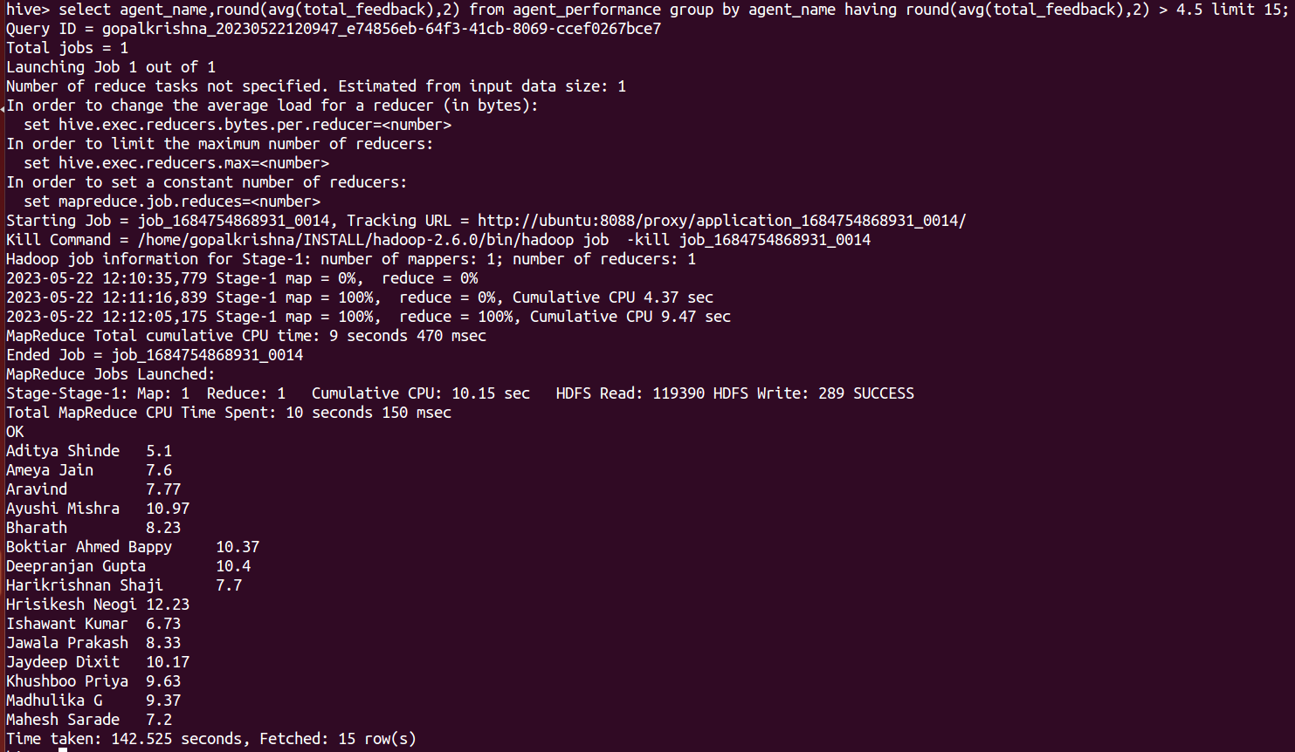

1. **average weekly response time for each agent.**

hive> SELECT agent_name, CONCAT_WS(':', LPAD(FLOOR(AVG(seconds) / 3600), 2, '0'), LPAD(FLOOR((AVG(seconds) % 3600) / 60), 2, '0'), LPAD(AVG(seconds) % 60, 2, '0')) AS average_time FROM ( SELECT agent_name, UNIX_TIMESTAMP(average_response_time, 'HH:mm:ss') AS seconds FROM agent_performance) subquery GROUP BY agent_name limit 15;

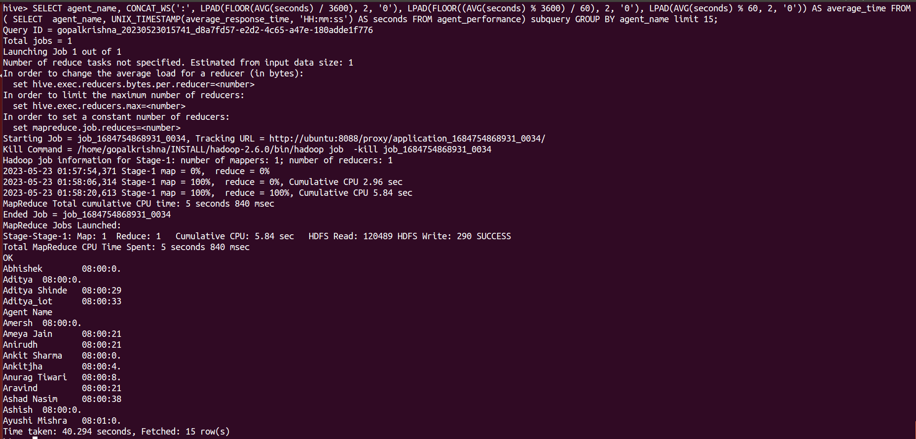

1. **average weekly resolution time for each agents.**

hive> SELECT agent_name, CONCAT_WS(':', LPAD(FLOOR(AVG(seconds) / 3600), 2, '0'), LPAD(FLOOR((AVG(seconds) % 3600) / 60), 2, '0'), LPAD(AVG(seconds) % 60, 2, '0')) AS average_resol_time FROM ( SELECT agent_name, UNIX_TIMESTAMP(average_resolution_time, 'HH:mm:ss') AS seconds FROM agent_performance) subquery GROUP BY agent_name limit 15;

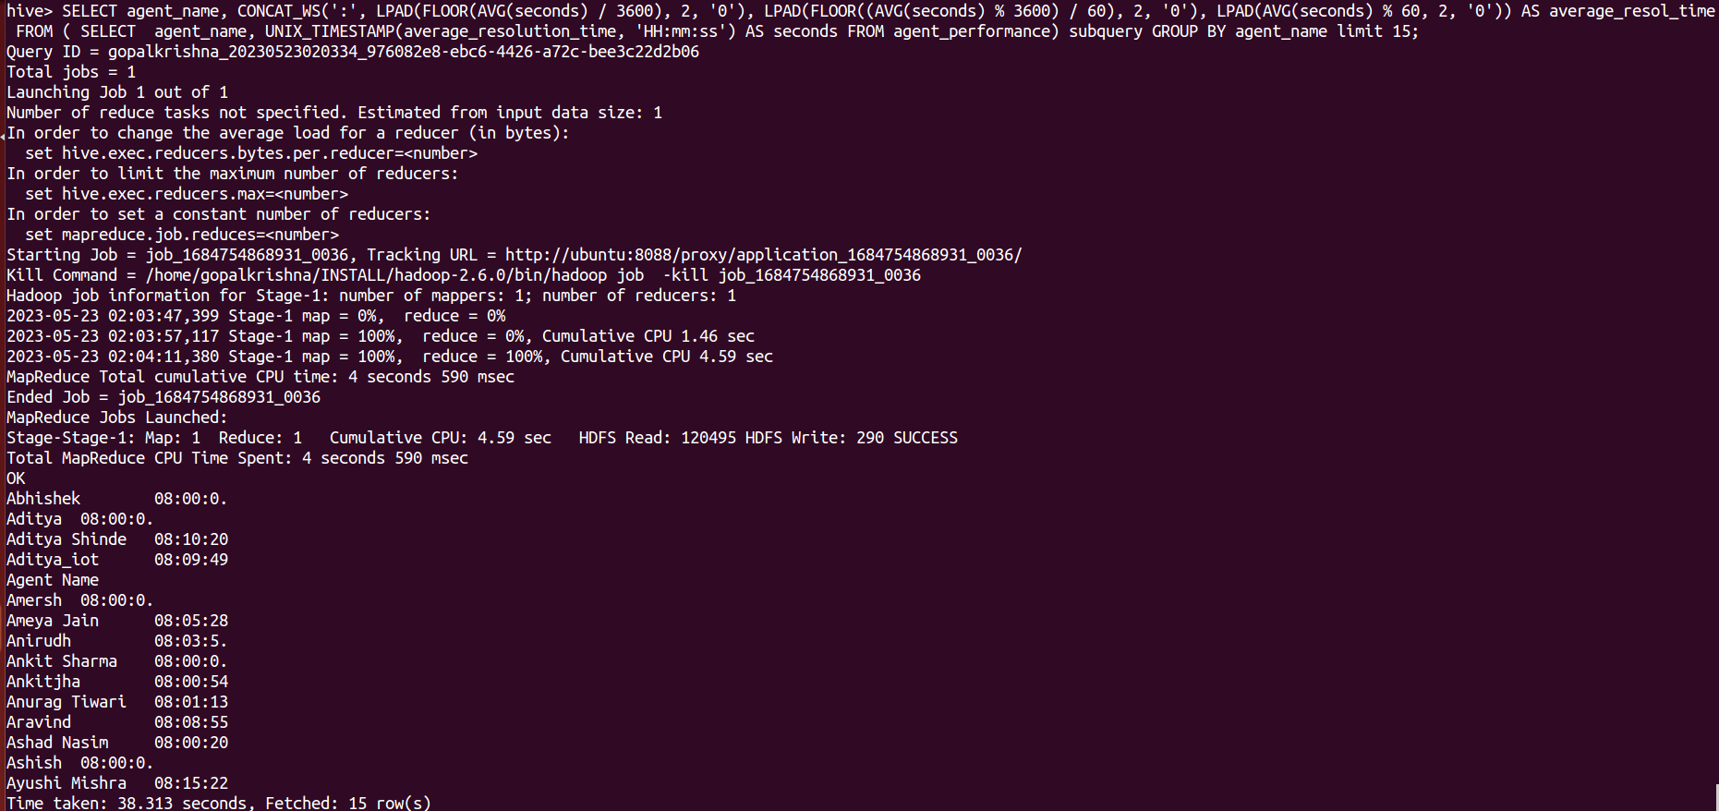

1. **Find the number of chat on which they have received a feedback.**

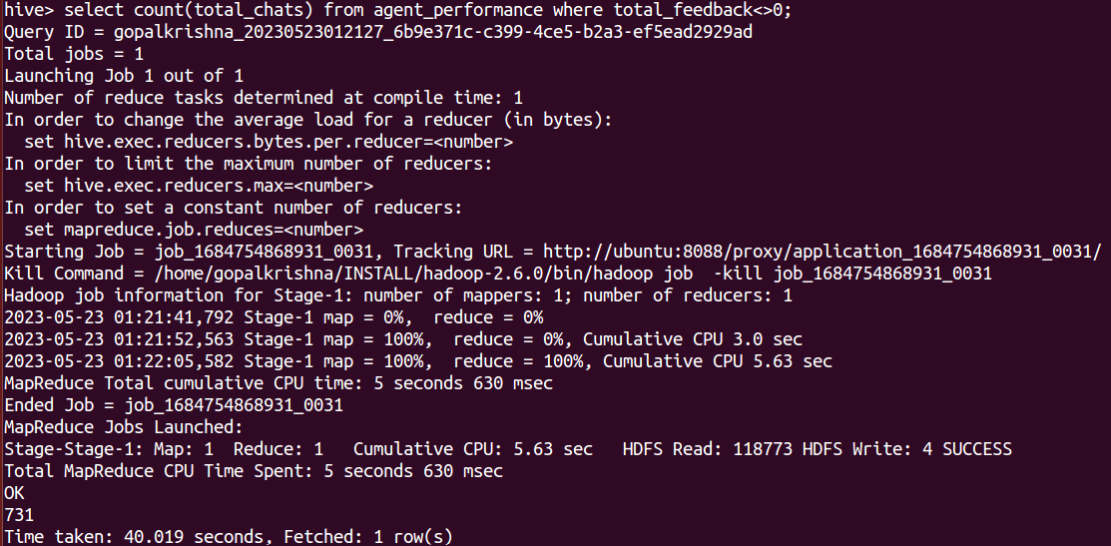

1. **Total contribution hour for each and every agents weekly basis.**

hive> SELECT agent_name, CONCAT_WS(':', LPAD(FLOOR(AVG(seconds) / 3600), 2, '0'), LPAD(FLOOR((AVG(seconds) % 3600) / 60), 2, '0'), LPAD(AVG(seconds) % 60, 2, '0')) AS average_duration FROM ( SELECT agent_name, UNIX_TIMESTAMP(duration, 'HH:mm:ss') AS seconds FROM agent_loging_report) subquery GROUP BY agent_name limit 15;

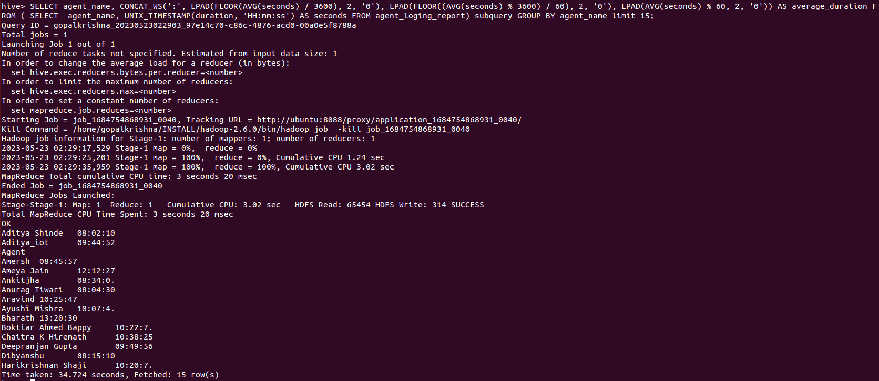

1. **Perform inner join, left join and right join based on the agent column and after joining the table export that data into your local system.**

INNER JOIN:-

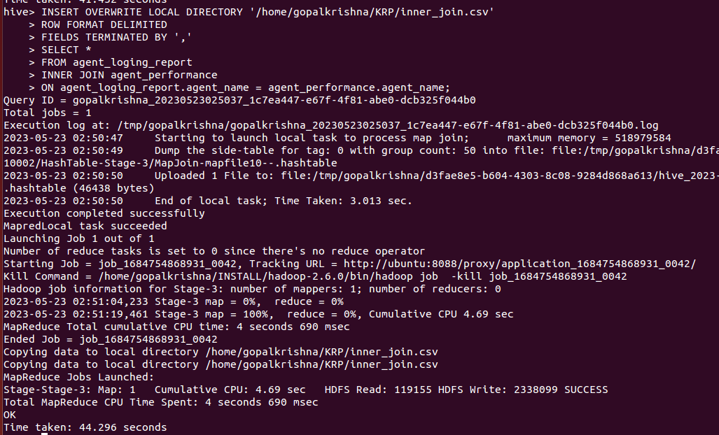

RIGHT JOIN:-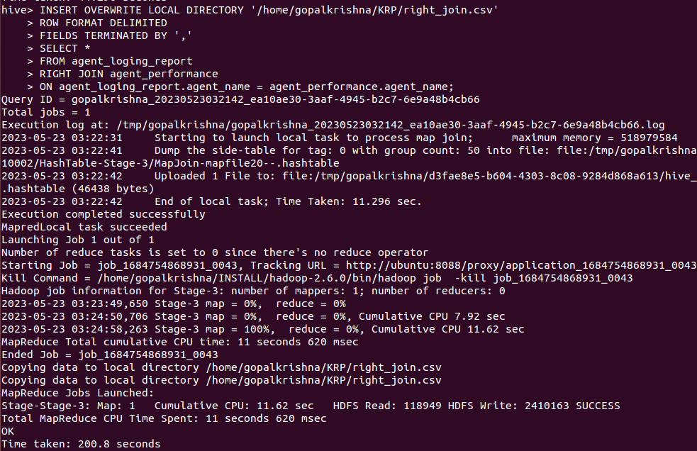

LEFT JOIN:-

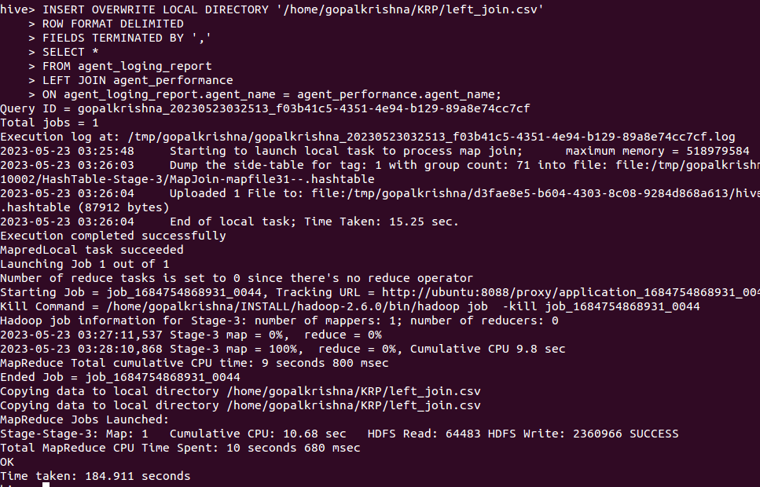

1. **Perform partitioning on top of the agent column and then on top of that perform bucketing for each partitioning.**

hive> set hive.exec.dynamic.partition=true;

hive> set hive.exec.dynamic.partition.mode=nonstrict;



hive> insert overwrite table partition_bucketed_agent_loging partition(agent_name) select sl_no, dates, login_time, logout_time, duration, agent_name from agent_loging_report;

