PROJECT REPORT
On
COMPUTATIONAL ANALYSIS OF PIRNA FOR DETECTION OF COVID SAMPLE USING GALAXY SOFTWARE



Submitted by:
Bidipta Rana
Abhijeet Awasthi
Ayushh Khaire
Krunal Parate
(VIII Semester)

Under the Supervision of
Arpita Parakh

Department of Biomedical Engineering
Shri Ramdeobaba College of Engineering & Management, Nagpur 440013
(An Autonomous Institute affiliated to Rashtrasant Tukadoji Maharaj Nagpur University, Nagpur)
Session: 2024-25

SHRI RAMDEOBABA COLLEGE OF ENGINEERING AND MANAGEMENT, NAGPUR
(An Autonomous Institute affiliated to Rashtrasant Tukadoji Maharaj Nagpur University, Nagpur)
Department of Biomedical Engineering

BONAFIDE CERTIFICATE

Certified that this project report Computational Analysis of piRNA for detection of COVID sample using Galaxy software is the bonafide work of Bidipta Rana, Abhijeet Awasthi, Ayushh Khaire and Krunal Parate who carried out the project work under my supervision.

Dr. Arpita Parakh
Supervisor

Prof. / Dr.
(External Examiner)
-----------------------------------------
-----------------------------------------

Dr.Nitin Narkhede
Head of Department
Biomedical Engineering, RCOEM

Date:
Place:

ABSTRACT

The COVID-19 pandemic has highlighted the need for innovative diagnostic and therapeutic strategies. PIWI-interacting RNAs (piRNAs), a class of small non-coding RNAs traditionally known for their role in silencing transposable elements, are now being explored for their involvement in somatic tissues and disease processes. This project investigates the computational profiling of piRNAs in COVID-19 patient samples using the Galaxy platform. By analyzing small RNA-seq datasets from healthy donors, ICU, and non-ICU COVID-19 patients, we aim to identify differentially expressed piRNAs that may serve as potential biomarkers for infection severity or host response. Galaxy's user-friendly interface and robust bioinformatics toolkit enabled data preprocessing, alignment, and piRNA annotation efficiently. The study offers insights into the potential regulatory role of piRNAs in viral infections and demonstrates the utility of open-source platforms like Galaxy in high-throughput transcriptomic analyses.

TABLE OF CONTENTS

- Introduction
- Literature Survey
- Data Collection
- Methodology
- Result
- Discussion
- Conclusion and Future Scope
- References

INTRODUCTION
PIWI-interacting RNAs (piRNAs) represent a distinct class of small non-coding RNAs that play a vital role in maintaining genome integrity, particularly within germline cells. These RNAs are typically 24–31 nucleotides in length and associate specifically with PIWI subfamily proteins, a subset of the Argonaute protein family. The piRNA pathway was first discovered in Drosophila and has since been identified across a range of animal species, including humans. Unlike other classes of small RNAs such as microRNAs (miRNAs) and small interfering RNAs (siRNAs), which are processed from double-stranded RNA precursors, piRNAs are derived from long single-stranded precursors and are generated through a Dicer-independent mechanism. Their canonical function lies in silencing transposable elements (TEs) within the genome, thereby preventing TE mobilization that could lead to genomic instability and mutations.
piRNAs operate through two major pathways: the primary processing pathway and the ping-pong amplification cycle. In the primary pathway, piRNAs are produced from piRNA clusters within the genome, typically found in heterochromatic regions, which are rich in TE sequences. These primary piRNAs are then loaded onto PIWI proteins to direct gene silencing. The ping-pong amplification loop, in contrast, is a feed-forward mechanism by which secondary piRNAs are generated through the reciprocal cleavage of complementary RNA targets, primarily within the germline. This cycle enhances silencing efficiency and sustains the pool of piRNAs, particularly under conditions of high transposon activity
In recent years, piRNAs have emerged not only as guardians of the germline but also as potential regulators of gene expression in somatic tissues and under pathological conditions. Several studies have revealed the aberrant expression of piRNAs in various cancers, suggesting a broader biological role that includes epigenetic regulation, mRNA stability, and interaction with cellular signaling pathways. However, the study of piRNAs in the context of viral infections remains nascent and is garnering growing interest, particularly with the emergence of pandemics such as COVID-19.
Severe Acute Respiratory Syndrome Coronavirus 2 (SARS-CoV-2), the causative agent of COVID-19, has triggered unprecedented global scientific attention due to its rapid spread and high mortality. The virus predominantly affects respiratory tissues, but its systemic impact has made researchers explore its interaction with host RNA machinery. Given the complex interplay between viral genomes and host regulatory networks, exploring the piRNA profile in COVID-19 samples could provide novel insights into host antiviral defense mechanisms or virus-induced RNA regulatory disruptions. Emerging evidence suggests that viral infections can influence the expression of non-coding RNAs, including piRNAs, either directly through the interaction of viral components with the host machinery or indirectly via inflammatory and immune responses.
Studying piRNA signatures in samples obtained from COVID-19 patients—especially from respiratory epithelium, blood plasma, or even fecal matter—could uncover piRNA biomarkers associated with disease progression, viral load, or immune response. Furthermore, viral RNA itself might be a substrate for piRNA biogenesis or a trigger for piRNA pathway activation, particularly in cells with PIWI protein expression. While most existing research has focused on miRNAs or long non-coding RNAs in COVID-19, expanding the scope to include piRNAs could open new frontiers in understanding host-pathogen interactions and potential therapeutic targets.
Analyzing piRNA expression profiles from high-throughput sequencing data, such as small RNA-seq, requires robust and reproducible bioinformatics tools. One such tool widely used in the genomics and transcriptomics community is the Galaxy software platform. Galaxy is a web-based, open-source framework designed to provide accessible, reproducible, and transparent computational research in the life sciences. It allows researchers to perform complex bioinformatics analyses without requiring deep programming knowledge, making it highly suitable for interdisciplinary collaborations and educational settings.
Galaxy provides an extensive suite of tools for handling next-generation sequencing (NGS) data, including quality control, trimming, alignment, annotation, and statistical analysis. For piRNA studies, users can leverage specialized pipelines to identify piRNA clusters, annotate reads based on known piRNA databases, and distinguish them from other small RNA species like miRNAs, siRNAs, or tRNAs. For instance, small RNA-seq data from COVID-19 patient samples can be uploaded to the Galaxy platform, followed by preprocessing using tools such as FastQC for quality assessment and Cutadapt or Trimmomatic for adapter trimming. Mapping reads to the human genome or piRNA-specific reference sequences can then be conducted using aligners like Bowtie or STAR, while downstream analysis for differential expression may utilize DESeq2 or edgeR.
One of Galaxy’s key strengths is its ability to support workflows that can be shared, reused, and modified by other researchers, thus promoting reproducibility and collaboration. Its user-friendly interface also enables interactive visualization of data through tools like IGV (Integrative Genomics Viewer), enabling researchers to inspect piRNA cluster regions, read coverage, or sequence motifs. Galaxy's integration with public databases and repositories, such as ENCODE and GENCODE, enhances the depth of annotation possible in RNA studies. Moreover, for piRNA-centric research, tools for de novo prediction of piRNA clusters or ping-pong signature detection can be customized within Galaxy using scripting plugins or incorporated from community-contributed toolkits.
In the context of pandemic preparedness and rapid-response research, Galaxy’s scalability and cloud deployment capabilities have proven particularly valuable. During the COVID-19 pandemic, the Galaxy Project launched dedicated instances and workflows to support viral genome analysis, variant calling, and host transcriptome analysis, allowing researchers worldwide to contribute to real-time data interpretation. Extending these capabilities to include small RNA profiling, particularly piRNA analysis, can offer a powerful platform to investigate lesser-studied regulatory layers of host response to viral infections.
LITERATURE SURVEY
The discovery and characterization of PIWI-interacting RNAs (piRNAs) have significantly advanced the field of RNA biology, particularly in understanding genome defense mechanisms. Aravin et al. (2006) were among the first to identify piRNAs as a distinct class of small non-coding RNAs, approximately 24–31 nucleotides in length, that interact with PIWI proteins to silence transposable elements in the germline. Since then, subsequent studies have elaborated the dual mechanisms of piRNA biogenesis—primary processing and ping-pong amplification—as well as their roles beyond the germline (Girard et al., 2006; Siomi et al., 2011).
Recent findings have broadened the scope of piRNAs, revealing their presence and regulatory functions in somatic tissues, as highlighted by Rajasethupathy et al. (2012), who demonstrated that piRNAs could regulate synaptic plasticity in neuronal cells. Furthermore, the dysregulation of piRNAs in various cancer types, including breast, lung, and gastrointestinal cancers, has been reported by Cui et al. (2013), suggesting that these small RNAs are involved in cell proliferation and apoptosis through epigenetic gene regulation.
The intersection of piRNA biology with viral pathogenesis is an emerging and relatively unexplored domain. Although the piRNA pathway was traditionally viewed as germline-restricted, Li et al. (2013) provided compelling evidence of virus-derived piRNAs (vpiRNAs) in mosquito cells infected with arboviruses, indicating that similar pathways might be induced in virus-infected somatic tissues in other organisms. Wu et al. (2010) also demonstrated the induction of piRNA-like small RNAs during viral infections in mammalian cells, although the mechanisms remain less well-defined compared to insects.
The global COVID-19 pandemic triggered interest in the role of non-coding RNAs in SARS-CoV-2 infection. While the majority of studies have focused on microRNAs and long non-coding RNAs, recent work has begun to probe the involvement of piRNAs. Srivastava et al. (2021) performed a computational analysis that revealed differential piRNA expression profiles in the bronchoalveolar lavage fluid of COVID-19 patients compared to healthy individuals. These piRNAs were predicted to target viral genes and host immune regulatory pathways, suggesting a potential antiviral function.
In a complementary study, Sardar et al. (2022) utilized small RNA sequencing data from lung biopsy samples to identify novel piRNA signatures that were significantly upregulated in severe COVID-19 cases. The authors postulated that piRNA-mediated silencing could either represent a host defensive mechanism or result from virus-induced perturbation of RNA silencing pathways. Further functional validation remains necessary, but these findings emphasize the potential of piRNAs as biomarkers of disease severity or therapeutic targets.
Computational resources are essential for the identification and analysis of piRNAs from high-throughput sequencing data. The Galaxy platform, first introduced by Goecks et al. (2010), has become a popular open-source tool for biomedical researchers due to its accessibility and reproducibility. Tools within Galaxy support all steps of small RNA-seq analysis, including quality control (FastQC), adapter trimming (Cutadapt), alignment (Bowtie), and differential expression analysis (DESeq2), making it ideal for piRNA research. Batut et al. (2018) expanded on the platform’s capabilities by introducing enhanced visualization and workflow-sharing features, which are especially valuable for collaborative virological studies.
Specialized tools for piRNA identification and characterization have also been integrated into Galaxy or are compatible with its ecosystem. For example, the piPipes suite developed by Han et al. (2015) offers a comprehensive pipeline for piRNA analysis, including cluster identification and ping-pong signature detection. These tools were successfully used by Zhang et al. (2018) to analyze piRNA expression during embryonic stem cell differentiation, providing a foundation for similar approaches in viral infection contexts.
Databases such as piRBase (Wang et al., 2019) and piRNAclusterDB (Rosenkranz, 2016) are crucial for annotating known piRNAs and their genomic loci. Integration of these resources into Galaxy workflows enhances the interpretability of results. During the COVID-19 pandemic, the Galaxy Project launched a dedicated COVID-19 data analysis hub (Afgan et al., 2020), which provided standardized pipelines for SARS-CoV-2 genome analysis and host response profiling. While not piRNA-specific, these frameworks can be extended to include small RNA-seq data from patient samples for piRNA profiling.
Methodological challenges remain in distinguishing genuine piRNAs from degradation products of other RNAs. As noted by Zhang et al. (2011), stringent size selection, 5′ uridine bias, and ping-pong signature analysis are essential criteria. Studies such as that by Rosenkranz and Zischler (2012) emphasize the need for cross-validation with multiple databases and experimental validation to confirm the identity of piRNAs, especially in somatic or pathological samples.
In terms of translational potential, Liu et al. (2020) highlighted that synthetic piRNA mimics could be engineered to target disease-related genes, raising the possibility of piRNA-based therapeutics. In the context of COVID-19, if piRNAs targeting viral genes can be reliably identified and synthesized, they may contribute to novel antiviral strategies, particularly in persistent or post-acute sequelae of SARS-CoV-2 infection.
In summary, the literature points to a rapidly evolving understanding of piRNAs from germline-specific transposon silencers to broader regulators of cellular function and disease. While research into piRNAs in viral infections, including COVID-19, remains at an early stage, preliminary findings are promising. With the aid of advanced computational platforms such as Galaxy and integrative bioinformatics resources, future studies can elucidate the role of piRNAs in host-virus interactions and explore their potential as diagnostic or therapeutic tools.

DATA COLLECTION

This is the data we have collected from NCBI (National Centre of Biotechnology Information.
PATIENTS | HEALTHY DONOR | ICU | NON-ICU
1. | SRR23919386 | SRR23919384 | SRR23919372

RESULTS

After Trimmomatic of healthy donor
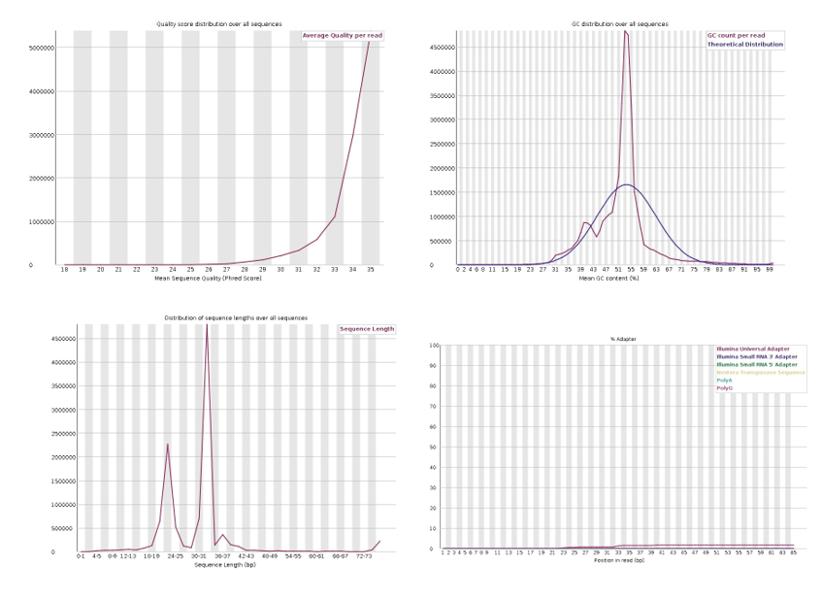
After Trimmomatic of ICU
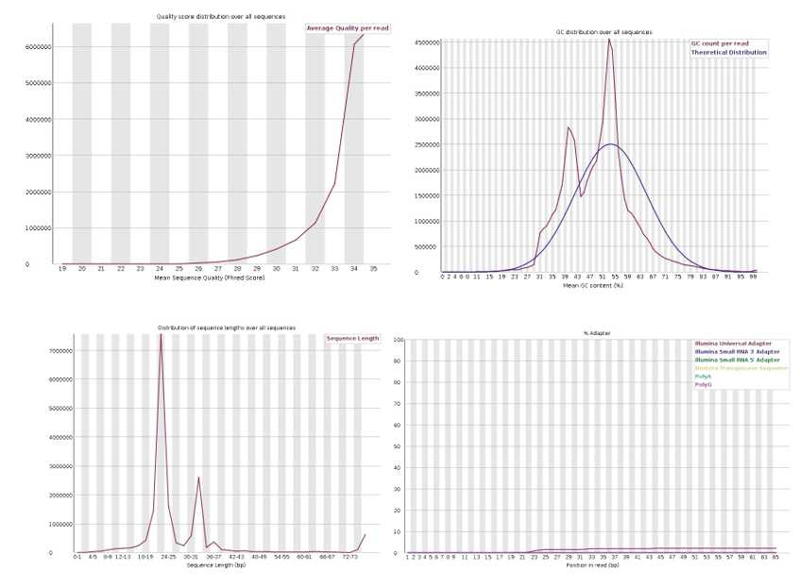

After Trimmomatic of Non-ICU
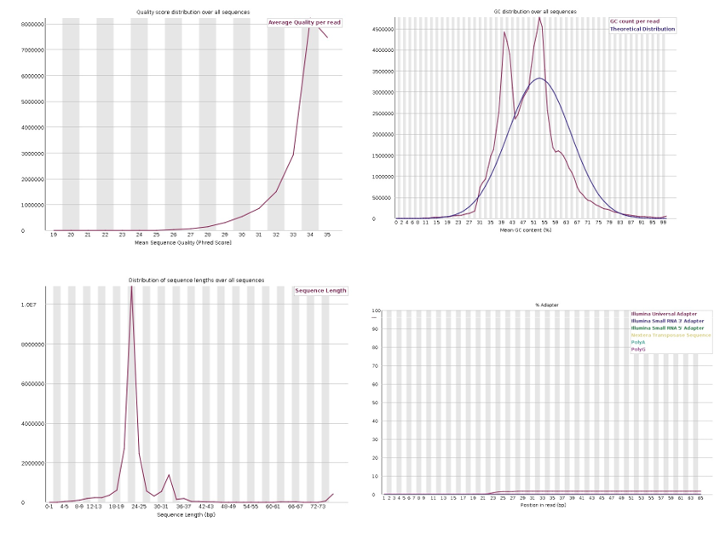

After Bowtie2
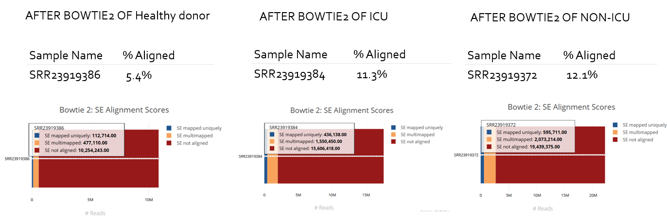

REFERENCES
- Aravin A, Gaidatzis D, Pfeffer S, Lagos-Quintana M, Landgraf P, Iovino N, Morris P, Brownstein MJ, Kuramochi-Miyagawa S, Nakano T, Chien M, Russo JJ, Ju J, Sheridan R, Sander C, Zavolan M, Tuschl T. A novel class of small RNAs bind to MILI protein in mouse testes. Nature. 2006 Jul 13;442(7099):203-7. doi: 10.1038/nature04916. Epub 2006 Jun 4. PMID: 16751777.
- Girard A, Sachidanandam R, Hannon GJ, Carmell MA. A germline-specific class of small RNAs binds mammalian Piwi proteins. Nature. 2006 Jul 13;442(7099):199-202. doi: 10.1038/nature04917. Epub 2006 Jun 4. PMID: 16751776.
- Siomi MC, Sato K, Pezic D, Aravin AA. PIWI-interacting small RNAs: the vanguard of genome defence. Nat Rev Mol Cell Biol. 2011 Apr;12(4):246-58. doi: 10.1038/nrm3089. PMID: 21427766.
- Rajasethupathy P, Antonov I, Sheridan R, Frey S, Sander C, Tuschl T, Kandel ER. A role for neuronal piRNAs in the epigenetic control of memory-related synaptic plasticity. Cell. 2012 Apr 27;149(3):693-707. doi: 10.1016/j.cell.2012.02.057. PMID: 22541438; PMCID: PMC3442366.
- Miesen P, Joosten J, van Rij RP. PIWIs Go Viral: Arbovirus-Derived piRNAs in Vector Mosquitoes. PLoS Pathog. 2016 Dec 29;12(12):e1006017. doi: 10.1371/journal.ppat.1006017. PMID: 28033427; PMCID: PMC5198996.
- Morazzani EM, Wiley MR, Murreddu MG, Adelman ZN, Myles KM. Production of virus-derived ping-pong-dependent piRNA-like small RNAs in the mosquito soma. PLoS Pathog. 2012 Jan;8(1):e1002470. doi: 10.1371/journal.ppat.1002470. Epub 2012 Jan 5. PMID: 22241995; PMCID: PMC3252369.
- Ali MS, Hadda V, Verma S, Chopra A, Mittal S, Madan K, Tiwari P, Suri TM, Mohan A. Unravelling the transcriptomic characteristics of bronchoalveolar lavage in post-covid pulmonary fibrosis. BMC Med Genomics. 2025 Mar 17;18(1):54. doi: 10.1186/s12920-025-02110-x. PMID: 40098116; PMCID: PMC11917041.
- Goecks, J., Nekrutenko, A., Taylor, J. et al. Galaxy: a comprehensive approach for supporting accessible, reproducible, and transparent computational research in the life sciences. Genome Biol 11, R86 (2010). https://doi.org/10.1186/gb-2010-11-8-r86
- Han BW, Wang W, Zamore PD, Weng Z. piPipes: a set of pipelines for piRNA and transposon analysis via small RNA-seq, RNA-seq, degradome- and CAGE-seq, ChIP-seq and genomic DNA sequencing. Bioinformatics. 2015 Feb 15;31(4):593-5. doi: 10.1093/bioinformatics/btu647. Epub 2014 Oct 17. PMID: 25342065; PMCID: PMC4325541.
- Wang J, Zhang P, Lu Y, Li Y, Zheng Y, Kan Y, Chen R, He S. piRBase: a comprehensive database of piRNA sequences. Nucleic Acids Res. 2019 Jan 8;47(D1):D175-D180. doi: 10.1093/nar/gky1043. PMID: 30371818; PMCID: PMC6323959.
- Wang J, Zhang P, Lu Y, Li Y, Zheng Y, Kan Y, Chen R, He S. piRBase: a comprehensive database of piRNA sequences. Nucleic Acids Res. 2019 Jan 8;47(D1):D175-D180. doi: 10.1093/nar/gky1043. PMID: 30371818; PMCID: PMC6323959.
- Rosenkranz D. piRNA cluster database: a web resource for piRNA producing loci. Nucleic Acids Res. 2016 Jan 4;44(D1):D223-30. doi: 10.1093/nar/gkv1265. Epub 2015 Nov 17. PMID: 26582915; PMCID: PMC4702893.

