IT314 – Software Engineering

# Lab 06 : Domain Modelling

202101160 – Krupesh Parmar

* Que: 01 – Activity Modelling

Draw an activity diagram to graphically represent the following workflow. Let us consider the development activities of SE Virtual Labs. The process begins by checking out the code from Subversion repository. Necessary modifications are then made to the checked-out code (local copy). Once the developer is done with his changes, the application has to be tested to verify whether the new functionalities are working fine. This test has to be performed with two of the more popular web browsers: Firefox and Internet Explorer, to support cross-browser accessibility. If testing fails in at least one of the two browsers, developer goes back to his code, and fixes it. Only when all the browsers pass the test, a patch is generated from the local copy, and applied to the production code. The local copy is then committed resulting in update of the SVN repository. Note that, if the local copy is committed before generating a patch file, then local changes would get registered, and one won't be further able to generate the patch file.

**Note:** For further clarification, at any point of time there exists three versions of the source code: Production copy, local copy, and copy in SVN repository.

**Think over the following questions:**

**1. How would you represent testing of the application with multiple browsers?**

🡪 Testing of the application with multiple browsers is represented by the “Testing with Firefox” and “Test with Internet Explorer” activities, which are performed in parallel using fork and merge.

**2. Can generation of the patch file and update the Subversion repository be done concurrently?**

🡪 Generation of the patch file and Subversion repository cannot be done concurrently in this workflow. The patch file must be generated before applying it to the production code, and updating the repository should happen after applying the patch.

**3. Can patching the production code and updating the Subversion repository be done in parallel?**

🡪 Patching the production code and updating the Subversion repository can be done in parallel, as they are not dependent on each other in this workflow. However, it’s essential to generate the patch file first before applying it to the production code.

* **Activity Diagram:**

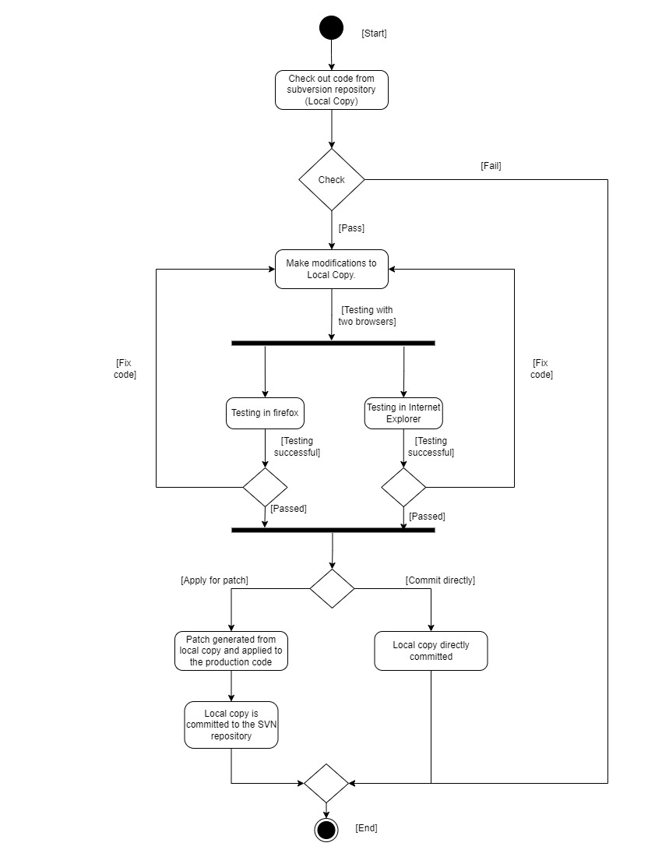

* Que: 02 – Class Diagram

**Draw class diagram for anyone of the sprints by identifying objects, classes and their relationships.**

