IT314 – Software Engineering

# Lab 07 : Domain Analysis Modeling & Sequence Diagram

202101160 – Krupesh Parmar

* Que: 01 – Library Management System

1. Use - case Diagram

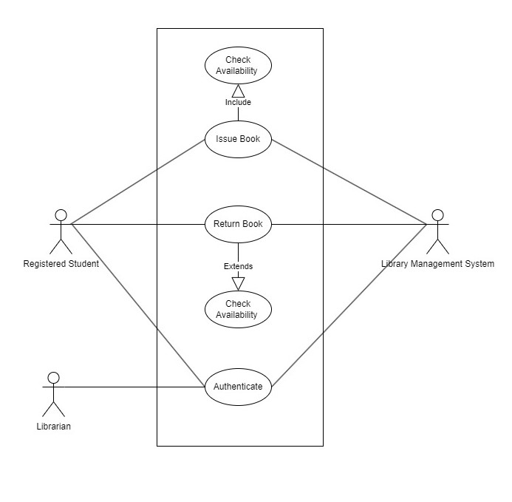

* **Use - case Documentation**

Use case name: Issue Book

Description: Represents the process Issuing book Primary Actors: Registered Students

Secondary Actors: Library, Librarian

# **Pre-conditions:**

* Registered student must be logged in and authenticated by the librarian.
* The book being issued must be available in the library.

**Post-conditions:**

* The book is marked as issued to the student.
* The due date for returning the book is set.
* The student is notified of the successful issuance.

**Main flow:**

* The registered student requests to issue a book.
* The system validates the student’s authentication status.
* The system checks if the requested book is available.
* If the book is available, the system marks it as issued to the student.
* The system sets the due date for returning the book.
* The system notifies the student and the librarian about the successful issuance.

**Alternate flow:**

* If the book is not available, the system notifies the student that the book cannot be issued at the moment.
* If the user is not authenticated, the system notifies the librarian

2. Sequence Diagram

**registered**

**student Librarian System**



Request to Issue Authenticate

Provide credentials

Mark as issued

Notify Issuance

Return book

Mark as returned

3. Analysis Object Diagram

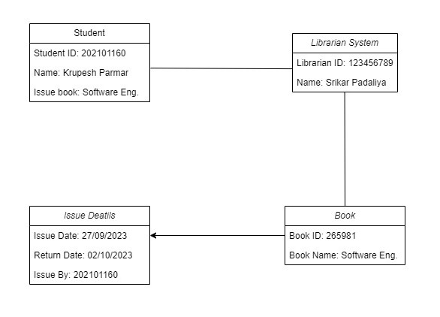

* Que: 02 –Examination Management Process



:Instructor P

:Student P

:TA P

:Staff P

setExam(dt,material)

prepare(exam)

makeCopies(exam)

*handOut(exam)

writeAnswers(exam)

[Time Up?]

*handIn(exam)

*mark(paper,

*return(pa

*record(marks)

*inform(mark)

pers,marks)

exam, solution)