IT314 – Software Engineering

# Lab 08 : Testing - Introduction

202101160 – Krupesh Parmar

**Question:** Write a set of test cases – specific set of data – to properly test a relatively Simple program. Create a set of test data for the program - data the program must handle correctly to be considered a successful program.

Format:

|  |  |
| --- | --- |
| Tester Action and Input Data | Expected Outcome |
|  |  |

Here’s a description of the program:

*“The program reads three integer values from an input dialog. The three values represent the lengths of the sides of a triangle. The program displays a message that states whether the triangle is scalene, isosceles, or equilateral”.*

***Code:*** The function triangle takes three integer parameters that are interpreted as the lengths of the sides of a triangle. It returns whether the triangle is equilateral (three lengths equal), isosceles (two lengths equal), scalene (no lengths equal), or invalid (impossible lengths).

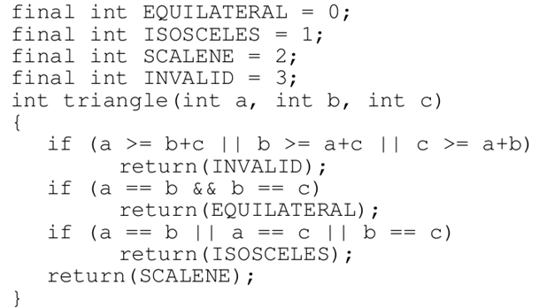

|  |  |  |  |  |  |  |
| --- | --- | --- | --- | --- | --- | --- |
| **Test Action** | **Input Data** | | | **Code Output** | **Expected Output** | **Result** |
| **A** | **B** | **C** |
| Equilateral | 5 | 5 | 5 | Equilateral | Equilateral | True |
| Equilateral | 36 | 36 | 36 | Equilateral | Equilateral | True |
| Equilateral | 1 | 1 | 1 | Equilateral | Equilateral | True |
| Equilateral | INT_MAX | INT_MAX | INT_MAX | Invalid | Equilateral | False |
| Equilateral | 100000 | 100000 | 100000 | Equilateral | Equilateral | True |
| Invalid | 1 | 1 | 2 | Invalid | Invalid | True |
| Invalid | 3 | 3 | 100 | Invalid | Invalid | True |
| Invalid | -10 | -10 | 56 | Invalid | Invalid | True |
| Invalid | -5 | -8 | 3 | Invalid | Invalid | True |
| Invalid | 15 | 15 | 32 | Invalid | Invalid | True |
| Isosceles | 31 | 31 | 5 | Isosceles | Isosceles | True |
| Isosceles | INT_MAX | INT_MAX | 6 | Invalid | Isosceles | False |
| Isosceles | 10 | 9 | 10 | Isosceles | Isosceles | True |
| Isosceles | 1 | 13 | 13 | Isosceles | Isosceles | True |
| Isosceles | 7 | 7 | 9 | Isosceles | Isosceles | True |
| Scalene | INT_MAX | 500 | 379 | Invalid | Scalene | False |
| Scalene | 2 | 3 | 4 | Scalene | Scalene | True |
| Scalene | 15 | 16 | 28 | Scalene | Scalene | True |
| Scalene | 9 | 8 | 13 | Scalene | Scalene | True |
| Scalene | 3 | 4 | 5 | Scalene | Scalene | True |

**Note:** INT_MAX = 2147483647