IT304 – Software Engineering

# Lab 05

# Modeling requirements into activity diagram

# **Lab Group: 02**

# **Project Group: 09**

# **Project: Online Faculty Staff Directory For Multi University**

* Group Member’s name and ID:
* 202101158 – Ruchika Amin
* 202101135 – Lav Chaudhari
* 202101107 – Anshul Darediya
* 202101153 – Smit Patel
* 202101160 – Krupesh Parmar
* 202101152 – Kaushalkumar Prajapati
* 202101100 – Parth Khunt
* 202101108 – Prabhakar Hembrom
* 202101140 – Jahnvee Patel

1) There are four different sprints in our project- Login, Admin Interface, Faculty Interface,

1. Login

The admin has to register himself and the respective university on the website. If the registration details are valid then after he would be able to access facilities like, add colleges, add faculty, drop faculty, etc. After the registration is complete admin would be able to add colleges under that university and add faculties belonging from that colleges. Faculty can only login by the credentials provided by the admin to him, faculty doesn’t need to register himself. If email and password is not valid, faculty would be again redirected to the login page, there is also a forgot password feature is available. There is no login/registration required to access basic functionality of the website, like searching for a faculty, view faculty details, etc.

2. User interface

There is no need to login to use basic functionalities of the website like, search faculty, see faculty details, etc. There is a registration/login option available on the homepage for faculty and admin registration/login. User can search faculty by his/her name, search university/college by its name. After the search result, user can filter out the result by location, faculty’s education field, by college tier, etc. After getting desired result user can see faculty details by clicking on his profile.

3. Admin interface

After admin registers himself completely, he can view his/her profile in the profile section. In the profile section there are options from which he can add colleges under his university. If the college is already registered than he will receive an alert about the same. He can also add(register) faculties into colleges of his domain. If the faculty is already registered, then he will receive an alert for the same. After submitting the details of the faculty details an approval mail is sent to the respective faculty for the registration approval on his end. Admin can also drop(remove) faculty from the college. There will be a notification mail sent to respective faculty, but no confirmation needed. Admin can also remove college, which will lead to remove all the respective data of faculties belonging to that college.

4. Faculty interface

Faculty can login into the website by credentials given to him/her from the admin. If login credentials are not valid then, he will be asked to re-enter the details and there is also a forgot password functionality provided. After the login process is complete, faculty can his/her profile in the profile section. He/she will be able to edit his profile details and will also be able to de-register himself. In case of de-register, a confirmation mail be sent to the respective admin to approve his/her request.

2)Activity Diagram for each Sprint:

Sprint 1: Registration/Login

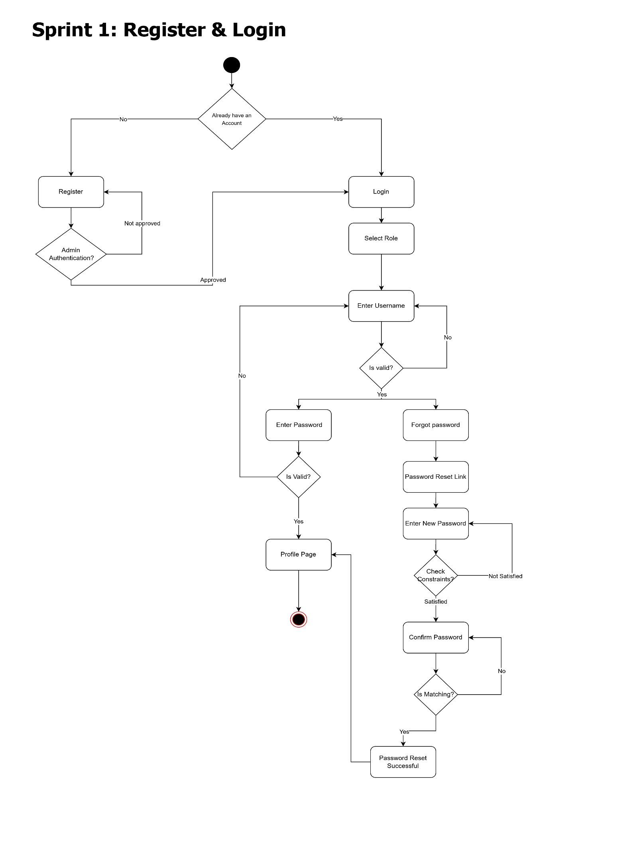

Sprint 2: User interface

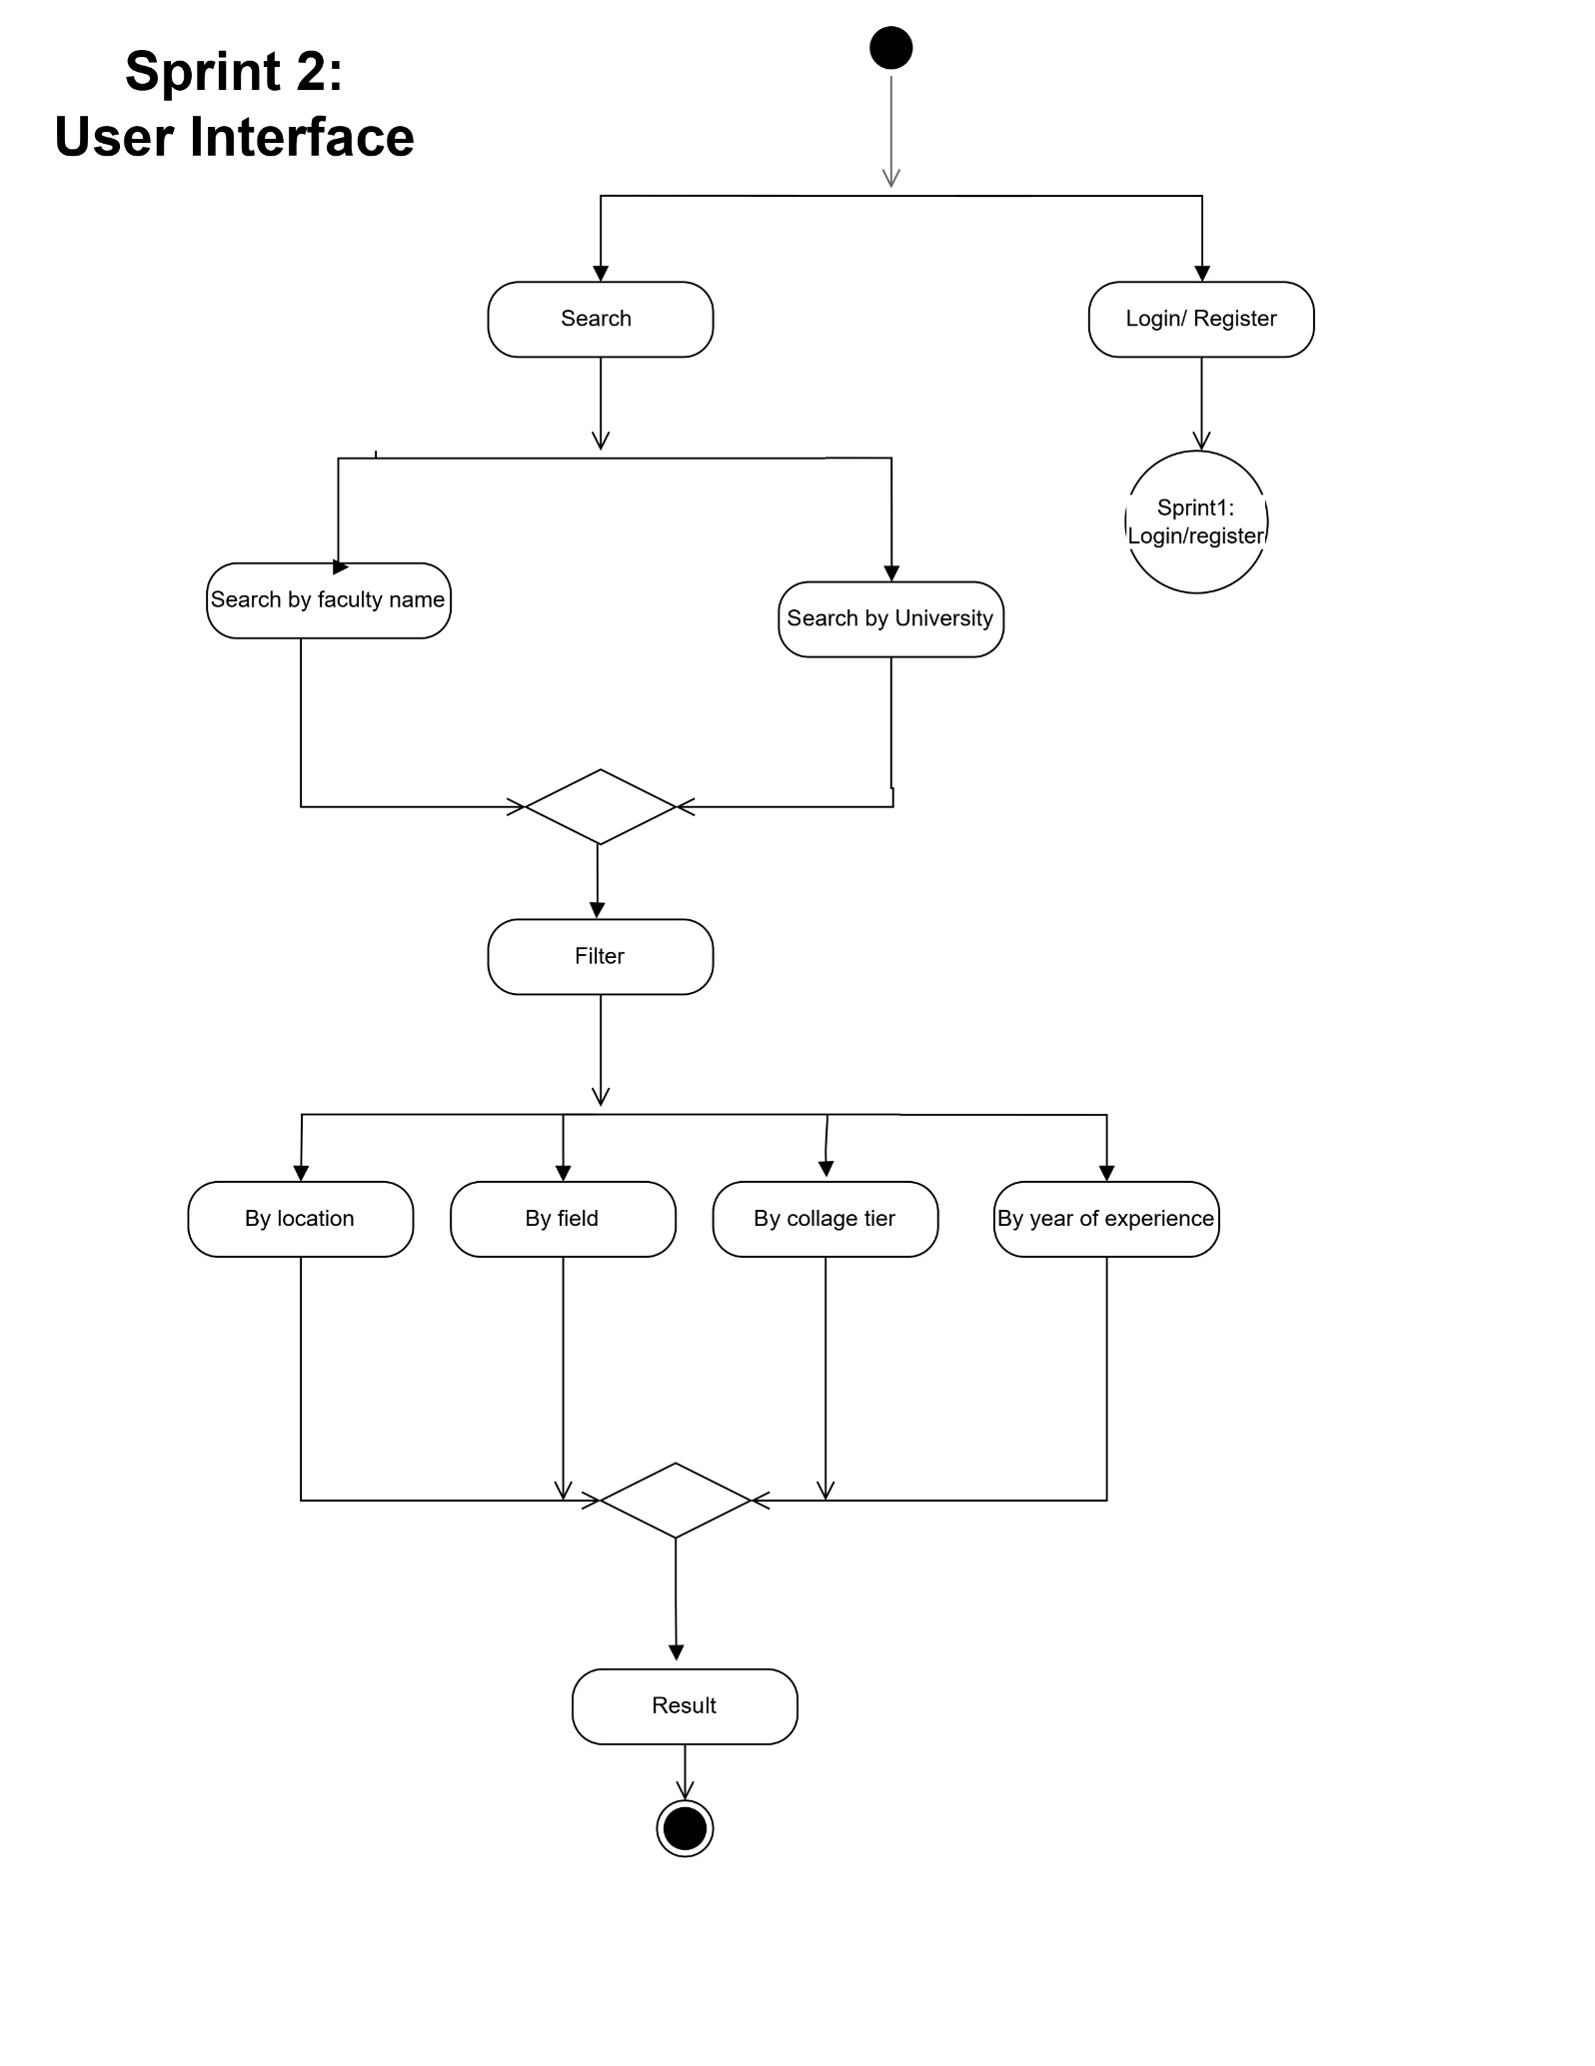

Sprint 3: Faculty interface

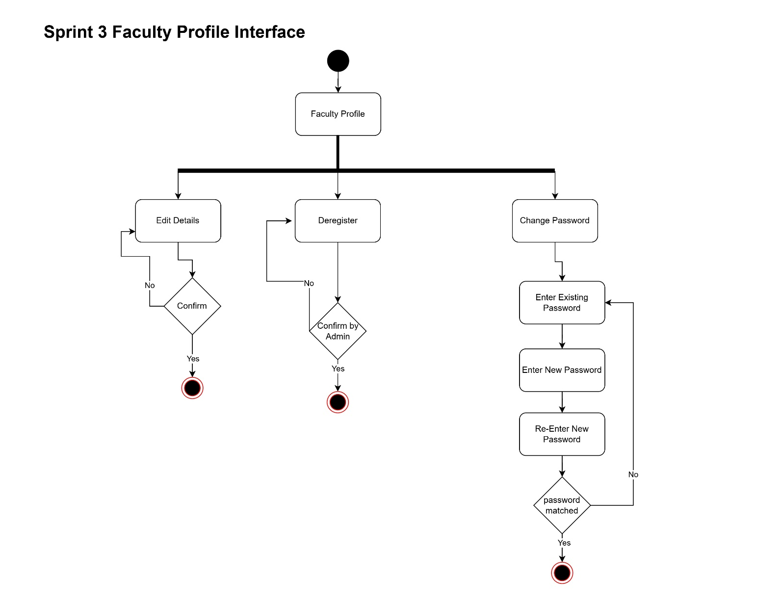

Sprint 4: Admin Interface

