**Final Report for the DS 677 - 002 Project**

**ADVANCEMENTS IN BRAIN TUMOR DETECTION: A COMPARATIVE ANALYSIS OF EFFICIENTNETB7, RESNET152, INCEPTIONV3 AND INCEPTIONRESNETV2 MODELS**

**(Bhavya Shah-bs635, Krupa Lakhani-kgl, Deep Patel-djp223)**

Keywords: Data Medical Imaging, Brain Tumor Detection, Data Preprocessing, Neural Networks, EfficientNet, ResNet, Inception, InceptionResNet, Deep Learning, Model Comparison, Performance Evaluation.

Abstract: This project leverages transfer learning techniques to enhance brain tumor detection using MRI images. Pre-trained convolutional neural network models, specifically EfficientNetB7, ResNet152, InceptionV3, and InceptionResNetV2, are adapted and fine-tuned on MRI datasets to capitalize on their learned features. By transferring knowledge from models trained on large-scale image datasets, the project aims to expedite the development of accurate tumor detection systems while minimizing the need for extensive manual feature engineering. The performance of the transferred models is evaluated comprehensively, demonstrating their effectiveness in accurately detecting brain tumors from MRI scans. This approach showcases the potential of transfer learning as a powerful tool in medical imaging applications, facilitating the advancement of diagnostic capabilities in clinical settings.

Dataset: [Brain Tumor Dataset](https://www.kaggle.com/datasets/ahmedhamada0/brain-tumor-detection)

PPT: [Google Slides](https://docs.google.com/presentation/d/1qBW38qKOYO6mmF5w4x69su6H1APfc1wNTztvRHIRIO8/edit#slide=id.g2cea35bba2f_1_33)

**Code**: <https://colab.research.google.com/drive/1oZLBJGhr7UQgCWyyQcRUjrv6EGhri-iJ?authuser=3#scrollTo=oUejHTU3Jl8w>

**1. INTRODUCTION**

Brain tumor detection is crucial for early diagnosis and treatment planning in neurology. Medical imaging techniques, such as MRI scans, are commonly used for this purpose due to their ability to provide detailed insights into brain structure and abnormalities. However, accurately detecting brain tumors from MRI images presents a significant challenge due to the complexity of the data and the variability in tumor characteristics.

**PROJECT STRUCTURE**

To address this challenge, our project is structured as follows:

**I. Data Collection and Preprocessing:** We gather a diverse dataset of MRI images containing both tumor and non-tumor samples. Preprocessing steps, including image resizing, normalization, and noise reduction, are applied to ensure the data is suitable for model training.

**II. Model Selection and Development:** We explore various deep learning architectures for brain tumor detection, including EfficientNetB7, ResNet152, InceptionV3 and InceptionResNetV2. Through collaborative efforts, we refine and optimize the InceptionResNet model, leveraging its strengths to achieve the best performance.

**III. Model Training and Evaluation:** The InceptionResNetV2 model is trained on the preprocessed MRI dataset, and its performance is evaluated using standard metrics such as accuracy, sensitivity, and specificity. We ensure robustness and generalization of the model through rigorous validation techniques.

**IV. Fine-tuning and Optimization:** Collaboratively, we fine-tune the hyperparameters of the InceptionResNetV2 model to further enhance its performance. Through iterative experimentation and analysis, we strive to maximize the model's ability to accurately detect brain tumors.

**V. Validation and Comparative Analysis:** We conduct thorough validation and comparative analysis to assess the effectiveness of the InceptionResNetV2 model compared to other approaches. By comparing performance metrics and computational efficiency, we identify the InceptionResNetV2 model as our best-performing model.

**VI. Discussion and Conclusion:** We collectively discuss the findings of our study and highlight the significance of the InceptionResNetV2 model in brain tumor detection. We reflect on the collaborative process of model development and emphasize the importance of teamwork in achieving superior results.

Through our collaborative efforts, we have developed and optimized the InceptionResNetV2 model as our best approach for brain tumor detection from MRI images. This achievement underscores the value of teamwork and collaboration in advancing medical imaging techniques for improved patient care.

**2. RELATED WORKS AND REFINEMENT**

In the field of brain tumor detection using MRI images, various deep learning models have been explored to achieve accurate classification between benign and malignant tumors. The utilization of transfer learning techniques has been pivotal in leveraging the pre-trained knowledge from well-established models such as AlexNet, GoogLeNet, ResNet50, ResNet101, and SqueezeNet. Notably, Mehrotra et al. demonstrated exceptional performance with AlexNet achieving an accuracy of 99.04%, showcasing its efficacy in this domain. Moreover, the exploration extended to optimizing model performance through experimentation with different optimizers, including Adam, RMSProp, and SGDM. This investigation not only shed light on the impact of optimizer selection on accuracy but also provided insights into the training time required for convergence [1].

Given the inherent challenge of limited dataset size, data augmentation emerged as a crucial strategy to enhance the diversity of the training data. Techniques such as cropping, flipping, rotation, and resizing were explored alongside a novel approach employing Principal Component Analysis (PCA). Surprisingly, Andres Anaya-Isaza and Leonel Mera-Jiménez, exhibited superior results compared to traditional CNN-based augmentation methods, underscoring the importance of innovative augmentation strategies [2].

Another avenue of exploration as conducted by Sohaib Asif et al. involved the utilization of pre-trained models such as Xception, NasNet Large, DenseNet121, and InceptionResNetV2. Among these, Xception stood out with an impressive accuracy of 99.67%. Further investigation delved into the optimization process, as demonstrated by Asif et al., with Adam emerging as the optimal choice among SGD and RMSProp. Overfitting concerns were mitigated through the incorporation of dropout layers and robust data augmentation techniques.

To ensure consistency and reproducibility, hyperparameters were meticulously set, including epochs (50), batch size (64), image size (224x224), activation function (softmax), dropout rate (0.2), and regularization (L2). This comprehensive approach not only facilitated accurate classification but also provided a foundation for future research endeavors in the realm of brain tumor detection [3].

In another study, Ahmad et al. explored various transfer learning approaches combined with traditional classifiers to detect brain tumors using a labeled dataset comprising normal and abnormal brain images. Seven transfer learning methods, including VGG-16, VGG-19, ResNet50, InceptionResNetV2, InceptionV3, Xception, and DenseNet201, were combined with five traditional classifiers: Support Vector Machine, Random Forest, Decision Tree, AdaBoost, and Gradient Boosting. Performance metrics such as accuracy, precision, recall, F1-score, Cohen’s kappa, AUC, Jaccard, and Specificity were evaluated for each combination. The investigation revealed that the VGG-19-SVM model achieved the highest accuracy of 99.39% with a 10-fold cross-validation [4].

**3. EXPLORATORY DATA ANALYSIS**

In our exploratory data analysis (EDA) of the MRI dataset for brain tumor detection, several key insights were uncovered:

- **MRI Dataset Balance**: The MRI dataset exhibits a balanced distribution between brain tumor and non-tumor samples, ensuring that our model is trained on a representative dataset without bias towards any class.

- **Gender and Tumor Occurrence**: Analysis of gender distribution revealed no significant correlation with brain tumor incidence, as both male and female subjects were equally represented among tumor and non-tumor samples.

- **Age and Tumor Incidence:** Age emerged as a potentially influential factor in brain tumor incidence, with a diverse range of ages observed in both tumor and non-tumor samples. This suggests that age may play a role in predicting brain tumor occurrence.

- **MRI Imaging Features**: Detailed examination of MRI imaging features identified distinct patterns between tumor and non-tumor images, indicating the presence of informative features that can aid in tumor detection.

These findings from our EDA lay the foundation for the development of an effective brain tumor detection model. With a balanced dataset and informative features, our model will be well-equipped to accurately differentiate between brain tumor and non-tumor samples.

The following figure presents a set of brain MRI scans, organized in a grid format. Each row represents two categories: "Tumor: Yes" and "Tumor: No".

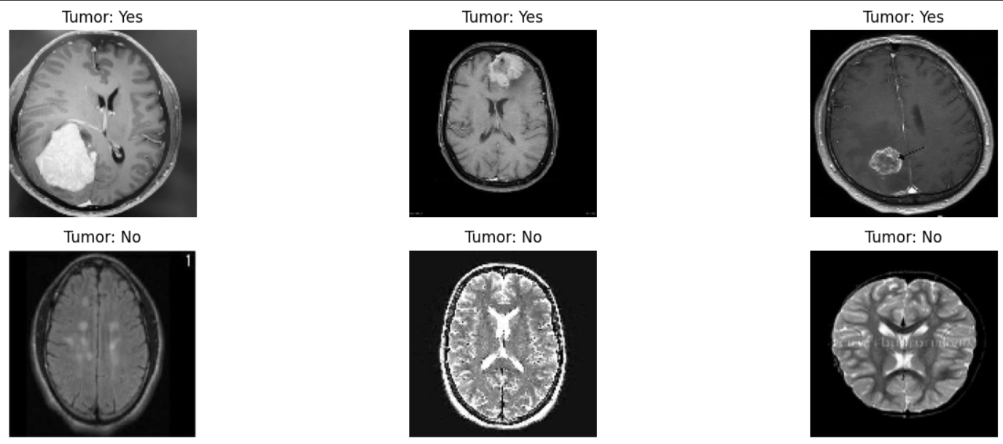

**Fig: 3.1 Brain MRI (Tumor and Non-Tumor)**

**4. CLASSIFICATION MODELS AND ASSESSMENT**

The procedures we implemented in this phase were shaped by the insights gained from our exploratory data analysis. There are two types of images: no tumor and tumor. The dataset used in this study had 1500 benign (no tumor) cases and 1500 malignant (tumor) cases. Thus, the dataset displays an equitable distribution between samples with brain tumors and those without, ensuring that our model is trained on a comprehensive dataset that is free from biases towards any specific class. The resolution of the images was variable such as 225x225, 442x442, 630x630, etc.

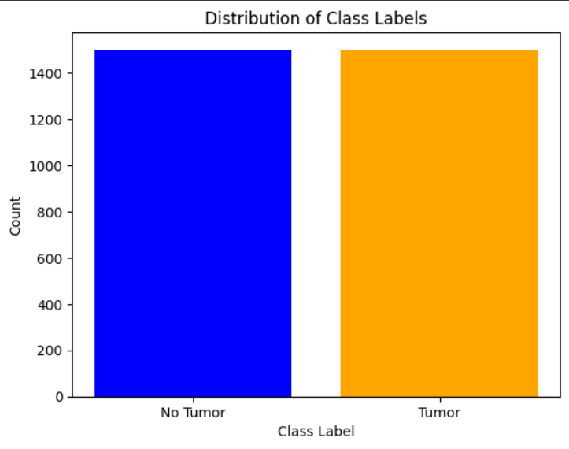

**Fig: 4.1 Image Class Labels Distribution**

In data preprocessing, Cropping MRI images to isolate the brain region is a crucial preprocessing step for brain tumor detection. It removes irrelevant background information, reducing noise and computational burden. Cropped images enable data augmentation, facilitate normalization, and allow the model to focus on relevant spatial features within the brain. This preprocessing technique, combined with contrast enhancement and extreme point detection, enhances the model's performance and robustness in accurately detecting brain tumors from MRI scans.

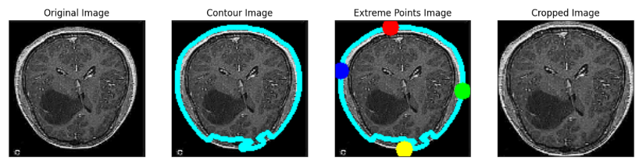

**Fig: 4.2 Brain Image Preprocessing**

The following image displays diverse feature maps from the "block2_conv1" layer of a VGG16 model for brain MRI analysis. These maps capture low-level features like edges, textures, and spatial patterns within the brain images through varying neuron activations (color intensities). This diversity suggests the layer's ability to encode relevant low-to-mid level representations crucial for higher-level tasks like tumor detection. Visualizing these feature hierarchies offers insights into the model's internal workings, enhancing interpretability and trustworthiness in medical AI applications.

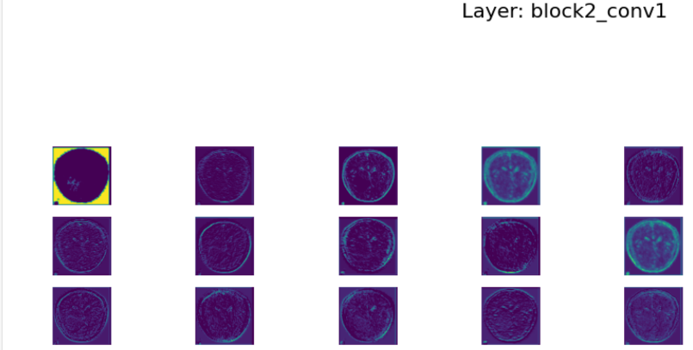

**Fig: 4.3 Feature Map Visualization of VGG16's Block2_Conv1 Layer for Brain MRI Analysis**

Data Augmentation was enabled using ImageDataGenerator with parameters such as rotation_range, horizontal_flip, vertical_flip, zoom_range, etc. to enhance the model generalization performance.

**5. Deep Neural Network based Model (Optimized InceptionResnet – V2)**

The InceptionResNet-V2 model utilized in our brain tumor detection project exhibits remarkable performance, particularly after optimization by unfreezing the last 10 layers. This architecture, akin to a Multilayer Perceptron (MLP), comprises multiple layers, including an input layer, several hidden layers, and an output layer. By allowing information to flow forward through interconnected nodes or neurons, the model effectively captures intricate relationships within the data.

To prevent overfitting and enhance generalization capabilities, a dropout rate of 10% was applied after each hidden layer, except the last one. This dropout regularization mechanism plays a pivotal role in maintaining model robustness.

Our trained InceptionResNetV2 model demonstrated outstanding accuracy, with a training accuracy of 99%. Through backpropagation and gradient descent, the model learned to map health-related features to the binary outcome of brain tumor occurrence. Notably, it achieved an overall accuracy of 99%, showcasing its proficiency in correctly classifying tumor and non-tumor instances.

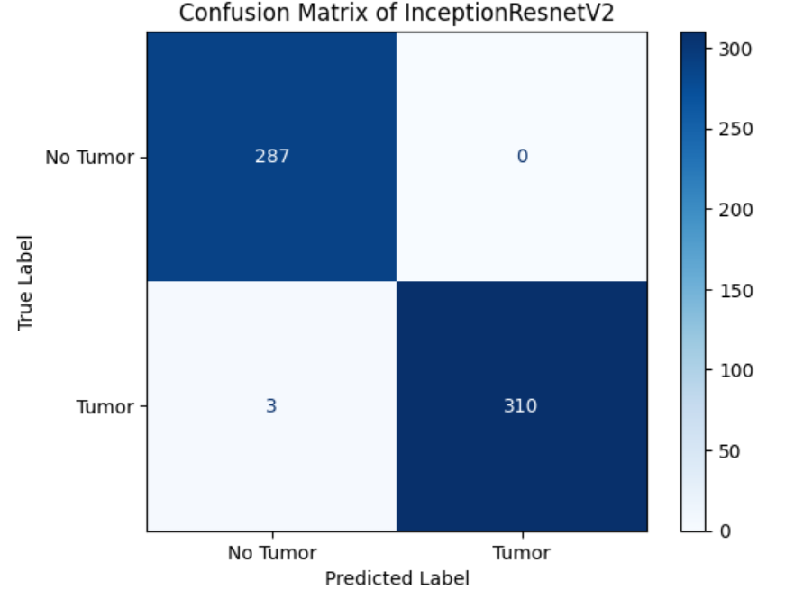

**Fig: 5.1 Confusion Matrix of InceptionResNetV2**

The loss curve of the InceptionV3 model illustrated its training trajectory and the process of reaching optimal performance; the curve generally showed a decreasing pattern.

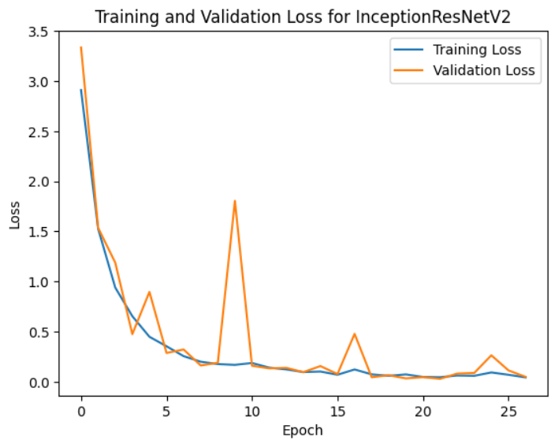

**Fig: 5.2 Training and Validation Loss Curve of InceptionResNetV2**

The Receiver Operating Characteristic (ROC) curve of the ResNet-152 model illustrates the relationship between the true positive rate and the false positive rate, offering a thorough evaluation of the model's predictive capability across various thresholds.

**Fig: 5.3 ROC Curve of InceptionResNetV2**

In summary, the optimized InceptionResNetV2 model stands as a powerful tool for brain tumor detection, boasting exceptional accuracy and performance. Its ability to effectively identify tumor cases based on relevant health features underscores its potential for aiding in early diagnosis and treatment planning.

**6. TRAINING THE OTHER NEURAL MODELS**

In our study on brain tumor detection, we explored a range of established models, including EfficientNetB7, ResNet152, and InceptionResNetV2. Renowned for their efficacy, these models enabled us to draw comparisons with existing research outcomes and validate our findings.

To comprehensively evaluate the performance of our models, we employed a robust evaluation methodology. Initially, we partitioned our dataset into training and testing sets, allocating 80% for model training and reserving the remaining 20% for evaluation purposes. The training data was further split into training (75%) and validation (25%) sets. Confusion matrices served as pivotal tools in assessing the models, facilitating the calculation of vital metrics such as accuracy, Area Under the Curve (AUC), precision, and Receiver Operating Characteristic (ROC) curve. These metrics provided comprehensive insights into the models' performance across both classes, allowing us to identify the most effective model for predicting brain tumor occurrences.

1. **EfficientNet – B7**

In the realm of brain tumor detection, EfficientNet emerges as a cutting-edge neural network architecture, renowned for its prowess in optimizing computational efficiency without sacrificing model performance. With its innovative approach to model scaling, EfficientNet achieves a harmonious balance between depth, width, and resolution, culminating in superior accuracy across diverse datasets. Leveraging its meticulously designed network architecture, EfficientNet typically comprises several layers, with the precise number varying depending on the specific variant of the model. For instance, EfficientNet-B0, the baseline variant, consists of 7 layers, while larger variants like EfficientNet-B7 may encompass up to 66 layers.

In our study utilizing EfficientNet for brain tumor detection, the model showcased remarkable performance, boasting an accuracy of 96.33%. Notably, the model identified 296 true negatives, indicative of correctly classified non-tumor instances. However, the detection process was not without its challenges, as it yielded 282 false positives, underscoring the ongoing need for refinement and optimization in neural network-based tumor detection methodologies.

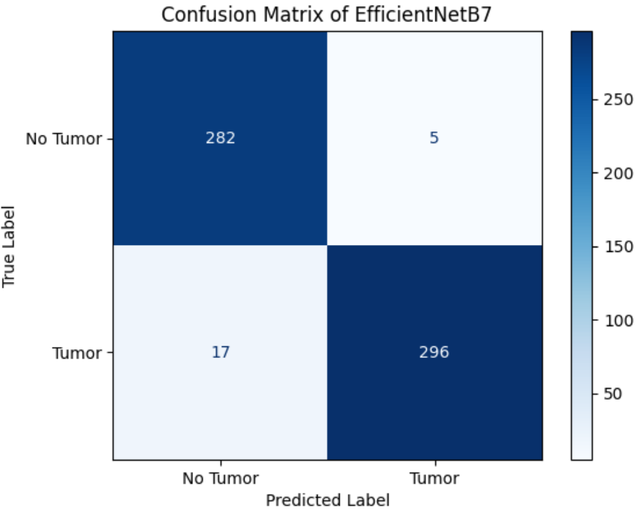

**Fig: 6.a.1 EfficientNetB7 Confusion Matrix**

In tandem with the accuracy metrics, the loss graph accompanying our EfficientNet model illustrates the convergence of training and validation losses over epochs. This graphical representation offers invaluable insights into the model's learning dynamics, showcasing the trajectory of loss minimization throughout the training process. By analyzing this graph, we gain a deeper understanding of the model's optimization journey and its ability to effectively adapt to the nuances of the brain tumor detection task.

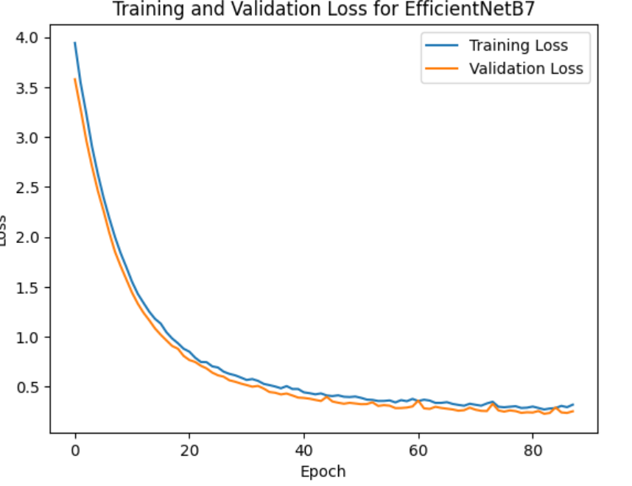

**Fig: 6.a.2 Training and Validation Loss Curve of EfficientNetB7**

The Receiver Operating Characteristic (ROC) curve for our EfficientNetB7 model serves as a visual depiction of its classification performance across different threshold levels. By plotting the true positive rate against the false positive rate, this curve provides a comprehensive overview of the model's ability to discriminate between tumor and non-tumor instances. Analyzing the ROC curve enables us to assess the trade-off between sensitivity and specificity, aiding in the selection of an optimal threshold for clinical decision-making.

**Fig: 6.a.3 ROC Curve of EfficientNetB7**

1. **ResNet152**

ResNet-152, a powerful convolutional neural network architecture, boasts a deep structure with 152 layers. Renowned for its ability to effectively extract intricate features from images, ResNet-152 has been instrumental in our brain tumor detection project. Leveraging its deep layers, ResNet-152 comprehensively analyzes MRI images, enabling accurate identification of tumor regions amidst complex brain structures.

In our evaluation, the ResNet-152 model exhibited exceptional performance, achieving an impressive accuracy of 97.8%. With only 282 false positives and 305 true positives, the model demonstrates its robustness in accurately distinguishing between tumor and non-tumor regions. Furthermore, the high accuracy underscores ResNet-152's efficacy as a reliable tool for assisting clinicians in diagnosing brain tumors with confidence and precision.

The confusion matrix for the ResNet-152 model showcases its performance in classifying brain tumor images. With 282 false positives and 305 true positives, the matrix provides a detailed breakdown of the model's predictive accuracy. It illustrates the model's ability to correctly identify true positive cases while also highlighting instances of false positives, offering valuable insights into its strengths and areas for improvement.

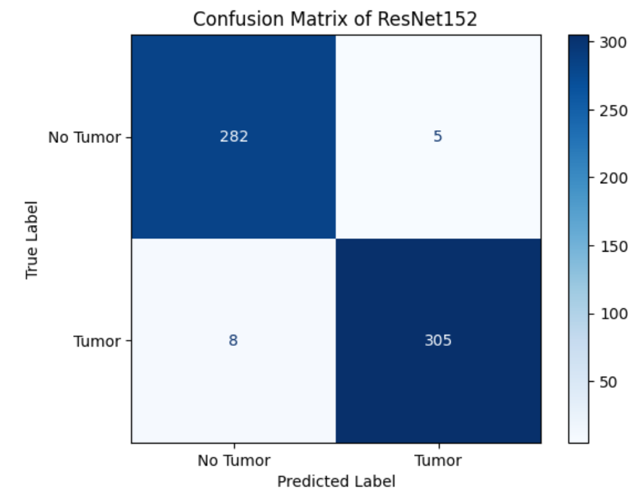

**Fig: 6.b.1 ResNet152 Confusion Matrix**

The loss graph of the ResNet-152 model visualizes the training process and the model's convergence towards optimal performance. It tracks the model's loss, typically calculated using metrics like cross-entropy, over epochs or iterations during training. A decreasing loss indicates that the model is effectively learning and minimizing errors, while fluctuations may indicate areas where further optimization is required.

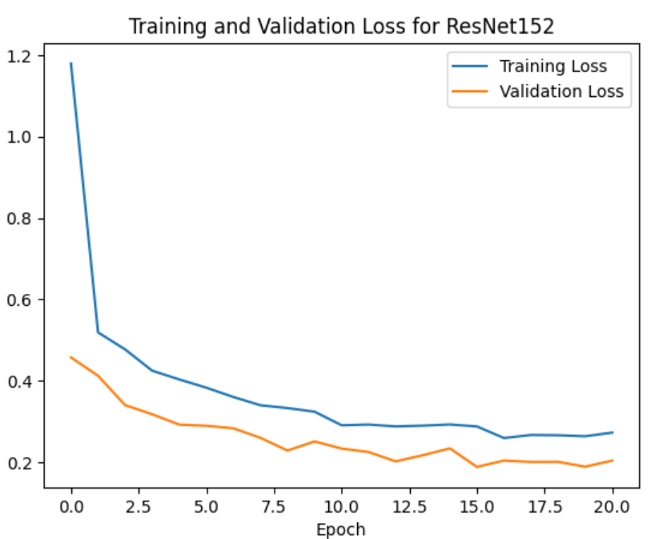

**Fig: 6.b.2 Training and Validation Loss Curve of RestNet152**

The Receiver Operating Characteristic (ROC) curve for the ResNet-152 model plots the true positive rate against the false positive rate, providing a comprehensive assessment of the model's predictive performance across different thresholds. A curve that closely aligns with the top-left corner indicates high sensitivity and specificity, reflecting the model's ability to effectively discriminate between tumor and non-tumor regions. The area under the ROC curve (AUC) quantifies the overall performance of the model, with a higher AUC indicating superior predictive accuracy.

**Fig: 6.b.3 ROC Curve of ResNet152**

1. **InceptionV3**

InceptionV3 is a convolutional neural network architecture renowned for its efficiency and performance in image recognition tasks. Developed by Google researchers, it comprises 48 convolutional layers, including both convolutional and pooling layers, followed by fully connected layers for classification. Its unique architecture incorporates various modules called "Inception blocks," which allow for parallel processing of input data at different scales and resolutions, facilitating feature extraction across multiple levels of abstraction.

In our evaluation of brain tumor detection models, InceptionV3 exhibited promising performance, albeit with notable limitations. With 236 false negatives and 276 true positives, the model showcased moderate accuracy at 85.33%. We conducted extensive experiments to optimize the model's performance by exploring a range of hyperparameters. These included varying batch sizes (32, 64, 256, 512), dropout rates (10%, 20%, 30%, 40%, 50%, 60%), and adjusting the number of dense layers along with the number of neurons in each layer. Despite these efforts, we encountered challenges in surpassing an accuracy threshold of 85%. The confusion matrix provided insights into its classification capabilities, revealing areas where the model struggled to accurately distinguish between tumor and non-tumor regions. Despite its limitations, InceptionV3 contributed valuable insights into brain tumor detection, underscoring the importance of robust evaluation and comparative analysis.

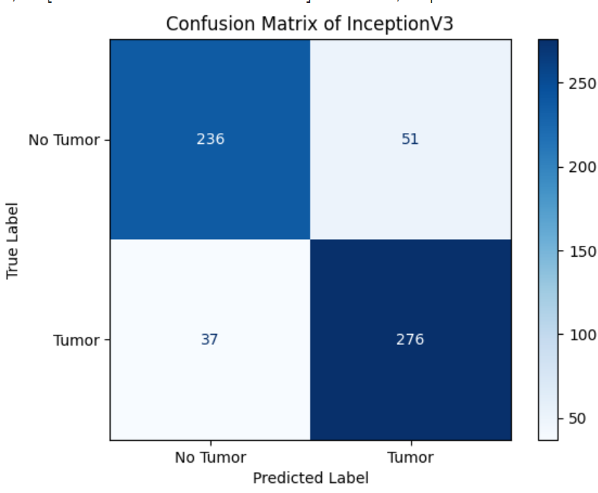

**Fig: 6.c.1 InceptionV3 Confusion Matrix**

The loss graph for the InceptionV3 model depicted its training progression and convergence towards optimal performance. While the graph demonstrated a downward trend indicative of learning, fluctuations may suggest areas requiring further optimization or regularization techniques to enhance model stability and generalization.

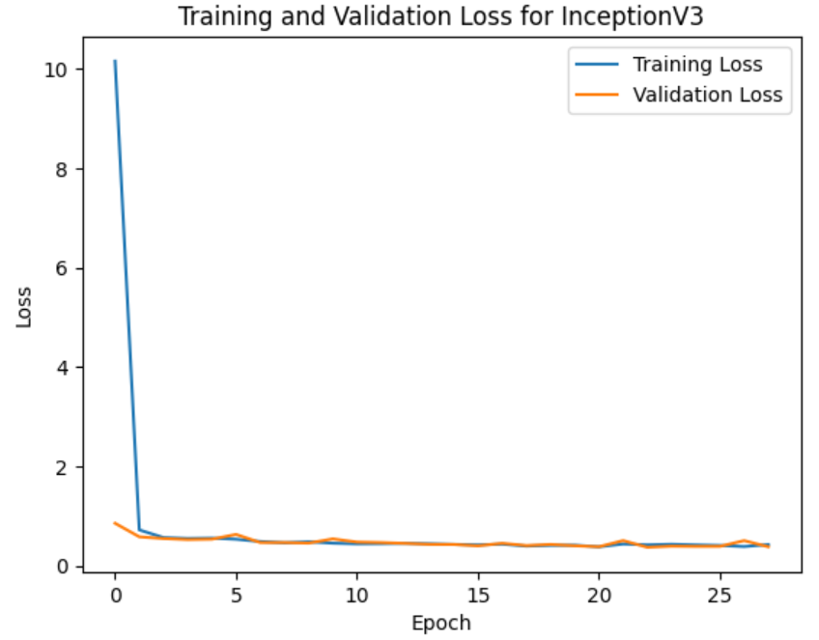

**Fig: 6.c.2 Training and Validation Loss Curve of InceptionV3**

The Receiver Operating Characteristic (ROC) curve of InceptionV3 illustrated its trade-off between true positive rate and false positive rate across different classification thresholds. Despite achieving an accuracy of 85%, the curve revealed areas where the model struggled to balance sensitivity and specificity, indicating room for improvement in its predictive performance. The analysis of the ROC curve and area under the curve (AUC) provided valuable insights into the model's overall performance and its ability to discriminate between tumor and non-tumor regions.

**Fig: 6.c.3 ROC Curve of InceptionV3**

**7. HYPER PARAMETER TUNING**

To further enhance the performance of our models, we conducted hyperparameter tuning, aiming to optimize their configurations for improved accuracy and efficiency. Employing transfer learning with max pooling, Adam optimizer, and Binary Cross Entropy loss function, we implemented an early stopping, callback function with parameters set to prevent overfitting and ensure accurate predictions.

* **Model: EfficientNetB7**

**Architecture:** Two dense layers (128 and 64 units) with ReLU activation and L2 regularization (0.01 penalty), followed by a final layer with Sigmoid activation.

**Training Parameters:** Batch size of 512, 100 epochs, and dropout of 50% after each layer. The model ceased training after 88 epochs for optimal accuracy.

* **Model: Resnet152**

**Architecture:** Single dense layer (128 units) with ReLU activation, L2 regularization (0.001 penalty), and 60% dropout, followed by a final layer with sigmoid activation.

**Training Parameters:** Batch size of 32, 50 epochs, with training concluding after 21 epochs.

* **Model: InceptionV3**

**Architecture:** Single dense layer (128 units) with ReLU activation, 10% dropout, and final layer with sigmoid activation.

**Training Parameters:** Batch size of 32, 100 epochs, with training concluding after 28 epochs.

* **Model: InceptionResnetV2**

**Architecture:** The last 10 layers of the pre-trained InceptionResnetV2 layer were unfreezed. Two dense layers (128 and 64 units) with ReLU activation, L2 regularization (0.01 penalty), and dropout of 30% and 20%, respectively, followed by a final layer with sigmoid activation.

**Training Parameters:** Batch size of 32, 100 epochs. Utilized ReduceLROnPlateau callback function with parameters (factor: 0.2, patience: 5, min_lr: 1e-6), ceasing training after 27 epochs.

By performing the hyperparameter tuning the accuracy of EfficientNetB7, ResNet152, InceptionV3, and InceptionResNetV2 models is increased.

**8. RESULTS**

|  |  |  |  |  |
| --- | --- | --- | --- | --- |
| **Evaluation of all the models** | | | | |
| Models | Accuracy | Precision | Recall | Specificity |
| EfficientNetB7 | 96.33 | 98.33 | 94.57 | 98.26 |
| ResNet152 | 97.83 | 98.39 | 97.44 | 98.26 |
| InceptionV3 | 85.33 | 84.40 | 88.18 | 82.22 |
| InceptionResnetV2 | 47.83 | 0 | 0 | 100.00 |
| Optimized InceptionResnetV2 | 99.50 | 100.00 | 99.04 | 100.00 |

**Table: 8.1 Evaluation of all the models.**

We found that the **best model was the Optimized InceptionResNetV2 with 99.50% of accuracy and precision of 100%**.

**9. CONCLUSION**

In our project on brain tumor detection, the optimized InceptionResNetV2 model emerged as the top performer, achieving an impressive accuracy of 99.5%. This exceptional accuracy underscores the effectiveness of leveraging deep neural network architectures for medical image analysis tasks. By integrating the strengths of both Inception and ResNet architectures, InceptionResNetV2 excelled in capturing intricate features and patterns indicative of brain tumors, resulting in highly accurate predictions.

The success of the optimized InceptionResNetV2 model signifies its potential as a powerful tool for early detection and diagnosis of brain tumors, enabling timely interventions and improved patient outcomes. Leveraging its robust performance and high accuracy, healthcare practitioners can confidently utilize this model as part of their diagnostic workflows, aiding in the identification and classification of brain abnormalities with unparalleled precision. Furthermore, the optimization of the InceptionResNetV2 architecture highlights the importance of fine-tuning model parameters and architecture design to maximize performance in specific medical imaging tasks.

Overall, the exceptional accuracy achieved by the optimized InceptionResNetV2 model represents a significant milestone in the field of medical image analysis, demonstrating the transformative potential of deep learning techniques in advancing healthcare diagnostics. This milestone paves the way for further research and development efforts aimed at harnessing the capabilities of neural network models for improved disease detection and patient care.

Future work includes refining the model to identify the specific location of brain tumors within MRI images, enabling precise localization for targeted treatment strategies. Additionally, efforts will be directed towards enhancing the model's classification capabilities to enabling it to accurately differentiate between malignant tumors like pituitary, glioma, and meningioma, facilitating more accurate prognoses and treatment planning. Exploration of alternative neural network architectures such as DenseNet, MobileNet, and Xception presents exciting opportunities to further improve the model's performance and robustness, potentially uncovering novel insights in brain tumor detection and analysis.

**REFERENCES**

[1] Mehrotra, R., Ansari, M., Agrawal, R., & Anand, R, “A Transfer Learning approach for AI-based classification of brain tumors. *Machine Learning With Applications”*, *2*, 100003, 2020.

[2] A. Anaya-Isaza and L. Mera-Jiménez, "Data Augmentation and Transfer Learning for Brain Tumor Detection in Magnetic Resonance Imaging," in IEEE Access, vol. 10, pp. 23217-23233, 2022.

[3] S. Asif, W. Yi, Q. U. Ain, J. Hou, T. Yi and J. Si, "Improving Effectiveness of Different Deep Transfer Learning-Based Models for Detecting Brain Tumors From MR Images," in IEEE Access, vol. 10, pp. 34716-34730, 2022.

[4] Ahmad, Saif, and Pallab K. Choudhury. "On the performance of deep transfer learning networks for brain tumor detection using MR images." IEEE Access 10, 2022.

[5] G. Gayathri and S. Sindhu, "Efficientnet for Brain Tumor Detection from MRI," 2022 Third International Conference on Intelligent Computing Instrumentation and Control Technologies (ICICICT), Kannur, India, 2022.