Software Requirements Specification (SRS) Template

Project: Attrition Analysis System
Version: 1.0
Authors: <BEE>
Date: 03-09-2025
Status: Model Answer / Approved

Revision history
Version | Date | Author | Change summary | Approval
1.0 | 03-09-2025 | BEE | SRS with diagrams embedded

Approvals
Role | Name | Signature / Email | Date
Course Coordinator

Table of Contents
1. Introduction
2. Overall description
3. External interfaces
4. System features (detailed)
5. Non-functional requirements (detailed)
6. Quality attributes & Acceptance tests
7. UML Use-Case Diagram
8. Requirements Traceability Matrix (RTM)

1. Introduction

1.1 Purpose
This document describes the requirements for an Attrition Analysis System that will be used by the HR department to study employee turnover. The aim is to identify patterns in employee exits, predict who might leave in the near future, and help the company reduce attrition through better decision-making.
1.2 Scope
The system focuses mainly on:
Collecting and analyzing employee data such as demographics, performance, and tenure. Generating attrition prediction scores using statistical or ML models. Showing HR managers easy-to-understand dashboards and reports .Alerting HR when an employee is flagged as “high risk. ”The system will not replace the HRMS but will connect to it and act as an analytics tool. Recruitment, payroll, and attendance are outside the scope.
1.3 Audience
HR Managers , Business Executives, Data Analysts.
1.4 Definitions / Acronyms
•HR: Human Resources
•ML: Machine Learning
•KPI: Key Performance Indicator
•RTM: Requirements Traceability Matrix

2. Overall description

2.1 Product perspective
This will be a web-based solution that works on desktops and tablets. It will integrate with the HRMS systems and employee databases .

2.2 Major product functions (detailed)
- Import and process employee data
-Predict attrition risks using ML models.
-Show dashboards with insights).
-Generate reports for decision-making.
- Provide secure role-based access.

2.3 User roles and characteristics (expanded)
-HR Manager – day-to-day user of the dashboards.
-Business Executive – mainly reviews high-level reports.
-Data Analysts – configures, maintains, and retrains the model.

2.4 Operating Environment
Runs as a cloud-based web app, accessible on desktops and mobiles using browsers.
2.5 Constraints
Must follow data privacy rules (GDPR/DPDP), handle large datasets, and allow only authorized HR staff access.

3. External interface requirements

3.1 User interfaces
• The system provides interactive dashboards that show attrition trends and predictions.
• Users can apply filters (e.g., by department, role, age group, gender, salary range).
• Reports can be downloaded in PDF and Excel formats.
• The interface is designed to be simple, with graphs, charts, and KPIs for quick understanding
3.2 Hardware interfaces
• Works on standard laptops, desktops, and mobile devices.
• No special hardware required apart from internet access.
3.3 Software interfaces
• Connects with existing HRMS/ERP systems to pull employee data.
• Accepts CSV and Excel uploads for bulk data import.
• Exports data and reports for use in other business tools.
3.4 Communications
• Uses HTTPS (TLS 1.2+) for secure communication.
• Supports API connections for data exchange with HR systems.

4. System features (detailed)
Each requirement below includes acceptance criteria and a reference test case. IDs follow ATR-FR-###.

4.1 Functional Requirements

Req ID | Requirement | Category | Priority | Acceptance criteria / Test case ref
ATR-FR-001 | Import employee data from CSV/Excel files or HRMS. | Data Management | High | System successfully imports without errors.
ATR-FR-002 | Automatically clean, validate, and prepare data for analysis. | Data Management | High | Missing/invalid data handled correctly.
ATR-FR-003 | Allow filtering by department, role, age, gender, salary, etc. | Data Management | Medium | Filters return correct results.
ATR-  FR-004 | Calculate attrition rates by department, job role, or tenure | Analytics & Prediction | High | Rates match with manually calculated data.
ATR-  FR-005 | Predict which employees may leave using ML models. | Analytics & Prediction | High | Prediction accuracy ≥ 80%.
ATR-  FR-006 | Show trends and patterns in attrition through graphs/charts. | Analytics & Prediction | Medium | Charts correctly show historical data.
ATR-  FR-007 | Provide dashboards with KPIs, insights, and summaries. | Reporting & Dashboards | High | HR dashboard loads under 3s with valid data.
ATR-  FR-008 | Generate monthly, quarterly, and yearly attrition reports. | Reporting & Dashboards | High | Reports generated correctly and downloadable.
ATR-  FR-009 | Export reports as PDF or Excel files. | Reporting & Dashboards | Medium | File exports open without corruption.
ATR-  FR-010 | Send notifications when attrition exceeds a threshold. | Alerts & Feedback | High | HR receives alerts when thresholds are met.
ATR-  FR-011 | Allow HR to provide feedback on prediction accuracy. | Alerts & Feedback | Medium | Feedback stored in system.
ATR-  FR-012 | Retrain prediction models with new HR data. | Alerts & Feedback | Medium | Retraining executes without errors
ATR-  FR-013 | Provide secure role-based login (HR, Executive, Analyst). | Security Features | High | Access restricted based on user role.
ATR-  FR-014 | Maintain audit logs of all system activity. | Security Features | High | All actions logged and retrievable.
ATR-  FR-015 | Ensure visual display of attrition trends over time. | Analytics & Prediction | High | Graphs show time-based patterns clearly.

4.2 Data Management
- 4.1.1 Import Data: HR can upload employee data from files or integrate directly with HRMS.
- 4.1.2 Data Cleaning: The system automatically checks for errors, missing values, and prepares data for analysis.
- 4.1.3 Data Filtering: Users can filter by department, role, age, gender, or salary.

4.3 Analytics & Prediction
- 4.2.1 Attrition Rate Analysis: Calculates attrition rates by department, job role, or tenure.
- 4.2.2 Attrition Prediction: Uses ML models to predict which employees might leave soon.
- 4.2.3 Trend Visualization: Shows attrition patterns over time in graphs and charts.

4.4 Reporting & Dashboards
- 4.3.1 Dashboards: Interactive dashboard with KPIs, charts, and summaries.
- 4.3.2 Reports: Generates monthly, quarterly, and yearly reports.
- 4.3.3 Export Options: Allows reports to be downloaded as PDF or Excel.

4.5 Alerts & Feedback
- 4.4.1 Notifications: Sends alerts to HR when attrition crosses thresholds.
- 4.4.2 Feedback Collection: Lets HR give feedback on whether predictions were accurate.
- 4.4.3 Model Retraining: Updates ML models with new data and feedback.

4.6 Security Features
- 4.5.1 Role-Based Access: HR, Executives, and Analysts see different features based on their role.
- 4.5.2 Audit Logs: All actions are recorded for monitoring and security compliance.

5. Non-functional requirements (detailed)
NFRs below are measurable and tied to test plans. IDs ATR-NF-###.

Req ID | Requirement | Category | Priority | Acceptance criteria / Measurement
ATR-NF-001 | The system shall load dashboards and reports within ≤ 3 seconds for 90% of requests under normal load | Performance | High | 90th percentile ≤ 5s in production-like test. Test: TC-Perf-01
ATR-NF-002 | The system shall provide 99.5% availability monthly (excluding scheduled maintenance). | Reliability | High | Uptime reports show ≥99.5%.
ATR-NF-003 | All employee data shall comply with GDPR/DPDP privacy regulations, ensuring encryption at rest and in transit. | Security/Compliance | High | Data protection audit passed.
ATR-NF-004 |  | Audit/Data Retention | High | Logs retrievable and intact.
  System shall
  maintain
  Audit logs of
  all HR
  activities for
  minimum 5
  years
ATR-NF-005 | The user interface shall support accessibility features (screen readers, high contrast) conforming to WCAG 2.1 AA. applicable. | Usability/Accessibility | Medium | Accessibility audit passed.

5.1. Security

5.1.1 Security Objectives
* Ensure confidentiality of employee data.
* Maintain data integrity and prevent unauthorized changes.
* Enforce role-based access control.
* Comply with GDPR/DPDP policies.

5.1.2 Security Requirements
Req ID | Requirement (shall...) | Type | Priority | Acceptance criteria / Test case ref
ATR-SR-001 | TLS 1.2+ mandatory for all network connections. | Security | High | Security test cases pass.
ATR-SR-002 | Encrypt all employee data at rest and in transit | Security | High | Data audit shows no plaintext storage.
ATR-SR-003 | Implement role-based access (HR, Executives, Analysts). | Access control | High | Uses restricted by roles in tests
ATR-SR-004 | Maintain audit logs of logins and data access activities. | Audit | High | Logs retrievable and intact.
ATR-SR-005 |  | Autentication | Medium | Login/MFA test cases passes.
  Enforce strong passwords
  and support MFA

6. Quality attributes & Acceptance tests
• Exit criteria:
The system will be accepted if all high-priority functional and non-functional requirements are met, prediction accuracy is ≥ 80%, dashboards and reports load within 3 seconds, and security compliance with GDPR/DPDP is verified.
• Acceptance test suites:
Data Accuracy & Prediction Tests – Validate correct import, cleaning, and calculation of attrition rates, with ML predictions meeting the accuracy threshold.
Performance & Reliability Tests – Ensure dashboards and reports load quickly, system uptime ≥ 99.5%, and response time within acceptable limits.
Security & Compliance Tests – Verify role-based access, encryption, audit logs, and adherence to data privacy regulations.
Usability & Accessibility Tests – Confirm dashboards are easy to use, support filters, and meet WCAG 2.1 AA accessibility standards.

7. System models and diagrams

7.1 UML Use-Case diagram
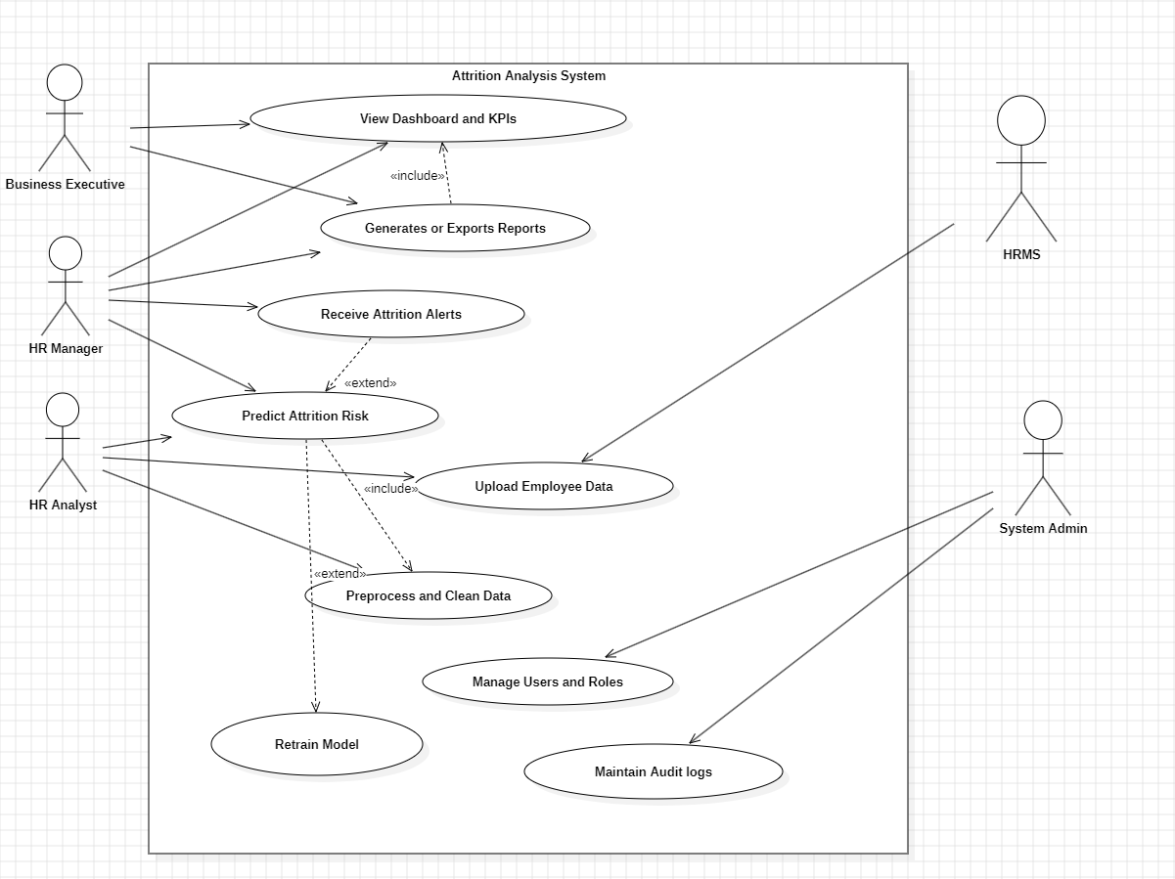

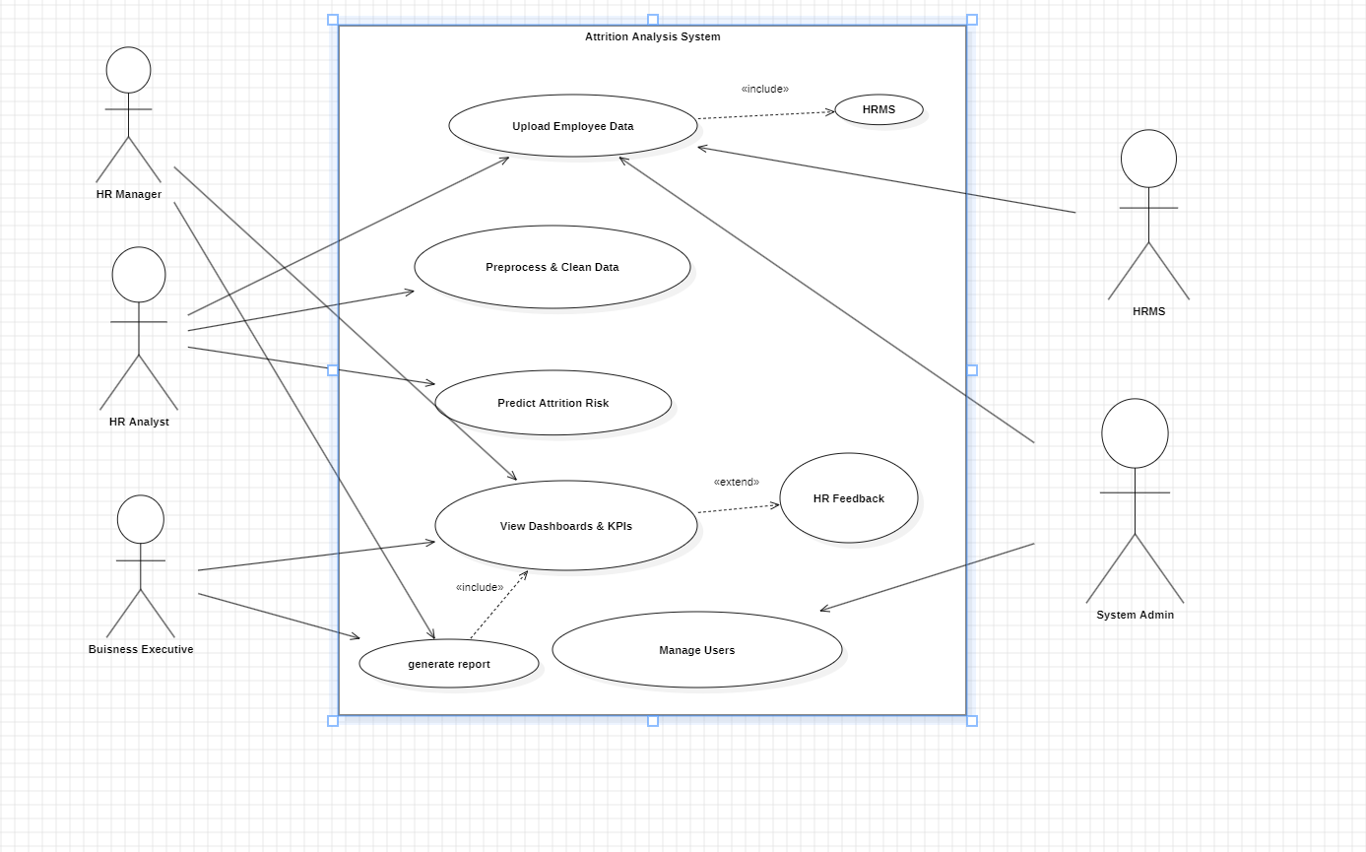

8. Requirements Traceability Matrix (RTM)

Req ID | Requirement short | Section ref / Design Spec | Module | Test case(s) | Status (N/P/A) | Comments
ATR-FR-001 |  | 4.1 / DS-Data-01 | DataIngestion | TC-Data-01 | N
  Import employee data
  HRMS / CSV input needed
ATR-FR-005 | Predict attrition risk | 4.3 / DS-Model-01 | MLModel | TC-Model-01 | N | Accuracy ≥ 80% required
ATR-FR-007 | Show dashboards & KPIs | 4.4 / DS-UI-01 | Dashboard | TC-UI-01 | N | Must load < 3s
ATR-FR-008 | Generate reports | 4.4 / DS-Report-01 | Reporting | TC-Report-01 | N | Export as PDF/Excel
ATR-NF-001 | Dashboard load ≤ 3s | 5 / DS-Perf-01 | WebUI/API | TC-Perf-01 | N | 90% requests within limit
ATR-NF-003 | GDPR/DPDP compliance | 5 / DS-Sec-01 | SecurityModule | TC-Sec-01 | N | Encrypt at rest & transit
ATR-SR-004 | Maintain audit logs | 5.1 / DS-Audit-01 | AuditModule | TC-Audit-01 | N | Logs retrievable for 5 yrs

