**PHASE 4 : Fashion MNIST Project exploration in IBM Cloud:**

Dataset Description: Fashion MNIST is a dataset of grayscale images of clothing items, with a total of 10 different categories. Each category corresponds to a different type of clothing, such as T-shirts, dresses, sneakers, and more. There are 60,000 training images and 10,000 testing images, each of size 28x28 pixels.

Purpose: Fashion MNIST is often used as a replacement for the classic MNIST dataset of handwritten digits. It's a more challenging dataset because it involves classifying images of real-world objects with more visual complexity.

Machine Learning Projects: Organizations like IBM, as well as many other companies and researchers, may use the Fashion MNIST dataset for various machine learning and computer vision projects. Some common use cases include:

Image Classification: Building machine learning models to classify the images into one of the 10 categories.

Deep Learning: Using convolutional neural networks (CNNs) to achieve state-of-the-art performance on Fashion MNIST.

Transfer Learning: Adapting pre-trained models (e.g., from ImageNet) for the task of fashion item classification.

Benchmarking Algorithms: Comparing and evaluating different machine learning algorithms and models using this dataset.

Research and Education: Fashion MNIST is also used in educational contexts and research to teach and explore concepts related to image classification, deep learning, and computer vision.

Open Source Community: The dataset is readily available to the open-source community, making it accessible for researchers, students, and developers to experiment with and build upon.

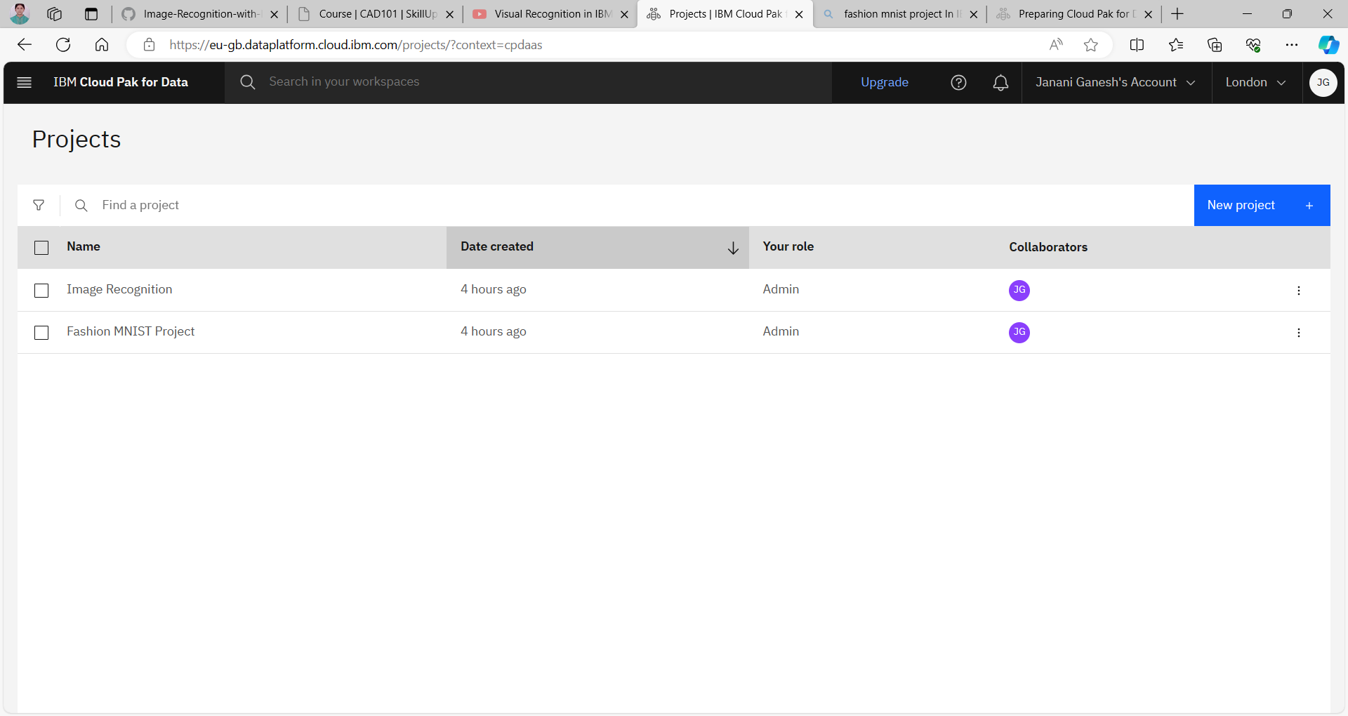

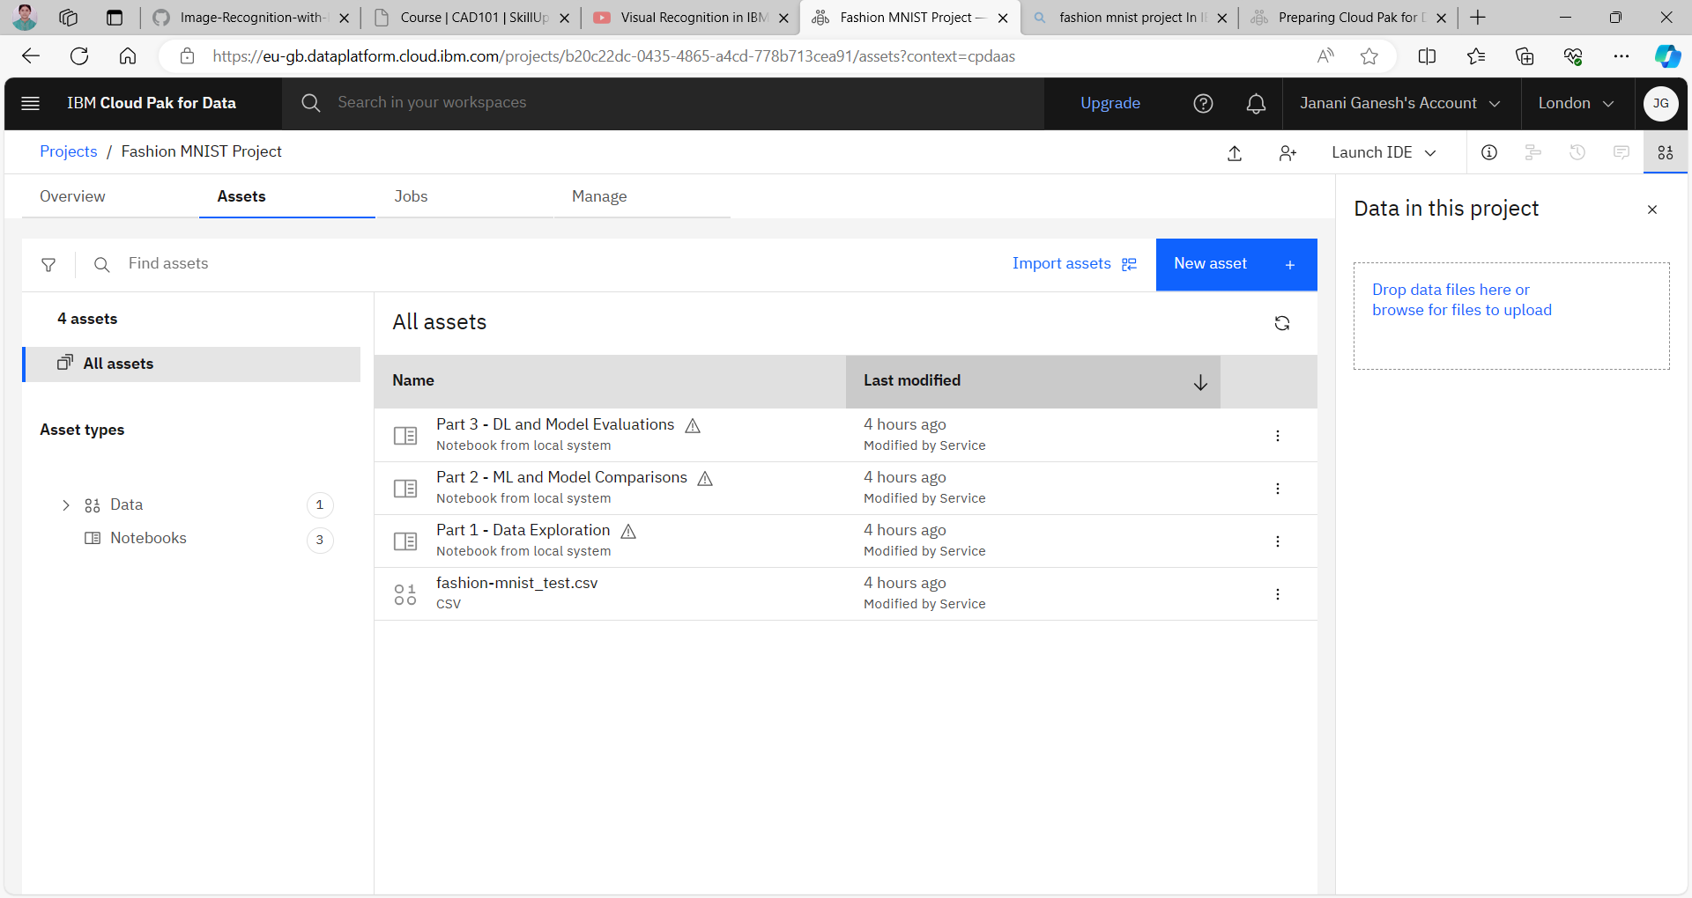

Part 1 : Data Exploration

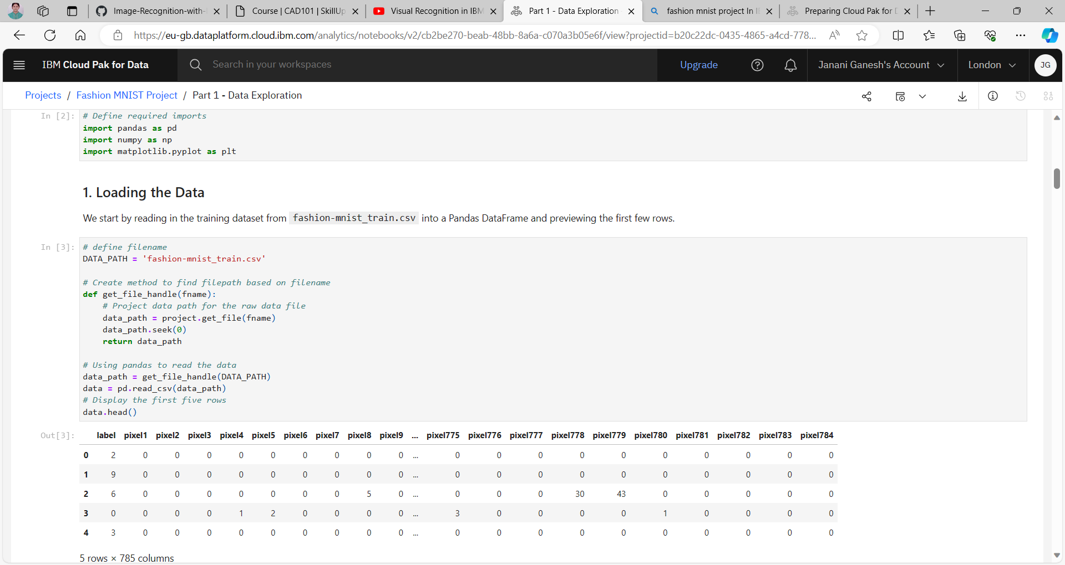

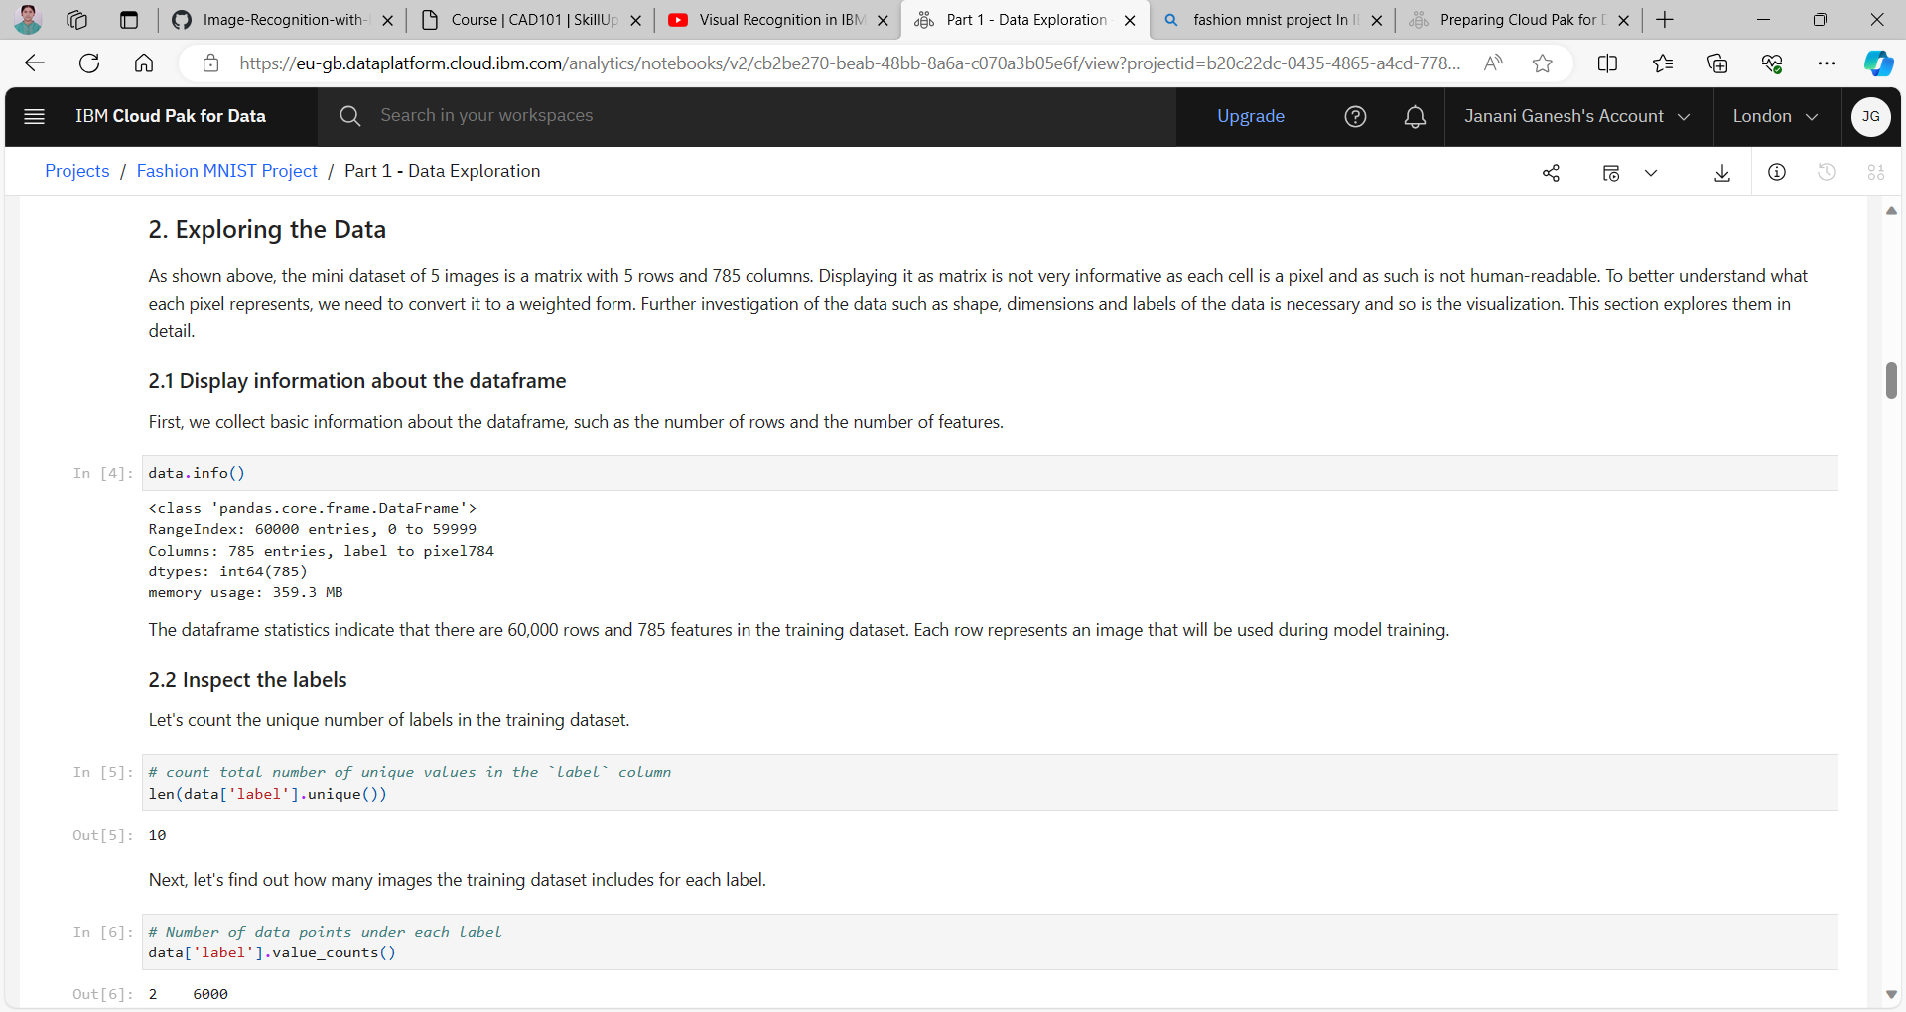

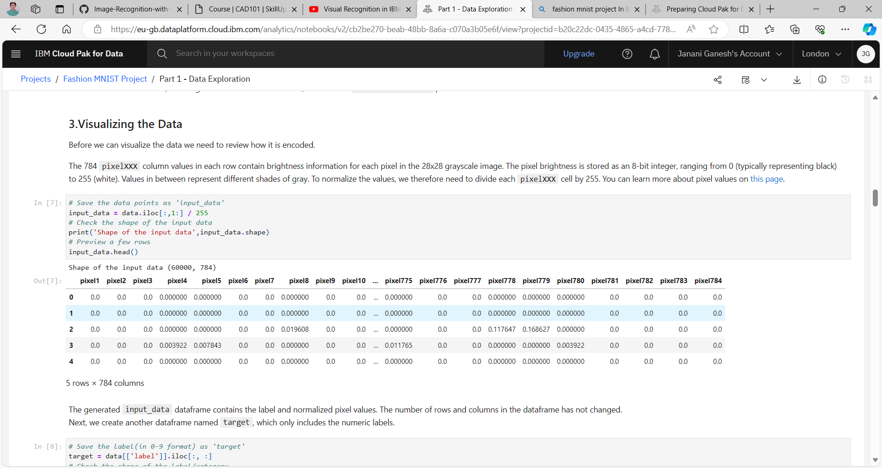

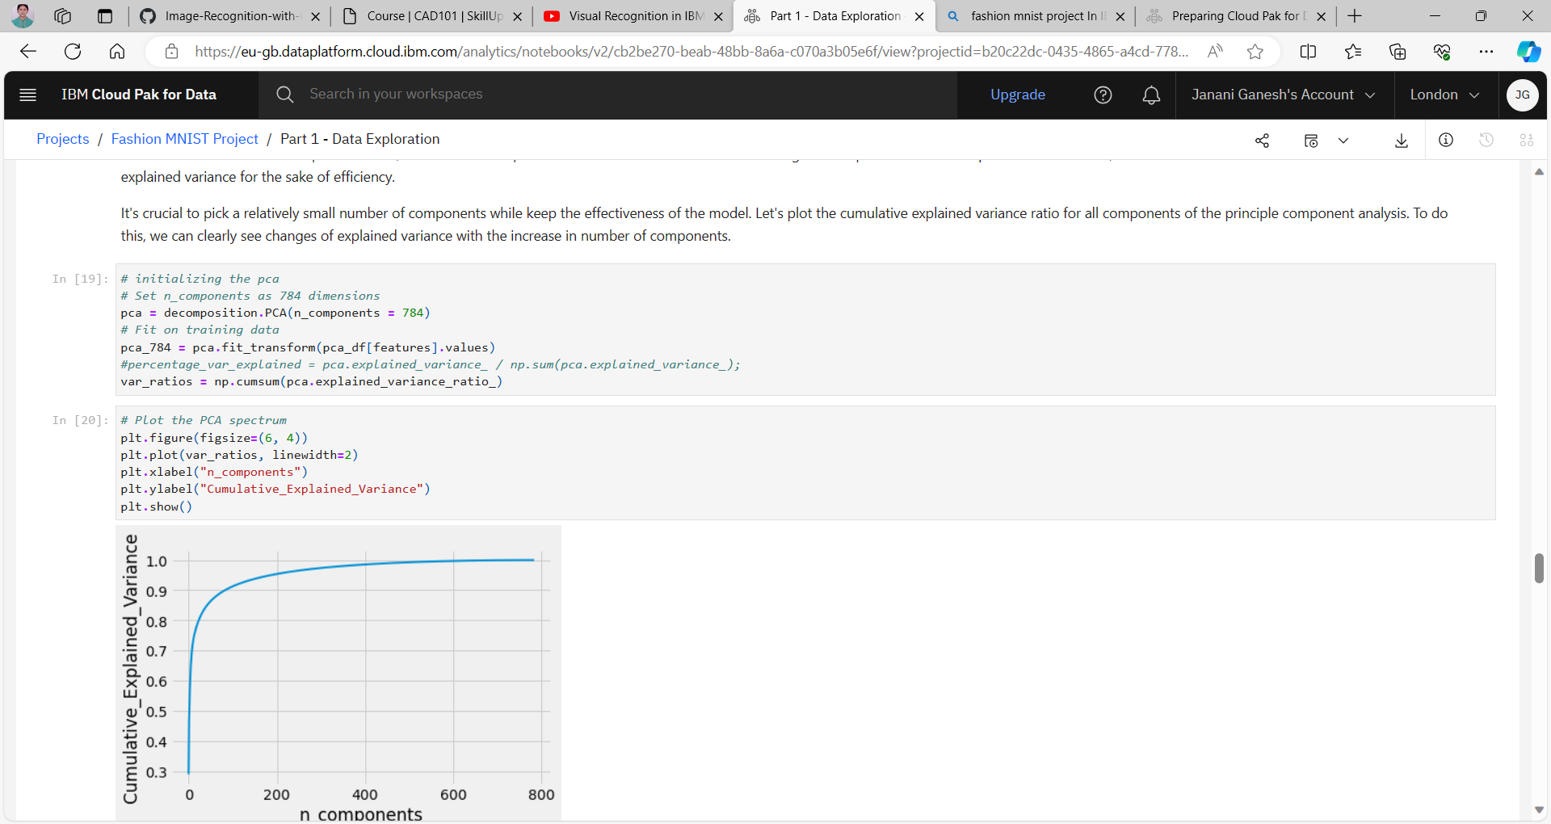

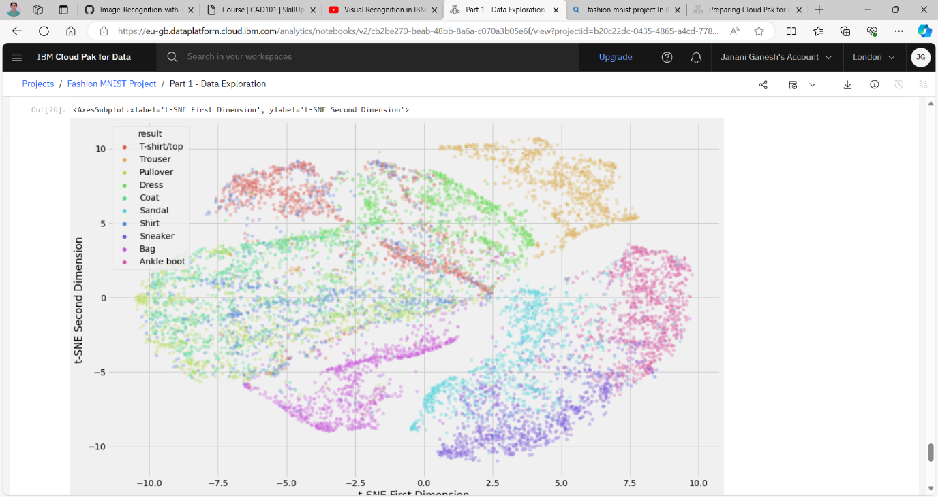

Part 2: ML and Model Comparisons

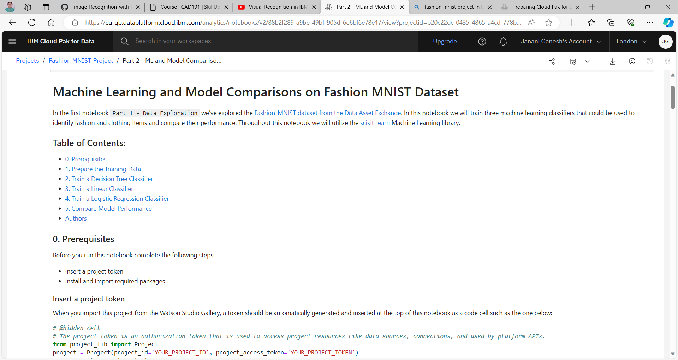

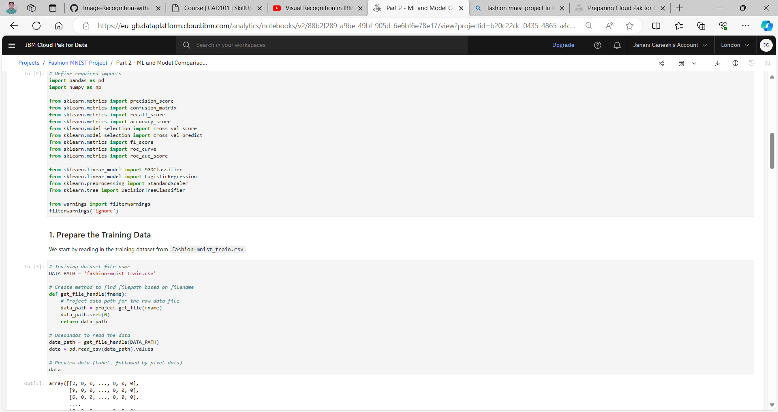

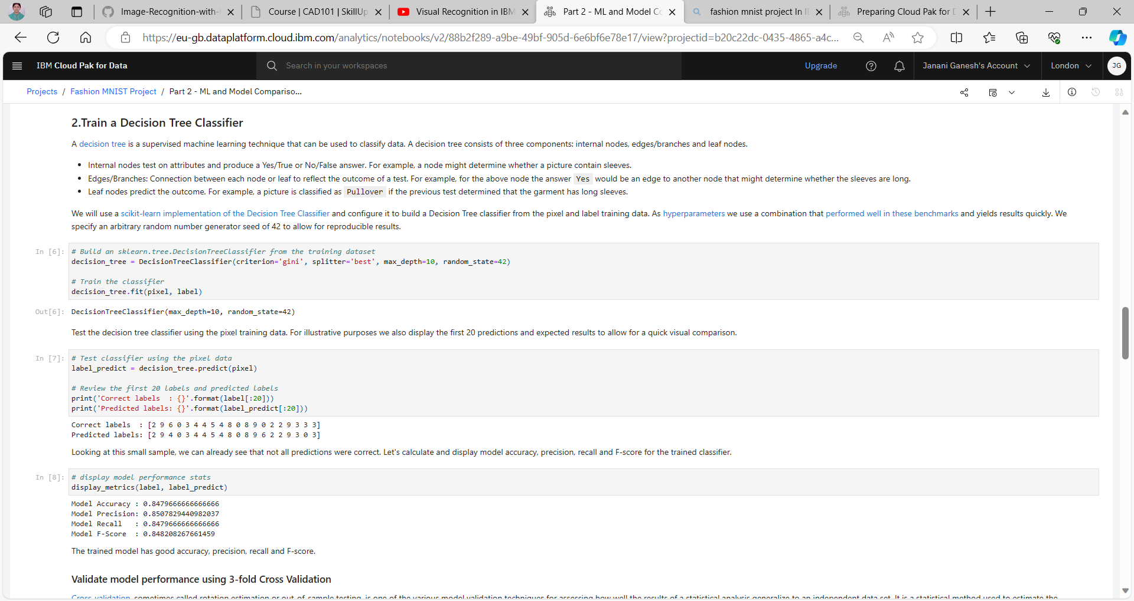

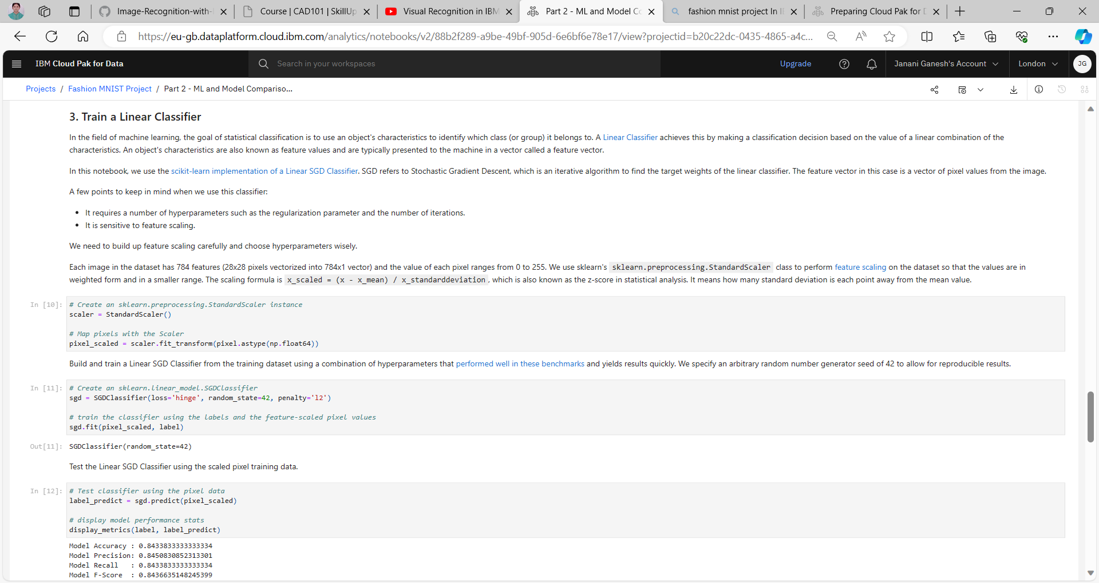

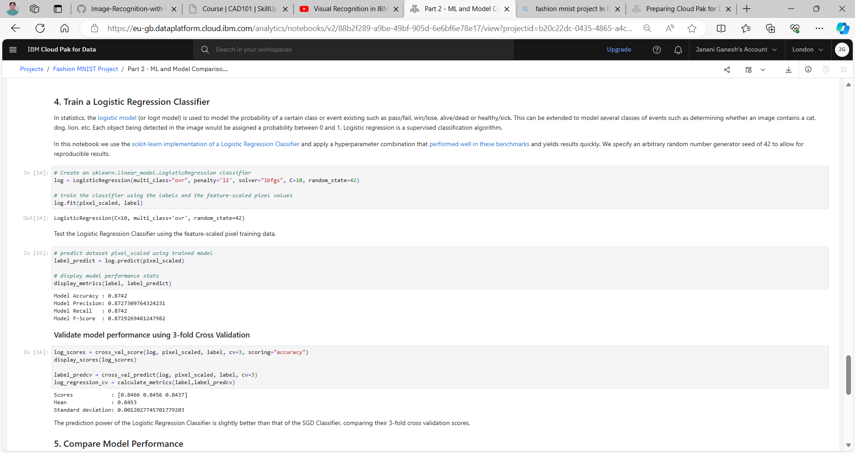

Part 3 : DL and Model Evaluations

