**IMAGE RECOGNITION USING IBM CLOUD VISUAL RECOGNITION**

**PHASE 2 – INNOVATION :**

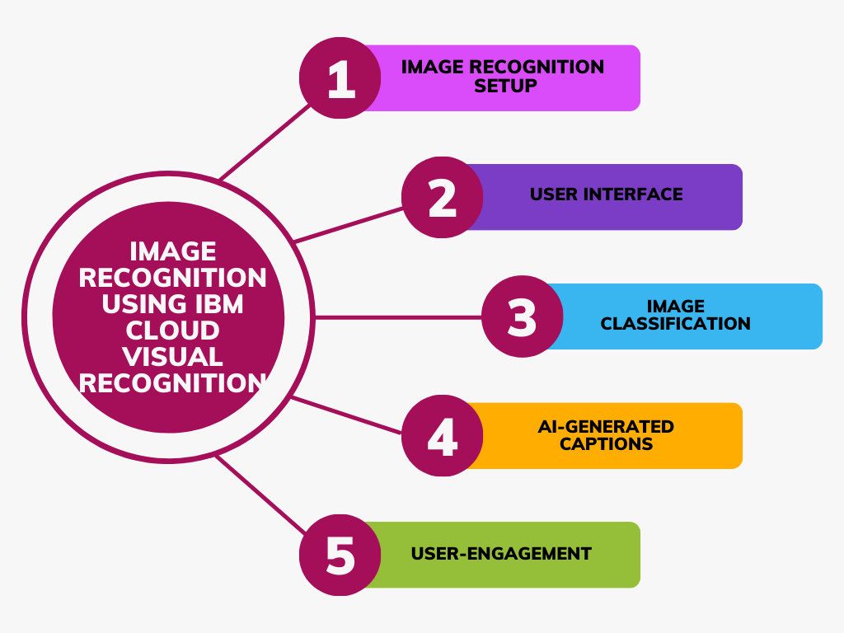

In the phase one, the five steps to proceed with developing the solution for the problem : image recognition using IBM cloud visual recognition were discussed. Now in phase two, the innovative ideas planned to be integrated in each step are listed out.

1. ***Image Recognition Setup:***

**Smart Triggered Actions:** Setting up actions based on recognition results, such as automatically organizing images into folders, in response to IBM Cloud Visual Recognition's classification results.

**Mobile Image Recognition App:** Integration of IBM Cloud Visual Recognition with a mobile app to perform image recognition on images captured by a smartphone's camera.

**Voice-Guided Image Labelling:** Voice recognition for labelling to be implemented as a separate feature within the app or platform and integrated with IBM Cloud Visual Recognition for image analysis- to be tried in final phase.

1. ***USER INTERFACE :***

**Collaborative Canvas:** A collaborative canvas where users can invite others to collaboratively recognize and annotate images in real-time, making it ideal for teamwork, education, or creativity.

**Interactive Data Visualizations:** Incorporating interactive data visualizations that provide insights into the recognized images. Users can explore data-driven graphs, charts, and heatmaps to gain a deeper understanding of their content.

**Voice-Controlled UI:** Implementing voice control for key functions, allowing users to navigate, upload images, or interact with the platform using voice commands, making it accessible and hands-free.

**AI-Powered Content Suggestion Widgets:** Adding smart widgets that suggest content recommendations and actions based on the recognized images. For instance, if an image of a recipe is recognized, the platform could suggest related recipes, ingredients, or cooking tips.

1. ***Image Classification:***

**Contextual Classification**: Developing a feature that recognizes not just objects but the context in which they appear. For instance, the system recognizes a "cat in a kitchen" as opposed to just a "cat."

**Visual Similarity Clustering:** Implementation of a feature that groups similar images into clusters based on their visual content. This allows users to discover related images easily, even if they have different labels. For example, pictures of various dog breeds could be grouped together.

**Emotion Detection in Images:** Enhancing the image classification by recognizing emotions expressed in images. For example, the system can identify if people in photos are happy, sad, surprised, or neutral, providing a richer understanding of the visual content.

**Localized Scene Recognition:** Developing a feature that recognizes and classifies not only objects but also specific scenes or landmarks within the image. For instance, the system can identify famous landmarks, parks, or beaches.

**Object Co-Occurrence Analysis:** Analysing and classifying objects based on their co-occurrence in images. The system can identify relationships between objects, such as recognizing a "bike next to a tree" or a "coffee cup on a desk," providing a more detailed context.

1. ***AI-Generated Captions:***

**Conversational AI Captions:** Creation of a chatbot-like interface where users can engage in a conversation with the AI to generate captions. The AI can ask clarifying questions for context.

**Emotion-Driven Captions:** Generating captions that reflect the emotions or sentiments detected in the image. This adds a deeper layer of storytelling to the captions.

**Storytelling Mode:** Developing a storytelling mode where the system generates a series of captions for multiple images, creating a narrative or a visual story for the user's content.

1. ***User Engagement:***

**Gamification**: Implementing gamification elements where users earn points or rewards for engaging with the platform, recognizing images, or generating creative captions.

**In-App Community Marketplace:** Creating a virtual marketplace within the platform where users can trade, sell, or purchase images and captions from one another. This encourages users to engage not only with content but also with each other, fostering a sense of community.

**Thematic Community Challenges:** Organizing themed image recognition challenges where users can collaborate and contribute images and captions related to specific topics, such as "Nature Photography," "Travel Adventures," or "Foodie Delights." Users can vote on the best submissions, fostering community engagement.

**User-Generated Caption Contests:** Running regular caption contests where users submit their captions for a featured image. The user community can vote on the most creative and engaging captions, and winners receive recognition or prizes, encouraging creativity and participation.

**User Recognition Leaderboards:** Creating leaderboards that showcase the most active and successful users in recognizing images and generating captions. Users can compete to earn top positions, badges, or recognition, promoting healthy competition and encouraging ongoing engagement.