Predicting Goals at the FIFA World Cup 2026 with Linear Regression
HIT140 Foundations of Data Science · Assessment 3 · Group 2
Marium Akter Mim | Róisín [surname] | Krupa [surname]
S397784 | [Student ID] | [Student ID]

1. Introduction
The FIFA World Cup 2026 was the first one with 48 teams, so it had 104 matches. In this project we used linear regression to see how well information that is known before a match can predict what happens in it. We built two models. Model 2.1 predicts the goal difference between the two teams in a match and uses 104 rows, one for each match. Model 2.2 predicts how many goals one team scores in a match and uses 208 rows, one for each team in each match. Each model has exactly eight explanatory variables, and every variable only uses data that was available before kickoff. For both models we compared a few versions, checked them against a simple baseline and used cross validation to see if the results still hold on matches the model has not seen.

2. Data and Methodology
Match results and kickoff times came from the official fixture list of the tournament. Squad details such as birth dates, caps and international goals came from the FIFA World Cup 2026 squad list. Coach salaries were taken from Salary Leaks, rankings from the April 2026 FIFA ranking, team xG from FootyStats, and the 2025 transfer counts were collected by our team. Each team's recent form was built from the International Football Results dataset by Mart Jürisoo on GitHub, using the last 10 full internationals of every team before 11 June 2026. We checked this dataset against the fixture list and all 104 World Cup results matched.
To follow the pre match rule, average age is counted on 11 June 2026, rest days are counted from a team's previous World Cup match (0 for the first match) and no statistic from the match itself is used. Table 1 lists the variables. Coach salary, FIFA ranking and average age appear in both models, so three variables are shared, which is under the limit of four.
Table 1. Explanatory variables used in each model (* = shared between the two models)
# | Model 2.1: goal difference (104 rows) | Model 2.2: goals scored (208 rows)
1 | Coach salary difference (EUR) * | Coach salary (EUR) *
2 | FIFA ranking difference (April 2026) * | FIFA ranking (April 2026) *
3 | Squad caps difference | Average age *
4 | Squad goal rate difference | Team xG (FootyStats)
5 | Goalkeeper and forward caps difference | Average goals scored per match
6 | Average age difference * | Player transfers in 2025
7 | Goals conceded per match difference | Forward goal rate
8 | Rest days difference | Squad international goals
In Model 2.1 every variable is the absolute difference between the two teams and the target is the absolute goal difference (0 to 6), so this model predicts how one sided a match will be, not who wins it. Model 2.2 uses the values of each team. Both models were built in Python with scikit-learn and statsmodels. The data was split 80/20 into a training and a testing set, and each model was compared with a baseline that always predicts the training mean. We report MAE, RMSE and R². All numbers and figures in this report come from our two Jupyter notebooks (Model1_Group2.ipynb and Model2_Group2.ipynb). For Model 2.1 we also ran 10 fold cross validation, repeated 20 times. For Model 2.2 the split and the 5 fold cross validation kept both teams of the same match together, so one match never ends up in training and testing at the same time.

3. Linear Regression 2.1: Goal Difference

3.1 Data and EDA
Figure 1a shows that most matches were close. 82 of the 104 matches ended with a difference of two goals or less, and only 9 had a difference of four or more. The mean absolute goal difference is 1.56, and the distribution is skewed to the right. Most explanatory variables are skewed too, for example coach salary difference and rest days difference both have a skew above 1.8. Figure 1b shows how each variable relates to the target. Ranking difference (r = 0.23) and age difference (r = −0.21) have the clearest links, followed by goals conceded difference (r = 0.16) and goalkeeper and forward caps difference (r = 0.13). The variables are largely independent of each other. The largest correlation between two of them is 0.41 and every VIF is under 1.5, so each variable brings its own information to the model and multicollinearity is not a concern.
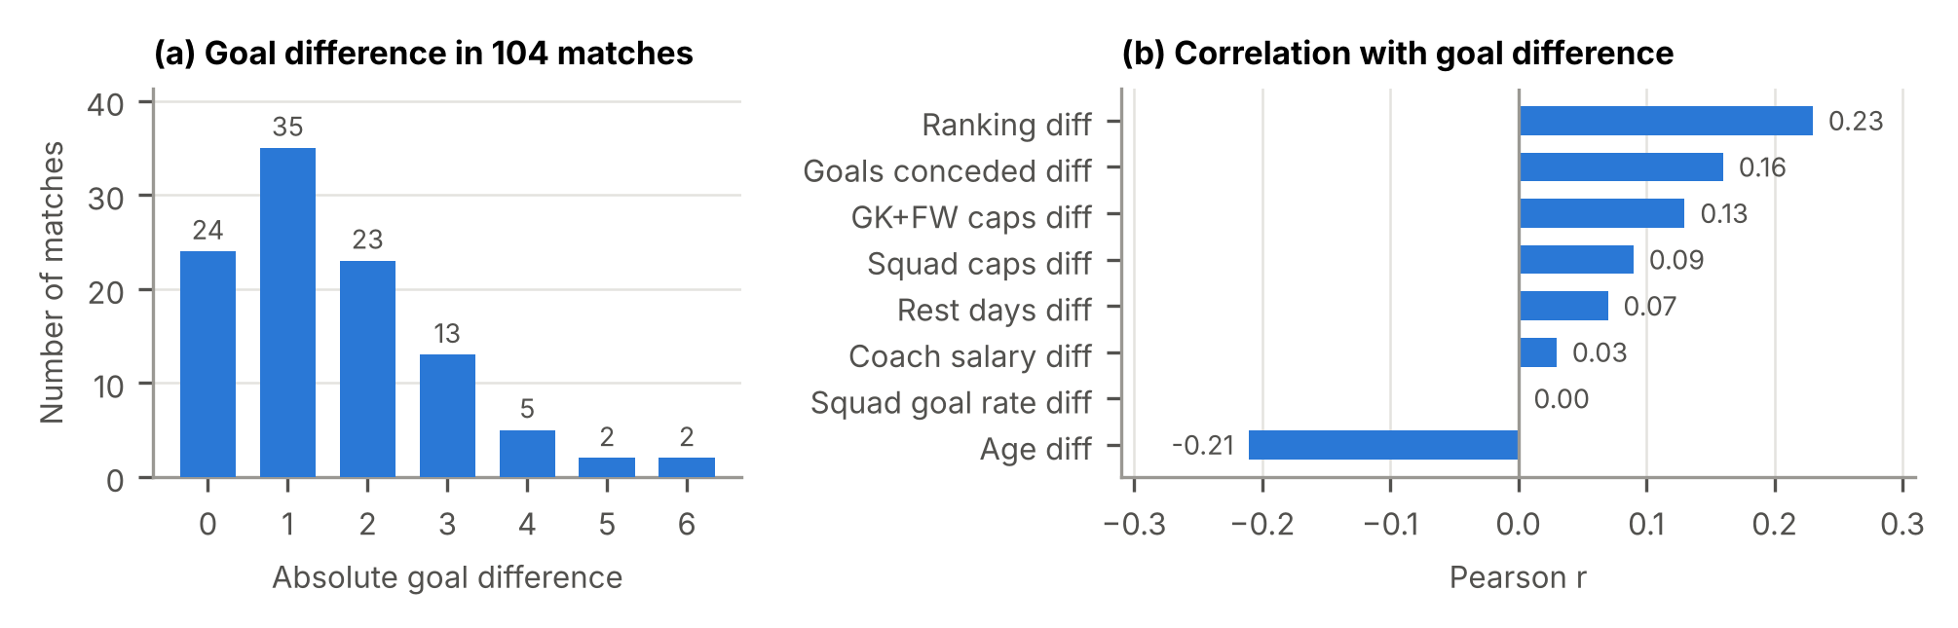
Figure 1. Model 2.1: (a) distribution of the absolute goal difference, (b) correlation of each variable with it.

3.2 Model Comparison and Results
We tested five versions (Table 2). The raw linear model was compared with a power transform version (Yeo Johnson, the same choice as in our first script), a version with the log of the four most skewed variables, and a Ridge regression which shrinks the coefficients to make them more stable.
Table 2. Model 2.1 results. Test = 80/20 split (21 matches). CV = 10 fold cross validation repeated 20 times.
Model | Test MAE | Test RMSE | Test R² | CV MAE | CV RMSE | CV R²
Baseline (training mean) | 1.262 | 1.709 | -0.035 | 1.106 | 1.381 | -0.024
Linear regression (raw) | 1.329 | 1.685 | -0.007 | 1.098 | 1.408 | -0.064
Linear, power transform | 1.349 | 1.712 | -0.039 | 1.078 | 1.397 | -0.049
Linear, log of skewed variables | 1.356 | 1.714 | -0.042 | 1.087 | 1.397 | -0.048
Ridge, power transform (chosen) | 1.287 | 1.683 | -0.005 | 1.079 | 1.378 | -0.020
Fitted on all 104 matches, the power transform model is statistically significant overall (F test p = 0.032, R² = 0.158, adjusted R² = 0.087). Two variables are significant at the 5% level: ranking difference (p = 0.021) and age difference (p = 0.007). A bigger ranking gap goes with a bigger goal difference, which confirms that the strength gap between teams is a key driver of the match margin. The age result adds an interesting finding, matches between teams with a bigger age gap tended to finish closer.
On unseen matches the Ridge model gave the lowest RMSE of all versions, both on the test set (1.683) and in cross validation (1.378), and the power transform reduced the cross validated MAE from 1.106 to 1.078. The gains over the baseline are modest, which is expected because World Cup margins are tightly packed, 82 of the 104 matches were decided by two goals or less. Figure 2 shows the predictions sit between 0.3 and 2.9 goals, the same range where most real results fall, while rare blowouts such as Germany 7-1 Curaçao stay hard to anticipate. We recommend the Ridge model with power transform as the most accurate and stable version, and it is especially useful for explaining which factors shape the margin of a match.
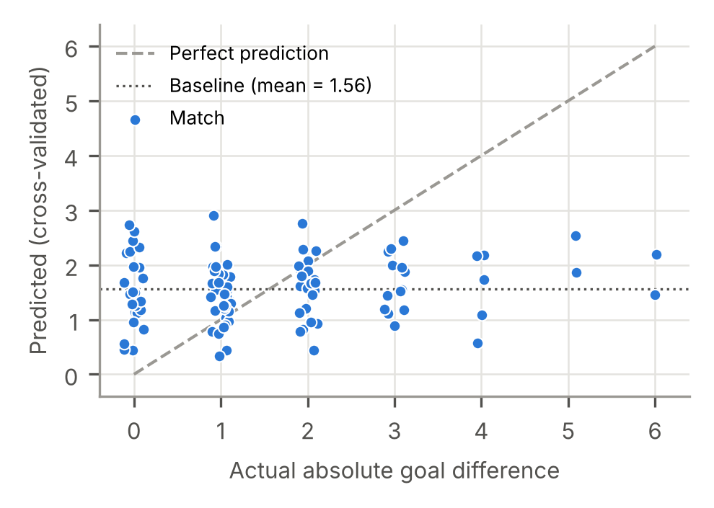
Figure 2. Model 2.1: actual vs cross validated predictions for all 104 matches (power transform model).

4. Linear Regression 2.2: Goals Scored

4.1 Data and EDA
Model 2.2 has 208 rows and no duplicate team and match pairs. Teams scored 1.48 goals per match on average, the median was 1 and the highest was 7. At least a quarter of the rows had no goals at all, so the target is skewed to the right. During cleaning, three Panama rows with an invalid xG value were flagged and filled with the median of the training data. Figure 3 shows that the correlations are stronger than in Model 2.1. FIFA ranking has the strongest link (r = −0.37). A lower rank number means a better team, so better teams scored more. Forward goal rate (0.35) and average goals scored (0.30) come next, and average age is weak (−0.10). Some variables are related to each other, like transfers and coach salary (r = 0.78), but every VIF is under 3.6, so all eight were kept.
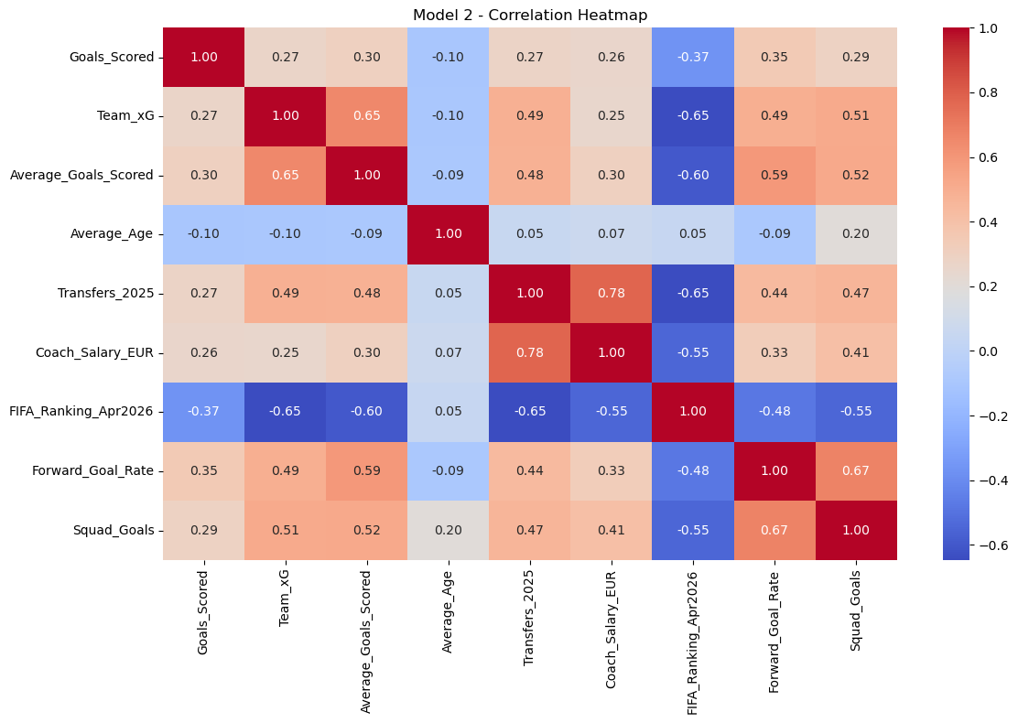
Figure 3. Model 2.2: correlation heatmap of goals scored and the eight explanatory variables.

4.2 Model Comparison and Results
Table 3. Model 2.2 results on the test set (42 rows, 21 matches kept whole). CV = 5 fold cross validation grouped by match.
Model | Test MAE | Test RMSE | Test R² | CV MAE | CV R²
Baseline (training mean) | 1.246 | 1.487 | -0.021 | n/a | n/a
Linear regression (raw, chosen) | 1.032 | 1.334 | 0.178 | 1.015 | 0.086
Linear, standardised | 1.032 | 1.334 | 0.178 | n/a | n/a
Linear, log of transfers and salary | 1.042 | 1.336 | 0.176 | n/a | n/a
The linear model beats the baseline clearly (Table 3). MAE goes down from 1.246 to 1.032, which is about 17% lower, and test R² is 0.178 compared with −0.021 for the baseline. Standardising gave exactly the same result. That is normal for plain linear regression because it only changes the scale of the variables. Taking the log of transfers and coach salary made it a little worse. In 5 fold cross validation the average MAE was 1.015 and the average R² was 0.086, with the best fold reaching an R² of 0.22.
Forward goal rate has the largest effect (coefficient 3.41). FIFA ranking (−0.016 per place) and average age (−0.09 per year) are both negative. Team xG got a negative coefficient (−0.19) even though its correlation with goals is positive. This happens because xG shares a lot of information with average goals scored (r = 0.65), so that coefficient on its own should not be read as a real effect. Figure 4 shows the predictions are centred on the 0 to 3 goal range where most real results fall. We recommend the plain linear model because it gives the best accuracy with the simplest setup.
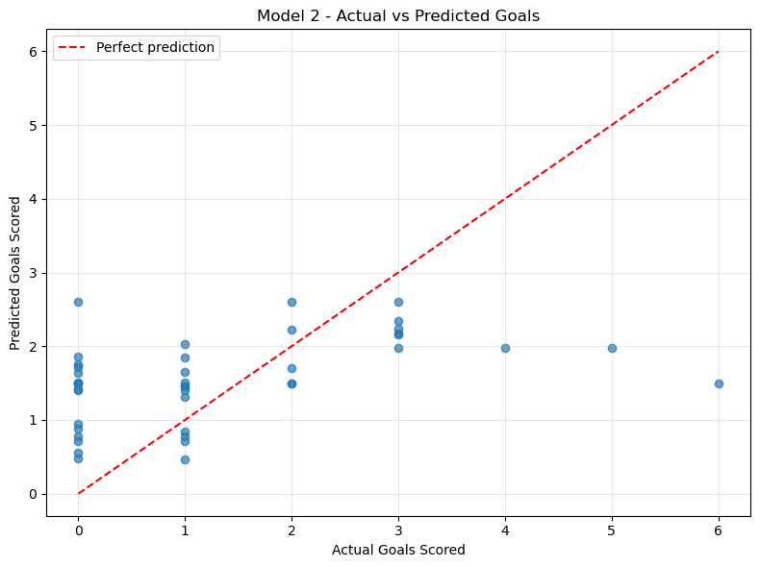
Figure 4. Model 2.2: actual vs predicted goals on the test set.

5. Cross-model Comparison
The two models play different roles. Model 2.2 gives the stronger predictive performance (test R² 0.178 against −0.021 for the baseline), while Model 2.1 is most valuable for explaining what drives the margin of a match, with ranking difference and age difference as significant factors. Model 2.2 has twice as many rows, and its target, the goals of one team, links directly to that team's own strength. Model 2.1 works with the gap between two teams, which is a harder target because the uncertainty of both teams adds up. In both models the typical error is about one goal (MAE 1.03 to 1.08), a strong result given how much a single football match can turn on one moment.

6. Limitations and Future Work
Both models are built on a single tournament, so adding the 2018 and 2022 World Cups would give more rows and more stable results. Squad caps and goals were taken from the official FIFA squad list, and a future version would fix these values to the release from before 11 June 2026 so every squad statistic is a strict pre tournament snapshot. Coach salaries come from public estimates, and official figures would make that variable stronger. As next steps we would use signed differences in Model 2.1 so it can also predict the winner, and try a Poisson regression, which is designed for goal counts.

7. Conclusion
We built and evaluated two linear regression models that only use pre match information. Model 2.2 improves on the baseline by about 17% in MAE (1.03 against 1.25) with a test R² of 0.18, and FIFA ranking and forward scoring are its strongest signals. Model 2.1 is statistically significant (p = 0.032) and shows that ranking difference and age difference are the key drivers of the goal margin. Our final recommendation is the plain linear model for Model 2.2 and the Ridge model with power transform for Model 2.1. Together the models show that pre match information about team strength gives a clear, measurable insight into World Cup results.

