Model 2.2: Predicting Goals Scored by a Team at the FIFA World Cup 2026
Marium Akter Mim · S397784 · HIT140 Foundations of Data Science · Assessment 3 (revised)

1. Objective
This model predicts how many goals one team scores in a FIFA World Cup 2026 match. The dataset has 208 rows, one for each team in each of the 104 matches, and the model uses exactly eight explanatory variables. Every variable is known before kickoff, so no statistic from the match itself is used.

2. Data and Preparation
The 208 row dataset was put together by our group. Average age and average goals scored per match (last 10 internationals before 11 June 2026) were prepared by me, team xG was collected by Krupa, and transfers in 2025, coach salary, FIFA ranking (April 2026), forward goal rate and squad goals were collected by Róisín. Match results come from the official fixture list. I checked the data in Python. There were no missing values and no duplicate rows, and every match had exactly two rows. Three rows for Panama had a team xG of −0.11, which is not possible, so I set them to 0, the closest valid value.

3. Exploration
Teams scored 1.48 goals per match on average, and 0 or 1 goal was the most common result (Figure 1a). FIFA ranking has the strongest link with goals (r = −0.37, a lower rank number means a better team), followed by forward goal rate (0.35) and average goals scored (0.30). Some variables carry the same information. Team xG and average goals scored have a correlation of 0.64, and transfers and coach salary 0.78. Every VIF stayed under 3.6, so multicollinearity is moderate.
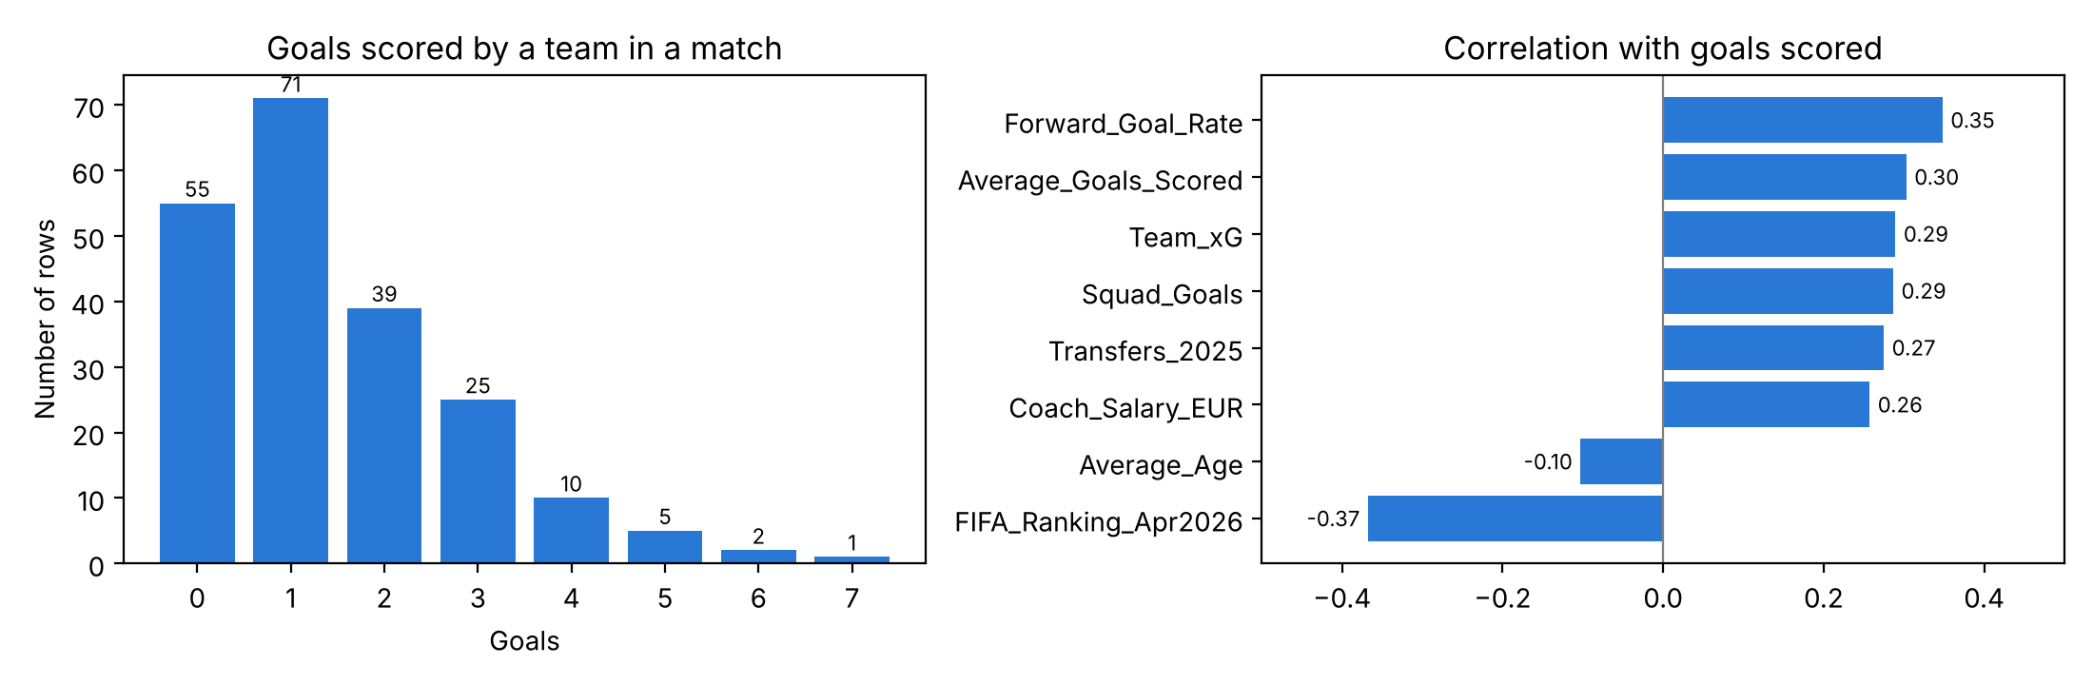
Figure 1. (a) Goals scored by a team in a match. (b) Correlation of the original eight variables with goals scored.

4. My Improvement: Adding the Opponent
All eight original variables describe only the team itself, so the model gives a team the same prediction in every match, whether it plays a top side or a weak one. My idea was to add the opponent's FIFA ranking, which is known before the match and can be built from the same dataset by matching each row with its opponent. To keep exactly eight variables I removed team xG, because it repeats average goals scored and it had the invalid Panama values. The opponent ranking has a correlation of 0.34 with goals and a VIF of only 1.02, so it adds new information.

5. Method
I compared Model A (group), the group's original Model 2.2 with eight variables, with Model B (Marium), my improved version with eight variables, using multiple linear regression in Python. The data was split 80/20 by match, so both teams of a match are always in the same set, and both models were compared with a baseline that always predicts the training average. I report MAE, RMSE and R², and I also ran 5 fold cross validation grouped by match, repeated 20 times with different shuffles, because one test set can be lucky or unlucky.

6. Results
Table 1. Test set (42 rows, 21 matches) and cross validation (5 fold, repeated 20 times).
Model | Test MAE | Test RMSE | Test R² | CV MAE | CV RMSE | CV R²
Baseline (training average) | 1.212 | 1.484 | -0.001 | n/a | n/a | n/a
Model A (group) | 1.218 | 1.540 | -0.078 | 1.003 | 1.316 | 0.103
Model B (Marium) | 1.124 | 1.456 | 0.037 | 0.958 | 1.259 | 0.180
Model B (Marium) is the best model in every measure (Table 1, Figure 2). On the test set its MAE is 1.124, lower than both the baseline (1.212) and Model A (group) (1.218). In cross validation, R² rises from 0.103 to 0.180, so the improvement holds across many different splits and is not a lucky result. Fitted on all 208 rows, Model B (Marium) is clearly significant (R² = 0.279, adjusted R² = 0.250, F test p < 0.001). The opponent's ranking is the strongest variable (coefficient 0.0189, p < 0.001), which means a team scores about 0.19 more goals for every 10 places weaker its opponent is ranked. Forward goal rate is also significant (coefficient 3.09, p = 0.031).
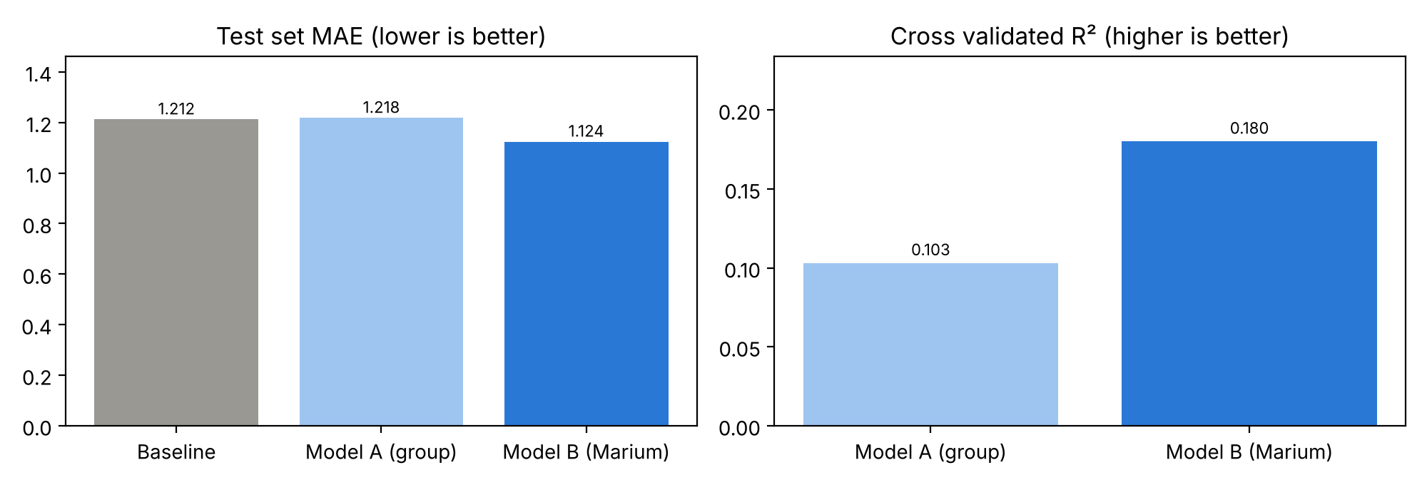
Figure 2. Test set MAE and cross validated R² for the baseline, Model A (group) and Model B (Marium).

7. Conclusion
Adding the opponent's FIFA ranking in place of team xG gave a clear improvement, nearly doubling the cross validated R² while keeping eight pre match variables. I recommend Model B (Marium). The typical error is still about one goal, which is normal for football because a single match has a lot of luck. In future, more tournaments could be added to give more rows.

