**Birla Institute of Technology & Science, Pilani**

**Second Semester 2022-2023**

**Online B.Sc. Computer Science Programme**

**Comprehensive Make-up Exam**

Course No. : BCS ZC239

Course Title : Writing Practice

Nature of Exam : Open Book

Weightage : 50%

Duration : 2 Hours 30 Minutes

Date of Exam : 25-02-2023

Note to Students:

1. All parts of a question should be answered consecutively. Each answer should start from a fresh page.
2. Assumptions made if any, should be stated clearly at the beginning of your answer.
3. Write an argumentative paragraph in 150-200 words on social media and cybercrime.

[7.5 Marks]

1. Paraphrase the following paragraph. Avoid using words and phrases from the original text as far as possible. [5 Marks]

Recently, inkless printing has attracted much attention because of the lower environmental impact. Inkless technology is a new revolutionary step in the history of printing technologies. Similar to inkless printing, inkless writing is also important in terms of environmental pollution. The inks used for writing contain toxic and harmful chemicals; they are not safe for human health and the environment. The information written by ink on paper is permanent, and most of the time it cannot be erased; this creates vast problems of paper waste and forest conservation. Therefore, it is important to search for a green solution for the replacement of ink.

1. Paraphrase the following paragraph. Avoid using words and phrases from the original text as far as possible. [5 Marks]

I learnt something from that fantastic singer, Frank Sinatra, who wrote a little article many years ago in Time magazine, where he said that if you use your microphone as your lover, you will know exactly how to control your voice. Because, if you’ve got to say something loving, you just bring it closer. Every time you’ve got to say something powerful, you just take it far away. All these things only come through experience.

1. Write a paragraph in 150 words describing the results of a survey conducted by the Government of India, presented in the following figure. [7.5 Marks]

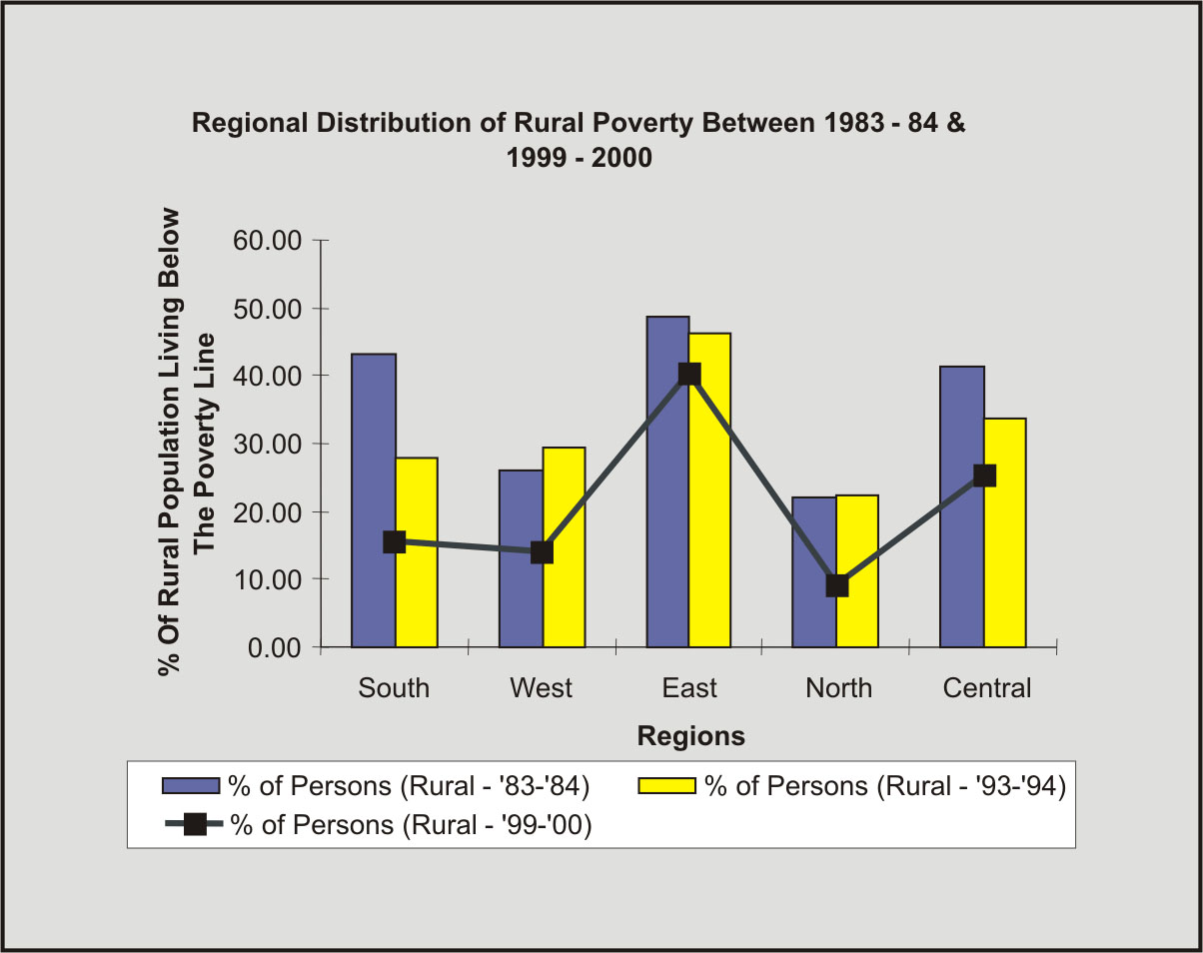

1. Summarize the following passage in 15-20 words. Avoid using words and phrases from the original text as far as possible. [5 Marks]

This National Education Policy envisions an education system rooted in Indian ethos that contributes directly to transforming India, that is Bharat, sustainably into an equitable and vibrant knowledge society, by providing high-quality education to all, and thereby making India a global knowledge superpower. The Policy envisages that the curriculum and pedagogy of our institutions must develop among the students a deep sense of respect towards the Fundamental Duties and Constitutional values, bonding with one’s country, and a conscious awareness of one’s roles and responsibilities in a changing world. The vision of the Policy is to instill among the learners a deep-rooted pride in being Indian, not only in thought, but also in spirit, intellect, and deeds, as well as to develop knowledge, skills, values, and dispositions that support responsible commitment to human rights, sustainable development and living, and global well-being, thereby reflecting a truly global citizen.

1. Summarize the following passage in 15-20 words. Avoid using words and phrases from the original text as far as possible. [5 Marks]

Due to the scale of the current learning crisis, all viable methods will be explored to support teachers in the mission of attaining universal foundational literacy and numeracy. Studies around the world show one-on-one peer tutoring to be extremely effective for learning not just for the learner, but also for the tutor. Thus, peer tutoring can be taken up as a voluntary and joyful activity for fellow students under the supervision of trained teachers and by taking due care of safety aspects. Additionally, it will also be made far easier for trained volunteers - from both the local community and beyond - to participate in this large-scale mission. Every literate member of the community could commit to teaching one student/person how to read, it would change the country’s landscape very quickly. States may consider establishing innovative models to foster such peer-tutoring and volunteer activities, as well as launch other programmes to support learners, in this nationwide mission to promote foundational literacy and numeracy.

1. Match each of the sentences (**A-G**) of the given abstract with one of the components (**I-V**) listed below. [7 Marks]

**A.** Nuclear image has emerged as a promising research work in medical field. Images from different modality meet its own challenge. **B.** Positron Emission Tomography (PET) image may help to precisely localize disease to assist in planning the right treatment for each case and saving valuable time. **C.** In this paper, a novel approach of Spatial Fuzzy C-Means (PET-SFCM) clustering algorithm was introduced on PET scan image datasets. **D.** The proposed algorithm incorporated the spatial neighborhood information with traditional FCM, updating the objective function of each cluster, and was implemented and tested on huge data collection of patients with brain neuro degenerative disorder such as Alzheimer’s disease. **E.** It demonstrated its effectiveness when tested for real world patient data sets. **F.** Experimental results were compared with conventional FCM and K-Means clustering algorithm. **G.** The performance of the PET-SFCM provided satisfactory results when compared with other two algorithms. (Meena & Raja, 2013, p. 50)

**Components**

1. Background to the study
2. Aim of the study
3. Methodology
4. Results
5. Match each of the following components (**I-IV**) with one or more sentences (**A-H**) from the given conclusion section of an academic report. [8 Marks]

**Components**

1. Restating research objectives
2. Suggesting a future research path
3. Summarising the main ideas or arguments
4. Signficance of the study

**A.** In summary, we have reported the use of off-the-shelf commercial dyes 1 and 2 for the detection of trace amounts of water in the organic solvents. **B.** Protonation of 1.F and 2.F using moisture (water) is the main working principle behind the colorimetric detection. **C.** Both sensors have high sensitivity for moisture in THF, acetone, and acetonitrile. **D.** Test papers incorporated with 1.F are fast, reversible, reusable, and portable moisture sensors that could measure moisture without the help of any instrument. **E.** In addition to the sensitivity and reversibility, these two probes have other advantages such as low cost, no chemical synthesis, easy availability, naked-eye detection, and fast response time. **F.** The test paper-based portable analytical device is well-explored for the rapid detection of moisture in organic solvents. **G.** Importantly, the inkless writings on the paper with write-and-erase properties are significant applications. **H.** We expect that a similar type of moisture detection mechanism has immense potential for the advance of water sensors and inkless writing.

***********