**Birla Institute of Technology & Science, Pilani**

**Second Semester 2022-2023**

**Online B.Sc. Computer Science Programme**

**Comprehensive Exam - 3**

Course No. : BCS ZC239

Course Title : Writing Practice

Nature of Exam : Open Book

Weightage : 50%

No. of Pages =

No. of Questions =

Duration : 2 Hours 30 Minutes

Date of Exam : 05-03-2023

Note to Students:

1. All parts of a question should be answered consecutively. Each answer should start from a fresh page.
2. Assumptions made if any, should be stated clearly at the beginning of your answer.
3. Write an argumentative paragraph in 150-200 on rumours and social media in contemporary times. [7.5 Marks]
4. Paraphrase the following paragraph. Avoid using words and phrases from the original text as far as possible. [5 Marks]

South Asia refers to the nation-states of Bangladesh, Bhutan, India, the Maldives, Nepal, Pakistan, Sri Lanka, and Tibet. “South Asia” as a constructed category is often used as a strategic geopolitical or geographical term indicating political alliances, both in Asia and the diasporas, and the term is one that can configure social identities and categories without necessarily alluding to national identities. It is not to be taken as a term designating an object of study, as does area studies, but rather as designating a constructed geopolitical region with interlinked political economies and histories, a subject of study. Nevertheless, it is important to recognize the ambivalent function of the term. (Adapted from Desai, 2003, p. 5)

1. Paraphrase the following paragraph. Avoid using words and phrases from the original text as far as possible. [5 Marks]

Entanglement lay at the heart of a fiery clash in the 1930s between physics titans Albert Einstein on the one hand and Niels Bohr and Erwin Schrödinger on the other about how the universe operates at a fundamental level. Einstein believed all aspects of reality should have a concrete and fully knowable existence. All objects — from the moon to a photon of light — should have precisely defined properties that can be discovered through measurement. Bohr, Schrödinger and other proponents of the nascent quantum mechanics, however, were finding that reality appeared to be fundamentally uncertain; a particle does not possess certain properties until the moment of measurement. (Wood, 2022)

1. Write a paragraph in 150 words describing the results of a study reported by the Reserve Bank of India, presented in the following figure. [7.5 Marks]

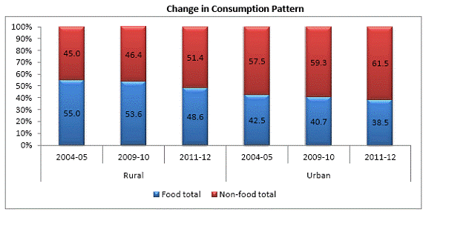

1. Summarize the following passage in 15-20 words. Avoid using words and phrases from the original text as far as possible. [5 Marks]

We have bartered away understanding for memory-based, short-term information accumulation. This must be reversed, particularly now that the mass of what could be memorised has begun to explode. We need to give our children some taste of understanding, following which they would be able to learn and create their own versions of knowledge as they go out to meet the world of bits, images and transactions of life. Such a taste would make the present of our children wholesome, creative and enjoyable; they would not be traumatised by the excessive burden of information that is required merely for a short time before the hurdle race we call examination. The document suggests some ways of getting out of this self-imposed adversity. Achieving some degree of success in this area would also signify that we have learnt to appreciate the capacity for learning and the futility of filling up children’s memory banks with information that is best kept as ink marks on paper or bits on a computer disc. (NCERT, 2005)

1. Summarize the following passage in 15-20 words. Avoid using words and phrases from the original text as far as possible. [5 Marks]

The school ethos is discussed as a dimension of the curriculum as it predisposes the child towards the aims of education and strategies of learning necessary for success at school. As a resource, school time needs to be planned in a flexible manner. Locally planned and flexible school calendars and time tables which permit time slots of different lengths required for different kinds of activities, such as project work and outdoor excursions to natural and heritage sites, are recommended. Efforts are required for preparing more learning resources for children, especially books and reference materials in regional languages, for school and teacher reference libraries, and for access to interactive rather than disseminative technologies. The NCF emphasises the importance of multiplicity and fluidity of options at the senior secondary level, discouraging the entrenched tendency to place children in fixed streams, and limiting opportunities of children, especially from the rural areas. (NCERT, 2005)

1. Match each of the sections (**a-h**) of the given abstract with one of the components (**I-V**) listed below. [8 Marks]

**Components**

1. Result
2. Outline
3. Background
4. Methodology

**a)** This study deals with an active balanced cuber-circuit. **b)** This circuit can be used as IM3 generator in analogue predistortion systems for mean power amplifiers. **c)** Such a circuit exploits the odd non-linear characteristic of a B-class push-pull amplifier. **d)** When compared to conventional diode designs, it shows an improved third-order generation. **e)** A laboratory prototype of the cuber was created. **f)** Then, it was inserted into a pre-distortion system. **g)** As a next step, a pre-industrialized pre-distorter prototype was realized using the active-cuber block: the whole system seemed to be flexible enough to be used for the IM3 linearization of PAs. **h)** From experimental results obtained from a target 6 W power amplifier, we found that more than 8 dB of correction can be achieved in a fractional bandwidth of about 10%. (Adapted from Roselli, 2003)

1. Match each of the sentences (**a-g**) of the given conclusion section of a research paper with one of the functions (**I-IV**) listed below. [7 Marks]

**Functions**

1. Suggesting a future research path
2. Stating the limitation of the existing research
3. Summarising the main idea
4. Providing the background

**a)** The development of semi behaviour is a topic that is now being studied. **b)** It traditionally has its roots in the renowned Turing test. **c)** The possibilities created by incorporating science into videogames are endless, including the incorporation of emotions in artificial players and the option to create a direct connection between them and the player's emotive perception through the use of what is known as Active Computing. **d)** It has been shown that procedural content generation is a hot field in academia with lots of articles related to it. **e)** Additionally, the videogame industry successfully applies many of the technological improvements made in academia, despite the fact that there are still many problems that have not been solved. **f)** We conclude our study by pointing out that there are many applications of computational and artificial intelligence that haven’t been specifically covered here and where future research may find more difficulties, such as player modelling, computational narrative, and AI-assisted game design, among other things. **g)** Not only do we face interesting difficulties in the near future, but also in the present. (Adapted from Tank, 2023)

***********