1. Type of CSS :-
1.1 Inline CSS
Definition: Inline CSS is used to apply styles directly to an HTML element using the style attribute.
<!DOCTYPE html>
<html>
<body>
<h1 style="color: red;">Hello World</h1>
<p style="font-size: 20px;">Welcome to CSS</p>
</body>
</html>
It is not recommended for styling large websites because it makes HTML difficult to maintain.

1.2 Internal CSS
Definition: Internal CSS is written inside the <style> tag in the <head> section of an HTML document.
<head>
<style>
selector {
property: value;
}
</style>
</head>
It is useful when a single HTML page requires its own styles.

1.3 External CSS
Definition: External CSS is written in a separate .css file and connected to the HTML document using the <link> tag.
<head>
<link rel="stylesheet" href="style.css">
</head>
It is the preferred approach for styling most multi-page websites.

2. CSS Priority and Specificity
When multiple CSS rules apply to the same element and property, the browser determines which rule should be applied using the CSS cascade.
2.1 CSS Selector Specificity
Specificity determines which CSS selector has greater priority when competing declarations have the same cascade importance and origin.
The common selector specificity order, from highest to lowest, is:
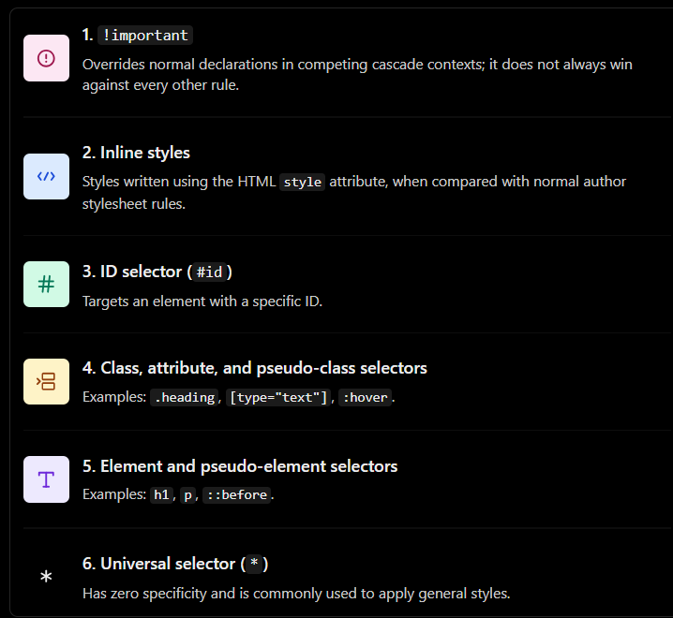
CSS Specificity score :-
Specificity can be represented using three numbers:
(A, B, C)
- A: Number of ID selectors.
- B: Number of class, attribute, and pseudo-class selectors.
- C: Number of element and pseudo-element selectors.
The universal selector and combinators such as >, +, and space do not add specificity.

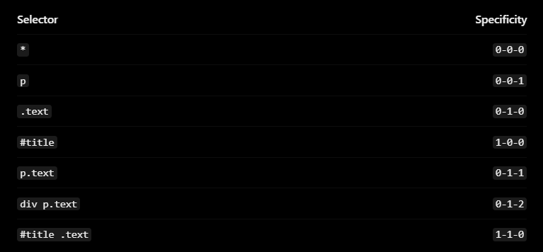
How to compare: Compare the first number, then the second, then the third. The first differing number determines the winner, assuming other cascade factors are equal.

1. Block-Level Elements and Inline Elements in HTML
In HTML, elements are commonly classified as block-level elements and inline elements based on how they are displayed on a webpage.
1.1 Block-Level Elements
Definition: A block-level element starts on a new line and, by default, occupies the full available width of its parent container.
Ex. Div, p, h1 to h6, section, article, header, footer, ul, ol, li, form
Multiple block elements normally appear one below another.
1.2 Inline Elements
Definition: An inline element does not normally start on a new line. It occupies only the space required by its content and flows along with surrounding text.
Ex. Span, a, strong, b, em, I, label, small
Padding and margins are only applied horizontally ( left-right side ) not vertically (top-bottom).
Note: Images (<img>) and form controls are examples of inline-level elements that can have their own width and height. Therefore, not every inline-level element behaves exactly like a <span>.

Css :- display : block, display : inline
1.3 Inline-Block Elements
Looks like inline from outside but behaves as block level from inside. Occupy only content space, cause no line breaks. But we can still set height and width and still set margin and padding just like a block level elements.

Selectors :-
Sibling selector :-
H1 + p{ … } :- select only those p which immediately comes after h1 element. Means it is sibling selector.
Positioning
Absolute :-
Means, fix position. But it will fix position relative to the first parent element who has set position:relative. If no parent has set that property then it would set absolute position relative to window.

Pseudo Elements :-
Let say we want to select first letter of paragraph or first line of paragraph etc. we use :: to use pseudo elements.
Ex. H1::first-letter{
Font-style:normal;
}

