**Software Testing**

**Assignment Module–1(Fundamental)**

1. **What is SDLC?**

* Software development life cycle is structure process that is used to planning, design, analysis, development and testing good quality product.

1. **What is Software testing?**

* Software testing is process that used to identify correctness, completeness and quality of developed computer software.

1. **Write SDLC phases with basic introduction.**

* Software development life cycle has following phases:

1. Requirement gathering
2. Analysis
3. Design
4. Implementation / Development
5. Testing
6. Deployment & Maintenance

* **Requirement gathering phase** : Requirement gathering phase is first phase of software development life cycle. In this phase we have to collect requirement from the client / customer. Whenever we are gathering requirement from the client at that time some kind of problems can be arise like : Lack ok clarity, Requirement confusion & Requirement amalgamation.
* **Analysis phase** : Analysis is the second phase of software development life cycle. In this phase we have to analyse all the gathered requirement by the client. And to identify that what are the function requirement and what are the non – functional requirement needs to be done.
* **Design phase** : Design phase is third phase of software development life cycle. This phase is critical phase for the life cycle because in this we have focus on to create blue print of software, make test plan, analyse risk. And remember that how it will meet with the customer needs.
* **Implementation / Development Phase:** This is fourth phase of the software development life cycle. In this phase where the developers write the code according to design specifications. Whenever coding is done then it delivers to the testing team.
* **Testing Phase :** This is the fifth phase of software development life cycle. In this phase we have to focus on identifying defects, preventing defects. We have to check all test scenarios or test plan. And we need to focus on that all software function meet with the requirement or not.
* **Deployment and Maintenance Phase :** This is the last phase of software development life cycle. After testing of the software, software release into the production environment where it will be used by the end users. After deployment software needs maintenance. Maintenance is the process of changing a system after it has been deployed. There are three types of maintenance: Corrective maintenance, Adaptive Maintenance and Perfective Maintenance.

1. **What is agile methodology?**

* Agile SDLC model is combination of iterative and incremental process models with focus on process adaptability and customer satisfaction by rapid delivery of working software product.

1. **What is SRS?**

* Software requirement specification is document that provides detailed description of system to be developed.

1. **What is OOPs?**

* OOPs stands for object-oriented programming. It is a programming paradigm that organizes software design around classes and objects.

1. **Write Basic Concepts of oops.**

* There are six concepts of oops:

1. Object
2. Class
3. Encapsulation
4. Polymorphism
5. Inheritance
6. Abstraction
7. **What is object?**

* Object is an instance of class.

1. **What is class?**

* Class is collection of data member and member function, with its behaviour.

1. **What is encapsulation?**

* Encapsulation is wrapping up of the data into single unit.

1. **What is inheritance?**

* Inheritance means that the parent class inherits their properties into the child class.

1. **What is polymorphism?**

* Polymorphism means having many forms.

1. **Explain phases of waterfall model.**

* There are following phases of waterfall model

1. Requirement gathering
2. Analysis
3. Design
4. Implementation
5. Testing
6. Maintenance

These are the phases of waterfall model. These all phases are in sequential manner is mandatory. The developer must complete phase before the next phase is begins. This kind of model is called waterfall model.

**When to use Waterfall model?**

* Requirements are clear, very well documented and fixed.
* Technology is understood and it’s not dynamic.
* The project is small.
* Product definition is stable.

**Advantages of waterfall model:**

* Simple and easy to understand and use.
* Easy to manage due to rigidity of the model.
* Easy to arrange task.
* Process and result are well documented.

**Disadvantages of waterfall model:**

* High amounts of risk and uncertainty
* Not a good model for complex and object-oriented projects.
* Poor model for long and ongoing projects.
* No suitable for that project in which risk of changing requirement.

1. **Write phases of spiral model.**

* These following are the phase of spiral model:

1. Planning
2. Risk analysis
3. Engineering
4. Customer evolution
5. **Planning** : In this phase, the objectives, constraints, and alternatives of the project are identify. In this phase requirement also gather from the client / stakeholder.
6. **Risk analysis** : In this phase focus on identifying and analyzing risks. This includes financial and technical risks
7. **Engineering** : This is the phase where actual system design, coding, and development will do.
8. **Customer evolution** : in this phase system undergoes to testing to identify bug defect and if need any improvement. After that feedback is gathered from the client to ensure that system meets their requirement or not.
9. **Write agile manifesto principles.**

* There are following some agile manifesto principles:
* **Individual and Interactions**: Focus on good communication and collaboration over following strict rules or using fancy tools.
* **Working Software**: Deliver functional software that works, instead of spending too much time on documentation.
* **Customer collaboration**: Keep in touch with customers to understand their needs and make changes as needed.
* **Responding to change**: Be ready to adjust plans as new information comes in or circumstances change.

1. **Draw Use case on Online book shopping.**

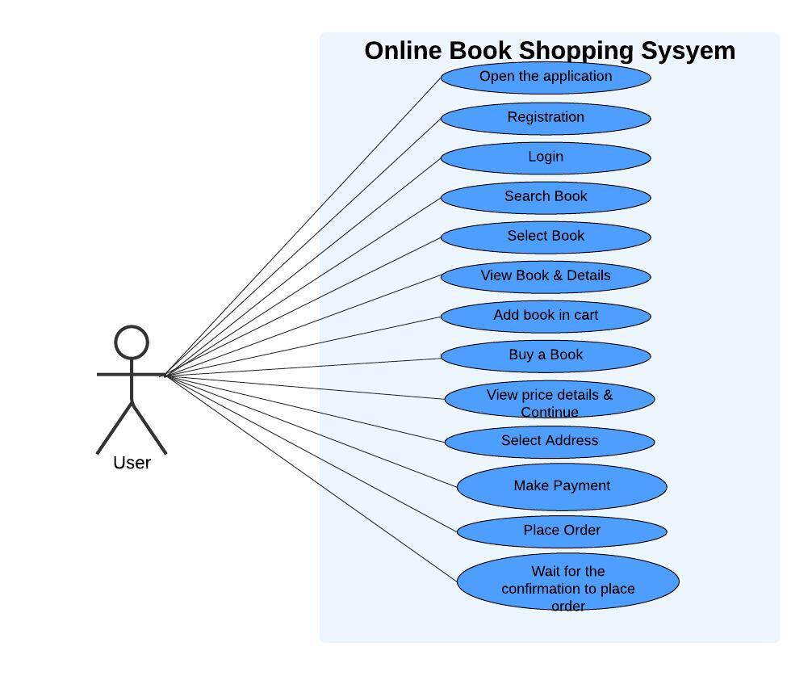

1. **Draw Use case on online bill payment system (Paytm).**

# 

1. **Draw Use case on Online shopping product using COD.**

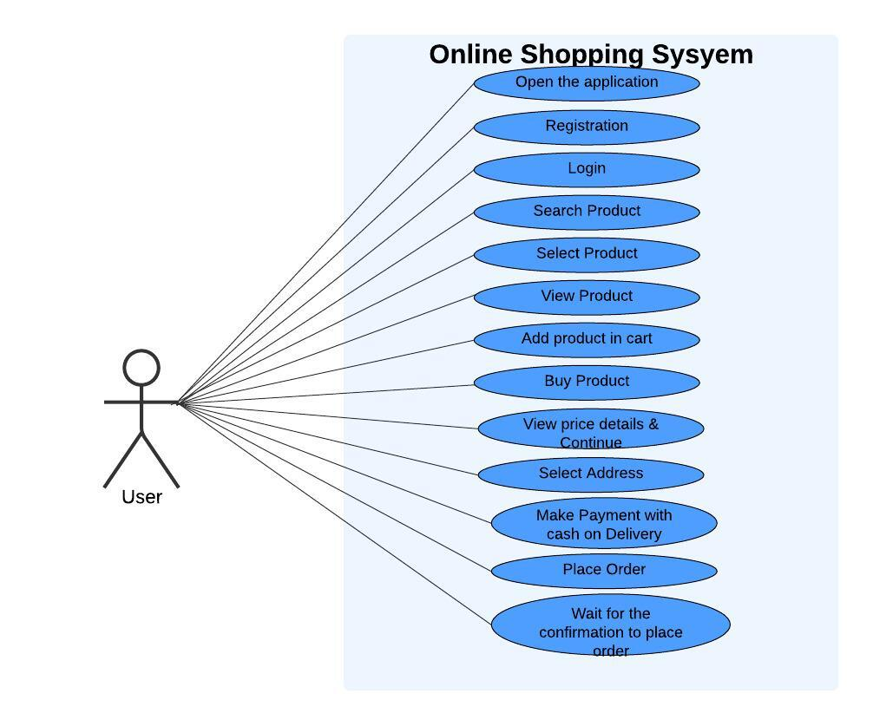

1. **Draw Use case on Online shopping product using payment gateway.**

