Project Report on Electric Vehicle Population Data Analysis
Course: Btech (IT)
Sub: Visual Analytics
Year: 3rd
Tool Used: Tableau
Dataset Name: Electric_Vehicle_Population_Data.csv
Source: Electric Vehicle Population Data From Kaggle

1. Introduction
The adoption of Electric Vehicles (EVs) in the United States has increased significantly in the past decade, driven by technological innovation, government incentives, and rising environmental awareness. This project, Electric Vehicle Population Data Analysis, aims to visually explore how EV ownership has evolved across different U.S. states using Tableau. Through various interactive dashboards, the project highlights state-wise EV counts, model distribution, and growth trends.
This analysis helps understand which regions are leading in EV adoption and how different types of electric vehicles (Battery Electric Vehicles and Plug-in Hybrids) are distributed across the country. The project is designed to showcase how visual analytics can support better decision-making in policy, infrastructure planning, and business investment.

2. Objectives of the Project
- To analyse the distribution of electric vehicles across U.S. states.
- To visualize growth trends in EV adoption over time.
- To identify the most popular vehicle makes and models.
- To compare EV adoption between Battery Electric Vehicles (BEVs) and Plug-in Hybrid Electric Vehicles (PHEVs).
- To design an interactive Tableau dashboard that clearly communicates insights to end-users.

3. Dataset Description
The dataset used in this project is titled “Electric_Vehicle_Population_Data.csv”, which contains detailed information about registered electric vehicles in the United States.
Major Attributes:
- VIN (Vehicle Identification Number) – unique ID of each vehicle.
- County / City / State – geographic location of registration.
- Model Year – manufacturing year of the vehicle.
- Make and model – brand and specific name of the EV.
- Electric Vehicle Type – classification as BEV or PHEV.
- Electric Range – distance the vehicle can travel on electric power.
- CAFV Eligibility – eligibility for Clean Alternative Fuel Vehicle incentives.
- Legislative District & Postal Code – used for geographic mapping in Tableau.
The dataset was cleaned and processed to ensure consistency and remove missing or irrelevant entries before visualization.

4. Data Cleaning and Preparation
Before importing the data into Tableau, the following preprocessing steps were carried out using Excel and Tableau’s built-in tools:
- Handling Missing Data: Null or incomplete values in Electric Range and Model Year were handled by either replacing them with averages or removing rows where necessary.
- Creating Derived Fields:
  - Vehicle Category – grouped by Electric Vehicle Type as BEV or PHEV.
  - Decade – calculated from Model Year (e.g., “2010s”, “2020s”).
  - EV Age – calculated as Current Year – Model Year.
- Data Standardization: Uniform formatting of state names and city labels for geographic visualization.
- Filtering: Only relevant fields were kept for visual analytics such as Model Year, Make, Electric Range, and State.

5.Dashboard Design and Visualization
The Tableau dashboard was designed to meet both KPI requirements and chart requirements outlined in the project problem statement. The visuals were developed to help users easily interpret EV adoption trends, manufacturer dominance, and model-wise performance across the United States.
A. KPI’s (Key Performance Indicators) Section
This section provides quick, high-level metrics at the top of the dashboard:
- Total Vehicles:
Displays the overall number of electric vehicles (EVs) in the dataset, covering both Battery Electric Vehicles (BEVs) and Plug-in Hybrid Electric Vehicles (PHEVs).
Purpose: Gives a clear view of total EV adoption and market size.
- Average Electric Range:
Shows the average distance an electric vehicle can travel on a single charge.
Purpose: Helps assess the efficiency and technological progress of EVs over time.
- Total BEV Vehicles and % of Total BEVs:
Indicates the total number of fully electric vehicles and their share of the total EV market.
Purpose: Highlights the dominance of BEVs, showing customer preference toward full electrification.
- Total PHEV Vehicles and % of Total PHEVs:
Presents the total number of plug-in hybrid vehicles and their percentage share.
Purpose: Allows comparison between hybrid adoption and fully electric vehicle growth.
These KPIs are displayed using summary cards and dynamic filters to allow year-wise or state-wise exploration.

B. Chart Visualizations
Five key charts were developed to visualize trends, distribution, and composition of EVs:
- Total Vehicles by Model Year (from 2010 onwards)
  - Visualization: Line or Area Chart
  - Description: Shows how EV registrations have increased year by year since 2010.
  - Insight: Helps understand growth rate, adoption timeline, and technology expansion in the EV market.
- Total Vehicles by State
  - Visualization: Filled Map Chart
  - Description: Displays the geographic distribution of EVs across U.S. states using color intensity.
  - Insight: Identifies high-adoption states like California, Washington, and Oregon, and highlights regions with low adoption.
- Top 10 Total Vehicles by Make (Manufacturer)
  - Visualization: Horizontal Bar Chart
  - Description: Ranks manufacturers based on total EVs registered.
  - Insight: Shows market dominance of brands such as Tesla, Nissan, and Chevrolet.
- Total Vehicles by CAFV Eligibility
  - Visualization: Pie Chart or Donut Chart
  - Description: Represents the proportion of vehicles eligible for Clean Alternative Fuel Vehicle (CAFV) incentives.
  - Insight: Demonstrates the effect of government policies and incentives on EV adoption rates.
- Total Vehicles by Model
  - Visualization: Grid View or Table Chart
  - Description: Lists top 10 electric vehicle models based on number of registrations.
  - Insight: Helps identify consumer preferences and the most popular EV models in the market.

- Dashboard Layout & Interactivity

- The main dashboard integrates KPIs at the top followed by visual charts arranged for easy comparison.
- Filters: Users can filter data by Year, State, Vehicle Type (BEV/PHEV), and Make.
- Tooltips: Display detailed values (make, model, range, CAFV eligibility) when hovering over data points.
- Color Scheme: Sequential and diverging color palettes used for clear differentiation of metrics.
- Interactivity: Clicking on any state or make dynamically updates other charts for focused analysis.
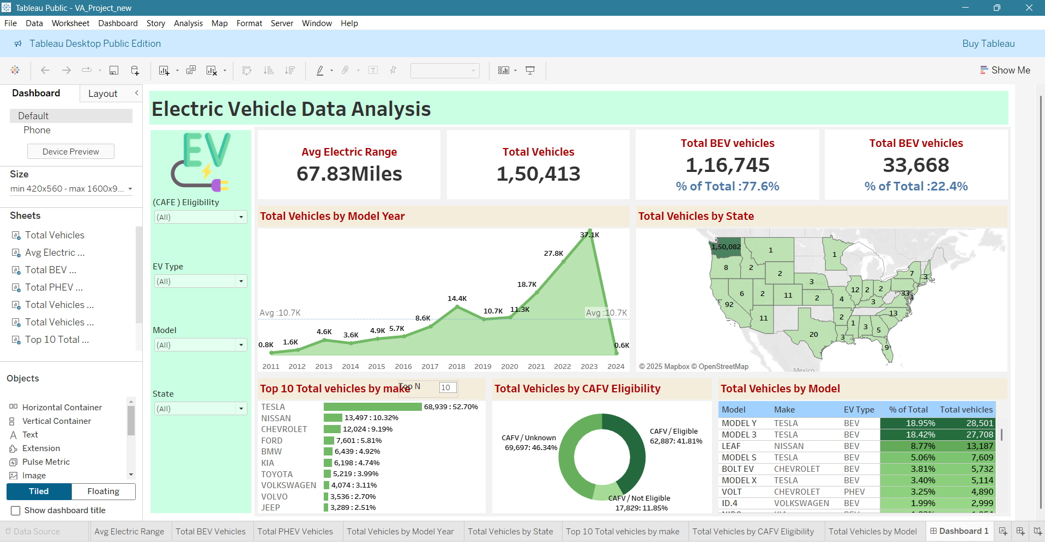

7. Challenges Faced
- Large dataset required cleaning and preprocessing to remove duplicates and handle missing data.
- Geographic mismatches between city/state fields had to be corrected for accurate mapping.
- Balancing visual clarity with dashboard interactivity took multiple design iterations.

8. Conclusion
This Tableau project successfully demonstrates how visual analytics can reveal meaningful insights from large datasets. By analysing the Electric Vehicle Population Data, it becomes evident that EV adoption is growing rapidly across the U.S., with a strong concentration in California and other coastal states.
The visual dashboards built in Tableau effectively display this information through maps, charts, and filters, making it easier for policymakers, businesses, and the general public to understand EV trends.
The project fulfils the course objective of applying data visualization techniques to extract insights and communicate findings through interactive dashboards.

9. Future Scope
- Incorporate charging station data to analyse infrastructure impact on EV adoption.
- Add temporal forecasting to predict future EV growth trends.
- Include economic and environmental variables (fuel prices, carbon savings) for richer analysis.
- Automate data refresh for continuous tracking of EV population statistics.

10. References
- Electric Vehicle Population Data from Kaggle
- Tableau Official Documentation – https://www.tableau.com/learn
------------------------------------------------------------------------------------------------------------------------
11.Project Summary
The project “Electric Vehicle Population Data Analysis in the United States” is a comprehensive data visualization study conducted using Tableau. The main objective of this project is to analyze and interpret the growth, distribution, and adoption trends of electric vehicles (EVs) across various states in the U.S. using publicly available data.
The dataset titled Electric_Vehicle_Population_Data.csv contains detailed information on vehicle make, model, year, type, and state of registration. After cleaning and organizing the data, multiple interactive dashboards were created to showcase insights such as the dominance of Tesla in the EV market, the increasing preference for Battery Electric Vehicles (BEVs), and the strong concentration of EV ownership in states like California, Washington, and Oregon.
Through visual storytelling in Tableau, the project highlights how government policies, technological advancement, and growing environmental awareness have influenced the rapid rise of electric vehicles in recent years. The dashboards allow users to interactively explore the data by state, year, and vehicle type, making the analysis informative and engaging.
Overall, this project demonstrates the practical application of visual analytics in understanding real-world datasets. It provides valuable insights that can assist policymakers, automobile companies, and environmental researchers in planning for a sustainable and electric-driven future.

