1. What is software? What is software engineering?

Ans: Software is a set of instructions, data or programs used to operate computers and execute specific tasks. It is the opposite of hardware, which describes the physical aspects of a computer. Software is a generic term used to refer to applications, scripts and programs that run on a device.

Software Engineering:

**Software Engineering** is the process of designing, developing, testing, and maintaining software. It is a systematic and disciplined approach to software development that aims to create high-quality, reliable, and maintainable software.

2. Explain types of software

Ans: Types of software

* Application software
* System software
* Driver software
* Middleware
* Programming software

**1). Application software:**

The most common type of software, application software is a computer software package that performs a specific function for a user, or in some cases, for another application.

An application can be self-contained, or it can be a group of programs that run the application for the user.

Examples of Modern Applications include office suites, graphics software, databases and database management programs, web browsers, word processors, software development tools, image editors and communication platforms.

**2). System software:**

These software programs are designed to run a computer's application programs and hardware.

System software coordinates the activities and functions of the hardware and software.

It controls the operations of the computer hardware and provides an environment or platform for all the other types of software to work in.

The OS is the best example of system software; it manages all the other computer programs.

Other examples of system software include the firmware, computer language translators and system utilities..

**3). Driver software:**

Also known as device drivers, this software is often considered a type of system software.

Device drivers control the devices and peripherals connected to a computer, enabling them to perform their specific tasks.

Every device that is connected to a computer needs at least one device driver to function.

Examples include software that comes with any nonstandard hardware, including special game controllers, as well as the software that enables standard hardware, such as USB storage devices, keyboards, headphones and printers.

**4). Middleware:**

The term middleware describes software that mediates between application and system software or between two different kinds of application software. For example, middleware enables Microsoft Windows to talk to Excel and Word.

It is also used to send a remote work request from an application in a computer that has one kind of OS, to an application in a computer with a different OS. It also enables newer applications to work with legacy ones.

**5). Programming software:**

Computer programmers use programming software to write code. Programming software and programming tools enable developers to develop, write, test and debug other software programs.

Examples of programming software include assemblers, compilers, debuggers and interpreters.

3. What is SDLC? Explain each phase of SDLC

Ans: The Software Development Life Cycle (SDLC) refers to a methodology with clearly defined processes for creating high-quality software.

* **Phase of SDLC:**

1). PLANNING

2). ANALYSIS

3). DESIGN

4). IMPLEMENTATION

5). TESTING & INTEGRATION

6). MAINTENANCE

1). PLANNING:

The concept is further developed to describe how the business will operate once the approved system is implemented, and to assess how the system will impact employee and customer privacy. To ensure the products and /or services provide the required capability on-time and within budget, project resources, activities, schedules, tools, and reviews are defined. Additionally, security certification and accreditation activities begin with the identification of system security requirements and the completion of a high level vulnerability assessment.

2). ANALYSIS:

The second SDLC phase is where teams will work on the root of their problem or need for a change. In case there’s a problem to solve, possible solutions are submitted and analysed to figure out the best fit for the project’s ultimate goal or goals. It’s where teams consider the functional requirements of the solution.

3). DESIGN:

Phase 3 defines the necessary specifications, operations, and features that will satisfy all functional requirements of the proposed system. It’s where end users can discuss and identify their specific business information needs for the application. During this phase, users will consider the important components, networking capabilities, and procedures to accomplish the project’s primary objectives.

4). IMPLEMENTATION:

This phase also involves the actual installation of the newly-developed application. The project is put into production by moving all components and data from the old system and putting them in a new one through a direct cutover.

5). TESTING & INTEGRATION**:**

In the fifth phase, systems integration and testing are carried out by [Quality Assurance (QA) professionals](https://www.bydrec.com/). They will be responsible for determining if the proposed design reaches the initial business goals set by the company. It’s possible for testing to be repeated, specifically to check for bugs, interoperability, and errors.

6). MAINTENANCE:

In the seventh and final phase, end users can fine-tune the completed system as necessary if they want to improve performance. Through maintenance efforts, the team can add new capabilities and features and meet new requirements set by the client.

4. What is DFD? Create a DFD diagram on Flipkart.

Ans: Data flow diagram (DFD) is a diagram Being used frequently in software design . It visually represents the flow of data throughout processes in a given system. DFD shows the kind of information that will be input to and output from processes as well as where the data will be stored.

* **DFD diagram on Flipkart.**

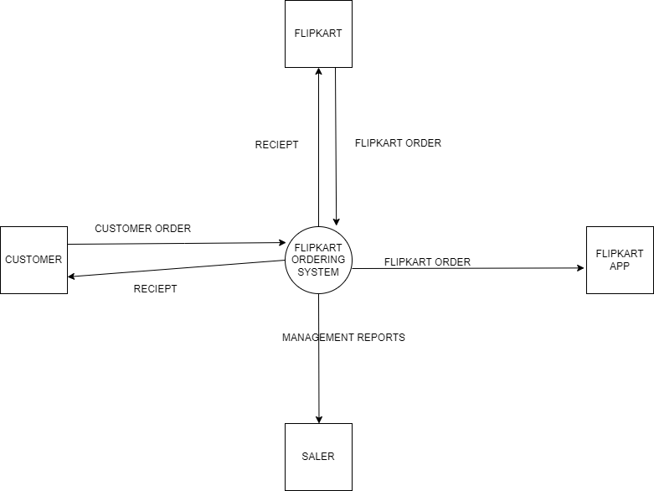

5. What is Flow chart? Create a flowchart to make addition of two numbers

Ans: Flowchart is a graphical representation of an algorithm. Programmers often use it as a program-planning tool to solve a problem. It makes use of symbols which are connected among them to indicate the flow of information and processing.

**Flowchart:**

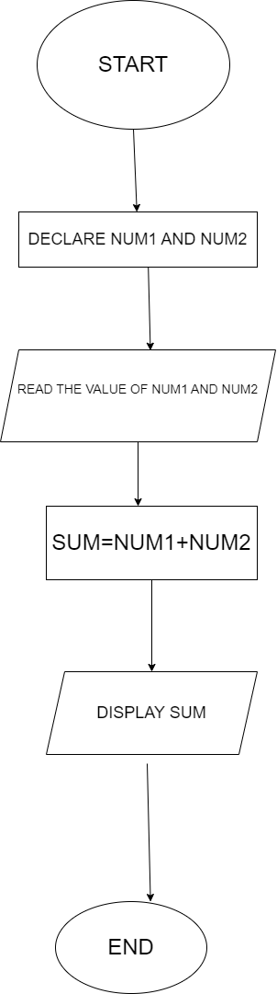

6. What is Use case Diagram? Create a use-case on bill payment on paytm.

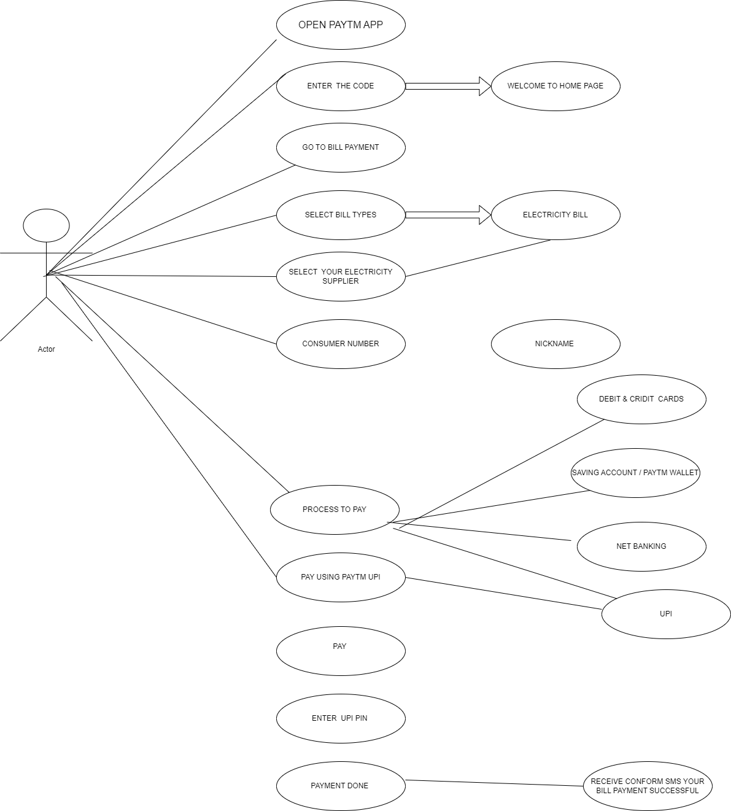Ans: A Use Case Diagram is a type of Unified Modelling Language (UML) diagram that represents the interaction between actors (users or external systems) and a system under consideration to accomplish specific goals. It provides a high-level view of the system’s functionality by illustrating the various ways users can interact with it.