**Projekt 2**

**Autor**: Jindřich Šíma (231287)

**Obor**: Informační bezpečnost

**Předmět**: Bezpečnost databázových systémů

Obsah

Úvod 3

Create a query that will retrieve only selected columns from the selected table 3

Create a query that will select user/person or similar table based on the email. 3

Create at least one UPDATE, INSERT, DELETE, and ALTER TABLE query 4

Create a series of queries that will separately use the following 7

– WHERE 7

– LIKE; NOT LIKE 8

– SUBSTRING; TRIM 8

– COUNT; SUM; MIN; MAX; AVG; 10

– GROUP BY; GROUP BY and HAVING; GROUP BY, HAVING, and WHERE; 12

– UNION ALL / UNION 13

– DISTINCT 13

– LEFT JOIN; RIGHT JOIN; FULL OUTER JOIN 14

Use in one query: LEFT JOIN, GROUP BY, HAVING, ORDER BY, AVG and DISTINCT 15

Create a query that will return the data from an arbitrary table for the last one and half days 15

Create a query that will return data from the last month 16

Write a select that will remove accents on a selected string 16

Create a query for pagination in an application (use LIMIT and OFFSET) 18

Create a query that will use subquery in FROM 19

Create a query that will use subquery in WHERE condition 20

Create a query that will use any aggregate function and GROUP BY with HAVING 20

Create a query that will join at least five tables 21

Create a query that will join at least three tables and will use GROUP BY, HAVING, and WHERE 21

Modify the database from the first project assignment to improve integrity constraints 22

Create database indexes 22

Create arbitrary database procedure 24

Create arbitrary database trigger 24

Create arbitrary database view 25

Create database materialized view 25

Create two roles teacher and student in your database 25

# Úvod

# Create a query that will retrieve only selected columns from the selected table

SELECT id_title, name, lenght FROM titles;

# Create a query that will select user/person or similar table based on the email.

# Create at least one UPDATE, INSERT, DELETE, and ALTER TABLE query

UPDATE person SET first_name = 'Carey' WHERE surname = 'Mahoney';

INSERT INTO person(id_person, id_address, first_name, surname, date_of_birth) VALUES(101, 12, 'Tom', 'Jerry', '1969-04-20');

DELETE FROM favourites WHERE id_user = 3;

ALTER TABLE favourites ADD COLUMN reason VARCHAR(256);

ALTER TABLE favourites DROP COLUMN reason;

Create a series of queries that will separately use the following:

## – WHERE

SELECT id_user, first_name, surname FROM public.user WHERE id_user >= 15;

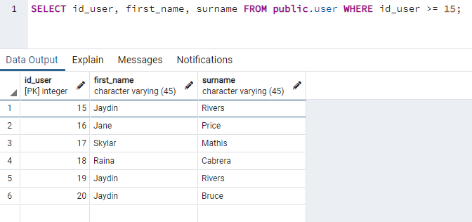

## – LIKE; NOT LIKE

SELECT id_user, first_name, surname FROM public.user WHERE first_name LIKE 'Nas%';

SELECT id_user, first_name, surname FROM public.user WHERE surname NOT LIKE '%a%';

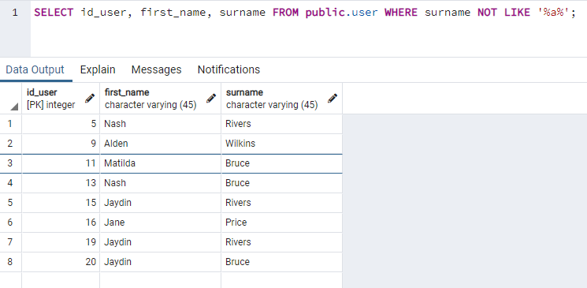

## – SUBSTRING; TRIM

SELECT first_name, surname, substring(password from 1 for 10) FROM public.user;

UPDATE public.user

SET first_name = TRIM(first_name),

surname = TRIM(surname);

## – COUNT; SUM; MIN; MAX; AVG;

SELECT COUNT(*) FROM public.user WHERE id_address <= 10;

SELECT SUM(lenght) as total_from_2000 FROM public.titles where year >= '2000-1-1';

SELECT MIN(lenght) as minimal_from_50s FROM public.titles where year >= '1950-1-1' and year < '1960-1-1';

SELECT MAX(lenght) as maximal_from_90s FROM public.titles where year >= '1990-1-1' and year < '2000-1-1';

SELECT AVG(lenght) as average_A FROM public.titles where name LIKE 'A%';

## – GROUP BY; GROUP BY and HAVING; GROUP BY, HAVING, and WHERE;

SELECT id_user, AVG(rating) AS avg_rating FROM rating GROUP BY id_user ORDER BY avg_rating DESC;

SELECT id_user, COUNT(id_person) AS avg_rating FROM favourites GROUP BY id_user HAVING COUNT(id_person) >= 2 ORDER BY avg_rating DESC;

SELECT id_user, COUNT(id_person) AS avg_rating FROM favourites WHERE id_user > 10 GROUP BY id_user HAVING COUNT(id_person) >= 2 ORDER BY avg_rating DESC;

## – UNION ALL / UNION

SELECT * from genre_name UNION SELECT * from role_name;

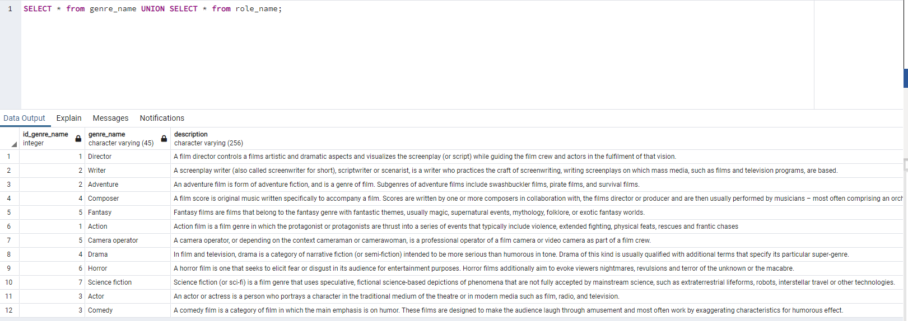

## – DISTINCT

## – LEFT JOIN; RIGHT JOIN; FULL OUTER JOIN

SELECT id_genre_name, id_type, genre_name, type_name FROM genre_name g LEFT JOIN type t on t.id_type = g.id_genre_name;

SELECT country,country_name,city,language,flag,description FROM address a RIGHT JOIN country c on c.country_name = a.country;

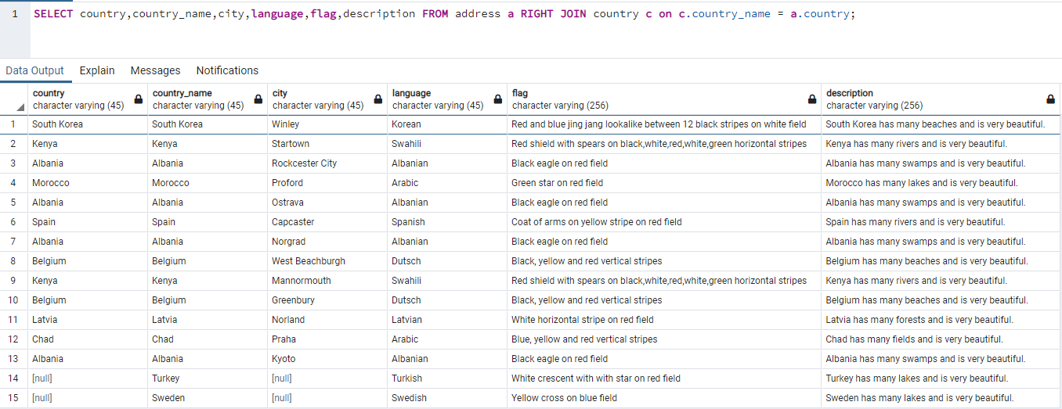

SELECT country,country_name,city,language,flag,description FROM address a FULL OUTER JOIN country c on c.country_name = a.country;

# Use in one query: LEFT JOIN, GROUP BY, HAVING, ORDER BY, AVG and DISTINCT

SELECT DISTINCT t.name, lenght, AVG(rating) AS average_rating FROM titles t LEFT JOIN rating r on t.id_title = r.id_title GROUP BY t.name, lenght HAVING AVG(rating) IS NOT NULL ORDER BY name;

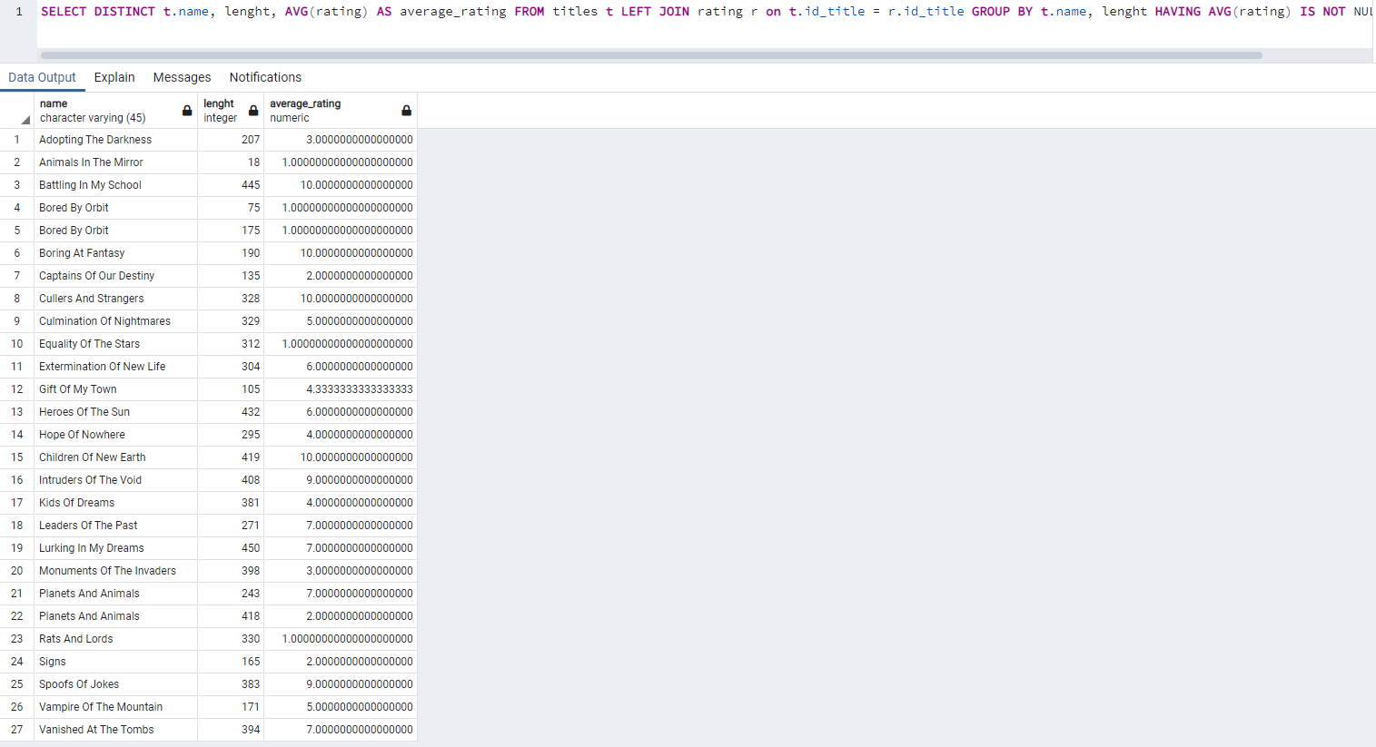

# Create a query that will return the data from an arbitrary table for the last one and half days

(1day + 12 hours, i.e., 36 hours). Do not hard code the query (e.g., created at > 7-11-2021)!

– Do it programmatically with DATE functions.

SELECT * FROM public.user WHERE NOW() - user_created < INTERVAL '36 hours';

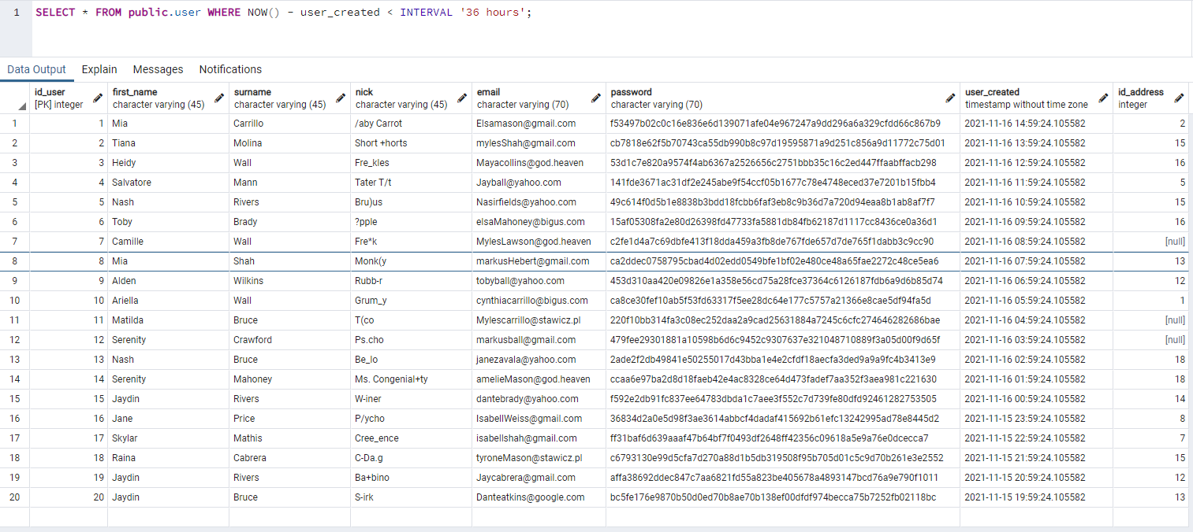

Create a query that will return data from the last month

(starting from the first day of the month)

SELECT id_user, first_name, surname, user_created FROM public.user WHERE user_created < date_trunc('month', CURRENT_DATE) AND user_created >= date_trunc('month', CURRENT_DATE - INTERVAL '1 months');

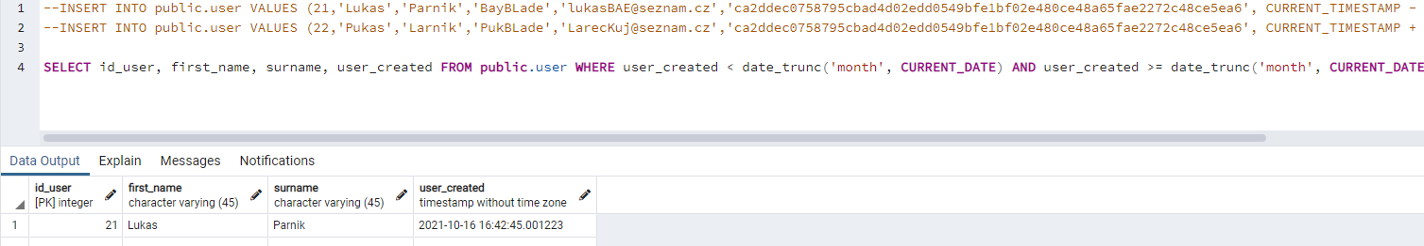

Write a select that will remove accents on a selected string

(e.g., ´a will be converted to a)

– Beforehand, you will need to save data that contain accents in the database (e.g., save

some Czech surname in the database that has accents)

CREATE EXTENSION UNACCENT;

SELECT id_user, UNACCENT(first_name), UNACCENT(surname) FROM public.user;

# Create a query for pagination in an application (use LIMIT and OFFSET)

SELECT id_title, name, description FROM titles LIMIT 20 OFFSET 10;

# Create a query that will use subquery in FROM

SELECT id_title, genre.genre_name, genre.description FROM (SELECT g.id_genre_name, id_title, genre_name, description FROM genre g JOIN genre_name n on g.id_genre_name = n.id_genre_name) genre;

# Create a query that will use subquery in WHERE condition

SELECT * FROM titles WHERE lenght > (SELECT AVG(lenght) FROM titles) AND id_title < (SELECT AVG(id_title) FROM titles) - 40;

# Create a query that will use any aggregate function and GROUP BY with HAVING

SELECT name, SUM(lenght) FROM titles GROUP BY name HAVING COUNT(name) > 2;

# Create a query that will join at least five tables

SELECT name, type_name, genre_name, country_name FROM titles t JOIN type p on t.id_type = p.id_type JOIN genre g on g.id_title = t.id_title JOIN genre_name n on g.id_genre_name = n.id_genre_name JOIN country c on c.id_country = t.id_country;

# Create a query that will join at least three tables and will use GROUP BY, HAVING, and WHERE

SELECT name, u.first_name, SUM(rating) FROM rating r JOIN titles t on r.id_title = t.id_title JOIN public.user u on u.id_user = r.id_user WHERE r.id_user > 10 GROUP BY name, u.first_name HAVING SUM(rating) > 5;

Modify the database from the first project assignment to improve integrity constraints (e.g.,reduce the size for varchar columns)

ALTER TABLE public.user ALTER COLUMN password TYPE VARCHAR(65);

– Set cascading, explain places where you used cascading and why?

ALTER TABLE favourites DROP constraint fk_favourites_user,ADD constraint fk_favourites_user FOREIGN KEY (id_user) REFERENCES public.user(id_user) ON DELETE CASCADE;

Aby když se smazal uživatel tak se smažou i jeho oblíbení herci.

ALTER TABLE rating DROP constraint fk_rating_user1,ADD constraint fk_rating_user1 FOREIGN KEY (id_user) REFERENCES public.user(id_user) ON DELETE CASCADE;

Aby když se smazal uživatel tak se smažou i jeho hodnocení.

ALTER TABLE rating DROP constraint fk_rating_titles1,ADD constraint fk_rating_titles1 FOREIGN KEY (id_title) REFERENCES public.titles(id_title) ON DELETE CASCADE;

Aby když se smazalo dílo tak se smažou i jeho hodnocení.

ALTER TABLE genre DROP constraint fk_genre_titles1,ADD constraint fk_genre_titles1 FOREIGN KEY (id_title) REFERENCES public.titles(id_title) ON DELETE CASCADE;

Aby když se smazalo dílo tak se smažou i jeho zastoupení v tabulce žánrů.

ALTER TABLE role DROP constraint fk_role_titles1,ADD constraint fk_role_titles1 FOREIGN KEY (id_title) REFERENCES public.titles(id_title) ON DELETE CASCADE;

Aby když se smazalo dílo tak se smažou jeho záznamy z tabulky role.

Create database indexes (create it only on columns where it can make a sense – explain in theprovided document why it make sense on a certain column(s))

CREATE INDEX titles_name_index ON titles (name);

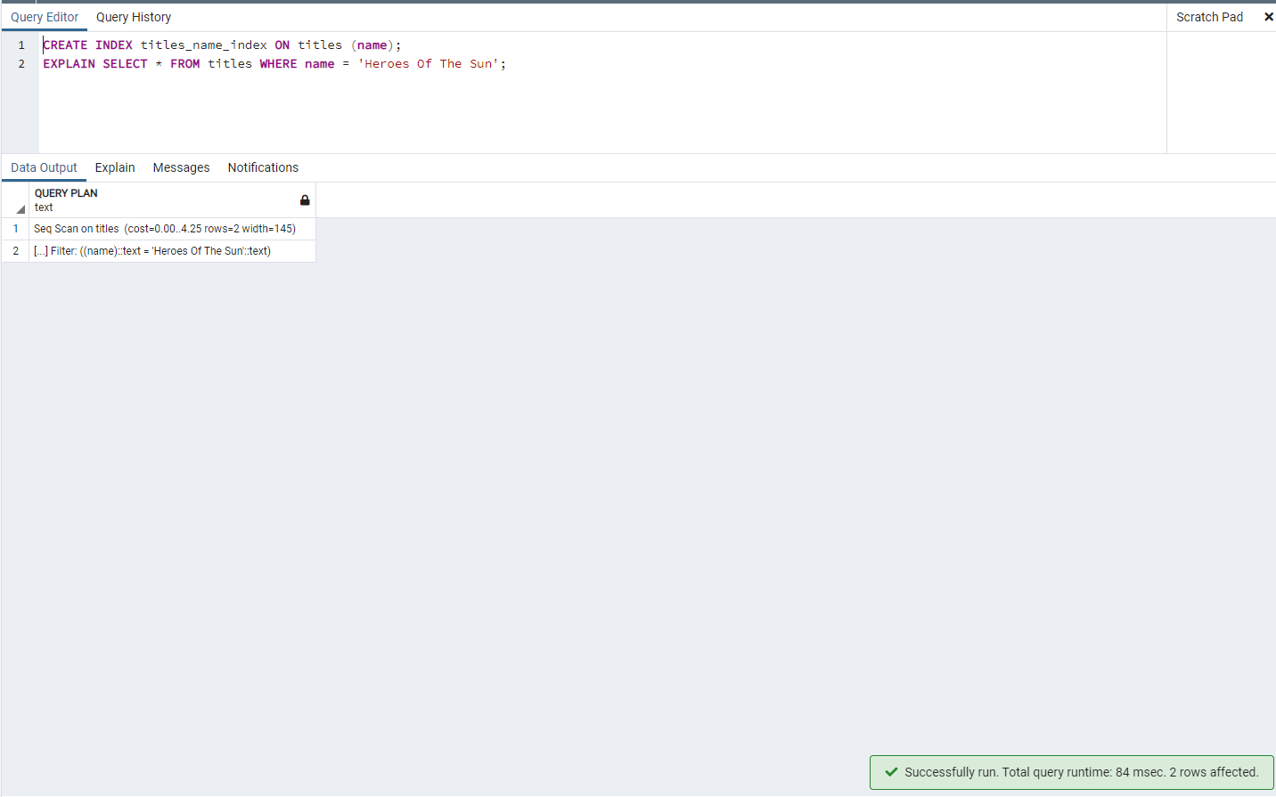

Dává to smysl protože se nemusí procházet všechny záznamy ale jen ty které vyhovují podmínce.

– Before you create a database index perform a query that will use WHERE condition on a column without index and then perform the same query on the column with index (note: use EXPLAIN keyword to note the differences – provide a comparison of the execution plans)

Po použití indexu je vyhledávání o něco rychlejší.

Create arbitrary database procedure (consider some complex case)

CREATE OR REPLACE PROCEDURE change_title_type(

title int,

new_type VARCHAR(45)

)

LANGUAGE SQL

AS $$

UPDATE titles

SET id_type = (SELECT id_type FROM type WHERE type_name = new_type)

WHERE id_title = title;

$$;

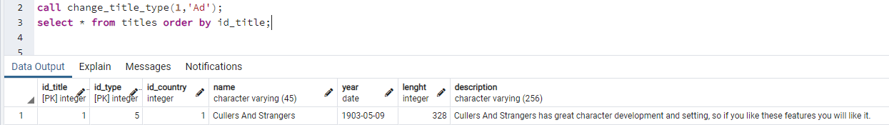

# Create arbitrary database trigger

CREATE FUNCTION after_user_insert() RETURNS TRIGGER AS $trigger$

BEGIN

RAISE NOTICE 'Another one bites a dust!';

RETURN NEW;

END;

$trigger$ LANGUAGE plpgsql;

CREATE TRIGGER adter_user_insert AFTER INSERT ON public.user EXECUTE PROCEDURE after_user_insert();

Create arbitrary database view (consider some complex case)

CREATE VIEW five_most_popular AS (SELECT first_name, surname, COUNT(r.id_person) AS most_popular FROM role r JOIN person p on r.id_person = p.id_person GROUP BY first_name,surname ORDER BY most_popular DESC LIMIT 5);

Create database materialized view (consider some complicated SQL query with several joins, aggregate function, GROUP BY with HAVING and complex WHERE condition). Explain why this materialized view is beneficial/needed.

CREATE MATERIALIZED VIEW good_long_titles AS (SELECT t.id_title, name, p.type_name, n.genre_name, t.year, t.lenght, AVG(r.rating) FROM titles t JOIN type p ON t.id_type = p.id_type JOIN genre g ON t.id_title = g.id_title JOIN genre_name n ON n.id_genre_name = g.id_genre_name JOIN rating r ON r.id_title = t.id_title WHERE t.lenght > 120 GROUP BY t.id_title, name, p.type_name, n.genre_name, t.year, t.lenght HAVING AVG(r.rating) >= 5);

Kdykoliv se někdo chce kouknout na dlouhé dobré dílo stačí použít tento view a nemusí se dotazovat z databáze a tím ji zatěžovat.

Create two roles teacher and student in your database. Assign for teacher privileges to SELECT, INSERT, UPDATE, and DELETE everything in arbitrary table. Furthermore, set for teacher the possibility to view only certain fields (e.g., without salary from ” person“ or your ”user“ object). For student assign a possibility to select only certain tables.

CREATE ROLE teacher NOSUPERUSER;

REVOKE ALL ON ALL TABLES IN SCHEMA public FROM teacher;

GRANT SELECT, INSERT, UPDATE, DELETE ON public.user TO teacher;

CREATE VIEW teacher_only AS (SELECT id_user, first_name, surname, email, id_address FROM public.user);

GRANT SELECT ON teacher_only TO teacher;

CREATE ROLE student NOSUPERUSER;

REVOKE ALL ON ALL TABLES IN SCHEMA public FROM student;

GRANT SELECT ON titles,type,genre,genre_name,role,role_name,person,rating,country TO student;