K .J .SOMAIYA COLLEGE OF ENGINEERING AND INFORMATION TECHNOLOGY, VIDYAVIHAR

**F.E EXAMINATION, SEM II, MAY-JUNE 2024**

**Time Table**

|  |  |  |
| --- | --- | --- |
| Day and Date | Time | Subject |
| Monday  27/05/2024 | 10:00 AM To 01:00 PM | Communication Skills |
| Wednesday  29/05/2024 | 10:00 AM To 01:00 PM | Applied Mathematics - II |
| Friday  31/05/2024 | 10:00 AM To 01:00 PM | Engineering Drawing |
| Monday  03/06/2024 | 10:00 AM To 01:00 PM | Applied Physics – II |
| Thursday  06/06/2024 | 10:00 AM To 01:00 PM | Applied Chemistry - II |
| Monday  10/06/2024 | 10:00 AM To 01:00 PM | Computer Programming – II |

|  |
| --- |
|  |
|  |

JUST FOR EXAMPLE:

H20 , H2SO4

X3 * X4 = X7



|  |  |  |  |
| --- | --- | --- | --- |
|  | |  | |
| MARKSHEET | | | | | | | | | |
| Subject: | MATHS | ENGLISH | SCIENCE | ECO | Accounts | Total | | Max  Marks | |
| NAMES : |
| John | 55 | 60 | 49 | 61 | 58 | 283 | | 500 | |
| Ron | 49 | 58 | 55 | 60 | 62 | 284 | | 500 | |
| Marry | 58 | 49 | 60 | 55 | 64 | 286 | | 500 | |
| JeNNIFER | 62 | 63 | 58 | 55 | 49 | 287 | | 500 | |

Images In Front Of Text and Behind Of Text

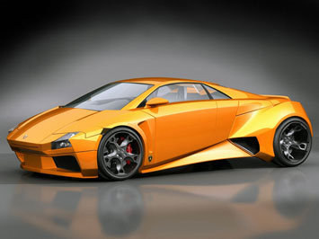

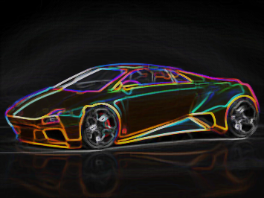

|  |  |
| --- | --- |
| **Height** | * **Coupé:** 1,165 mm (45.9 in) * **Spyder:** 1,184 mm (46.6 in) |
| [**Kerb weight**](https://en.wikipedia.org/wiki/Curb_weight) | * **LP 560-4:** 1,501 kg (3,310 lb)[[2]](https://en.wikipedia.org/wiki/Lamborghini_Gallardo#cite_note-2) * **Gallardo coupé:** 1,597 kg (3,520 lb) [[3]](https://en.wikipedia.org/wiki/Lamborghini_Gallardo#cite_note-3) * **Spyder:** 1,733 kg (3,820 lb) [[4]](https://en.wikipedia.org/wiki/Lamborghini_Gallardo#cite_note-4) * **Superleggera:** 1,558 kg (3,434 lb)[[5]](https://en.wikipedia.org/wiki/Lamborghini_Gallardo#cite_note-5) * **LP 550-2 Valentino Balboni:** 1,547 kg (3,410 lb)[[6]](https://en.wikipedia.org/wiki/Lamborghini_Gallardo#cite_note-6) * **LP 570-4 Superleggera:** 1,520 kg (3,350 lb)[[7]](https://en.wikipedia.org/wiki/Lamborghini_Gallardo#cite_note-7) |
| **Chronology** | |
| **Predecessor** | [Lamborghini Jalpa](https://en.wikipedia.org/wiki/Lamborghini_Jalpa) |
| **Successor** | [Lamborghini Huracán](https://en.wikipedia.org/wiki/Lamborghini_Hurac%C3%A1n) |

The **Lamborghini Gallardo** ([/ɡaɪˈjɑːrdoʊ/](https://en.wikipedia.org/wiki/Help:IPA/English); Spanish: [[ɡaˈʎaɾðo]](https://en.wikipedia.org/wiki/Help:IPA/Spanish)) is a [sports car](https://en.wikipedia.org/wiki/Sports_car) built by the Italian automotive manufacturer [Lamborghini](https://en.wikipedia.org/wiki/Lamborghini) from 2003 to 2013. It is Lamborghini's second car released under parent company [Audi](https://en.wikipedia.org/wiki/Audi), and the [best-selling model](https://en.wikipedia.org/wiki/List_of_best-selling_automobiles) at the time with 14,022 built throughout its production run.[[8]](https://en.wikipedia.org/wiki/Lamborghini_Gallardo#cite_note-8) Named after a famous breed of [fighting bull](https://en.wikipedia.org/wiki/Spanish_Fighting_Bull),[[9]](https://en.wikipedia.org/wiki/Lamborghini_Gallardo#cite_note-9) the [V10](https://en.wikipedia.org/wiki/Lamborghini_V10) powered Gallardo has been Lamborghini's sales leader and stable-mate to a succession of [V12](https://en.wikipedia.org/wiki/Lamborghini_V12) flagship models—first to the [Murciélago](https://en.wikipedia.org/wiki/Lamborghini_Murci%C3%A9lago" \o "Lamborghini Murciélago) (4,099 built between 2001 and 2010), then to the [Aventador](https://en.wikipedia.org/wiki/Lamborghini_Aventador" \o "Lamborghini Aventador), being the first entry-level Lamborghini in one-and-half decades. On 25 November 2013, the last Gallardo was rolled off the production line. The Gallardo was replaced by the [Huracán](https://en.wikipedia.org/wiki/Lamborghini_Hurac%C3%A1n" \o "Lamborghini Huracán) in 2014.

https://upload.wikimedia.org/wikipedia/commons/thumb/8/87/Gnome-mime-sound-openclipart.svg/50px-Gnome-mime-sound-openclipart.svg.png

[Lamborghini Gallardo Superleggera](https://en.wikipedia.org/wiki/File:Lamborghini_Gallardo_LP570-4_Superleggera.ogg)

After [Megatech](https://en.wikipedia.org/wiki/Megatech_(Indonesian_company)" \o "Megatech (Indonesian company)) purchased [Automobili Lamborghini S.P.A](https://en.wikipedia.org/wiki/Lamborghini" \o "Lamborghini) in 1994, [Italdesign Giugiaro](https://en.wikipedia.org/wiki/Italdesign_Giugiaro" \o "Italdesign Giugiaro) was hired to design concept cars to replace their existing cars. One of the concepts built by them was the [Lamborghini Calà](https://en.wikipedia.org/wiki/Lamborghini_Cal%C3%A0), built to replace the [Lamborghini Jalpa](https://en.wikipedia.org/wiki/Lamborghini_Jalpa) and was displayed at the 1995 [Geneva Motor Show](https://en.wikipedia.org/wiki/Geneva_Motor_Show).

After the [Volkswagen AG](https://en.wikipedia.org/wiki/Volkswagen_AG) took hold of the company in 1998, the Lamborghini Gallardo was built on the basis of the Calà and had many features absorbed from the [concept car](https://en.wikipedia.org/wiki/Concept_car) such as the exterior design and the traditional [V10 engine](https://en.wikipedia.org/wiki/V10_engine).

## 

## LAMBORGHINI’s REFLECTION

|  |  |  |  |  |  |  |
| --- | --- | --- | --- | --- | --- | --- |
| A | B | C | D | E | F | $$=sum(LEFT) 0$$ |
| B |  |  |  |  |  |  |
| C | B | C | D | E | F | $$=sum(LEFT) 0$$ |
| D |  |  |  |  |  |  |
| E | **B** | **C** | **D** | **E** | **F** | $$=sum(LEFT) 0$$ |
| F |  |  |  |  |  |  |

Text Wrapping In Images

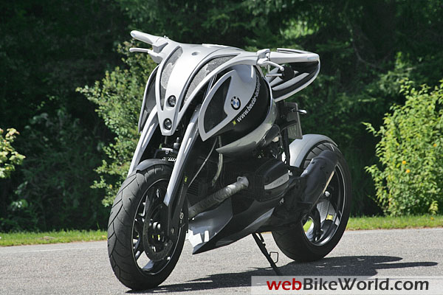

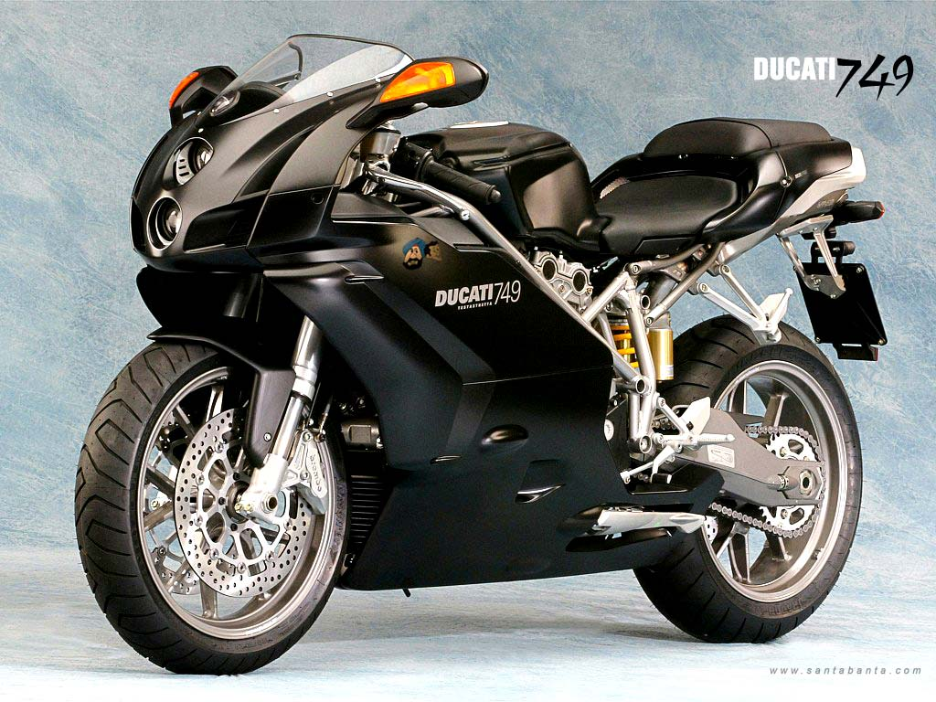

* 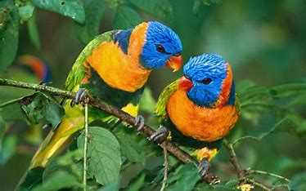Parrots are colorful, intelligent birds found in tropical regions. They are famous for their ability to mimic human speech.
* These social birds thrive on interaction and love to show off their vibrant plumage.
* **Squawk!** Parrots communicate with a variety of sounds. 🦜

Blue - Jay

[https://www.bing.com/ck/a?!&&p=d24cecc5feb98838JmltdHM9MTcxMjc5MzYwMCZpZ3VpZD0wZTE2MWNlYy1mZDBjLTY0MDItMDU0ZC0wOGYwZmNhNDY1ZDkmaW5zaWQ9NTY5OA&ptn=3&ver=2&hsh=3&fclid=0e161cec-fd0c-6402-054d-08f0fca465d9&u=a1L2ltYWdlcy9zZWFyY2g_cT1iaXJkcyUyMHBpY3MmRk9STT1JUUZSQkEmaWQ9QjNEM0E4RkNGM0E4OTRDOEQ5MTlGRTQ4RDc4NTNGMDY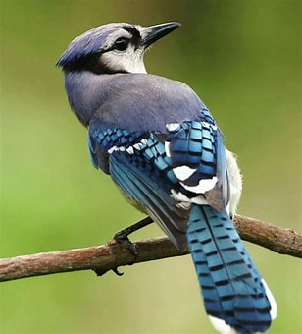1QUI4ODU0Rg&ntb=1](https://www.bing.com/ck/a?!&&p=d24cecc5feb98838JmltdHM9MTcxMjc5MzYwMCZpZ3VpZD0wZTE2MWNlYy1mZDBjLTY0MDItMDU0ZC0wOGYwZmNhNDY1ZDkmaW5zaWQ9NTY5OA&ptn=3&ver=2&hsh=3&fclid=0e161cec-fd0c-6402-054d-08f0fca465d9&u=a1L2ltYWdlcy9zZWFyY2g_cT1iaXJkcyUyMHBpY3MmRk9STT1JUUZSQkEmaWQ9QjNEM0E4RkNGM0E4OTRDOEQ5MTlGRTQ4RDc4NTNGMDY1QUI4ODU0Rg&ntb=1)

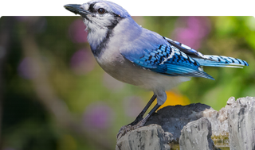**The blue jay (Cyanocitta cristata) is a passerine bird in the family Corvidae, native to eastern North America. It inhabits most of the eastern and central United States, with some populations being migratory.**[**Resident blue jays are also found in Newfoundland, Canada, while breeding populations span across southern Canada**](https://en.wikipedia.org/wiki/Blue_jay)**.**

* 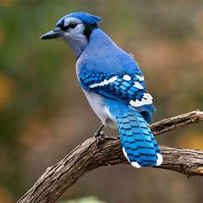**The blue jay measures around 9 to 12 inches in length and weighs between 2.5 to 3.5 ounces.**
* **Its most striking feature is its vibrant blue plumage, extending from its head to its tail.**
* [**A distinguishing black crest adorns its head, and it sports a black necklace-like band around its neck**](https://wildexplained.com/animal-encyclopedia/the-blue-jay-a-fascinating-bird-of-north-america/)