Corrugator

A bulletin can have several conjugations;

Each batch is a conjugation (Race is the same as conjugation, bulletin).

Each race is a conjugation. (To conjugate an order is to play within the batch, already optimized).

The order optimization can be run in 1-2 or more days, up to a week. (7 calendar days or 5 business days).

Red orders are produced only a percentage to complete the orders that were conjugated. The red order is in the order book.

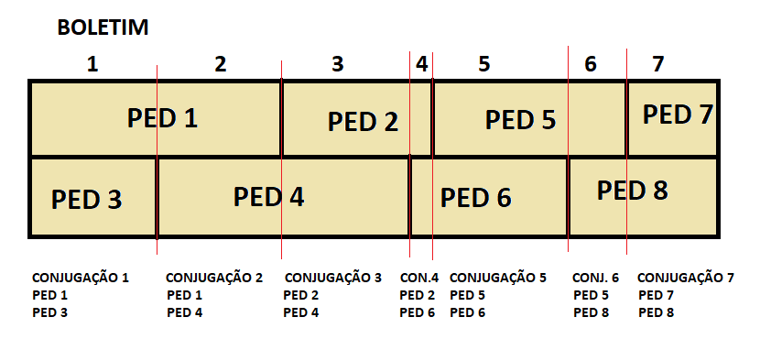

In Trimbox, you combine in advance precisely to have information about inputs, tools, paints, to see how the bulletins will look, etc.

Today they produce around 220 tons per day.

Is a bulletin with several combinations a problem or is it easy for the operation?

A: It has nothing to do with it. A combination cannot be less than 300 linear meters. Sometimes the restrictions can be broken.

About tolerance, Trimbox does an calculation that he could not explain, taking into account the loss and the tolerance itself. 24:31

List of restrictions

Wallet: 3:50

What is a FT? 17:00

Refill? 17:00

Corrugating screen

The idea is to create a screen with levels:

Level 1: Divided by day; Show more indicators;

Level 2: Data related to the bulletin, a bulletin contains several conjugations. And a conjugation contains several requests.

Level 3: Show the conjugations.