**Task-1: OS Information**

**Aim: Write a program that uses the OS module to display the current user's username, home directory and operating system platform**.

**Code:**

const os = require('os');

function displayUserInfo() {

  // Get the username

  const username = os.userInfo().username;

  // Get the home directory

  const homeDir = os.homedir();

  // Get the operating system platform

  const platform = os.platform();

  // Display the user information

  console.log('Username:', username);

  console.log('Home Directory:', homeDir);

  console.log('Operating System Platform:', platform);

}

// Call the function to display the user information

displayUserInfo();

**Output:**

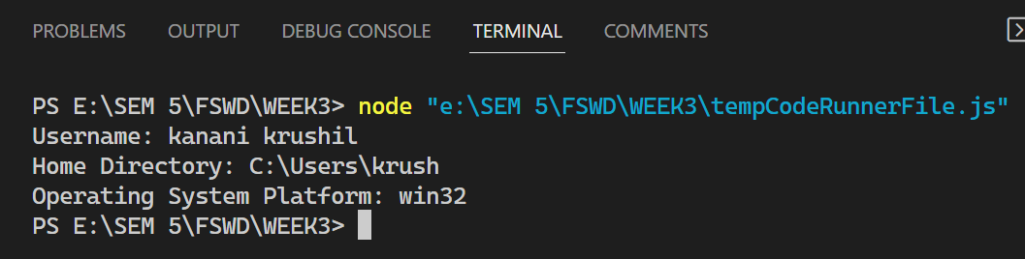

**Aim: Create a function that utilize the OS module to display the total system memory, free memory and the percentage of free memory available.**

**Code:**

const os = require('os');

function displayMemoryInfo() {

  // Get the total system memory

  const totalMemory = os.totalmem() / (1024 ** 3);

  // Get the free memory

  const freeMemory = os.freemem() / (1024 ** 3);

  // Calculate the percentage of free memory available

  const percentageFree = (freeMemory / totalMemory) * 100;

  // Display the memory information

  console.log('Total System Memory:', totalMemory.toFixed(2), 'GB');

  console.log('Free Memory:', freeMemory.toFixed(2), 'GB');

  console.log('Percentage of Free Memory Available:', percentageFree.toFixed(2), '%');

}

// Call the function to display the memory information

displayMemoryInfo();

**Output:**

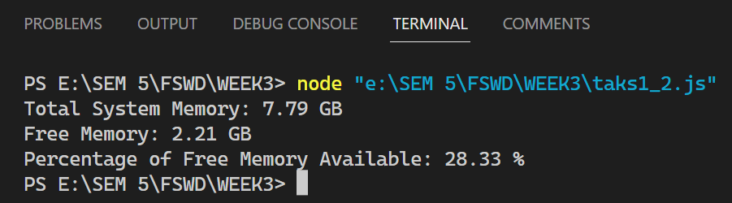

**Task 2**

**Aim:** **Experiment with chalk, uppercase any other external modules.**

**Code:**

// Example with chalk module

const chalk = require('chalk');

function displayColoredText() {

  console.log(chalk.blue('This is a blue text.'));

  console.log(chalk.green.bold('This is a bold green text.'));

  console.log(chalk.yellow.bgRed('This is a yellow text on a red background.'));

}

// Call the function to display colored text

displayColoredText();

**Output:**

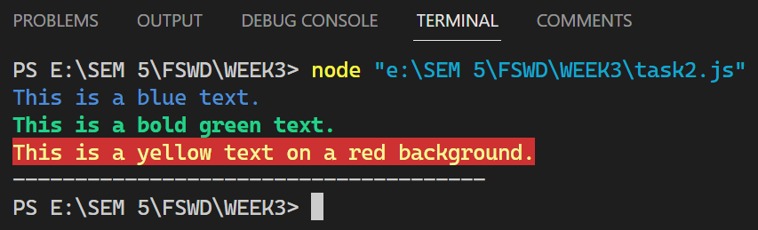

**Task 3**

**Aim:** **Create your own personal module and import/export to the main module**

**Code:**

function greetUser(name) {

    console.log(`Hello, ${name}! Welcome to my personal module!`);

  }

  module.exports = {

    greetUser,

  };

const greetings = require('./task3_1');

greetings.greetUser('Krushil Kanani');

**Output:**

