**Library Management Website**

Krushil Kanani - 21IT058 Prem Kaneria – 21IT060

[21it058@charusat.edu.in](mailto:21it058@charusat.edu.in) [21it060@charusat.edu.in](mailto:21it060@charusat.edu.in)

# **Mentor: Mikin Patel**

IT Department, Charotar University of Science and Technology

Anand, Gujarat

**ABSTRACT:**

Started our project Library Management in January 2023, this is a website feature related to Library. It is simply an informative website with all-in-one functionality. It will help to find the book’s availability from anywhere.

**INTRODUCTION:**

A library management system is a software application designed to help librarians and students manage and organize various library operations such as book acquisition, cataloging, circulation, and inventory management. The system provides a centralized platform to manage and track library resources, patrons, and borrowing history. With a library management system, librarians can streamline their workflows, automate routine tasks, and enhance the user experience for library patrons. The system can also generate various reports, statistics, and insights, which can help library staff make informed decisions and improve the overall efficiency of library operations.

**METHODOLOGY:**

First of all, this website is for those students who waste their time searching books visiting library.

First, it’s the home page where users can explore our whole website and its features. user can login/signup in user portal. There he/she can find the books.

The other portal for admin where admin can see the students information, the number of student registered.

Admin can also add books by clicking add book button given in the website. He/she can also see total number of books that he/she has added.

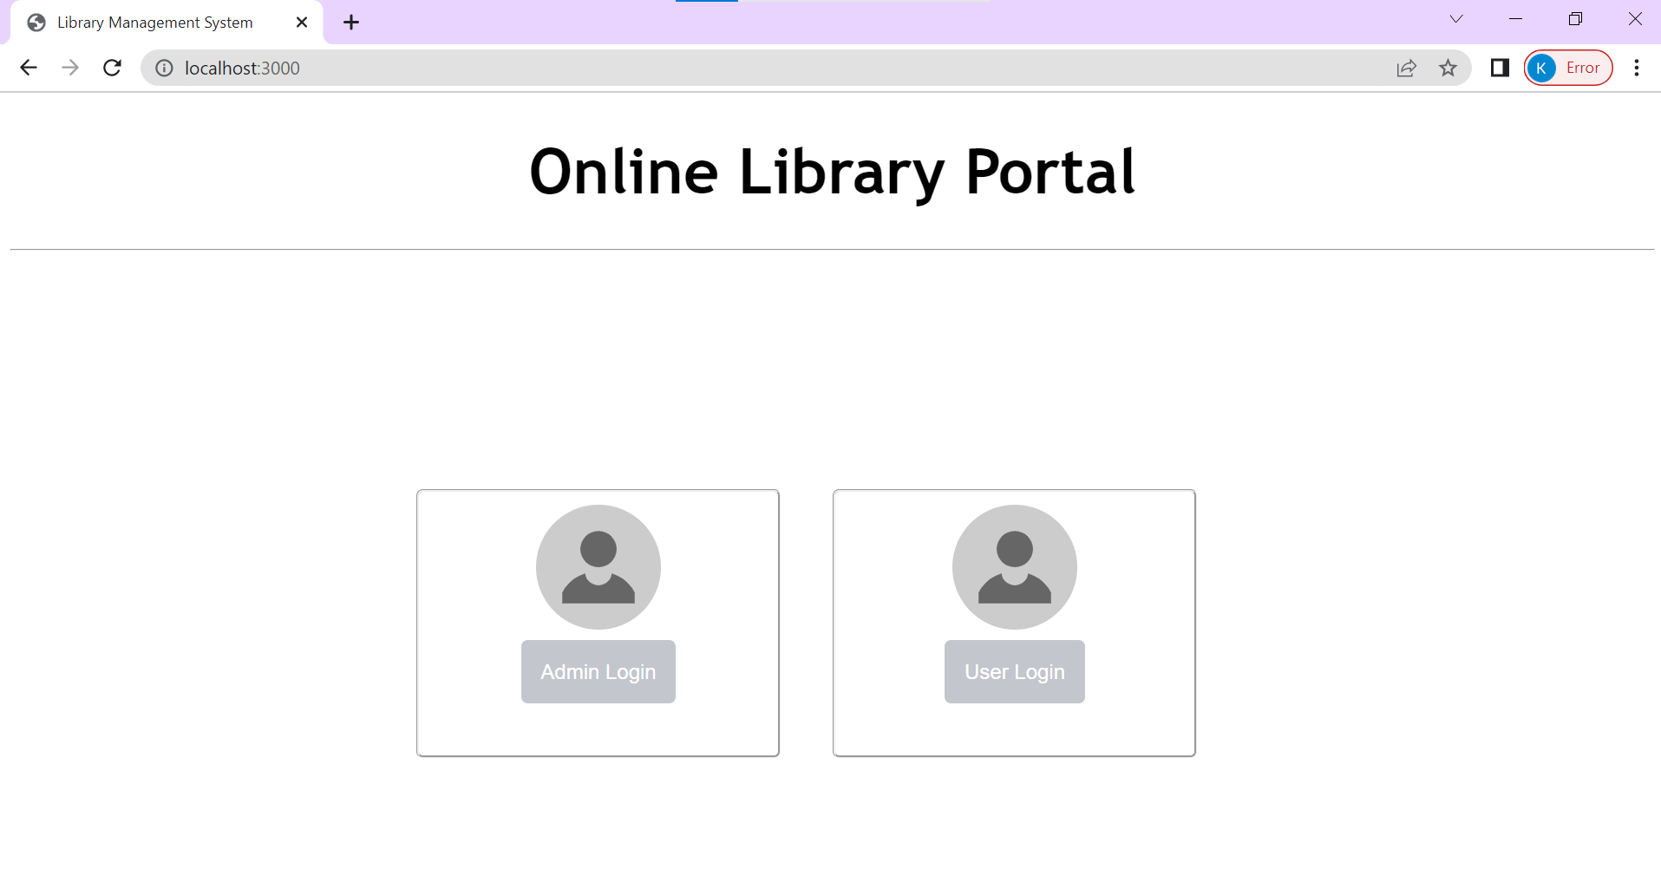

This is library portal.

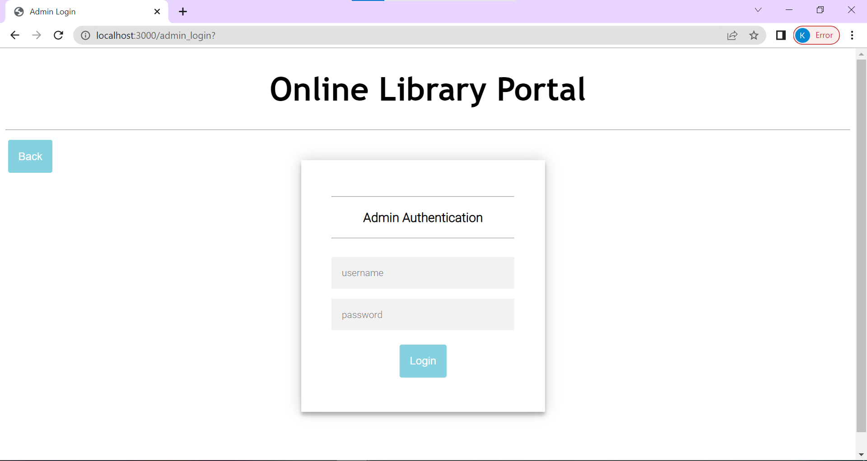

This is admin login page.

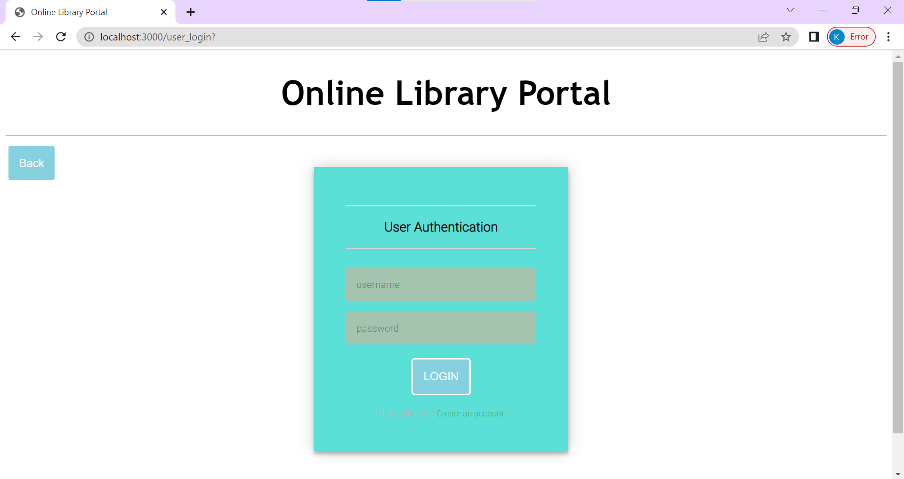

This is user login page.

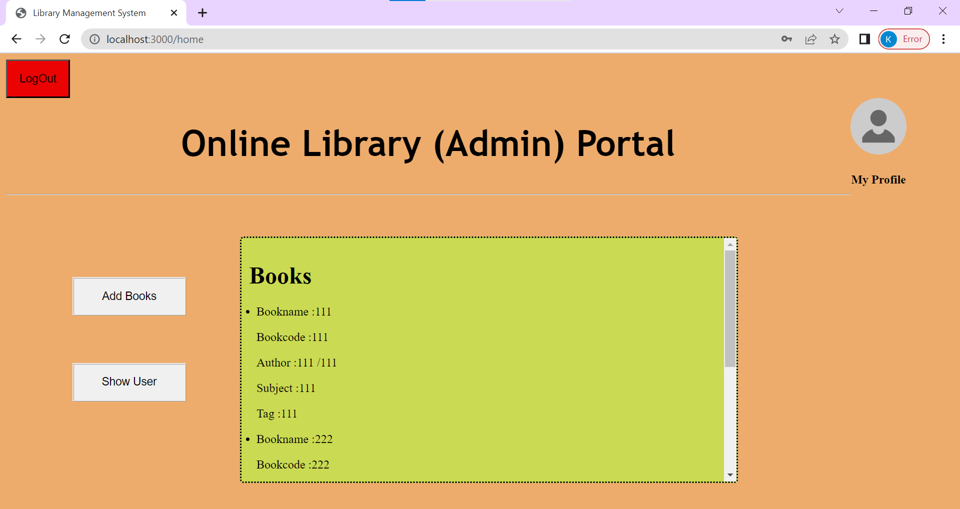

This section is admin portal.

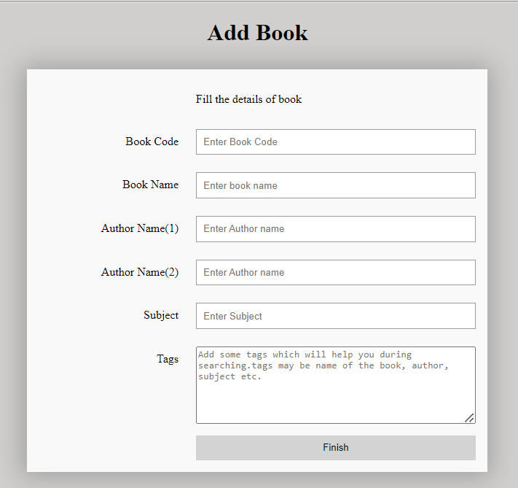

This is adding book section where admin can add the book by filling the above details.

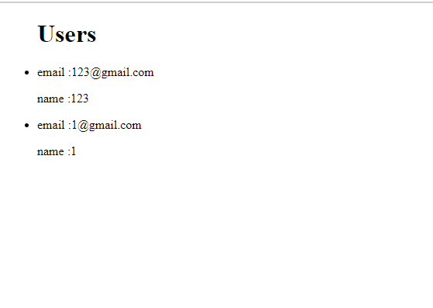

In this section admin can see the total number of registered students.

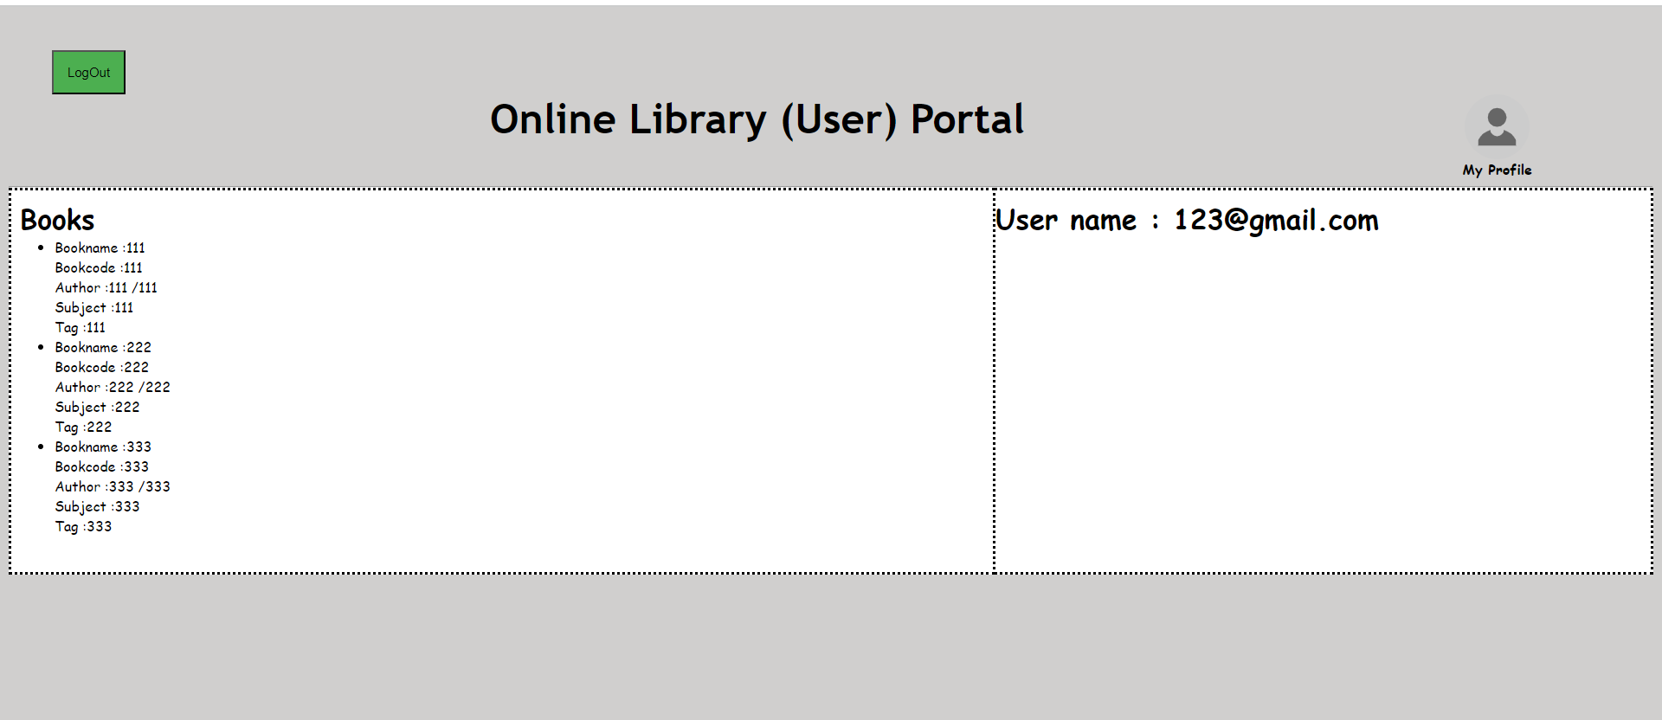

This is user portal where he/she can see the books availability and can also see his profile.

**FLOW CHART:**

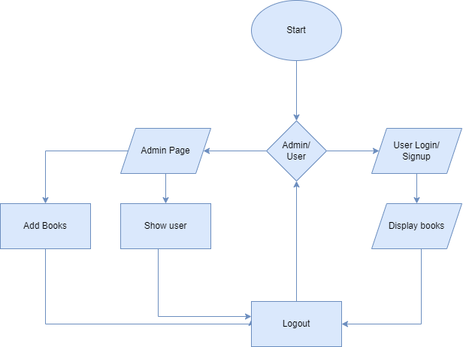

**RESULTS AND DISCUSSIONS:**

The technology used, JavaScript is mainly used with HTML and CSS. It’s developed in the frame of the mongo dB server.

**FUTURE PLANS:**

For future plans, we would like to include issue option for student so they can pre issue the book for their destination without coming to library.

We would also like to add the quantity model to this system so that user can have brief knowledge about the availability. Also we would like to add soft copy of some important books.

**CONCLUSION:**

It can be concluded that this website has the aim of providing informative features related to Library. The website is designed to offer a one-stop solution for books eBooks and their availability.