**Evolution and Advancements in ChatGPT: A Comprehensive Survey**

**INTRODUCTION**

The field of conversational AI is revolutionizing human-computer interactions by enabling natural language exchanges between machines and humans. This is made possible by breakthroughs in NLP and AI. It improves language comprehension and response creation by utilizing methods like deep learning and huge language models. Conversational AI helpers, such as virtual assistants and chatbots, are able to meet the increasing demand for intuitive interactions that arises from the increased integration of technology into daily life. These aides provide a recognizable and easy-to-use interface by using language models to comprehend user inquiries, deliver information, and carry out activities.

Natural language processing has advanced significantly with the introduction of massive language models such as GPT and BERT. By increasing the size and number of parameters, these models have made significant progress toward better language creation and comprehension. They are excellent at a variety of NLP tasks, including question answering, summarization, and translation, because to their billions of parameters. Attention mechanisms and transformer structures, which effectively capture long-range dependencies in text, are credited with their effectiveness. All things considered; these models mark a revolutionary development in NLP with a broad range of industrial applications.

With its ability to understand and produce text that is similar to that of a human, ChatGPT is a noteworthy advancement in conversational AI. It is excellent at comprehending and carrying out instructions, facilitating task-oriented and participatory discussions. Because of its adaptability, it may be used in a wide range of businesses and disciplines, such as customer service, healthcare, education, and entertainment, improving productivity and user experience.

The rationale for scrutinizing ChatGPT's development, structure, and influence stems from comprehending its incremental enhancements, monitoring progress in training techniques and model construction, and evaluating its possible uses and constraints in many fields. Researchers hope to learn more about the direction conversational AI technology is taking, pinpoint topics for future research, and provide guidance for ethically responsible deployment techniques by thoroughly analyzing these facets.

The first section of the survey introduces the fundamental ideas of machine learning and natural language processing used in ChatGPT. The development of Generative Pre-trained Transformers (GPT) is then traced, emphasizing significant breakthroughs. The features and restrictions of ChatGPT are covered next, along with some ethical issues. Applications from the real world in a variety of sectors are presented, and then a brief discussion of future directions is given, covering possible improvements, research topics, and social effects.

**FOUNDATION OF CHATGPT**

**Generative Pre-trained Transformer (GPT) Models:**

OpenAI, Inc. created the Generative Pre-Trained Transformer (GPT), a language model. GPT is a transformer-based artificial intelligence (AI) that, as its name implies, can generate new content (generative) using its pre-trained training set. GPT was created to handle problems related to natural language processing (NLP), namely natural language generation, which is the act of creating new phrases based on inputs, and natural language understanding, which is the analysis and interpretation of sentences. The traditional NLP models are rule-based and produce limited responses depending on a set of rules that have been encoded. They are therefore inflexible and struggle to adapt to the dynamic and diverse nature of language. The concept of machine translation (MT) was initially presented in 1949 by Weaver in a memo that would later become the basis for NLP models. While MT was a major emphasis of early NLP programs, models with a wider range of functionalities were also created. There are two training phases for the GPT model. Using a sizable corpus of unlabeled text data, the model is initially trained in an unsupervised, task-independent manner. The process of teaching the model on its own the patterns and representations in several languages is known as "pre-training." The "pre-trained" model is further educated to carry out particular tasks in the second stage through the use of fine-tuning and other cutting-edge training methods including reinforcement learning using human feedback. ChatGPT, a chatbot with a focus on creating natural language dialogues, was one of the final offerings. Together with a notable rise in size, GPT also showed that it could effectively learn new tasks using just a small amount of task-specific data (a process known as "few-shot" learning).

Fig. shows the simplified GPT training flowchart

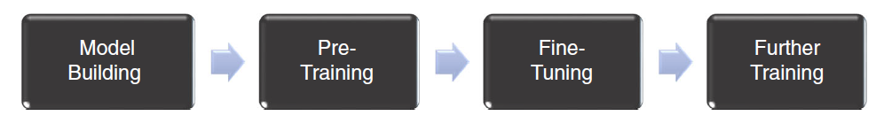

*Fig. 2 Simplified training flowchart for GPT. (a) Building the Model: Engineers in OpenAI built the basic structure of GPT called the Transformer, and set the hyperparameters (the number of layers and parameters in the Transformer), which cannot be changed by the model itself later after trained with data. (b) Pre-Training: The model was put into the unlabeled, unsupervised pre-training with huge amounts of data, where the model learned the patterns and presentations in languages. The learned knowledge was stored as data generated by the model, or “weights,” which could be changed after further training. (c) Fine-Tuning: The pre-trained model was then fine-tuned for natural language processing tasks. Novel techniques other than fine-tuning were also employed to acquire better performance. In the process, weights in the model were altered to better match specific tasks. The end products were the core builds of GPT called GPT-1 to 4. Different core builds varied as their hyperparameters and the quantity of training data differed. (d) Further Training: These core builds can be further trained into even more specialized models like the chatbot ChatGPT.*

Transfer learning involves leveraging knowledge from one task or domain to improve performance on another related task. Fine-tuning is a common approach in transfer learning where a pre-trained model is adapted to a specific downstream task by updating its parameters on task-specific data. This process is particularly effective in natural language processing (NLP), where pre-trained language models can be fine-tuned for tasks like sentiment analysis or named entity recognition, saving time and computational resources.

Language modeling refers to the task of predicting the next word in a sequence of words. It is a fundamental aspect of natural language understanding and generation. Language models are trained on large text corpora and can be used for various NLP tasks such as machine translation, text summarization, and question answering.

Language generation involves generating coherent and contextually relevant text based on a given prompt or input. Language models, particularly those utilizing techniques like recurrent neural networks (RNNs) or transformers, excel at generating human-like text in a variety of contexts, ranging from simple sentence completion to more complex story generation. These capabilities have applications in chatbots, content generation, and creative writing assistance.

**Self-Supervised Learning and Masked Language Modeling**

Masked language models (MLMs) are used in natural language processing (NLP) tasks for training language models. Certain words and tokens in a specific input are randomly masked or hidden in this approach and the model is then trained to predict these masked elements by using the context provided by the surrounding words.

Masked language modeling is a type of self-supervised learning in which the model learns to produce text without explicit labels or annotations. Instead, it draws its supervision from the incoming text. Because of this feature, masked language modeling can be used to carry out various NLP tasks such as text classification, answering questions and text generation.

Working:

As a pretraining technique for deep learning models in NLP, MLMs work by masking a portion of the input tokens in a sentence at random and then asking the model to predict the masked tokens. The model is trained on huge volumes of text data so that it can learn to recognize word context and forecast masked tokens depending on their context. For example, in the sentence, "The cat [MASK] the tree," the model would predict the word climbed as the masked token.

Throughout the training process, the model is updated based on the difference between its predictions and the words in the sentence. The pretraining phase assists the model in learning valuable contextual representations of words, which can then be fine-tuned for specific NLP tasks. The goal of masked language modeling is to use the large amounts of text data available to train a general-purpose language model that can be applied to a variety of NLP challenges.

**Key Research Milestones and Contributions**:

Transformer Architecture: The introduction of the Transformer architecture in the paper "Attention is All You Need" by Vaswani et al. in 2017 revolutionized natural language processing by enabling efficient training of large-scale models. Transformers form the backbone of many subsequent models, including GPT series.

GPT (Generative Pre-trained Transformer): The original GPT model, introduced by OpenAI in 2018, demonstrated the effectiveness of large-scale pre-trained language models for text generation tasks. GPT laid the groundwork for subsequent iterations and inspired further research in the field.

BERT (Bidirectional Encoder Representations from Transformers): Introduced by Google AI in 2018, BERT improved upon previous models by leveraging bidirectional context in pre-training. BERT's innovations in pre-training techniques significantly advanced natural language understanding tasks.

GPT-2: Released by OpenAI in 2019, GPT-2 further scaled up the model size and demonstrated impressive capabilities in generating coherent and contextually relevant text. It showcased the potential of large-scale language models for various text generation applications.

GPT-3: OpenAI's GPT-3, released in 2020, pushed the boundaries of scale with 175 billion parameters. It exhibited remarkable language understanding and generation capabilities, demonstrating the potential of very large pre-trained models for a wide range of tasks.

InstructGPT: InstructGPT, introduced in 2021, extended the GPT architecture to incorporate instructions or prompts to guide the generation process. This model enabled more fine-grained control over text generation, allowing users to specify desired attributes or constraints in generated output.

These papers and models have collectively advanced the field of natural language processing and paved the way for ChatGPT, which leverages the strengths of large-scale pre-trained transformers for conversational AI applications.

**GPT LINEAGE**

**TRANSFORMERS-**

**Overview of the Transformer Architecture:**

Transformers are a type of neural network architecture that have been gaining popularity which was introduced in the paper "Attention Is All You Need" by Vaswani et al. (2017). It is a sequence transduction model that relies entirely on attention mechanisms, dispensing with recurrence and convolutions entirely. It follows an encoder-decoder structure using stacked self-attention and point-wise, fully connected layers for both encoder and decoder.

Self-attention is a mechanism used in machine learning, particularly in natural language processing (NLP) and computer vision tasks, to capture dependencies and relationships within input sequences. It allows the model to identify and weigh the importance of different parts of the input sequence by attending to itself. Self-attention is vital in AI and machine learning for its capacity to capture distant relationships, understand context, and facilitate parallel computation. It enables the understanding of complex patterns by assigning relevance-based weights to sequence elements. Its parallel processing capability ensures computational efficiency, crucial for scalability with large datasets.

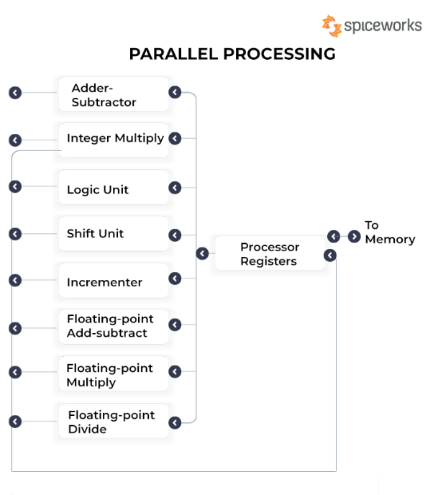 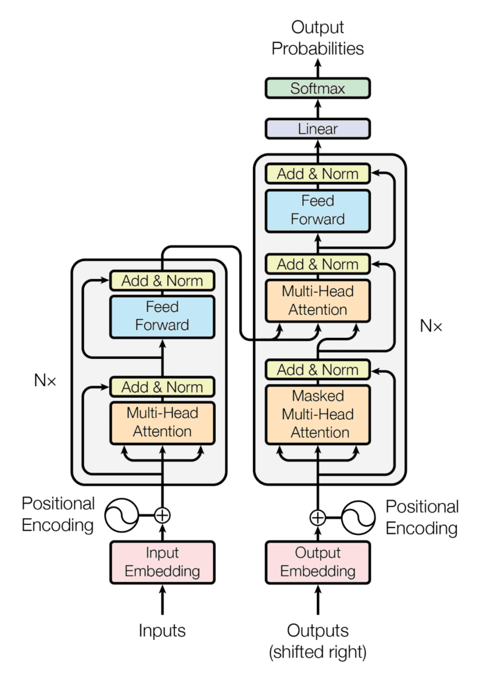

The encoder-decoder structure in machine learning facilitates various tasks such as translation and summarization. It consists of two components: an encoder that processes input data and a decoder that generates output. Parallel processing enhances the efficiency of this structure by allowing multiple inputs or outputs to be processed simultaneously, reducing computation time, and improving scalability.

Multi-head attention is a mechanism used in neural network architectures, particularly in the field of natural language processing (NLP), and it is a key component of transformer-based models like BERT and GPT. It extends the concept of self-attention by allowing the model to focus on different parts of the input simultaneously, using multiple attention heads. Multi-head attention extends this idea by allowing the model to perform multiple sets of attention calculations in parallel. Instead of having just one attention mechanism, you have multiple attention mechanisms or "heads" operating in parallel. Each head learns different attention weights, allowing the model to focus on different parts of the input sentence.

Advantages-

Transformer models have several advantages over conventional neural networks and recurrent neural networks (RNNs) such as long short-term memory (LSTM). They excel in handling long dependencies between input sequence elements and enable parallel processing. This makes them highly effective in tasks involving sequential data. Transformer-based models have shown remarkable achievements in various domains including Natural Language Processing (NLP), computer vision, audio and speech processing, healthcare, and the Internet of Things (IoT). In the field of computer vision, transformer-based models perform like or better than other types of networks, such as convolutional and recurrent neural networks, due to their strong representation capabilities and less need for vision-specific inductive bias. Additionally, transformer models have been successfully applied in reinforcement learning settings, where they outperform previous model-free and model-based algorithms by generating meaningful, new experiences and learning long-term dependencies while remaining computationally efficient.

**GPT**

Generative Pre-trained Transformers, commonly known as GPT, are a family of neural network models that uses the transformer architecture and is a key advancement in artificial intelligence (AI) powering generative AI applications such as ChatGPT. GPT models give applications the ability to create human-like text and content (images, music, and more), and answer questions in a conversational manner. The first GPT was introduced by OpenAI in the paper "Improving Language Understanding by Generative Pre-Training" (Radford et al., 2018) which was released on June 11, 2018.

The pre-training approach used in GPT (Generative Pre-trained Transformer) involves training the model on a large corpus of text data using a language modeling objective. Specifically, the model is trained to predict the next word in a sequence, given the previous words. This is done by maximizing the likelihood of the training data under the model's distribution. This pre-training process allows the GPT model to develop a deep understanding of natural language patterns, word relationships, and contextual information, without being explicitly trained on any specific task. The pre-trained model can then be fine-tuned on specific downstream tasks, such as text generation, summarization, or question answering, using a smaller amount of task-specific data.

Limitations-

1. Context Window:

GPT-1 had a limited context window due to its unidirectional nature. It could consider only the tokens to the left of the current word, which sometimes affected its understanding of long-range dependencies.

1. Parameter Size:

Compared to more recent models, GPT-1 had a smaller parameter size, which limited its capacity to understand complex linguistic structures.

1. Fine-Tuning:

GPT-1 could be fine-tuned for specific tasks, but the fine-tuning process required a considerable amount of labeled data to achieve high performance.

**GPT-2**

GPT-2, the second iteration of the GPT versions, marked a significant leap in scale and performance. Released by OpenAI in 2019, GPT-2 demonstrated the potential of large-scale language models for various NLP tasks. GPT-2 retained the fundamental architecture of GPT-1 but introduced significant improvements in model size and training data.

GPT-2 is a Transformer architecture that was notable for its size (1.5 billion parameters) on its release. The model is pretrained on a Web Text dataset - text from 45 million website links. It largely follows the previous GPT architecture with some modifications:

* Layer normalization is moved to the input of each sub-block, like a pre-activation residual network and an additional layer normalization was added after the final self-attention block.
* A modified initialization which accounts for the accumulation on the residual path with model depth is used. Weights of residual layers are scaled at initialization by a factor of where is the number of residual layers.
* The vocabulary is expanded to 50,257. The context size is expanded from 512 to 1024 tokens and a larger batch size of 512 is used.

Concerns were raised about OpenAI's GPT-2 model due to its ability to generate highly convincing and coherent text, raising fears about its potential misuse for spreading misinformation and creating harmful content like fake news and deepfakes.

As a response, OpenAI initially decided to withhold the full release of the GPT-2 model and instead released a smaller version while they assessed the risks and developed strategies to mitigate them.

Specific concerns included spreading misinformation, creating fake reviews and spam, generating deepfakes, and broader ethical and social implications.

The decision to release a smaller version first aimed to balance advancing research in natural language processing with addressing potential misuse, with OpenAI gradually increasing access to larger versions over time and collaborating with stakeholders to develop responsible use guidelines.

Limitations-

* Controversial text generation capabilities: GPT-2 has been criticized for its ability to generate fake news and misleading information, which has raised concerns about its potential misuse.
* Large computational requirements: GPT-2's large model size and complex architecture require significant computational resources, making it difficult to deploy on devices with limited computational resources.
* Limited interpretability: GPT-2's complex architecture makes it difficult to interpret its internal workings, which can be a challenge for researchers and practitioners who want to understand how it makes its predictions.
* Language-specific: Like other transformer-based models, GPT-2 is primarily trained on English language data and may not perform as well on other languages without additional training or modifications.

**GPT-3**

GPT3 is the third iteration of the GPT series and was released by OpenAI in 2020. It is currently the most advanced language model in the GPT series, with 175 billion parameters, which is more than ten times the number of parameters in GPT2. GPT3 was trained on an even larger corpus of text data than GPT2, which included web pages, books, articles, and even programming code. GPT-3 excels at various NLP tasks, such as text generation, summarization, translation, and code generation, often with minimal or no fine-tuning. The model's size and complexity allow it to generate more coherent, context-aware, and human-like text compared to GPT-2. GPT-3 is available through the OpenAI API, enabling developers and researchers to access the model for their applications.

GPT3 can generate high-quality text that is not only grammatically correct and semantically coherent but also demonstrates a greater degree of creativity and originality. It can also generate a wider range of text types, including poetry, jokes, and product descriptions.

The GPT-3 is not one single model but a family of models. Each model in the family has a different number of trainable parameters. The following table shows each model, architecture, and its corresponding parameters:

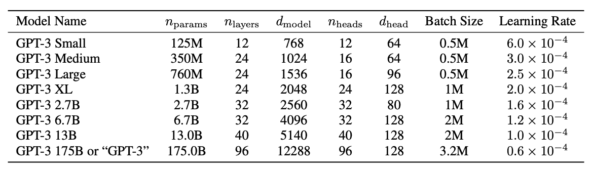

The development and deployment of large language models like GPT-3 have raised several ethical concerns and debates. Here are some of the key issues:

1. Bias and fairness issues due to biases present in training data.
2. Privacy concerns over the use of data for training without consent.
3. Potential for spreading misinformation and generating fake content.
4. Lack of transparency and accountability in their decision-making processes.
5. Environmental impact due to high computational and energy requirements.
6. Ethical use and need for robust oversight frameworks.
7. Societal impact and disruption in various industries.
8. Concentration of power and influence in a few tech companies.

Limitations-

* Large computational requirements: GPT-3's large model size and complex architecture require significant computational resources, making it difficult to deploy on devices with limited computational resources.
* Limited interpretability: GPT-3's complex architecture makes it difficult to interpret its internal workings, which can be a challenge for researchers and practitioners who want to understand how it makes its predictions.
* Language-specific: Like other transformer-based models, GPT-3 is primarily trained on English language data and may not perform as well on other languages without additional training or modifications.
* Ethical concerns: GPT-3's capabilities raise ethical concerns about its potential misuse and the need for responsible deployment.

**InstructGPT**

InstructGPT is a cutting-edge computer program engineered to excel in understanding and executing specific instructions, making it a valuable tool for a wide range of applications.

OpenAI has meticulously refined this model through a combination of reinforcement learning and human feedback, ensuring that its responses closely align with human intentions.

Model Sizes: InstructGPT is available in three different model sizes, offering varying levels of complexity and sophistication: 1.3 billion parameters, 6 billion parameters, and 175 billion parameters. This flexibility enables users to choose the model size that best suits their specific needs.

**ChatGPT**

ChatGPT (Chat Generative Pre-Trained Transformer) is a chatbot developed by OpenAI and launched on November 30, 2022. Based on a large language model, it enables users to refine and steer a conversation towards a desired length, format, style, level of detail, and language. Successive prompts and replies, known as prompt engineering, are considered at each conversation stage as a context.

ChatGPT works through its Generative Pre-trained Transformer, which uses specialized algorithms to find patterns within data sequences. ChatGPT originally used the GPT-3 large language model, a neural network machine learning model and the third generation of Generative Pre-trained Transformer. The transformer pulls from a significant amount of data to formulate a response.

ChatGPT now uses the GPT-3.5 model that includes a fine-tuning process for its algorithm. ChatGPT Plus uses GPT-4, which offers a faster response time and internet plugins. GPT-4 can also handle more complex tasks compared with previous models, such as describing photos, generating captions for images and creating more detailed responses up to 25,000 words.

**GPT4**

GPT4 is the fourth iteration of the GPT series, and it has been released on March 14 2023. One of the main goals of GPT4 is to address some of the limitations of its predecessors, such as a lack of factual accuracy and a tendency to generate biased or offensive text. It is OpenAI’s most advanced system, producing safer and more useful responses. Another goal of GPT4 is to improve the model’s ability to understand and generate text in multiple languages.

GPT-4 is more creative and collaborative than ever before. It can generate, edit, and iterate with users on creative and technical writing tasks, such as composing songs, writing screenplays, or learning a user’s writing style.

It surpasses ChatGPT in its advanced reasoning capabilities. It outperforms ChatGPT by scoring in higher approximate percentiles among test-takers.

GPT-4 is 82% less likely to respond to requests for disallowed content and 40% more likely to produce factual responses than GPT-3.5 on OpenAI’s internal evaluations.

It can analyze and generate texts as long as 25000 words and capable of producing programs in any computer language.

Limitations-

* GPT-4 has been known to hallucinate, meaning that the outputs may include information not in the training data or that contradicts the user's prompt
* GPT-4 also lacks transparency in its decision-making processes.

|  |  |  |  |  |  |
| --- | --- | --- | --- | --- | --- |
| **Model** | **Architecture** | **Parameter count** | **Training data** | **Release date** | **Training cost** |
| [GPT-1](https://en.wikipedia.org/wiki/GPT-1) | 12-level, 12-headed Transformer decoder (no encoder), followed by linear-softmax. | 117 million | [BookCorpus](https://en.wikipedia.org/wiki/BookCorpus): 4.5 GB of text, from 7000 unpublished books of various genres. | June 11, 2018 | 30 days on 8 P600 [GPUs](https://en.wikipedia.org/wiki/Graphics_processing_unit), or 1 peta[FLOP](https://en.wikipedia.org/wiki/FLOPS)/s-day.[ |
| [GPT-2](https://en.wikipedia.org/wiki/GPT-2) | GPT-1, but with modified normalization | 1.5 billion | WebText: 40 GB of text, 8 million documents, from 45 million webpages upvoted on [Reddit](https://en.wikipedia.org/wiki/Reddit). | February 14, 2019 (initial/limited version) and November 5, 2019 (full version) | "tens of petaflop/s-day", or 1.5e21 FLOP. |
| [GPT-3](https://en.wikipedia.org/wiki/GPT-3) | GPT-2, but with modification to allow larger scaling | 175 billion | 499 billion tokens consisting of [CommonCrawl](https://en.wikipedia.org/wiki/Common_Crawl" \o "Common Crawl) (570 GB), WebText, English Wikipedia, and two books corpora (Books1 and Books2). | May 28, 2020 | 3640 petaflop/s-day (Table D.1[]](https://en.wikipedia.org/wiki/Generative_pre-trained_transformer#cite_note-:2-36)), or 3.1e23 FLOP. |
| [GPT-4](https://en.wikipedia.org/wiki/GPT-4) | Also trained with both text prediction and [RLHF](https://en.wikipedia.org/wiki/Reinforcement_learning_from_human_feedback); accepts [both text and images](https://en.wikipedia.org/wiki/Multimodal_learning) as input. Further details are not public. | Undisclosed. Estimated 1.7 trillion | Undisclosed | March 14, 2023 | Undisclosed. Estimated 2.1e25 FLOP. |

**CAPABILITIES AND LIMITATIONS**

* **ChatGPT-3.5**

**Capabilities of ChatGPT-3.5**

The ChatGPT's most popular features are as follows:

Natural language generation: ChatGPT can produce text that is human-like, which makes it appropriate for a range of jobs like writing original stories or summarizing articles.

Automatic summarization: ChatGPT could automatically summarize lengthy articles into shorter versions while maintaining their original sense.

Natural language understanding (NLU): ChatGPT can comprehend natural language and adapt its responses. Conversational agents and virtual assistants can benefit from it as a result.

Conversation generation: ChatGPT could create live discussions between two or more individuals. It is therefore helpful for customer support representatives and chatbot applications.

Text-to-speech conversion: ChatGPT could translate text into speech in real time, enabling users to hear rather than read their chats.

Additionally, ChatGPT-3.5 can change data by creating data in a table, inserting indexes, deciphering JSON, and more. It can write anything from cliché rom-coms set in parallel universes to poems about sentient plants using probability theory to create an answer based on a variety of sources. Because of its capacity to comprehend user questions in plain language, it may also function as a personal assistant, creating reminders, organizing appointments, and even booking reservations.

**Limitations of ChatGPT-3.5**

* Lack of human insight

One limitation of ChatGPT-3.5 is its lack of human insight. While it can generate coherent responses to specific prompts or questions, it lacks the ability to provide deeper insights or analysis on a given topic. This means that while ChatGPT-3.5 is great for providing basic information on a subject (if it existed prior to September 2021), it cannot provide more complex answers that require higher-level thinking or analysis.

* Limited knowledge

Another drawback of ChatGPT-3.5 is its limited knowledge base. Since the chatbot relies on pre-programmed data, there are certain topics and questions which may not be answered correctly due to lack of information in its database. For example, if you ask ChatGPT-3.5 about a new technology that has just been released, it may not have sufficient information to answer your question accurately, because its learning sources don't include any information generated after September 2021, as mentioned above.

* Difficulty understanding context

ChatGPT-3.5 also has difficulty understanding context, especially when it comes to sarcasm and humor. Since the chatbot does not possess emotional intelligence, it cannot detect subtle nuances in conversations such as sarcasm or irony which may lead to misunderstandings or incorrect responses from the chatbot.

* Lacking human understanding

The absence of human understanding in ChatGPT-3.5 is one of its drawbacks. It can produce well-reasoned answers to certain queries or prompts, but it is unable to offer in-depth reflections or analysis on a particular subject. This means that, if a topic existed before September 2021, ChatGPT-3.5 would be excellent for giving basic information on it. However, it would not be able to deliver more complex replies that call for higher-level reasoning or analysis.

* Not being able to access the internet

The lack of ability for ChatGPT-3.5 to access the internet for extra information further restricts its functionality because it is unable to look up contextual data when needed. This implies that since it is unable to search the internet for more information, it will be unable to provide a correct response to any questions pertaining to subjects outside of its pre-programmed data set.

* Tendency to create false information

When asked certain questions or given specific prompts, ChatGPT-3.5 may provide incorrect information due to potential bias in training data and limits in training data sets. This could mislead users if they depend too much on its responses without first verifying them with other sources. About 15-20% of output from ChatGPT-3.5 is prone to "hallucinate" and make up facts.

* Potential bias in the training set

Finally, a potential bias in the training data sets of ChatGPT-3.5 may result in erroneous results based on the creators and methods of creation. Should these datasets be skewed in favor of a specific point of view, users may be misled and come to the wrong conclusions from the chatbot's information rather than conducting independent research before relying solely on what they learned from ChatGPT-3.5.

* **ChatGPT -4**

**Enhanced Capabilities**

1. When it comes to accurate information provision, Chat-GPT 4 excels.
2. It can handle more data concurrently and yield superior outcomes.
3. The data can be presented as text or as pictures.
4. Chat-GPT 4 excels at challenging tasks.
5. Chat-GPT 4 provides tools and guidance on self-care and mental health management.
6. It can efficiently assist you with large and complicated issue statements.
7. Compared to GPT3, it can write code ten times more quickly.

**Key benefits of ChatGPT 4 include the following:**

1. It saves time consistently and reliably.

For people who are always on the go and require prompt assistance with any topic under the sun, ChatGPT-4 is the ideal option. By drastically cutting down on the amount of time spent looking for solutions, this technology facilitates doing crucial activities swiftly.

To guarantee that accurate, trustworthy answers are produced when users ask questions, it also makes use of advanced AI. Customers will be more satisfied overall since they will find it simple to obtain the information they require with the highest level of efficiency and accuracy. In addition, it is always open, so consumers may get timely assistance whenever they need it.

2. ChatGPT 4 is scalable and reasonably priced.

Additionally, the technology significantly improves the productivity and scalability of the enterprises that use it. It enables companies to respond to a lot of inquiries at once, making sure that even during periods of high demand, none are overlooked.

Additionally, menial chores can be automated with its cost-effective paradigm, negating the need for costly human interaction. Consequently, there are no additional expenses and operations may run smoothly.

3. Customization is possible.

ChatGPT 4 is transforming online user interaction. Because ChatGPT 4 uses artificial intelligence (AI) to learn, it can readily adjust to the requests and instructions of its users. Because of its AI skills and capacity to learn from the natural language used by its users, it is sufficiently adaptable to allow each user to personalize their experience, improving overall usability with features that are intuitive and anticipate your needs.

4. GPT-4 has multiple languages.

Businesses can assist in bridging language barriers globally by utilizing ChatGPT 4. With the use of this multilingual tool, users from all over the world can produce content and responses that may improve their ability to communicate with other individuals and businesses that have international operations and multilingual user bases. It is a very strong and adaptable tool that may be used to communicate with clients who speak multiple languages or in multinational operations. It is also very versatile and adaptive.

**Limitations of ChatGPT**-**4**

The following is a list of some of ChatGPT 4's limitations:

* One of ChatGPT4's shortcomings is its inability to manage multiple tasks at once. When given a single task or objective to concentrate on, the model functions at its best. ChatGPT's efficiency and accuracy may suffer if you ask it to do several tasks at once because it won't be able to decide which ones to concentrate on.
* Knowledge Base Restrictions: Similar to ChatGPT 4, its knowledge base is restricted to September 2021 and does not include information on events that have happened since then.
* Need to Fine-Tune: In order to get the desired outcomes using ChatGPT, you may need to fine-tune the model if you must utilize it for particular circumstances. The process of fine-tuning involves using specific data to train the model in order to maximize its performance with respect to a given job or goal. It takes a lot of time and effort.
* Potentially Biased Reactions: ChatGPT is built on a large volume of textual data. Because of this, there is a chance that the data contains biased information, which could lead to unintentionally biased or discriminating replies from the AI.

**FUTURE DIRECTION**

Considering these difficulties and moral dilemmas, ChatGPT has the potential to significantly alter the field of scientific study. Some of the possibilities for the future are-

(a) Better AI models: As AI technology develops, we may anticipate increasingly accurate and dependable models that reduce biases, comprehend context more fully, and offer researchers even more useful support.

(b) Transdisciplinary research: ChatGPT's capacity to analyze and combine data from several academic fields may enable ground-breaking transdisciplinary research that yields fresh understandings and revelations.

(c) Democratizing scientific research: ChatGPT can assist in democratizing scientific research by facilitating access to complicated scientific concepts and streamlining research tasks. This will enable a greater number of people to engage in the scientific process and progress knowledge.

(d) Better language comprehension: ChatGPT can currently produce text of a high caliber, but greater advancements in language comprehension could result in more complex and advanced applications.

(e) Personalization: ChatGPT can currently produce responses that are specifically suited to each user based on user data, but further advancements may result in even more individualized and customized interactions.

(f) Multilingual capabilities: ChatGPT is now able to produce text in several languages, but further advancements may result in even more complex multilingual features that could comprehend and produce text in many languages.

(g) Real-time applications: ChatGPT can now generate text in real-time, but further advancements may result in even quicker and more responsive real-time text generation apps.

(h) Improved context comprehension: ChatGPT may be able to provide more accurate and pertinent responses if it is able to better comprehend the context of a text or discussion.

(i) Better emotional intelligence: ChatGPT may become more adept at identifying and addressing emotional cues, resulting in more customized and sympathetic exchanges.

(j) Cooperation with human specialists: ChatGPT could be used to give more effective and efficient solutions in a range of sectors, including law and medical, in partnership with human experts.

**APPLICATION AND USECASE**

ChatGPT is a useful tool that isn't just for scientific study because of its advanced natural language processing skills and versatility. This section examines ChatGPT's wide range of applications, emphasizing how it can change industries, improve communication, and foster creativity.

**HEALTHCARE AND MEDICINE**

ChatGPT can be used in the fields of healthcare and medicine to: (i) help doctors diagnose problems by examining patient information, medical histories, and symptoms Create individualized treatment plans based on each patient's needs and preferences; (ii) compile and synthesize medical research to support evidence-based practice; (iii) give patients easily comprehensible medical information and advice; and (iv) simplify communication and information sharing among healthcare professionals to promote collaboration.

These are a few potential applications for ChatGPT in the medical and healthcare fields.   
(i) Chatbot for patient triage: Healthcare professionals can utilize ChatGPT to create chatbots that help with patient triage, based on the severity of a patient's condition and the best course of action.   
(ii) Recommendations for medical diagnosis and treatment: ChatGPT can be utilized to create systems that offer support for medical diagnosis and therapy. ChatGPT can offer recommendations for diagnosis and treatment to healthcare practitioners by assessing patient data and symptoms.   
(iii) Medical education: Systems that support medical education can be developed using ChatGPT. ChatGPT can assist in educating individuals and healthcare professionals by offering information on medical issues and available treatments.

**BUSINESS ANF FINANCE**

ChatGPT can be used in the business and finance sector for the following tasks: (i) automate the creation of financial reports and summaries of market analyses; (ii) analyze customer reviews and feedback sentimentally to inform product development and marketing strategies; (iii) create customized investment recommendations based on individual risk profiles and financial objectives; (iv) help create business proposals, marketing materials, and other written content; and (v) support customer service functions by responding to customer inquiries promptly, accurately, and appropriately.

These are a few possible business and financial uses for ChatGPT.

(i) Chatbots for customer service: ChatGPT can be used to create chatbots for customer service that can answer questions, provide product suggestions, and handle transactions.  
(ii) Market forecasting and analysis: ChatGPT can be used to examine vast volumes of financial data, spot trends and patterns, and offer perceptions into the state and direction of the market.  
(iii) Investment management: Systems that help with investment management can be developed using ChatGPT. ChatGPT can assist companies and investors in making wise investment decisions by evaluating financial data and offering recommendations.

**CREATIVE WRITING AND CONTENT GENERATION**

ChatGPT can be used for the following purposes in the creative writing and content generation domains: (i) producing unique story ideas, plot outlines, and character descriptions; (ii) helping writers get past writer's block by offering writing prompts and creative directions; and (iii) automatically producing content for blogs, articles, and social media posts based on particular input parameters and style preferences. (iv) write and edit written content to enhance coherence, clarity, and grammar; (v) summarize books, news articles, and other written materials in an interesting and educational way.

Here are a few possible uses for ChatGPT in these domains.

(i) Content production: ChatGPT may help with content generation, including marketing copy, blog entries, and social media content. ChatGPT can produce interesting and educational natural language responses by evaluating topic, tone, and style data.

(ii) Creative writing prompts: For authors who are having trouble coming up with original ideas, ChatGPT can be used to produce creative writing prompts. ChatGPT is able to offer writers original and imaginative writing prompts that might stimulate fresh concepts and methods of writing by examining data on genres, themes, and story structures.

(iii) Writing novels: ChatGPT can help with narrative development, character development, and story structure by offering thoughts and suggestions. ChatGPT may give authors tailored advice on how to craft interesting and captivating stories by examining data on plot patterns and popular genres.

**EDUCATION AND TUTORING SYSTEM**

ChatGPT can be used in the field of education and training to: (i) create lesson plans and personalized learning materials based on the needs and preferences of individual students; (ii) give students real-time feedback and guidance during the learning process; (iii) create engaging educational content, such as quizzes, interactive exercises, and multimedia presentations; (iv) help teachers grade assignments and give students constructive criticism; and (v) create adaptive learning environments that respond to each student's progress and performance.

Here are a few possible uses for ChatGPT in these domains.

(i) Personalized learning: ChatGPT can be used to analyze data on students' learning preferences, skills, and limitations in order to provide them with individualized learning experiences. ChatGPT can assist students in enhancing their academic performance and engagement by offering personalized recommendations for learning resources and activities.   
(ii) Support for instructors: ChatGPT can help teachers by making suggestions for lesson planning, instructional methodologies, and methods for maintaining order in the classroom. ChatGPT can offer tailored suggestions to teachers to help them enhance their teaching methods by evaluating data on student learning results and best practices.

(iii) Online tutoring: By evaluating information about students' learning requirements and making tailored recommendations for tutoring sessions, ChatGPT can be utilized to offer online tutoring services to students. ChatGPT can assist students in enhancing their academic performance and engagement by customizing tutoring sessions to the student's preferred method of learning.

**PROGRAMMING AND CODE DEBUGGING**

(i) Code generation: Based on user input, ChatGPT can be used to produce code snippets. Code snippets that can be utilized to develop particular features or functions can be made available to users by ChatGPT through data analysis on the programming language, function, and requirements.   
(ii) Code optimization: By examining data about the programming language, algorithms, and data structures, ChatGPT can be utilized to optimize code. ChatGPT's ability to spot inefficiencies and make recommendations for enhancements can help developers write more performant and efficient code.   
(iii) Help with debugging: ChatGPT analyzes data on the programming language, code structure, and error messages to provide debugging support. Developers may detect and fix coding mistakes more quickly with ChatGPT's recommendations for debugging methods and approaches.