**Practical – 2**

**AIM: Create Basic Calculator using prompt**

**SOURCE CODE:**

<!DOCTYPE html>

<html lang="en">

<head>

<meta charset="UTF-8">

<meta http-equiv="X-UA-Compatible" content="IE=edge">

<meta name="viewport" content="width=device-width, initial-scale=1.0">

</head>

<body>

<p id="demo"></p></div>

<script>

function BasicCal() {

var x,y,z,oper;

x=prompt("Enter first number : ");

y=prompt("Enter second number : ");

oper=prompt("Enter any operator : ");

if(oper == "+"){

z = Number(x) + Number(y);

}

else if(oper == "/"){

z=Number(x)/Number(y);

}

else if(oper == "*"){

z=Number(x)*Number(y);

}

else if(oper == "-"){

z=Number(x)-Number(y);

}

return z;

}

document.getElementById("demo").innerHTML =BasicCal();

</script>

</body>

</html>

**OUTPUT:**

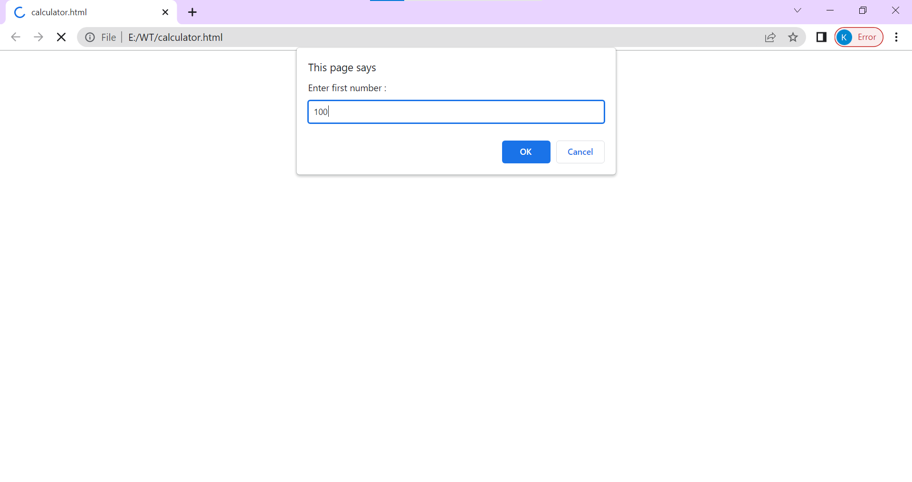

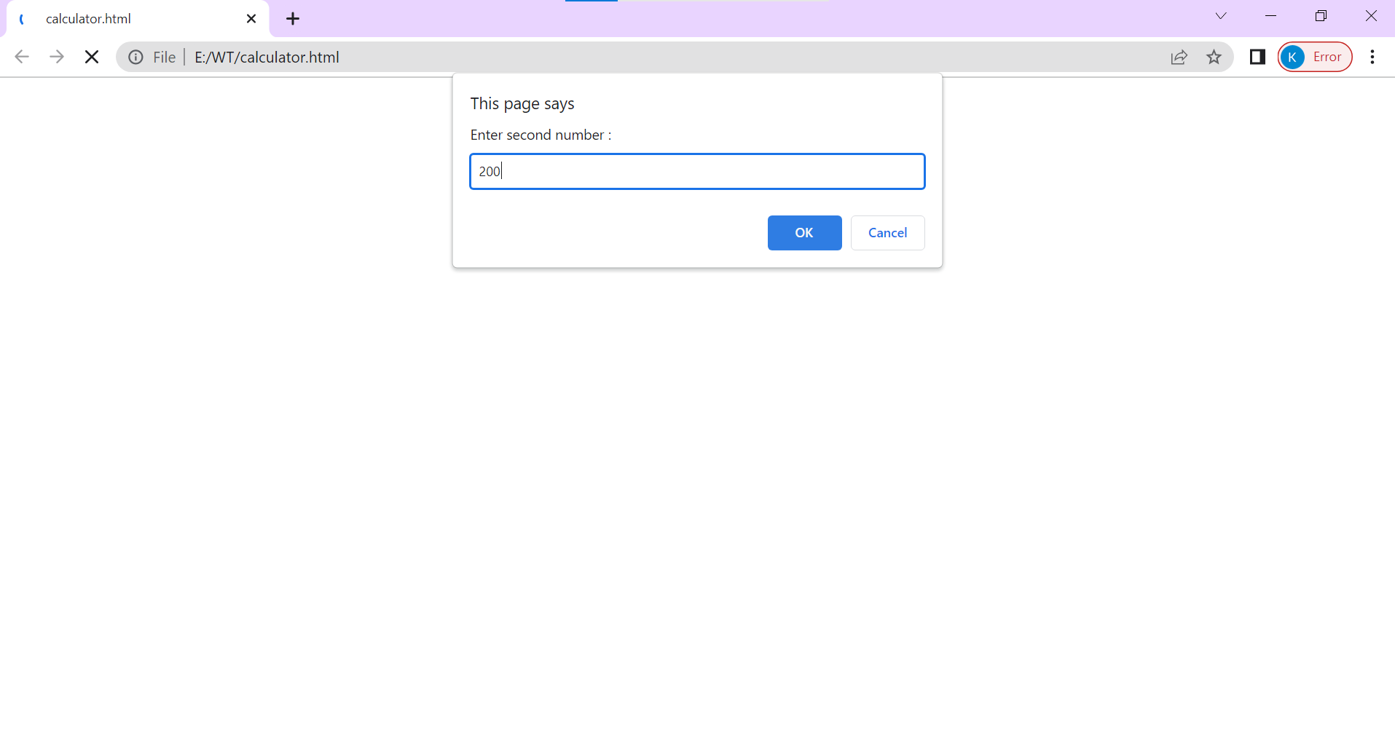

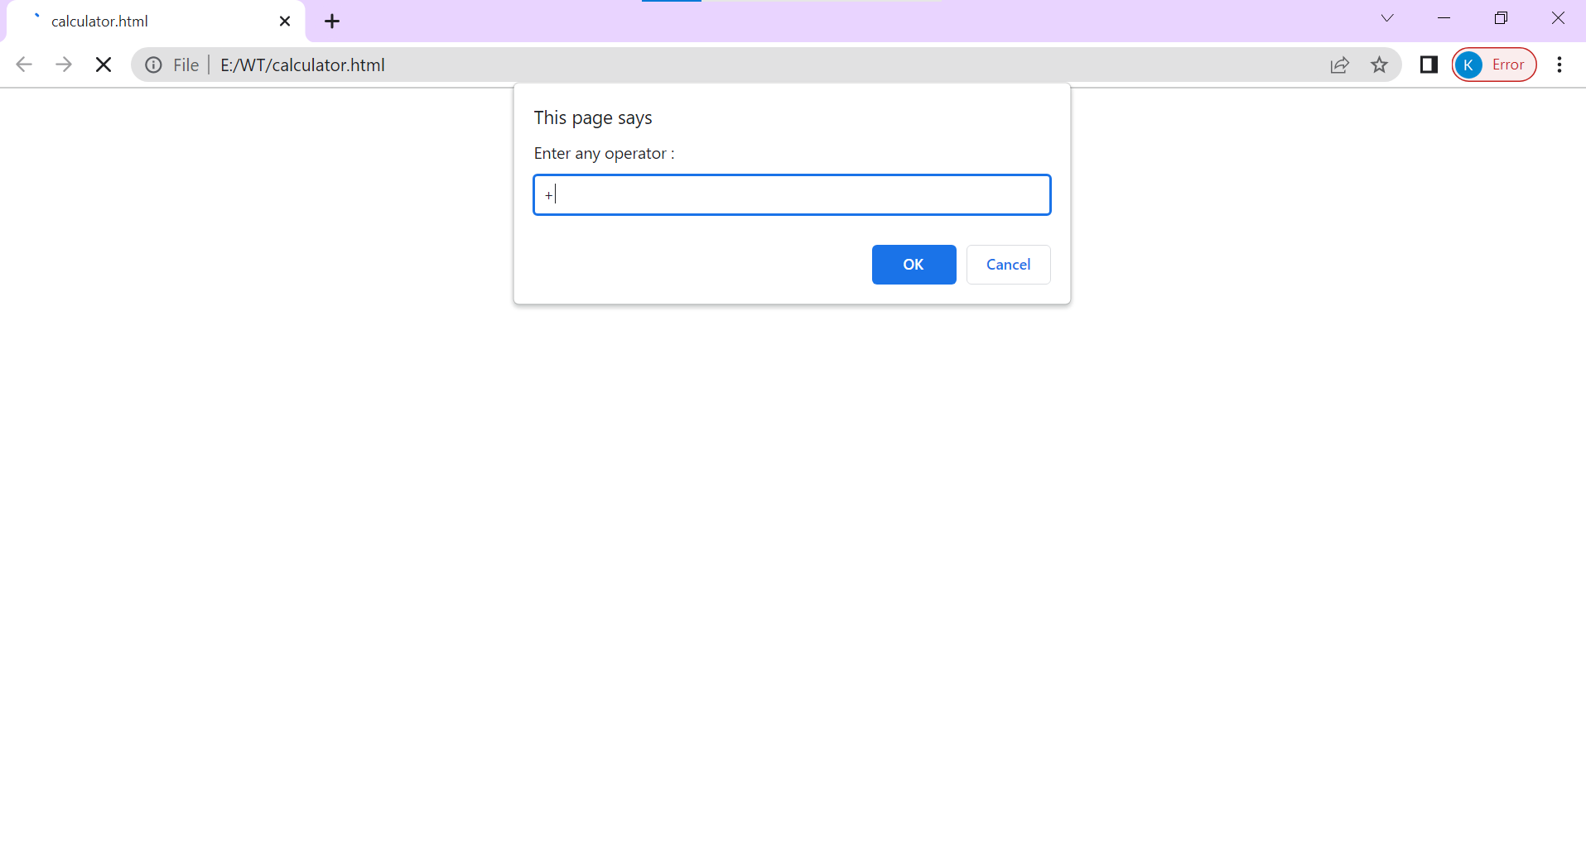



**AIM: Create Basic Calculator using inputbox**

**SOURCE CODE:**

<!DOCTYPE html>

<html lang="en">

<head>

<meta charset="UTF-8">

<meta http-equiv="X-UA-Compatible" content="IE=edge">

<meta name="viewport" content="width=device-width, initial-scale=1.0">

<div class="container">

<style>

.container {

box-shadow: 0 6px 8px blue,0 1px 2px yellow;

background-color: #fff;

width: 400px;

height: auto;

margin: 30px auto;

padding: 20px 30px 20px 30px;

}

h1 > span {

display: block;

font-weight: 400;

font-size: 0.9rem;

color: #999;

margin-top: 0;

}</style>

<h1>

CALCULATOR USING INPUT BOX

<span>

<br>CALCULATE TWO NUMBERS

</span>

</h1>

<div class="input-control">

<label for="num1">

Number 1: <input type="text" id="num1" placeholder="First number" autofocus>

</label>

</div>

<div class="input-control">

<label for="num1">

Number 2: <input type="text" id="num2" placeholder="Second number">

</label>

</div>

<div class="input-control controls">

<label for="method_add">

<input type="radio" name="method" id="method_add" value="add" checked>

ADDITION

</label>

<label for="method_sub">

<input type="radio" name="method" id="method_sub" value="sub">

SUBTRACTION

</label>

<label for="method_mul">

<input type="radio" name="method" id="method_mul" value="mul">

MULTIPLICATION

</label>

<label for="method_div">

<input type="radio" name="method" id="method_div" value="div">

DIVISION

</label>

</div>

<div class="input-control button">

<button id="calculate">CALCULATE</button>

</div>

</div>

<div class="container result">

Answer

<p class="answer">0</p>

</div>

</head>

<body>

<script>

var btn = document.querySelector('#calculate');

btn.addEventListener ('click', function () {

var num1 = Number ( document.querySelector('#num1').value ),

num2 = Number ( document.querySelector('#num2').value ),

rlt = document.querySelector('p.answer');

var method = document.querySelector('input[name="method"]:checked').value;

var answer = 0;

if ( 'add' === method ) {

answer = num1 + num2;

} else if ( 'sub' === method ) {

answer = num1 - num2;

} else if ( 'mul' === method ) {

answer = num1 * num2;

} else if ( 'div' === method ) {

answer = num1 / num2;

}

rlt.innerHTML = answer;

});

</script>

</body>

</html>

OUTPUT:

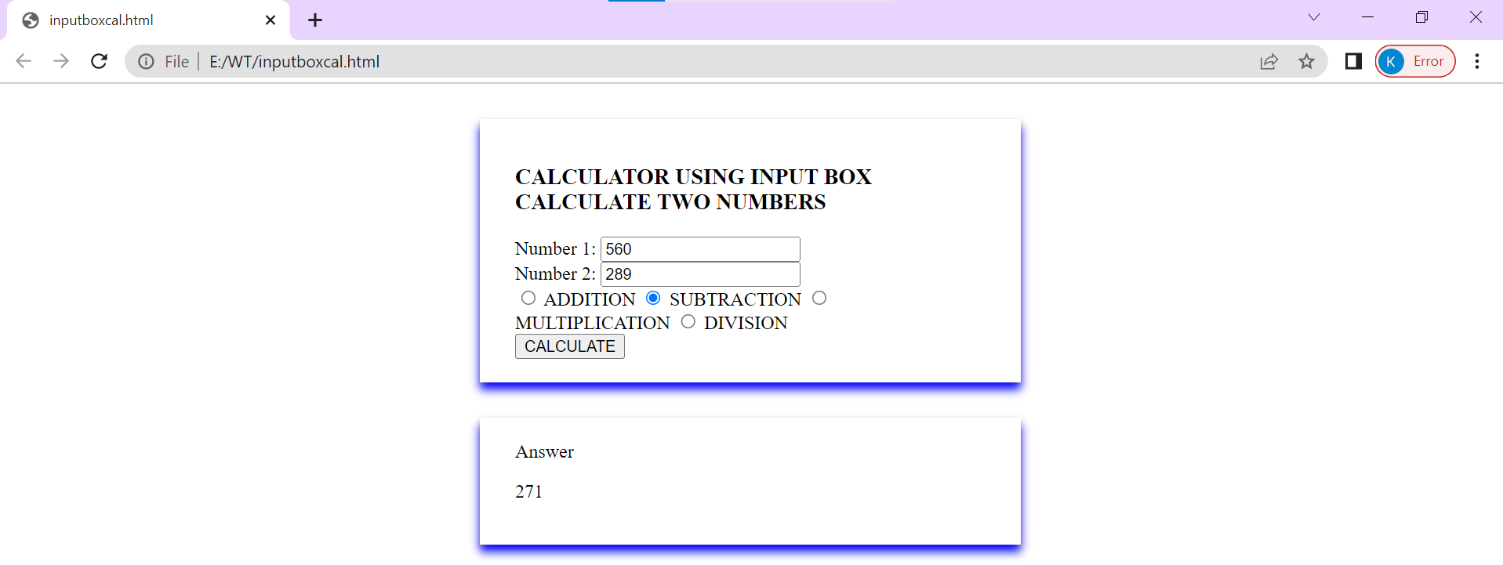

**AIM: Do temperature Conversion using the input box and display the result on the Web Page. (Celsius to Fahrenheit)**

**SOURCE CODE:**

<!DOCTYPE html>

<html lang="en">

<head>

<meta charset="UTF-8">

<meta http-equiv="X-UA-Compatible" content="IE=edge">

<meta name="viewport" content="width=device-width, initial-scale=1.0">

<form id="tempCalc" onsubmit="calculateTemp(); return false">

<input name="temp" id="temp" type="number">

<select name="temp_diff" id="temp_diff">

<option value="1">°Celsius</option>

<option value="2">°Fahrenheit</option>

</select> <br>

<input name="temp" type="submit"> <br>

<span id="resultContainer"></span>

</form>

</head>

<body>

<script>

function calculateTemp() {

function celToFah(celsius) {

var fahrenheit = Math.round((celsius * (9 / 5)) + 32);

return fahrenheit;

}

function fahToCel(fahrenheit) {

var celsius = Math.round((fahrenheit - 32) * (5 / 9));

return celsius;

}

var tempSelected = document.getElementById("temp_diff");

var valueTemp = tempSelected.options[tempSelected.selectedIndex].value;

var numberTemp = document.getElementById("temp").value;

var result;

if (valueTemp == 1) {

result = celToFah(numberTemp);

document.getElementById("resultContainer").innerHTML = "= " + result + "°Fahrenheit";

} else {

result = fahToCel(numberTemp);

document.getElementById("resultContainer").innerHTML = "= " + result + "°Celsius";

}

}

</script>

</body>

</html>

**OUTPUT:**

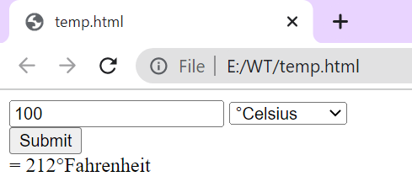

**CONCLUSION:**

In this practical we learn how to create a Basic Calculator using prompt/input box & conversion

using the input box and display the result on the Web Page. (Celsius to Fahrenheit). We have also learned the use of different tags in html and how it is used in javascript for the calculation.

**COURSE OUTCOME:**

Create a calculator where input is taken from alert message and also in wed page.

Create a conversion of Celsius to Fahrenheit or vice versa .

Insert design boarder in calculator form.

Insert Conversion of Celsius to Fahrenheit in JavaScript.