Federated Learning on Drone Swarms
Prateek Kalal, DA-IICT
Om Patel, DA-IICT
Krushna Parmar, DA-IICT
Abstract—We study federated learning on UAV swarms and show a 12% gain in accuracy over a baseline.
Index Terms—federated learning, UAV, edge computing

Introduction
Federated learning lets drones train a shared model without sending raw data to a server. Federated learning lets drones train a shared model without sending raw data to a server. Federated learning lets drones train a shared model without sending raw data to a server. Federated learning lets drones train a shared model without sending raw data to a server. Federated learning lets drones train a shared model without sending raw data to a server. Federated learning lets drones train a shared model without sending raw data to a server. Federated learning lets drones train a shared model without sending raw data to a server. Federated learning lets drones train a shared model without sending raw data to a server. Federated learning lets drones train a shared model without sending raw data to a server. Federated learning lets drones train a shared model without sending raw data to a server. Federated learning lets drones train a shared model without sending raw data to a server. Federated learning lets drones train a shared model without sending raw data to a server.
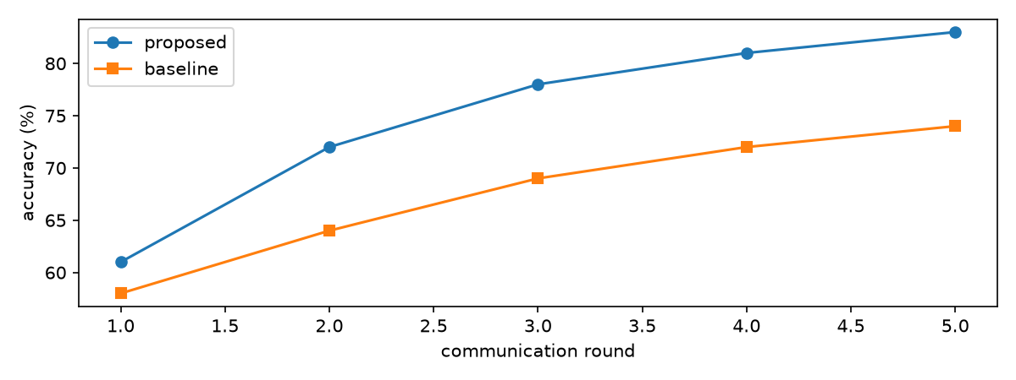
Accuracy over communication rounds

Results
Federated learning lets drones train a shared model without sending raw data to a server. Federated learning lets drones train a shared model without sending raw data to a server. Federated learning lets drones train a shared model without sending raw data to a server. Federated learning lets drones train a shared model without sending raw data to a server. Federated learning lets drones train a shared model without sending raw data to a server. Federated learning lets drones train a shared model without sending raw data to a server. Federated learning lets drones train a shared model without sending raw data to a server. Federated learning lets drones train a shared model without sending raw data to a server. Federated learning lets drones train a shared model without sending raw data to a server. Federated learning lets drones train a shared model without sending raw data to a server.

