Sample Paper

Introduction
Some introductory text.
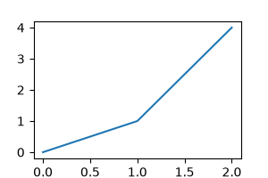
A plot

Results
Some results.

