task they are pending we need to add the points

1. Here is the list of languages that we need to add. These are the languages currently in use. By fetching the user's location, we can dynamically determine and display the appropriate languages use i18 angular here

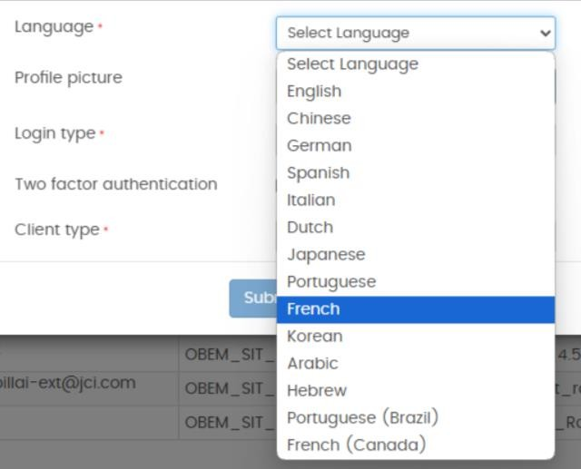

1. When considering time zone offsets, users from different countries such as Dubai, India, and Canada will have varying time zones. Additionally, different states within a country may also have distinct time zones. It is crucial that the system works according to the user's local time. Currently, when users click 'Add Request,' the system defaults to a 0:0 time zone because it isn't fetching the user's actual time. Making this adjustment dynamically will greatly improve functionality use UTC here also use timezone database
2. For the requestor name, the options will include 'User Name 1,' 'User Name 2,' 'User Name 3,' and so on, up to 'User Name 5.' This will be used in the UI

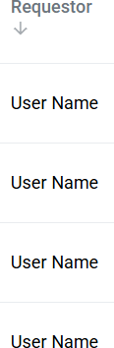

1. For pagination, each page will display a list of 10 latest requests. Users can navigate to the next page using a 'Next' button, which will update the list without changing the entire UI because he is going to infinity scroll

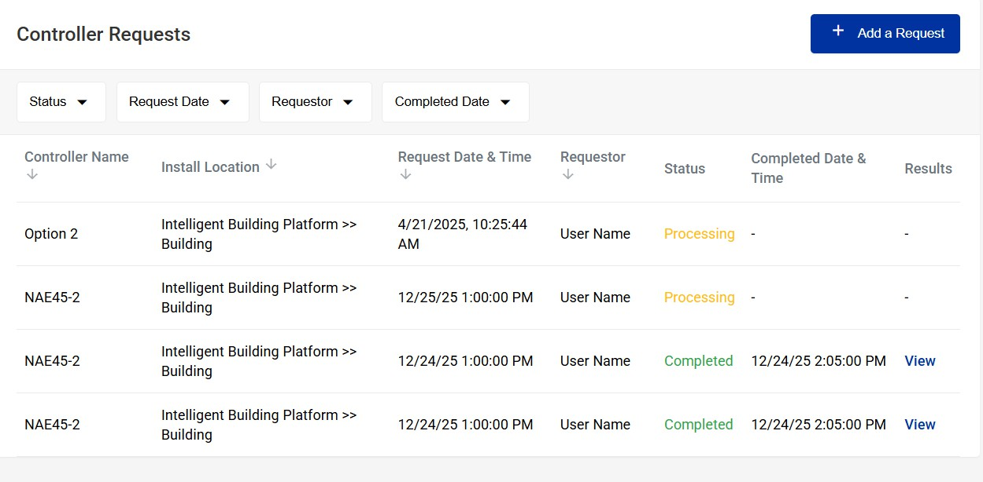

1. There are arrows next to the controller name, install location, request date and time. However, only the requestor date and status will have functional arrows. Clicking on

these arrows will sort and visualize the data accordingly

1. There are various options available. For status, options include 'Completed,' 'Processing,' and 'Cancelled.' For request date, a calendar will be provided. For the requestor option, statically add usernames such as 'User Name 1,' 'User Name 2,' up to 'User Name 5.' Similarly, for the completed date, a calendar will be available



1. Please add at least 20 mock data records so that we can demonstrate the pagination functionality. This will allow users to see how the 'Next' button works by navigating through multiple pages some of they will completed some will processing some will be the cancelled and some have results to view basically standalone