Roxiler Assigment Result:  
home Page:-

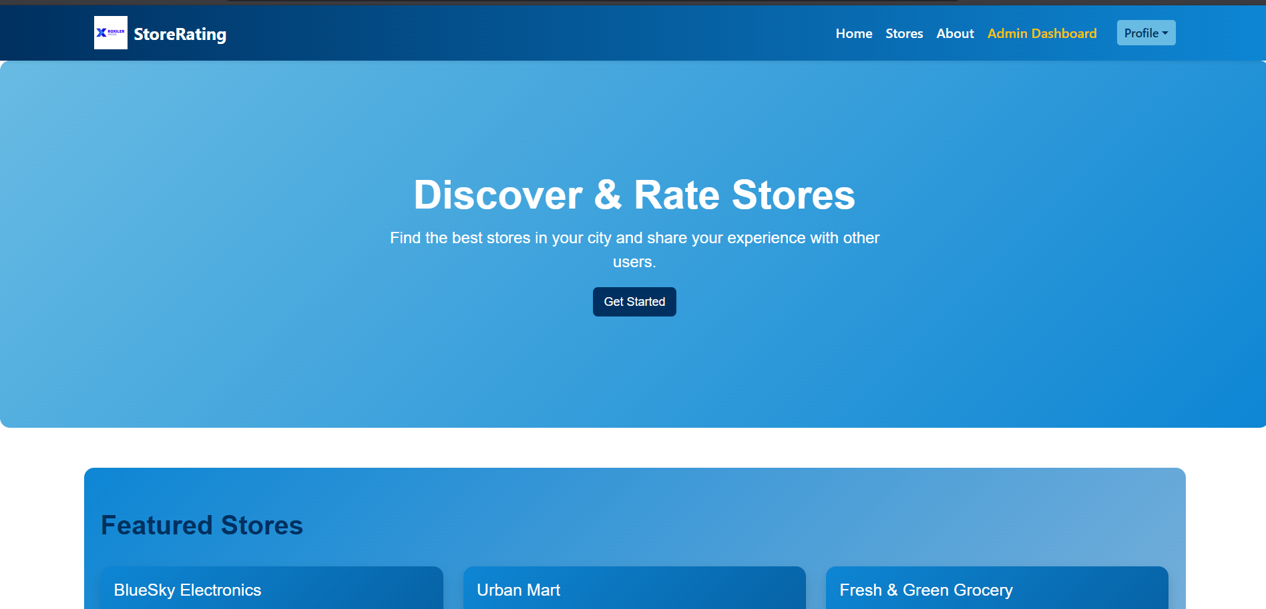

AboutPage:

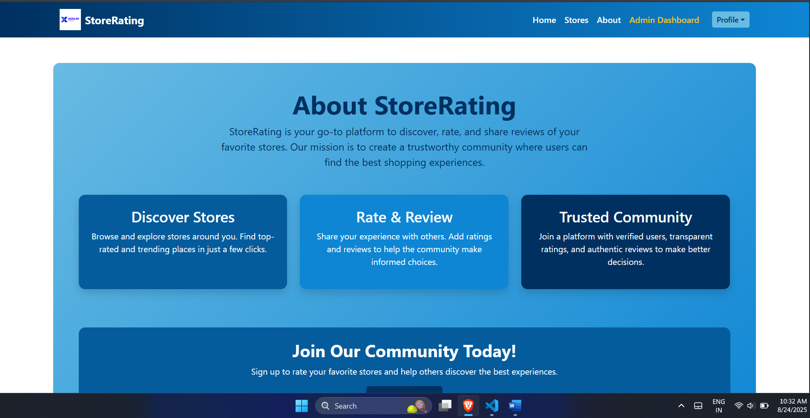

Login Page: for all user that owner/admin/normal user

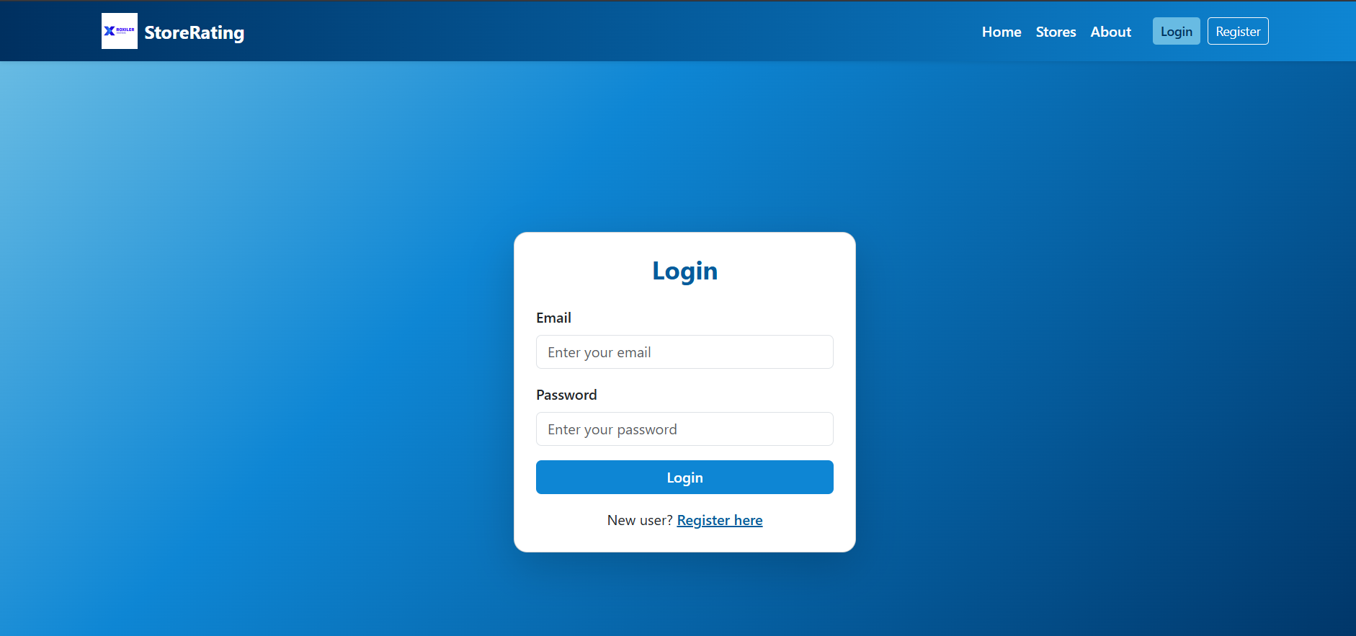

Register page for only for user:

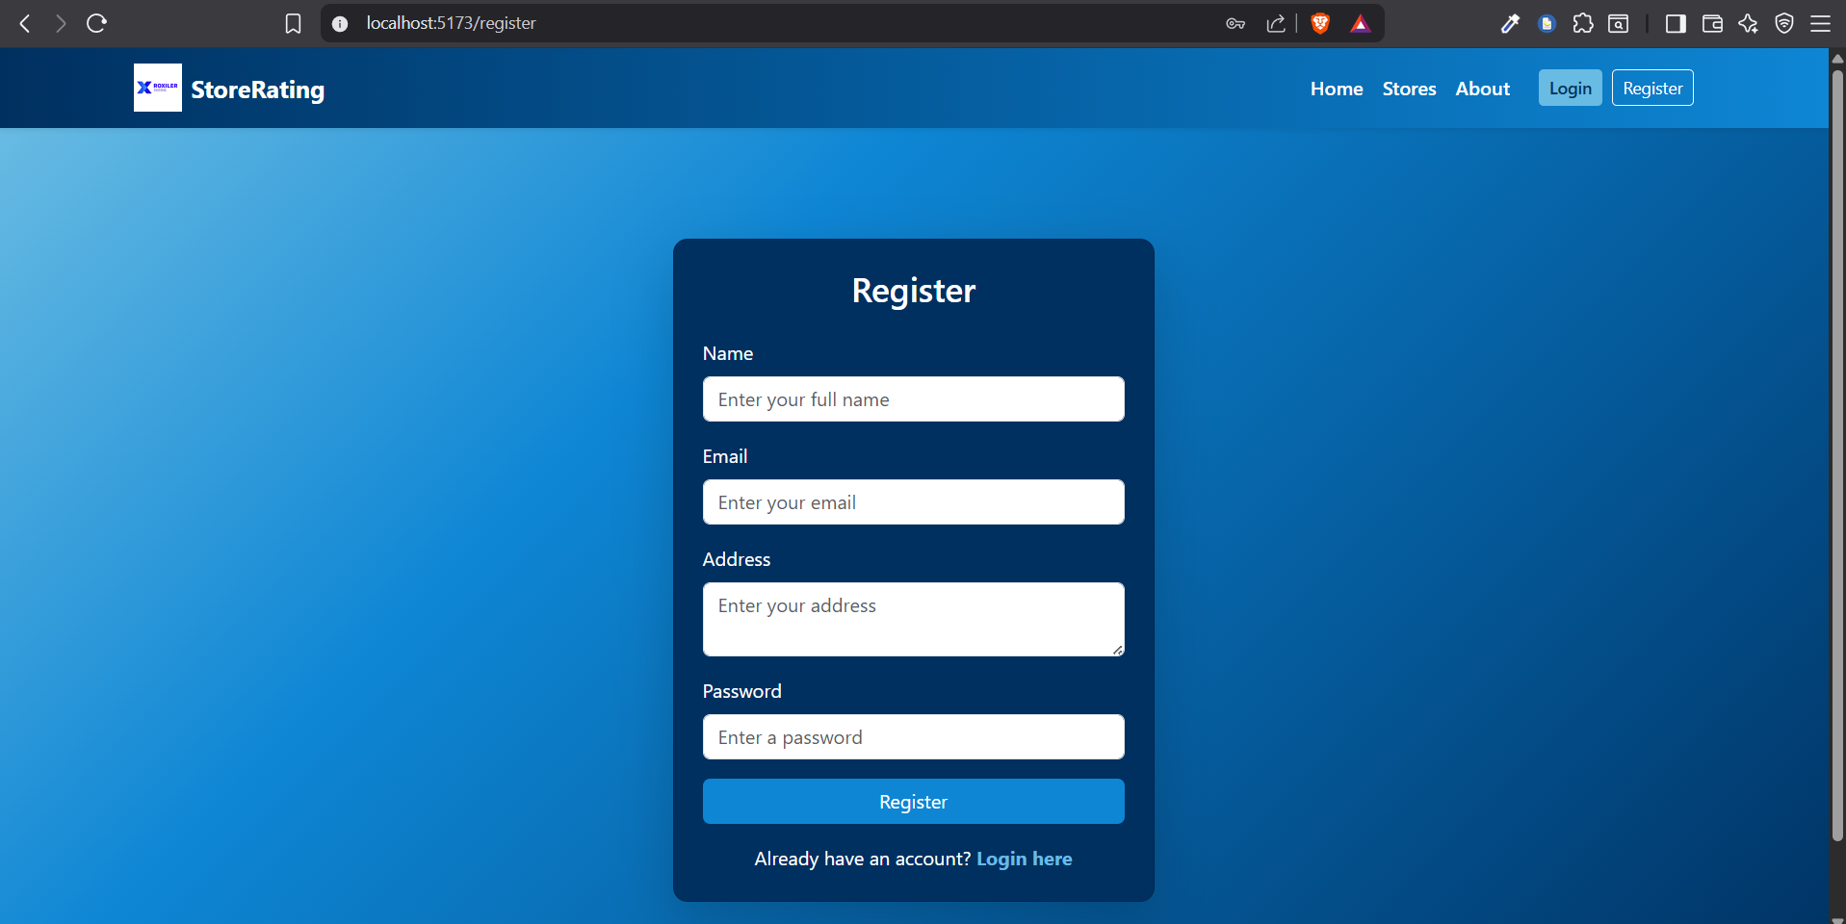

Normal user rating the available store /search and then rating: 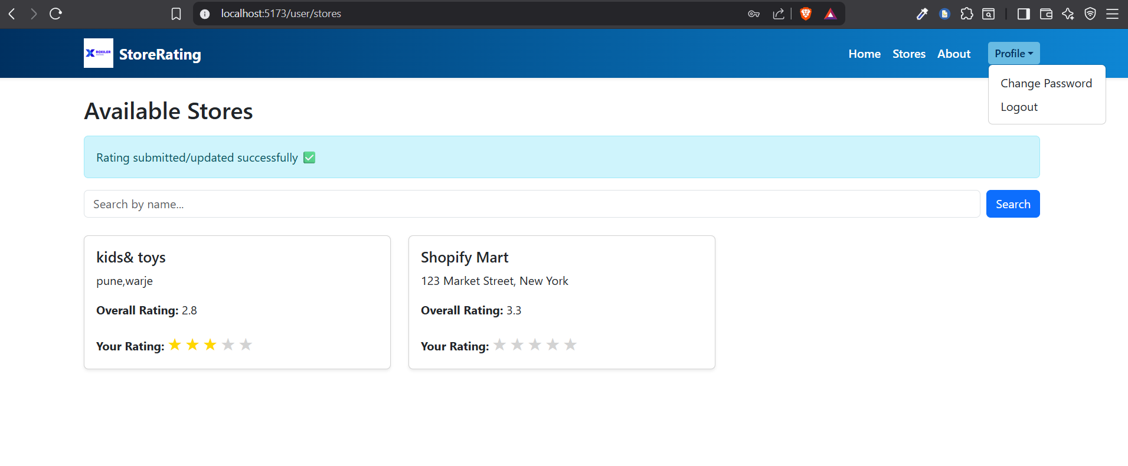

All user can changes password by enter the old password and new password and logout from the system

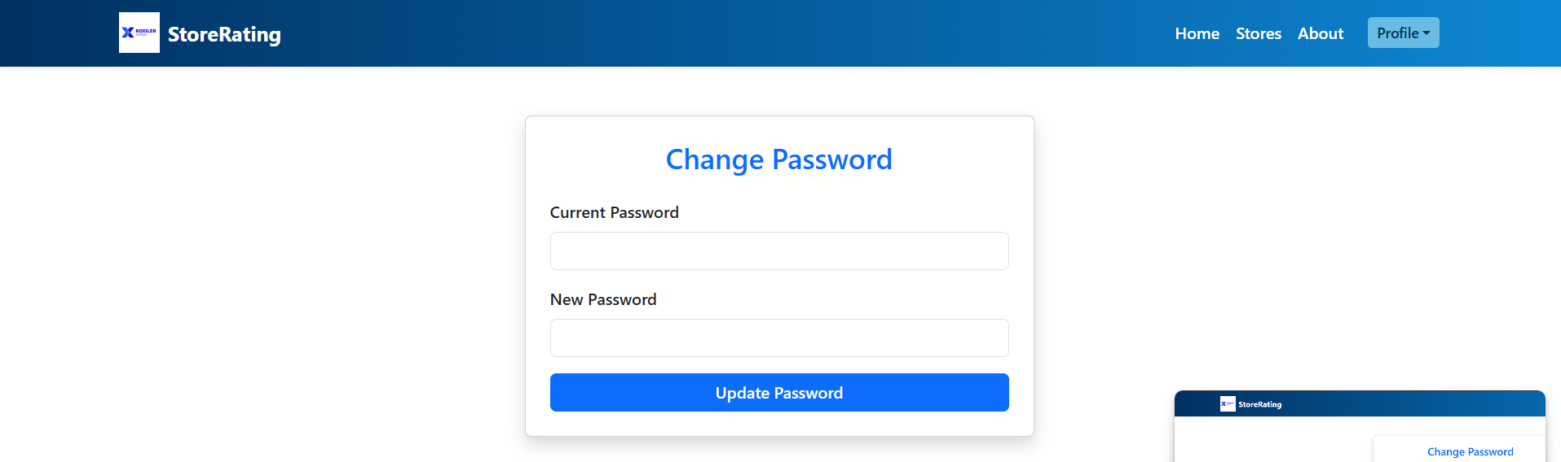

AdminDashboard :He/She can login to system and navigate to the Dashboard

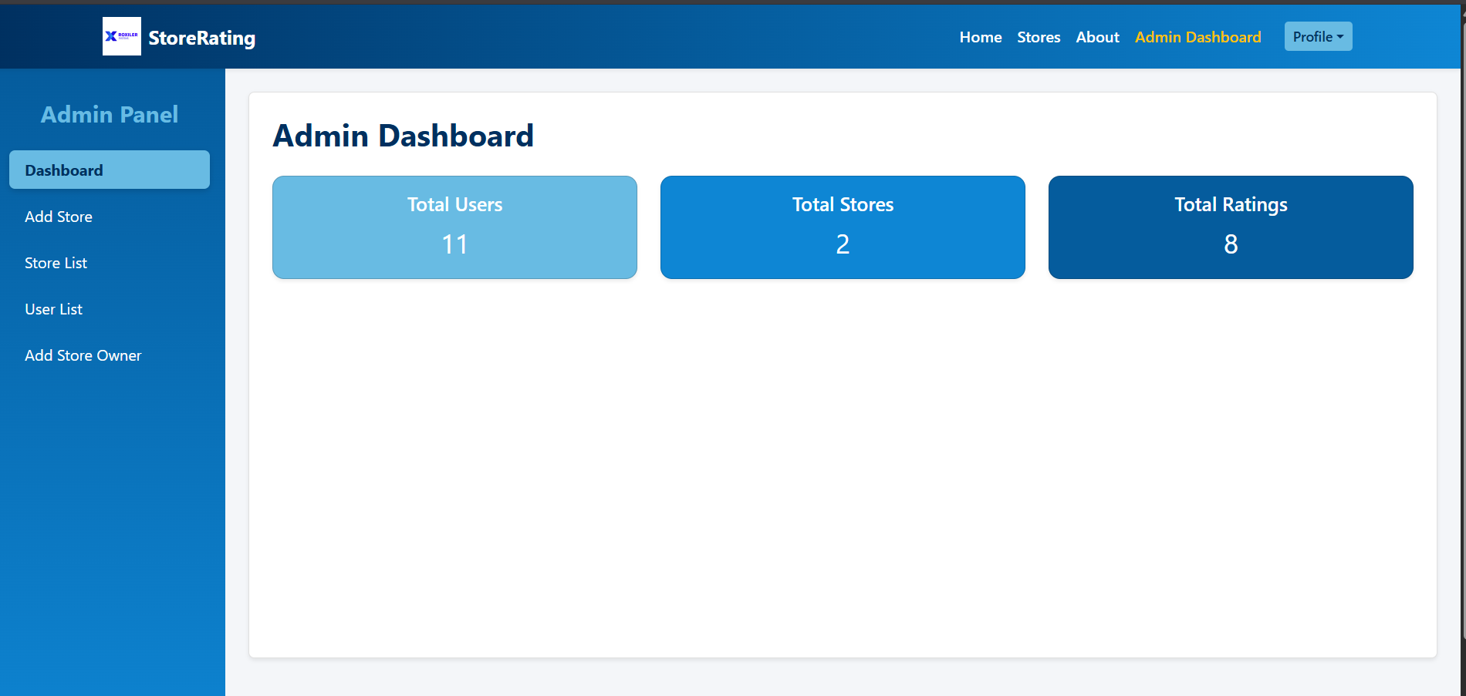

Add store byAdmin

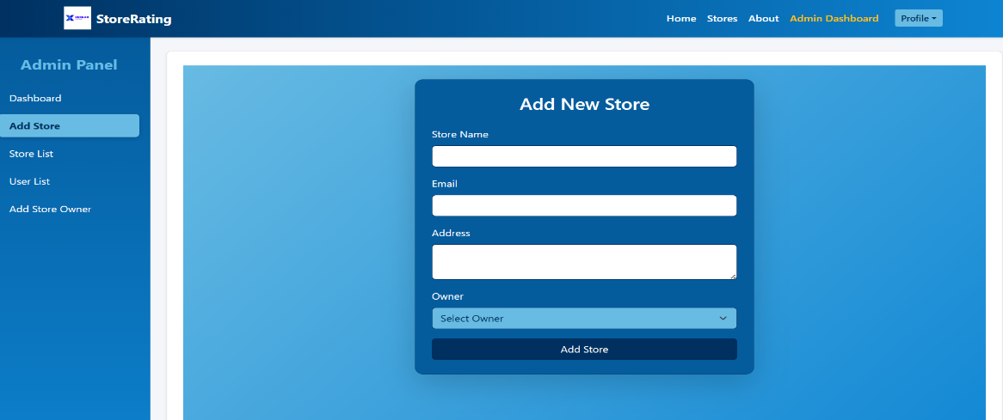

Admin can View All Users filter records

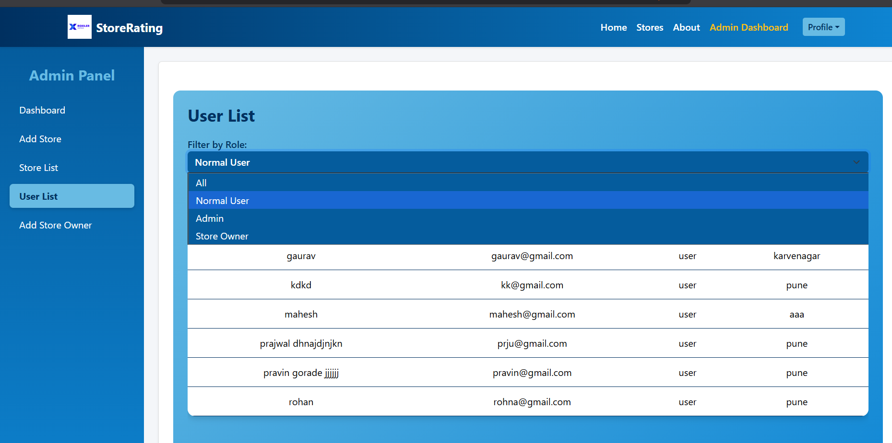

Creating the store owner and proving his login credentials

