AICTE Oasis Infobyte Internship

Domain: Data Analytics

Project Title:
Data Cleaning using NYC Airbnb Dataset

Submitted By:
Krushna Sanjay Bhuskute

GitHub Repository:
https://github.com/KrushnaBhuskute/OIBSIP

Submission Date:
June 2026

- Introduction
Data cleaning is one of the most important steps in data analytics.
Poor quality data can lead to incorrect conclusions and unreliable
business decisions.

The objective of this project is to identify and resolve data quality
issues such as missing values, duplicate records, inconsistent formats,
and outliers in a real-world dataset.

2. Dataset Description
The dataset used for this project is the New York City Airbnb Open Data
dataset obtained from Kaggle.
Dataset Features:
• Total Records: 48,895
• Total Columns: 16
Important Attributes:
• Name
• Host Name
• Location
• Room Type
• Price
• Reviews
• Availability

3. Tools and Technologies
• Python
• Pandas
• Matplotlib
• VS Code
• GitHub

4. Data Cleaning Process
4.1 Dataset Exploration
The dataset was explored using:
• head()
• shape
• info()
This helped understand the structure and quality of the data.
4.2 Missing Value Analysis
Missing values were identified in:
• name
• host_name
• last_review
• reviews_per_month
Appropriate handling techniques were applied.
4.3 Duplicate Record Check
The dataset was checked for duplicate rows.
Result:
No duplicate records were found.
4.4 Standardization
Column names were verified and standardized to maintain consistency.
4.5 Outlier Detection
Price statistics and boxplot visualization were used to identify
extreme values present in the dataset.

5. Results
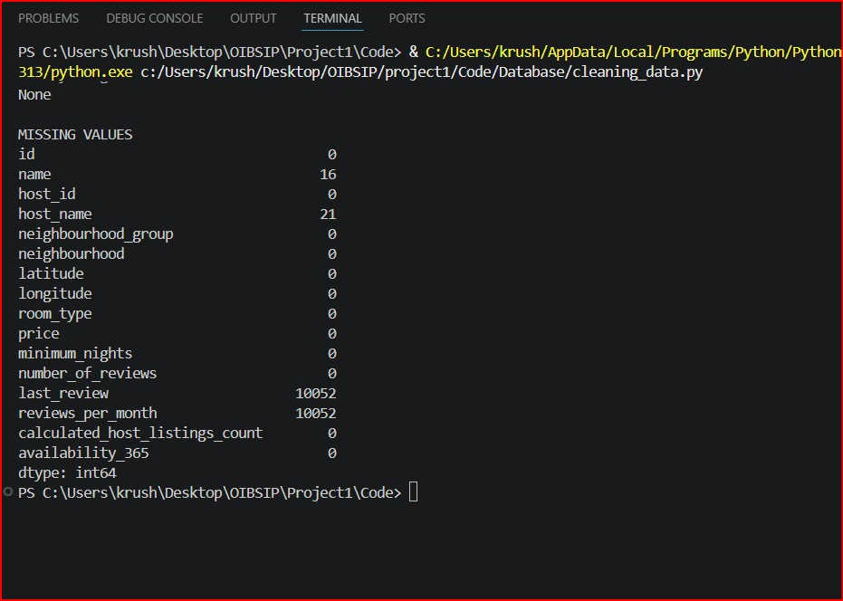

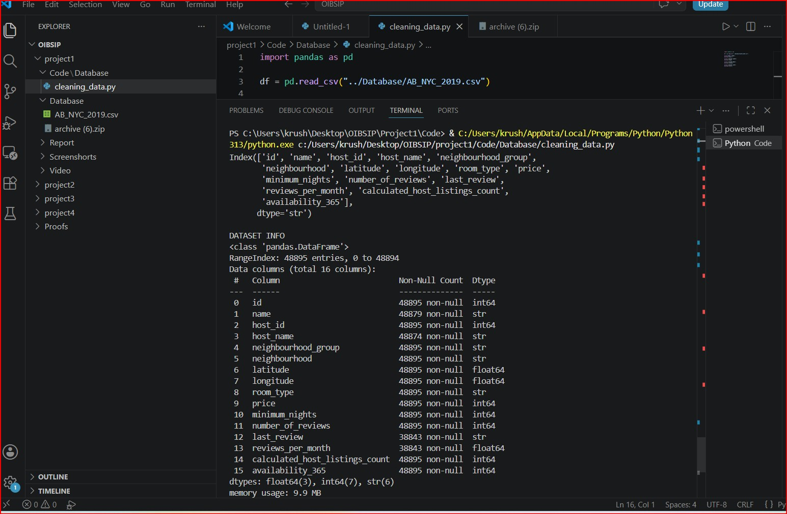
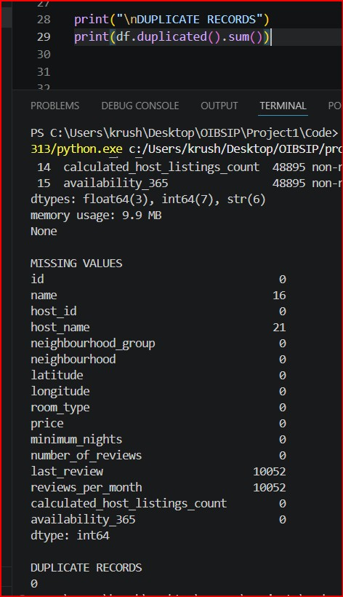
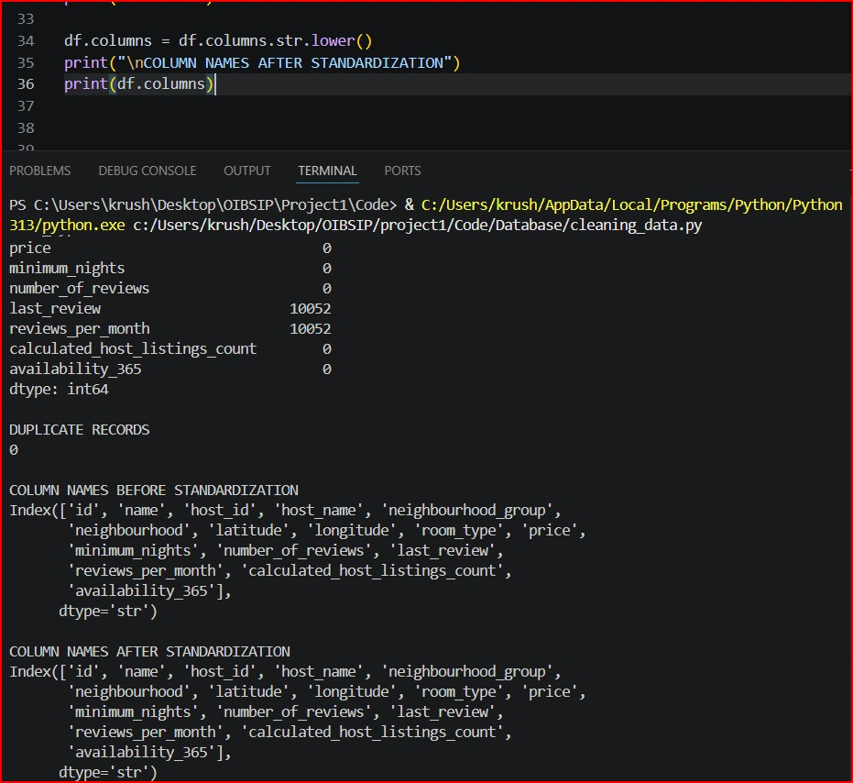
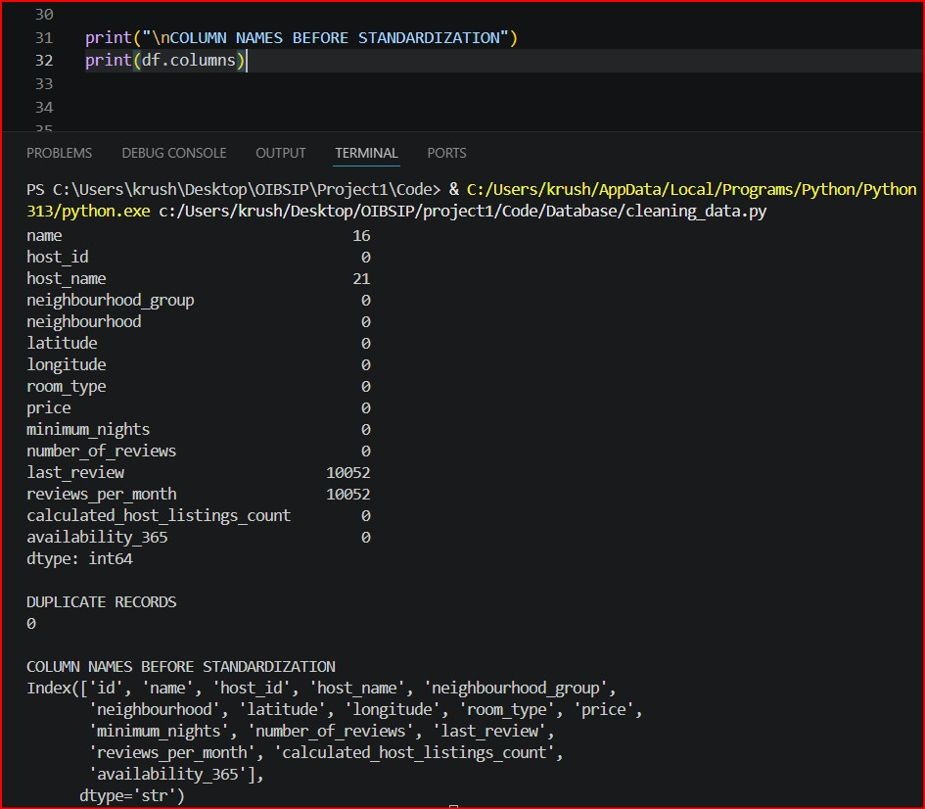

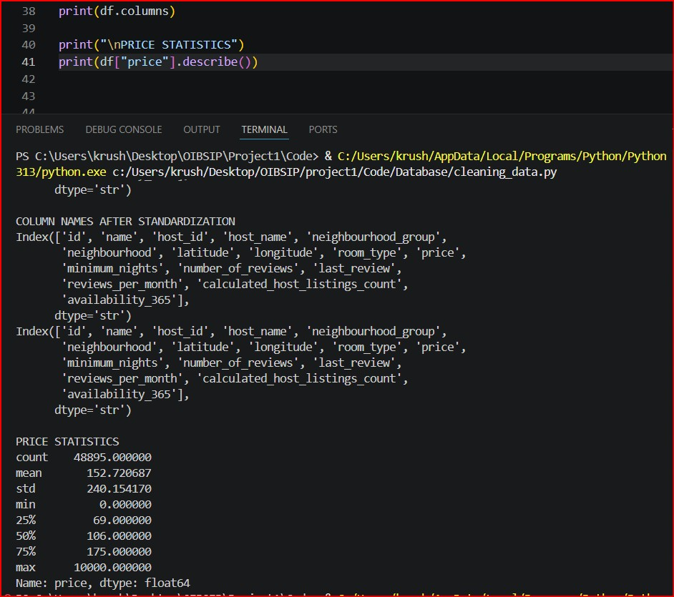
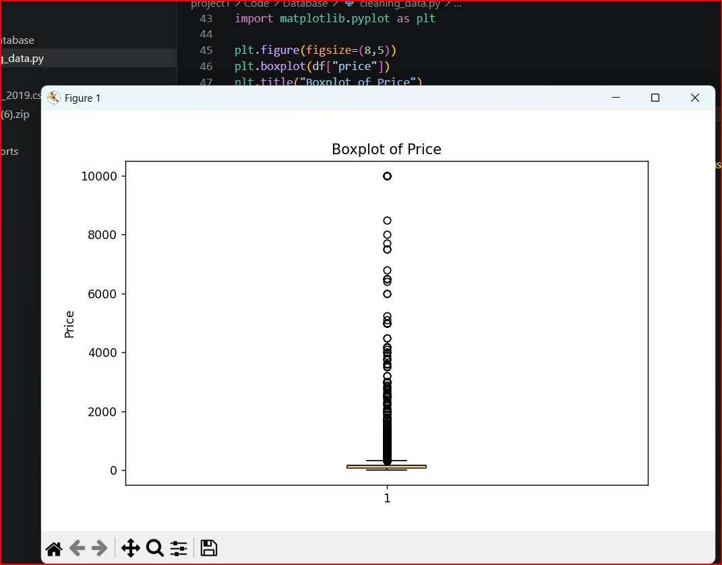
6. Conclusion
The dataset was successfully cleaned and prepared for further analysis.
The project involved:
• Missing value handling
• Duplicate checking
• Standardization
• Outlier detection
This project strengthened practical data preprocessing and data
cleaning skills using Python.

