Exploratory Data Analysis (EDA) on Retail Sales Data

OASIS INFOBYTE INTERNSHIP
PROJECT REPORT
Title:
Exploratory Data Analysis (EDA) on Retail Sales Data
Submitted By:
Krushna Bhuskute
Domain:
Data Analytics
Organization:
Oasis Infobyte
Year:
2026

Introduction

Exploratory Data Analysis (EDA) is an important process in data analytics that helps in understanding datasets, identifying patterns, detecting anomalies, and generating useful insights. The main objective of this project is to analyze retail sales data and discover trends related to customer behavior, product performance, and sales patterns.

The project involves data loading, data cleaning, descriptive statistical analysis, time series analysis, customer analysis, product analysis, and data visualization using Python libraries such as Pandas and Matplotlib.

Dataset Description
The dataset used in this project contains retail sales transaction information. It consists of 1000 records and 9 columns.

The dataset includes the following attributes:

1. Transaction ID
2. Date
3. Customer ID
4. Gender
5. Age
6. Product Category
7. Quantity
8. Price per Unit
9. Total Amount

These attributes help in analyzing customer demographics, purchasing behavior, product performance, and overall sales trends.

Data Cleaning and Preprocessing
The dataset was loaded using the Pandas library. Several preprocessing steps were performed to ensure data quality and consistency.

1. Missing Value Analysis:
The dataset was checked for missing values using the isnull() function. No missing values were found in any column.

2. Duplicate Record Analysis:
The dataset was checked for duplicate records using the duplicated() function. No duplicate records were found.

3. Date Conversion:
The Date column was converted into datetime format to enable time series analysis and monthly sales trend visualization.

These preprocessing steps ensured that the dataset was clean and ready for further analysis.
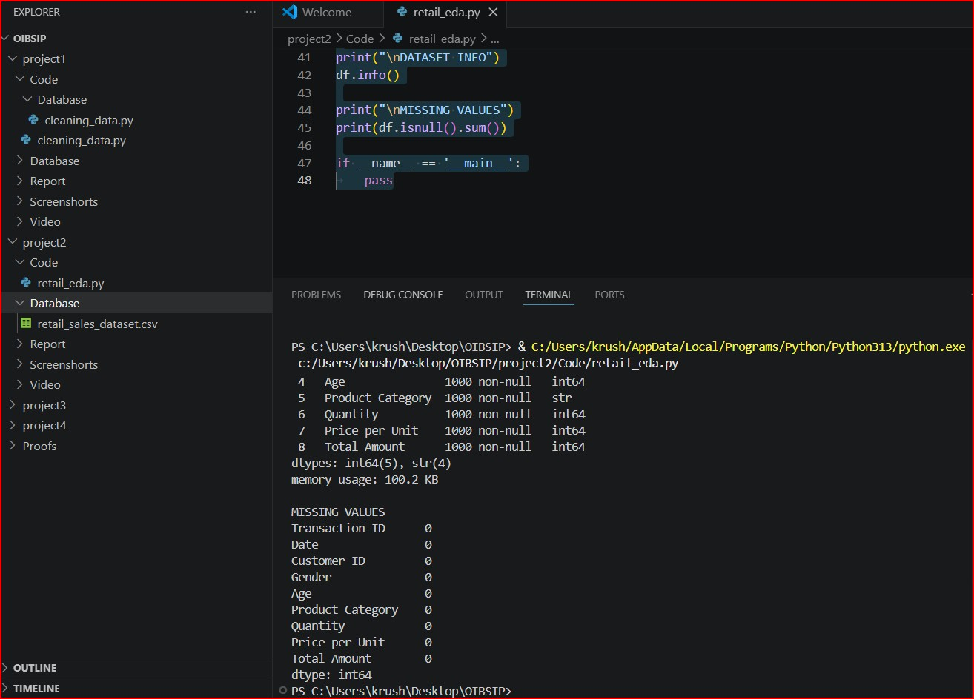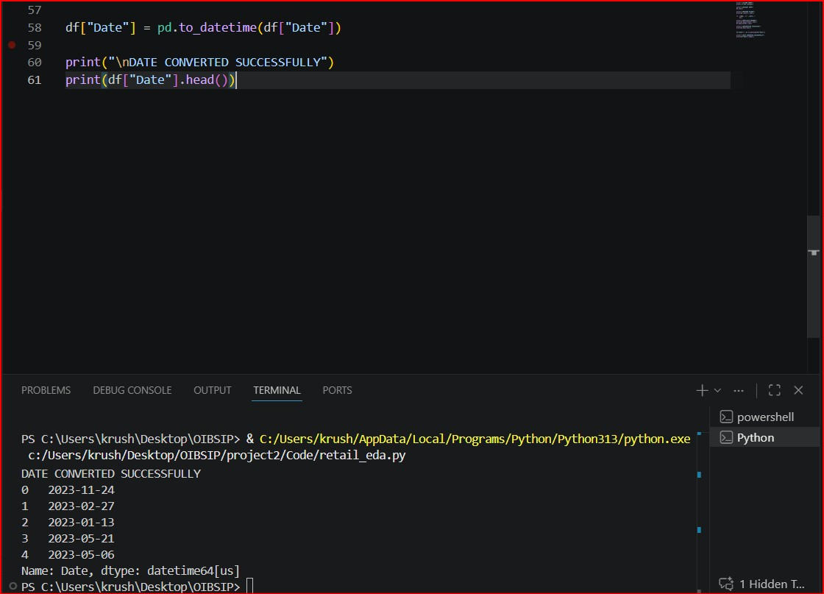

Descriptive Statistics
Descriptive statistical analysis was performed to understand the characteristics of the dataset.

Key observations:

• Average customer age: 41.39 years
• Minimum age: 18 years
• Maximum age: 64 years
• Average quantity purchased: 2.51 units
• Maximum quantity purchased: 4 units
• Average price per unit: ₹179.89
• Maximum price per unit: ₹500
• Average transaction value: ₹456
• Maximum transaction value: ₹2000
These statistics provide valuable information about customer purchasing patterns and transaction behavior.

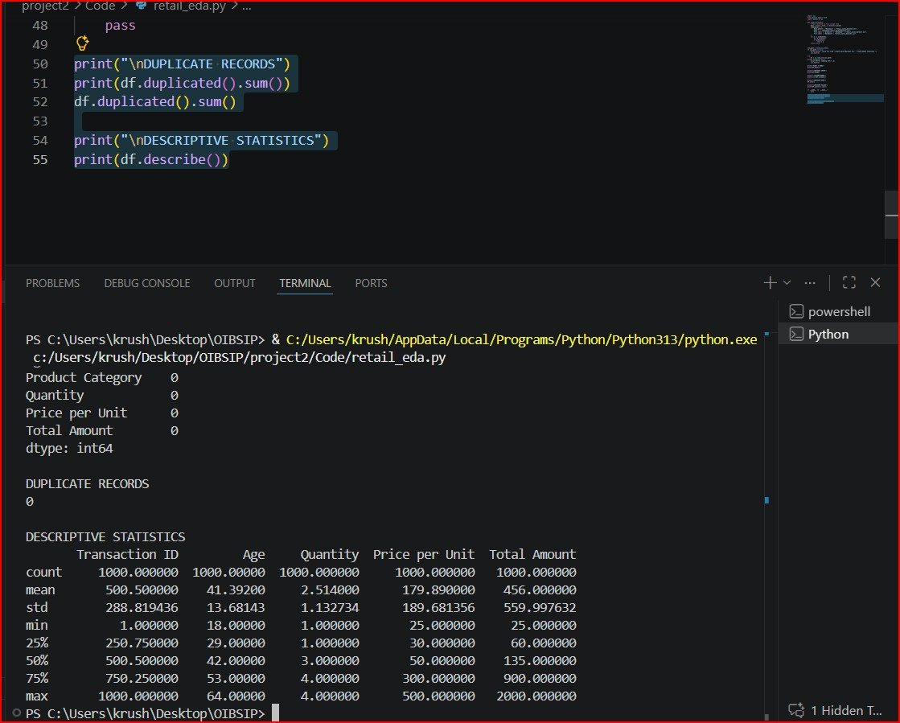
Data Visualization and Analysis
Several visualizations were created to analyze sales trends and customer behavior.

1. Monthly Sales Trend:
A line chart was created to analyze sales performance over different months. This visualization helps identify periods of high and low sales activity.

2. Product Category Analysis:
A bar chart was used to compare sales among different product categories.

Product Category Sales:
• Electronics: ₹156,905
• Clothing: ₹155,580
• Beauty: ₹143,515

Electronics generated the highest revenue among all categories.

3. Gender-wise Sales Analysis:
Sales revenue was analyzed based on customer gender.

• Female Customers: ₹232,840
• Male Customers: ₹223,160
Female customers contributed slightly higher revenue compared to male customers.

4. Correlation Heatmap:
A heatmap was created to visualize relationships between numerical variables such as Age, Quantity, Price per Unit, and Total Amount

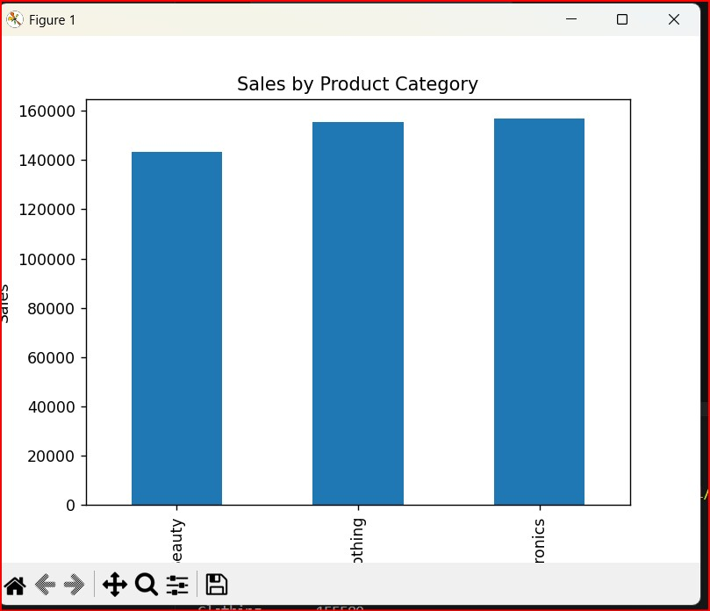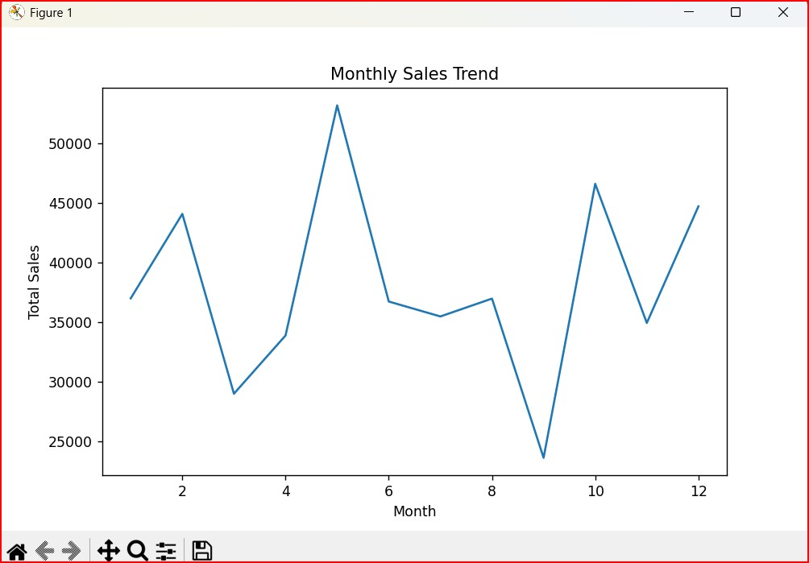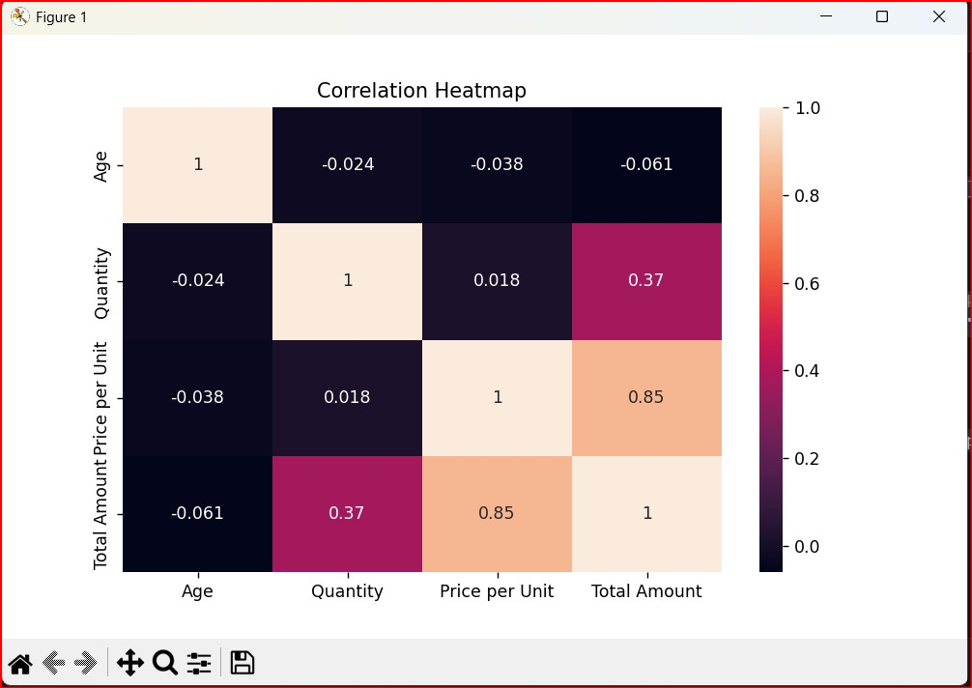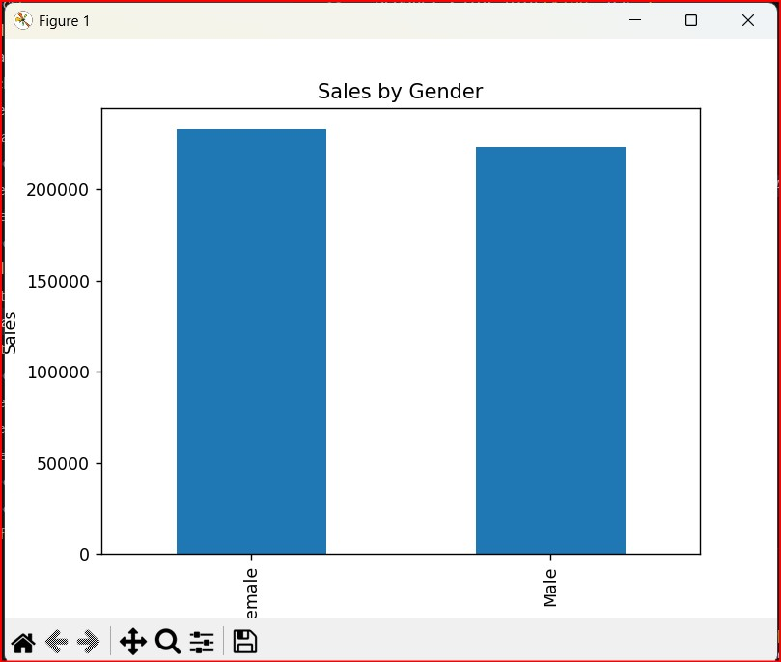

Insights and Recommendations

. Insights:

1. The dataset contains clean and reliable data with no missing values and no duplicate records.

2. Electronics is the highest-performing product category with total sales of ₹156,905.

3. Female customers generated slightly more revenue than male customers.

4. The average transaction value is ₹456, indicating moderate customer spending behavior.

5. Monthly sales analysis revealed variations in sales across different months.

Recommendations:

1. Increase inventory and promotional activities for Electronics products due to their high sales performance.

2. Develop targeted marketing campaigns for female customers as they contribute slightly higher revenue.

3. Monitor monthly sales trends to identify peak demand periods and optimize stock management.

4. Use customer demographic information to personalize marketing strategies and improve customer engagement.
Conclusion
This project successfully performed Exploratory Data Analysis on retail sales data using Python. Data cleaning, descriptive statistics, customer analysis, product analysis, and visualization techniques were applied to uncover valuable business insights.

The analysis demonstrated how data analytics can help organizations understand customer behavior, evaluate product performance, and make data-driven business decisions. The project enhanced practical knowledge of data preprocessing, visualization, and analytical techniques used in real-world retail environments.

