Web Bibliography

• www.google.com

• www.react.org.com

• www.nodejs.org.com

• Techinfo YT– Youtube

• https://chat.openai.com

• https://cloud.mongodb.com

1. **Manual For User**

Users can register on WorkBees by filling in their details.

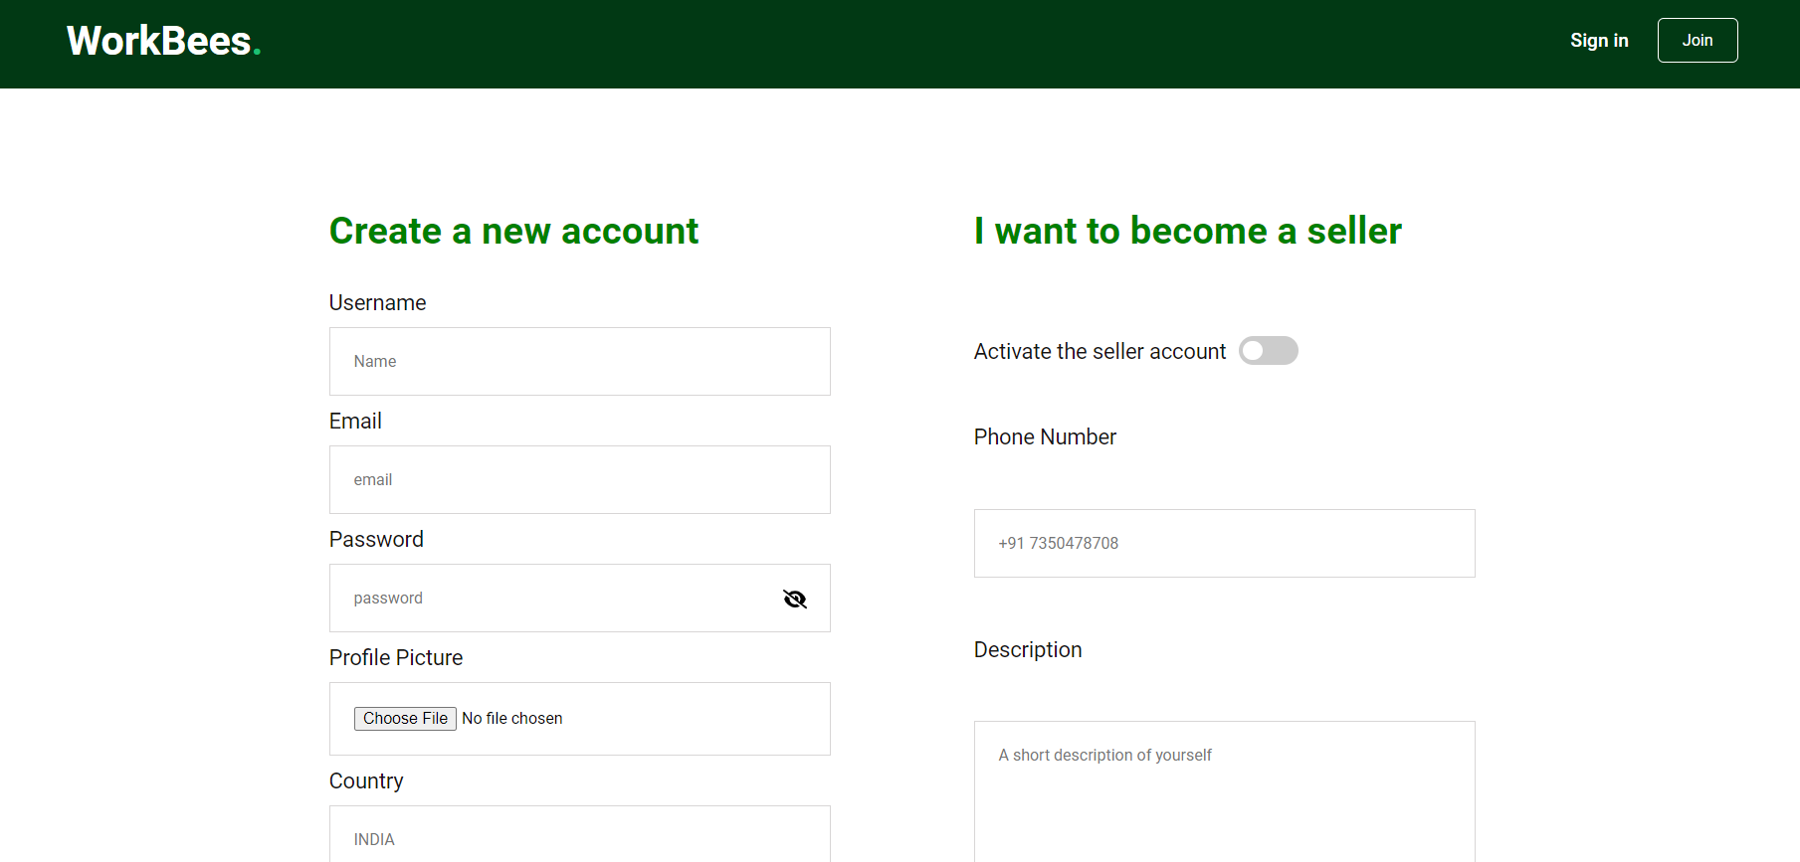

Users can log in to WorkBees by entering their login details.

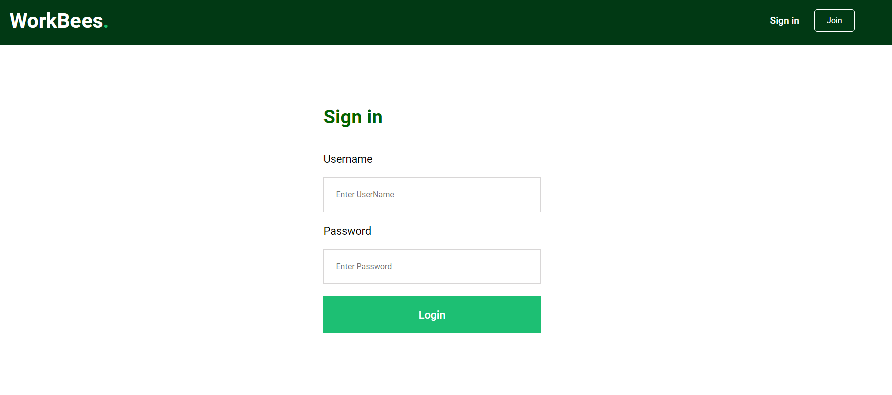

User can search for freelancer using category



User can directly select the best freelancer.



User can select the gig as per category and budget filter.

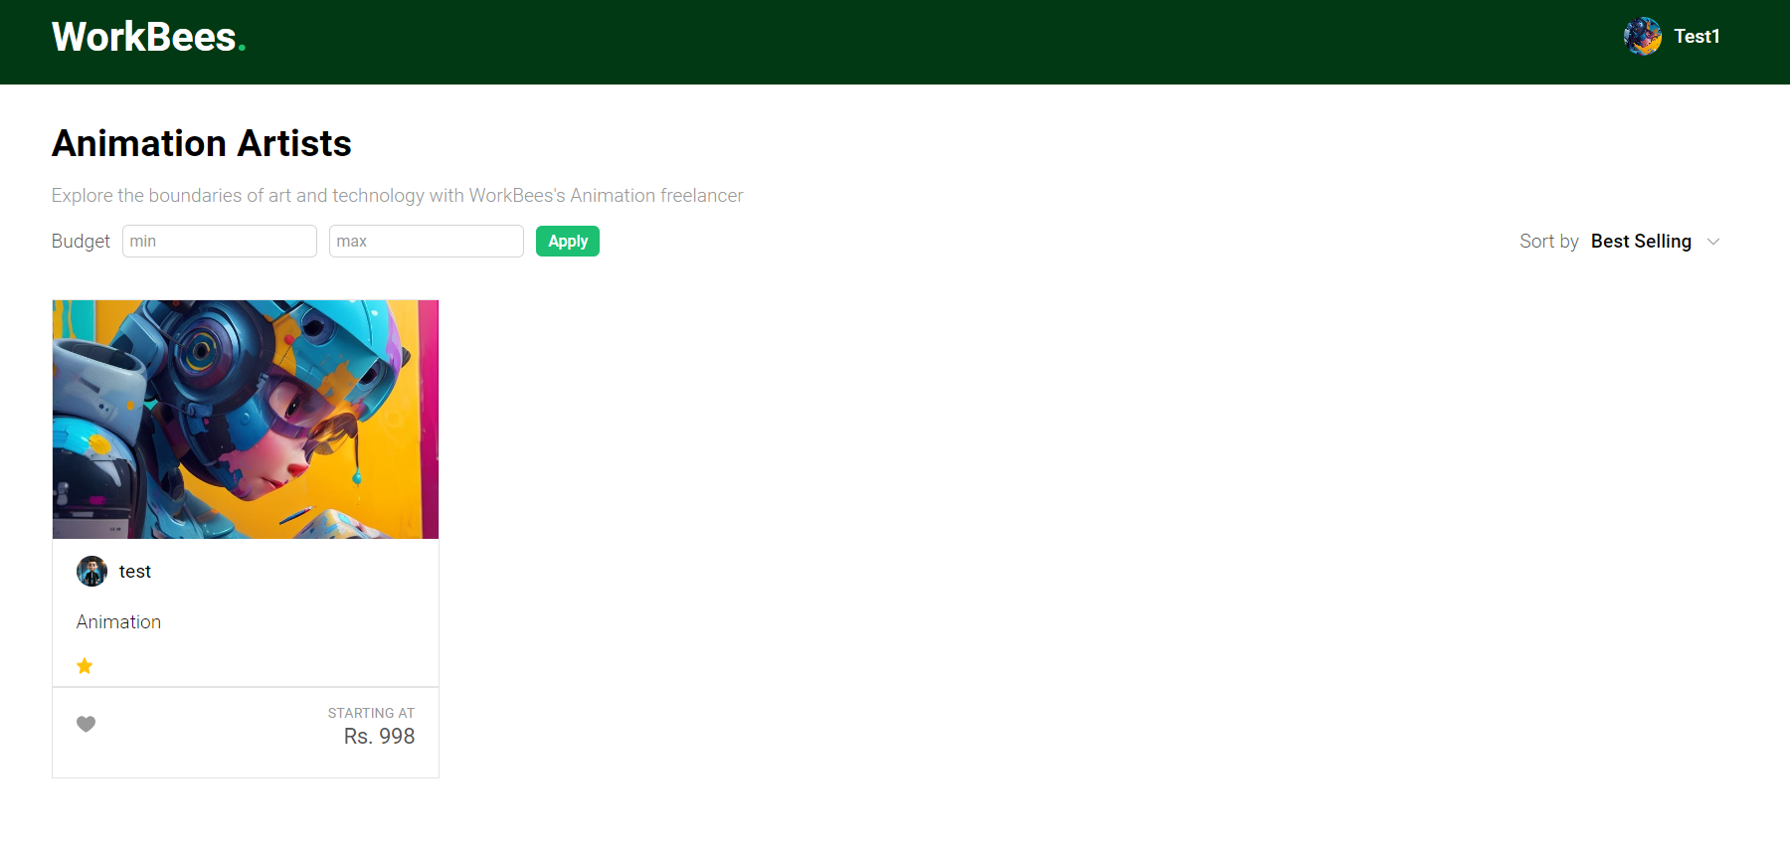

User is redirected to Gig page.

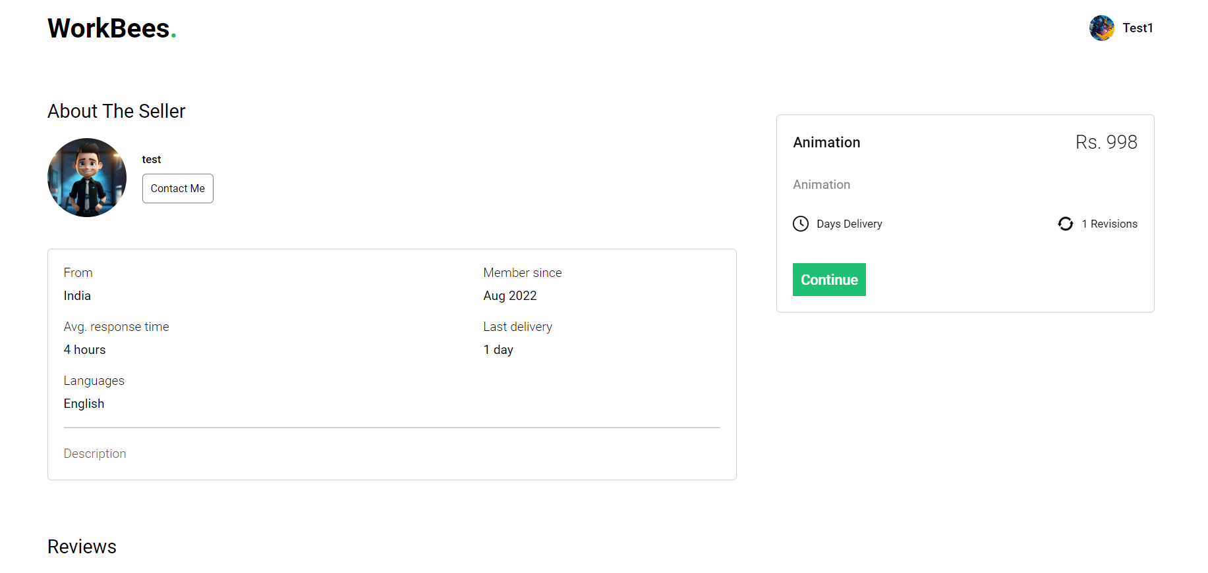

User can submit reviews and ratings.

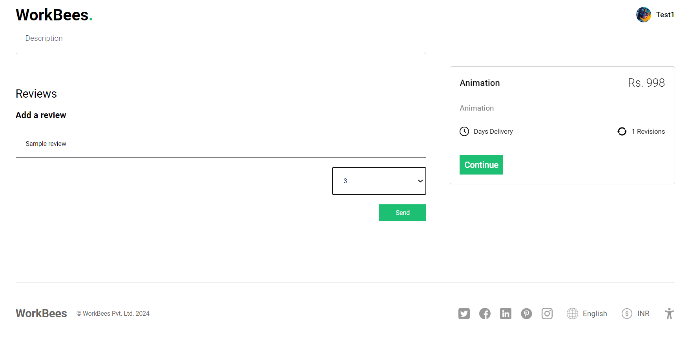

User can make payment through Stripe Payment Gateway.

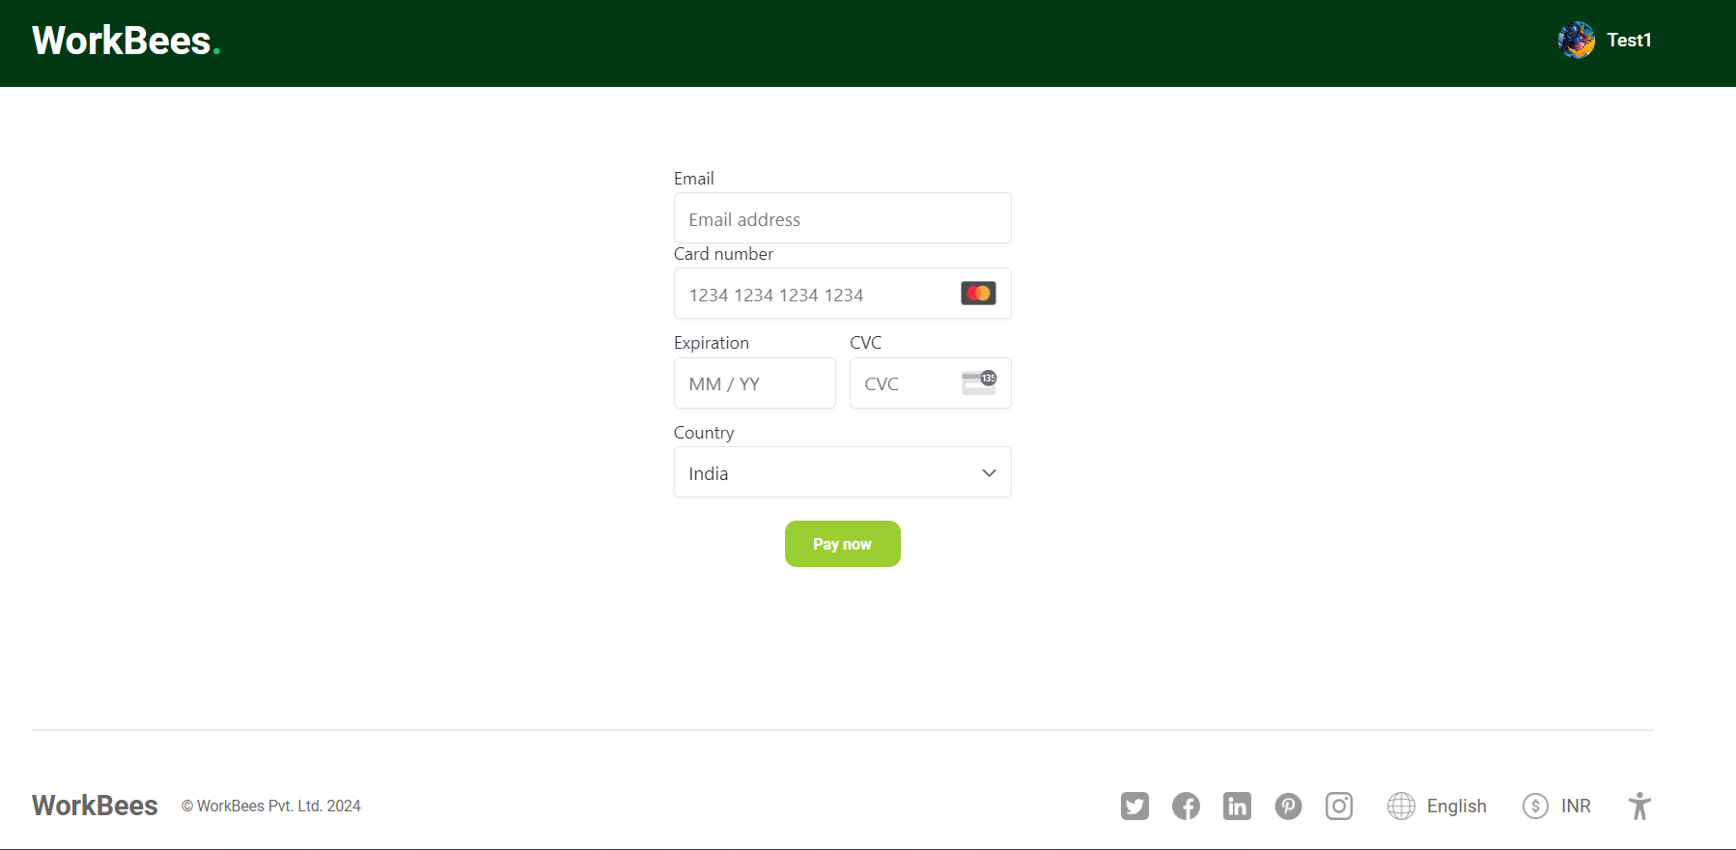

Upon successful payment user can see their orders.

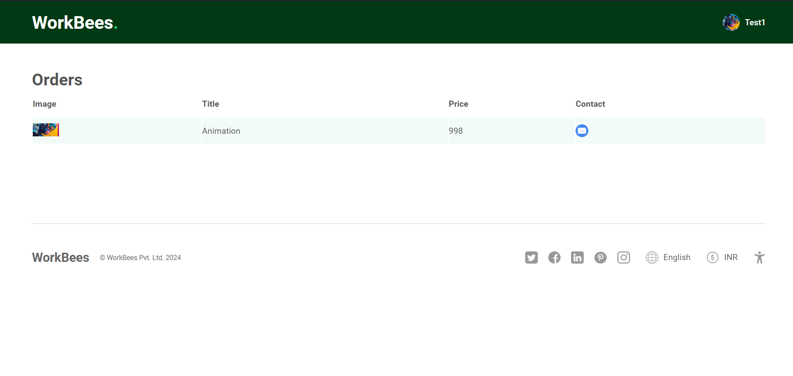

User can send messages to freelancer.

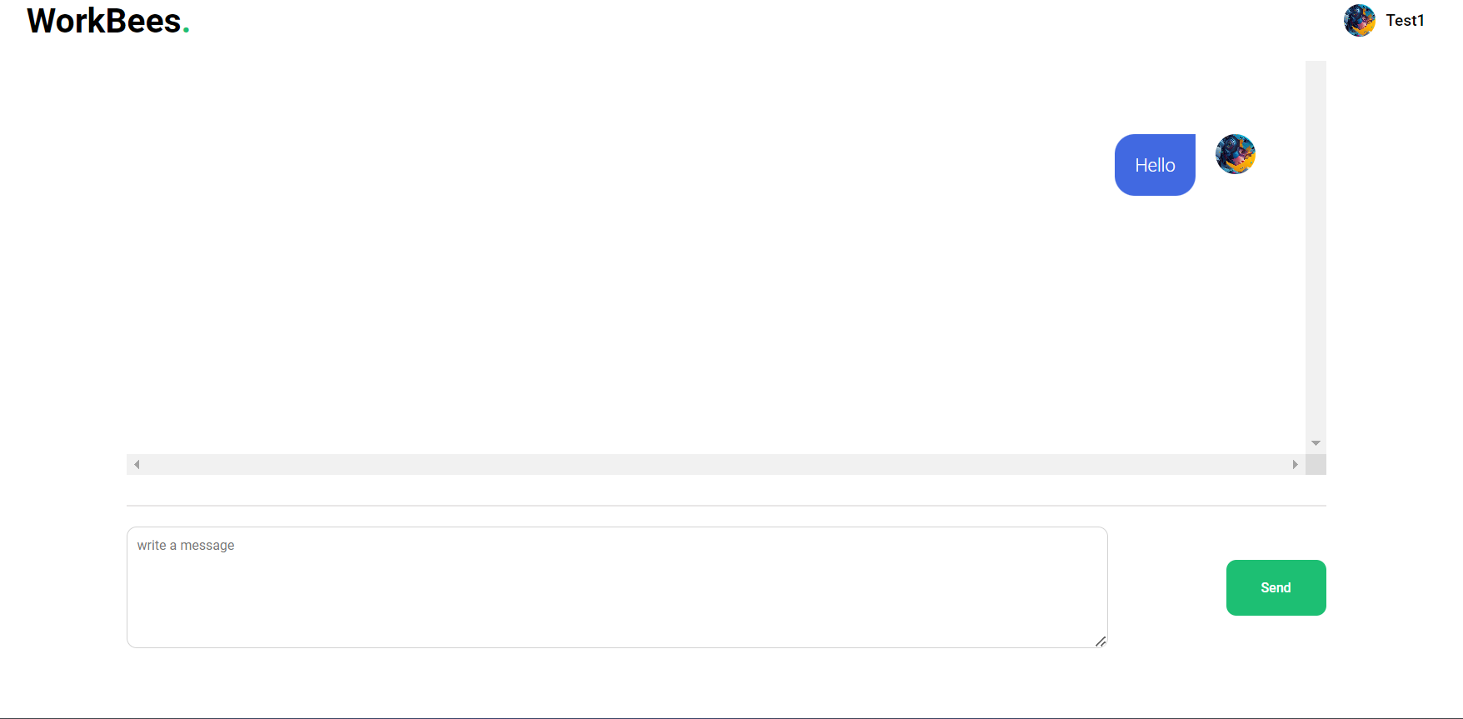

1. **Manual For Freelancer**

Freelancer can create their Profile



Freelancer can login to their account.



Freelancer can create gigs.

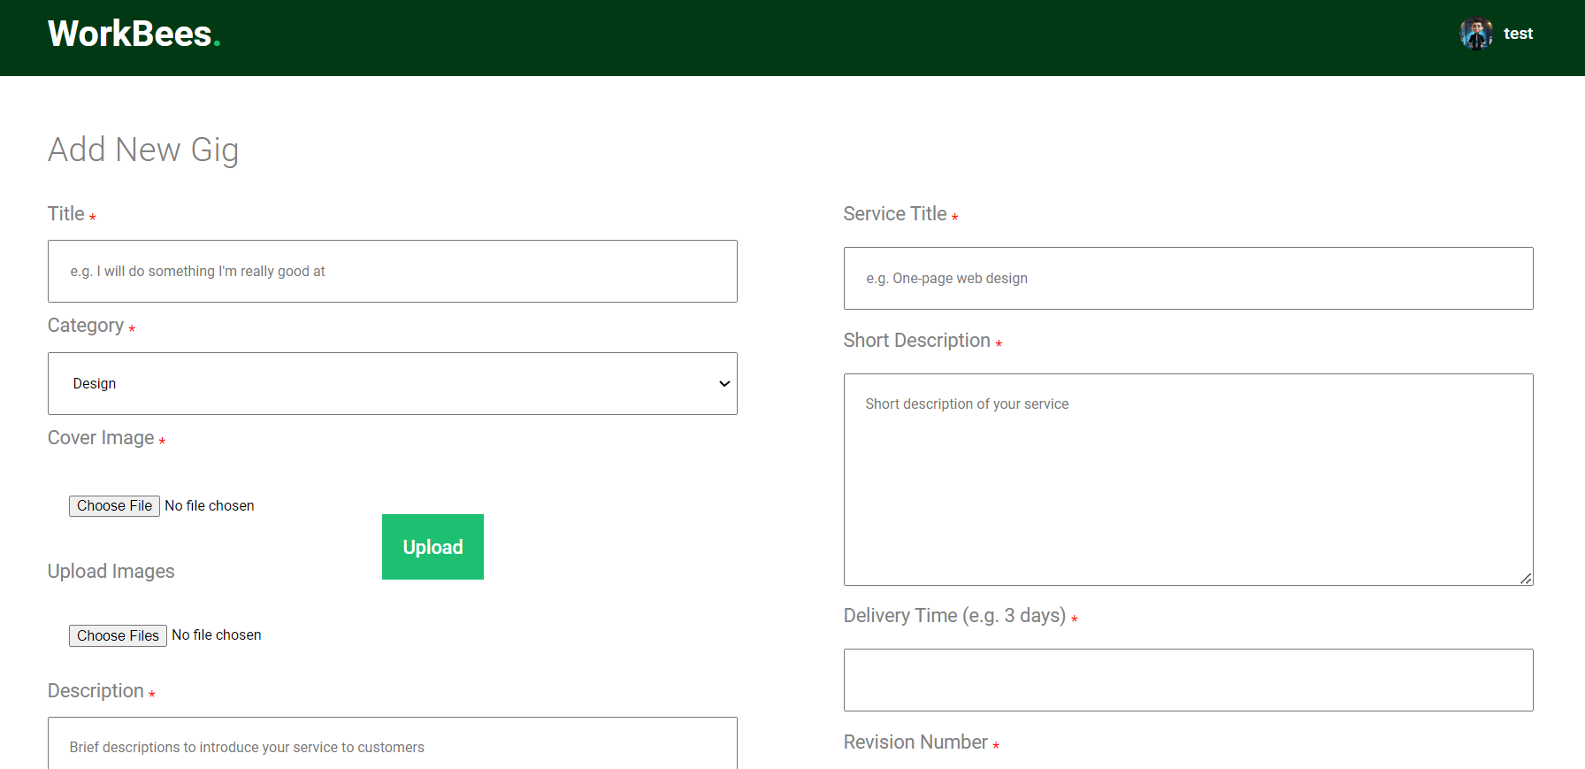

Freelancer can view and delete their created gigs.

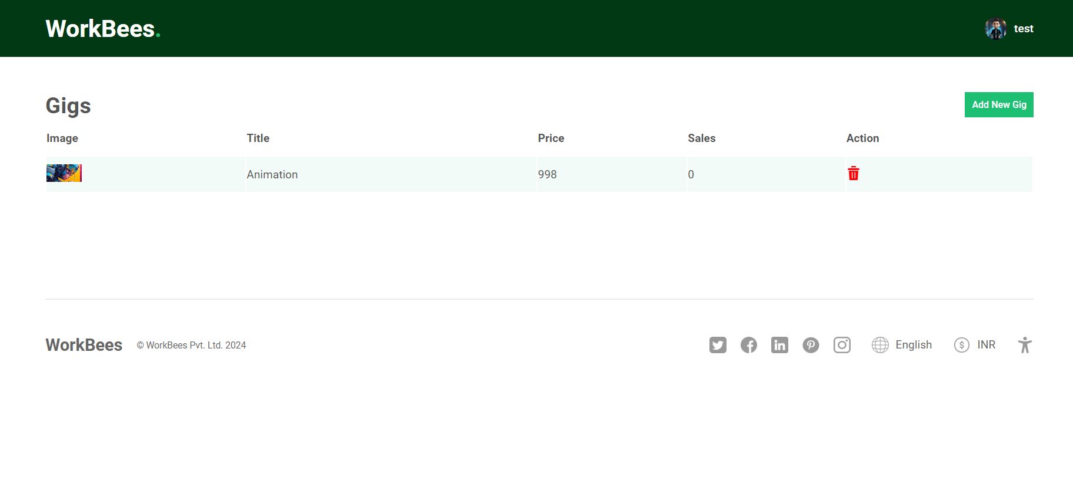

Freelancer can see their sold gig in order section.

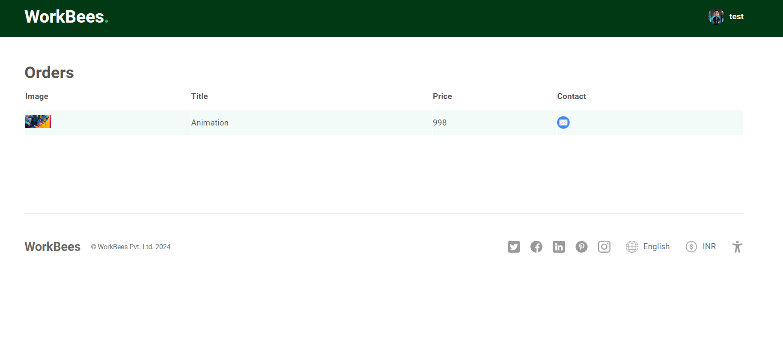

Freelancer can send messages to their customer.

