1)basic commands.
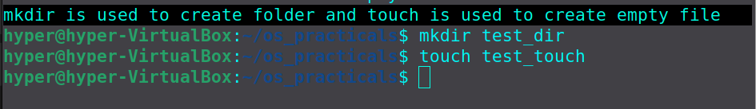

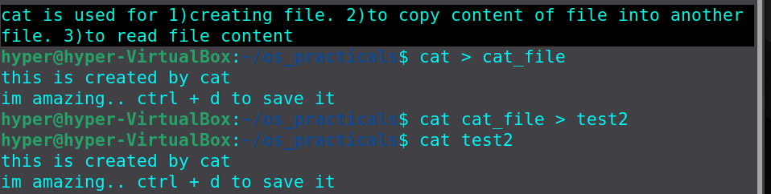

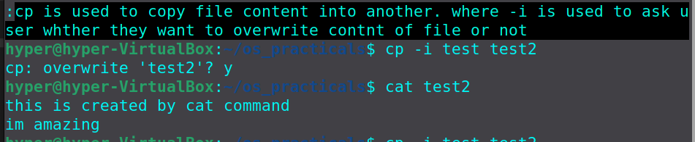

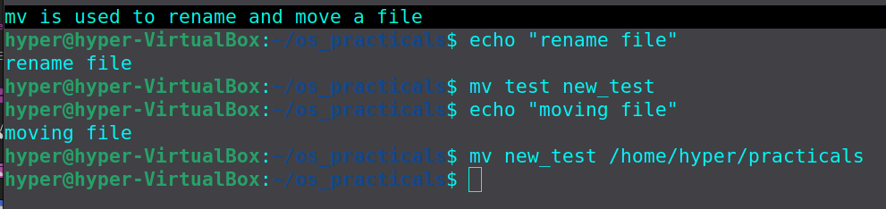

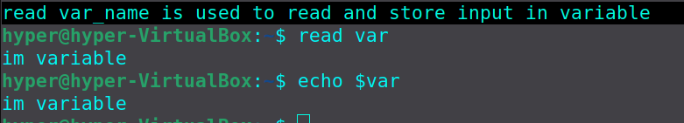

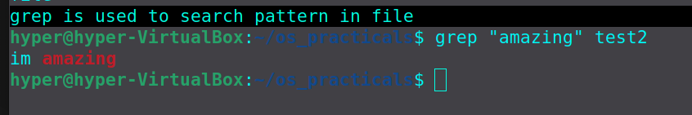

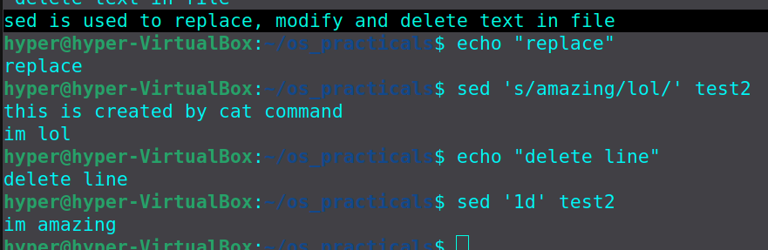
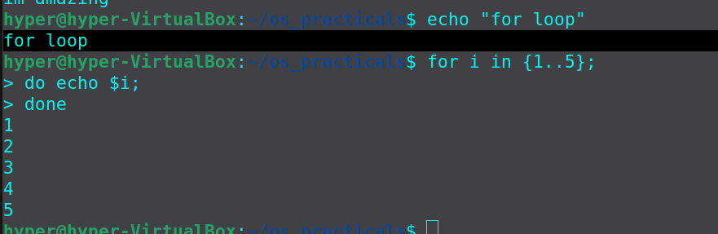

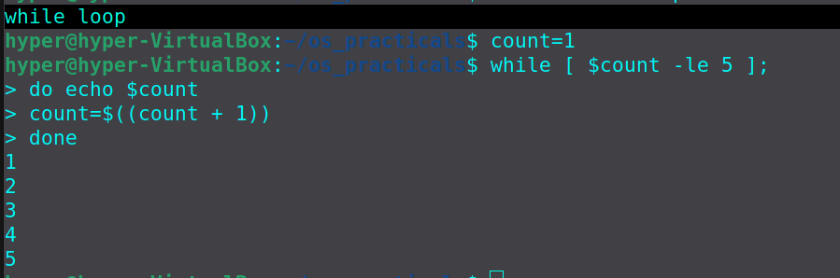

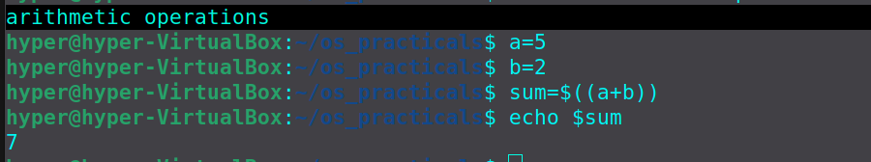

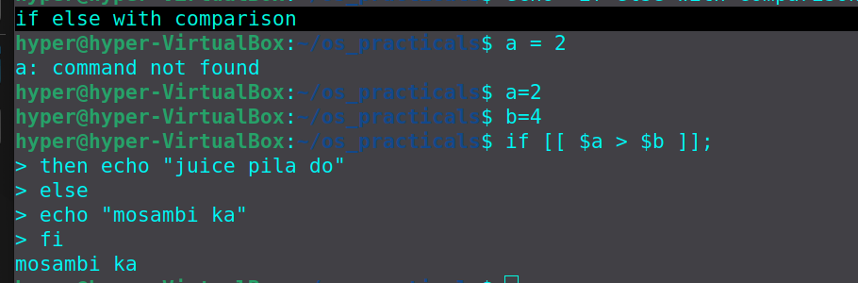

2)address book:

algorithm:

1)create menu using switch case.
2)define address book
2)create Create function.
3)create view function.
4)create Insert function
5)create Delete function.
6)create Modify function.

Create function algorithm:
1)initialize empty address book using >

View function algorithm:
1)check whther address book is empty or not using -s
2)-s is a size operator it returns true if file exist and file size is greater then 0

Insert function algorithm:
1)get user record and use -n to prevent new line
2)use >> operator to insert records in address book

Delete function algorithm:
1)get number from user to delete record
2)use grep -c to get count and store it in len
3)if len is greater thn 0 then use sed to delete record

Modify function algorithm:
1)get number from user
2)store its length in len
3)if len > 0 then get new name store it in new_var
4)use sed to modify record.

3)Zombie and orphan process:

Orphan process: it is a process whose parent process no more exist,parent process is either finished or terminated without waiting for its child process to terminate is called orphan process.
Orphan process is adopted by init process once its parent process dies.

Zombie Process: it is a process that has completed its execution but still remains in process table.
When process finish its execution it reports its status to parent process, it become zombie process when parent process does not read its status.

Fork(): it is used to create process,it returns process id.

Wait(): it is a system call used in child parent relationship between processes, it stops execution of parent process till termination of child process.

