Name – Bankar Krushna Lahanubhau
MIS – 612303031
Batch – S2

Assignment 3

two_stacks.c

#include <stdio.h>
#include <stdlib.h>

typedef struct two_stacks{
int *A;
int size1, size2;
int top1, top2;
}two_stacks;

void init_two_stacks(two_stacks *st, int size1, int size2) {
st->A = (int*)malloc(sizeof(int)*(size1 + size2));
st->size1 = size1;
st->size2 = size2;
st->top1 = -1;
st->top2 = -1;
return;
}

int isFull1(two_stacks st) {
if(st.top1 >= st.size1 - 1) return 1;
return 0;
}

int isFull2(two_stacks st) {
if(st.top2 >= st.size2 - 1) return 1;
return 0;
}

int isEmpty1(two_stacks st){
if(st.top1 == -1) return 1;
return 0;
}

int isEmpty2(two_stacks st){
if(st.top2 == -1) return 1;
return 0;
}
void push1(two_stacks *st, int data) {
if(isFull1(*st)) {
printf("Stack 1 is full\n");
return;
}
st->top1++;
st->A[st->top1] = data;
return;
}

void push2(two_stacks *st, int data) {
if(isFull2(*st)) {
printf("Stack 2 is full\n");
return;
}
st->top2++;
st->A[st->size1 + st->top2] = data;
return;
}

void pop1(two_stacks *st) {
if(isEmpty1(*st)){
printf("Stack 1 is empty\n");
return;
}
st->top1--;
return;
}

void pop2(two_stacks *st) {
if(isEmpty2(*st)){
printf("Stack 2 is empty\n");
return;
}
st->top2--;
return;
}

void print1(two_stacks st) {
for(int i = 0; i <= st.top1; i++) {
printf("%d ", st.A[i]);
}
printf("\n");
return;
}

void print2(two_stacks st) {
for(int i = st.size1; i <= (st.size1 + st.top2); i++) {
printf("%d ", st.A[i]);
}
printf("\n");
return;
}
int main() {
two_stacks st;
printf("Enter size of stack1\n");
int size1, size2;
scanf("%d%d", &size1, &size2);
init_two_stacks(&st, size1, size2);
push1(&st, 32);
push2(&st, 33);
push1(&st, 36);
pop1(&st);
push1(&st, 56);
push2(&st, 45);
pop2(&st);
push2(&st, 76);
print1(st);
print2(st);
return 0;
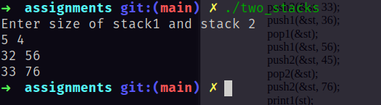
}

OUTPUT:

------------------------------------------------------------------------------------------------------------------------
char_stack

stack.h

typedef struct node {
char data;
struct node *next;
}node;

typedef struct stack {
node *top;
}stack;

void init_stack(stack *s);
void push(stack *s, char data);
char pop(stack *s);
char peek(stack s);
int is_empty(stack s);

stack.c
#include <stdlib.h>
#include "stack.h"
#include <limits.h>

void init_stack(stack *s) {
s->top = NULL;
return;
}

int is_empty(stack s) {
if(s.top == NULL) {
return 1;
}
return 0;
}

void push(stack *s, char data) {
node *nn = (node*)malloc(sizeof(node));

if(nn) {
nn->data = data;
nn->next = NULL;
}
else {
return;
}

nn->next = s->top;
s->top = nn;

return;
}
char pop(stack *s) {
node *p = s->top;
char data;
if(is_empty(*s)) return '\0';
s->top = s->top->next;
data = p->data;
free(p);
return data;
}

char peek(stack s) {
return s.top->data;
}

paranthesis_matching.c
#include <stdio.h>
#include "int_stack/stack.h"

int is_matching_pair(char opening, char closing) {
return (opening == '(' && closing == ')') ||
(opening == '[' && closing == ']') ||
(opening == '{' && closing == '}');
}

int check_parenthesis(char *str) {
stack st;
init_stack(&st);
int i = 0;
while(str[i] != '\0') {
if(str[i] == '(' || str[i] == '[' || str[i] == '{') {
push(&st, str[i]);
}
else {
if(is_empty(st)) return 0;

if(is_matching_pair(peek(st), str[i])){
pop(&st);
}
else {
return 0;
}
}
i++;
}
return is_empty(st);
}

int main() {
char str[100];
printf("Enter expresssion\n");
scanf("%[^\n]", str);
if(check_parenthesis(str)) {
printf("True\n");
}
else {
printf("False\n");
}
return 0;
}

output
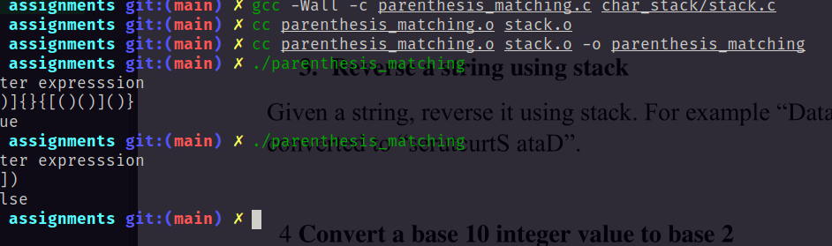

-----------------------------------------------------------------------------------------------------------------------

reverse_string.c

#include <stdio.h>
#include "char_stack/stack.h"

void reverse_string(char *str) {
stack st;
init_stack(&st);
int i = 0;
while(str[i] != '\0') {
push(&st, str[i]);
i++;
}
i = 0;
while(!is_empty(st)) {
str[i++] = pop(&st);
}
return;
}

int main() {
char str[100];
printf("Enter string\n");
scanf("%[^\n]", str);
reverse_string(str);
printf("%s\n", str);
return 0;
}

OUTPUT

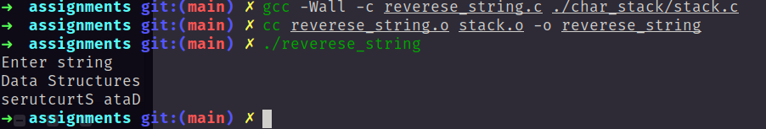

------------------------------------------------------------------------------------------------------------------------

decimal_to_binary.c

stack.h

typedef struct node {
char data;
struct node *next;
}node;

typedef struct stack {
node *top;
}stack;

void init_stack(stack *s);
void push(stack *s, char data);
char pop(stack *s);
char peek(stack s);
int is_empty(stack s);

stack.c

#include <stdlib.h>
#include "stack.h"
#include <limits.h>

void init_stack(stack *s) {
s->top = NULL;
return;
}

int is_empty(stack s) {
if(s.top == NULL) {
return 1;
}
return 0;
}

void push(stack *s, char data) {
node *nn = (node*)malloc(sizeof(node));

if(nn) {
nn->data = data;
nn->next = NULL;
}
else {
return;
}

nn->next = s->top;
s->top = nn;

return;
}
char pop(stack *s) {
node *p = s->top;
char data;
if(is_empty(*s)) return '\0';
s->top = s->top->next;
data = p->data;
free(p);
return data;
}

char peek(stack s) {
return s.top->data;
}

covert_to_binary.c

#include <stdio.h>
#include "int_stack/stack.h"

int conver_to_binary(int num) {
stack st;
int bin = 0;
init_stack(&st);
while(num) {
push(&st, num % 2);
num /= 2;
}
while(!is_empty(st)) {
bin = bin * 10 + pop(&st);
}
return bin;
}

int main() {
int num, bin;
printf("Enter number: \n");
scanf("%d", &num);
bin = conver_to_binary(num);
printf("Number %d with base 2 is %d\n", num, bin);
return 0;
}

