Internship Project Report – Task 3

Organization: CODTECH IT SOLUTIONS PVT. LTD.

Intern Name: Krushnakant Sonawane

Project Title: Multi-Cloud Architecture Using AWS Services

Internship Duration: May 20, 2025 – July 20, 2025

Report Date: June 26, 2025

# 1. Objective

The goal of this project is to design and demonstrate a multi-tier architecture using AWS services (S3, Lambda, API Gateway) to simulate a multi-cloud environment within a single cloud provider (AWS). This demonstrates service distribution, interoperability, and observability.

# 2. Architecture Overview

The architecture simulates a multi-cloud system using AWS services as follows:  
- Frontend hosted on Amazon S3 (Static Website)  
- Backend API using AWS Lambda via API Gateway  
- Inter-service communication is through HTTPS REST APIs

# 3. Implementation Steps

Step 1: S3 Static Website Setup

- Created S3 bucket with public access policy

- Enabled static website hosting and uploaded index.html

- Configured CORS settings

Step 2: Lambda Backend Function

- Created Lambda function with Node.js runtime

- Wrote handler function to parse JSON input and return response

- Deployed and tested with sample input

Step 3: API Gateway

- Created HTTP API Gateway

- Integrated with Lambda function

- Enabled CORS and deployed the API

Step 4: Frontend Integration

- Modified JavaScript to call the deployed API Gateway URL

- Uploaded updated HTML to S3

# 4. Testing and Results

Accessed the S3 website URL, submitted form data, and received successful response from Lambda via API Gateway.

# 5. Screenshots

[Include the following screenshots here before final submission:]

- S3 Bucket settings and Website URL

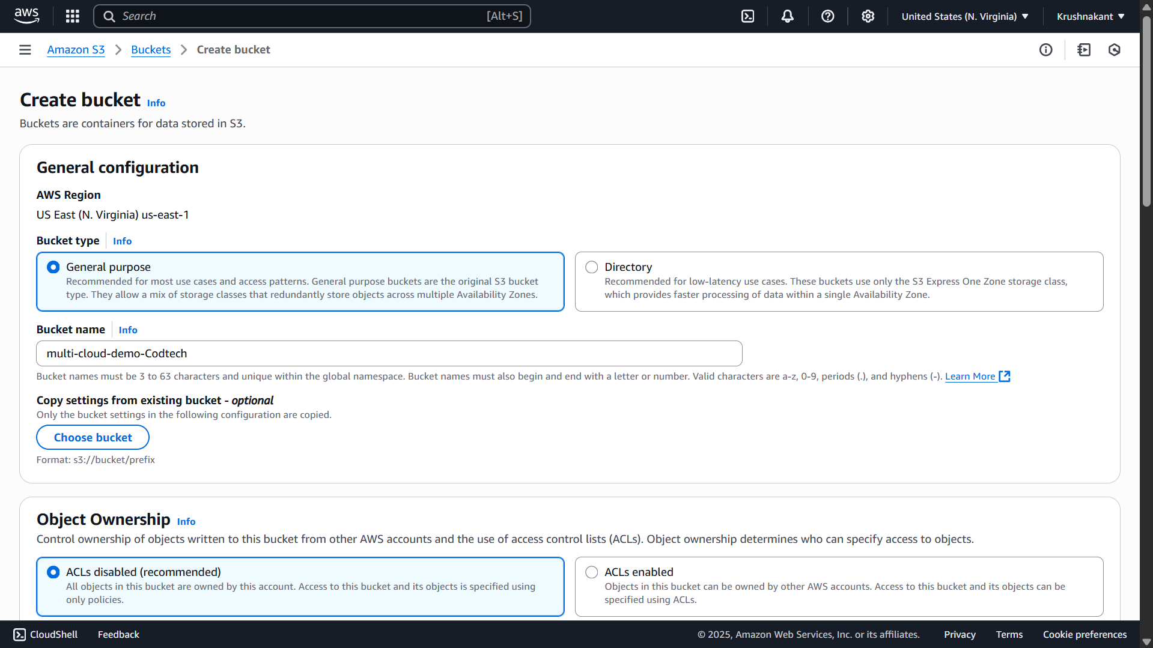

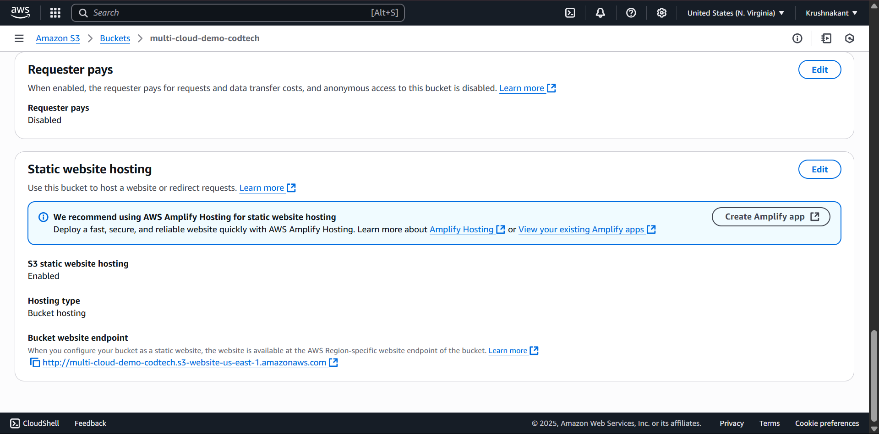

- Lambda function and test output

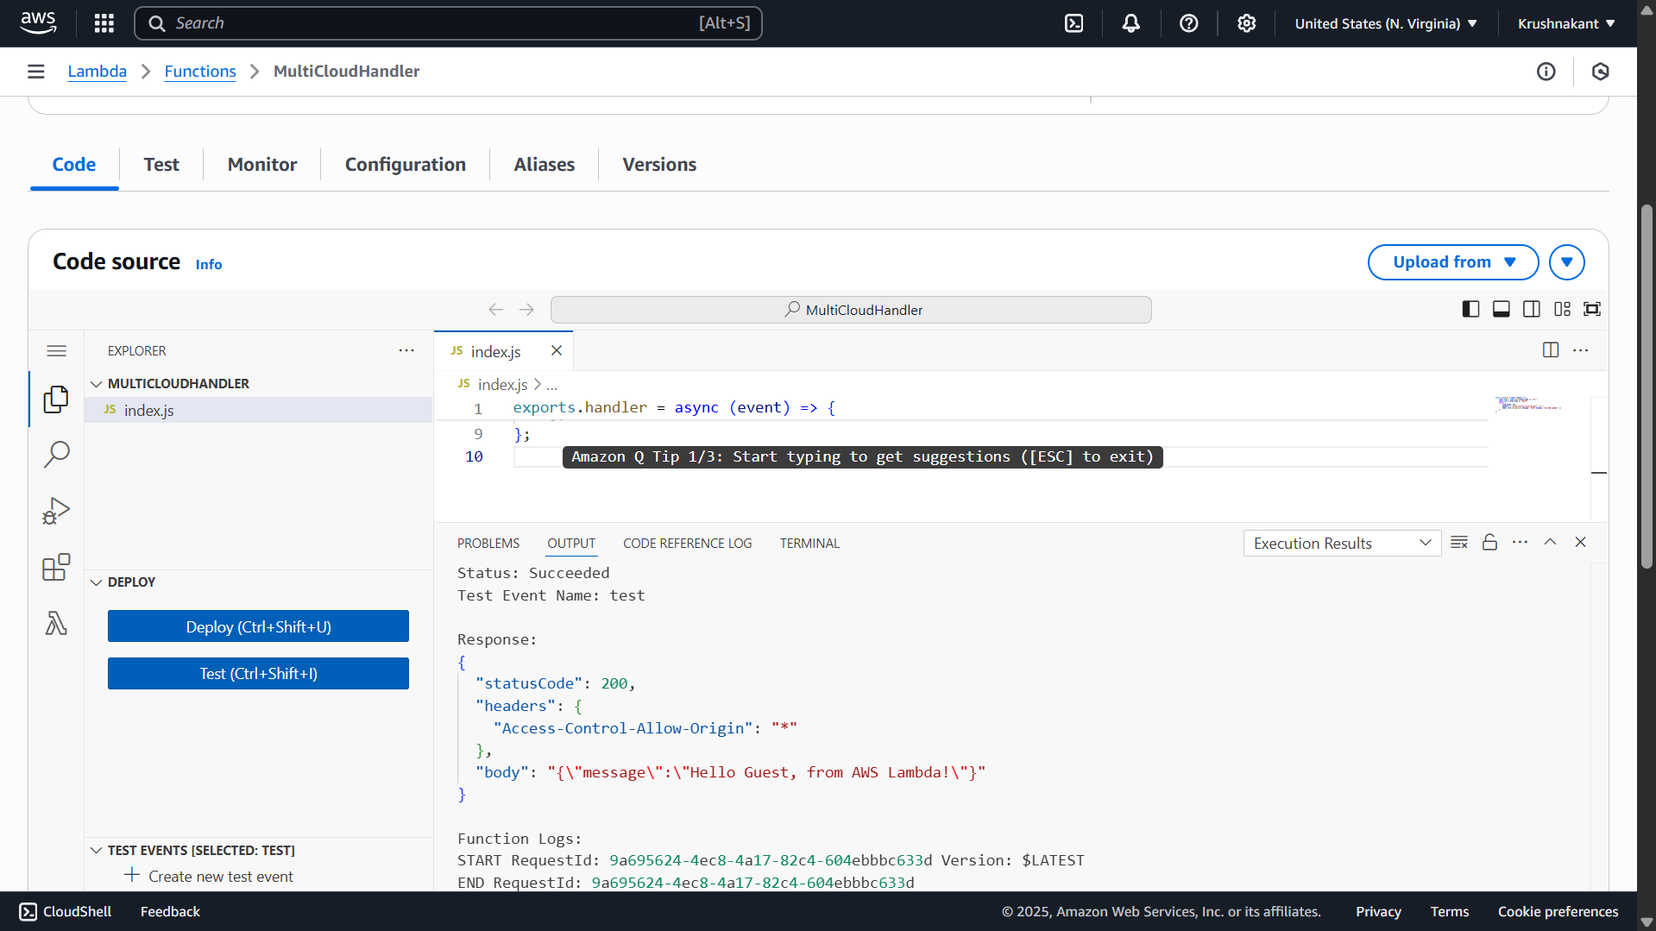

- API Gateway configuration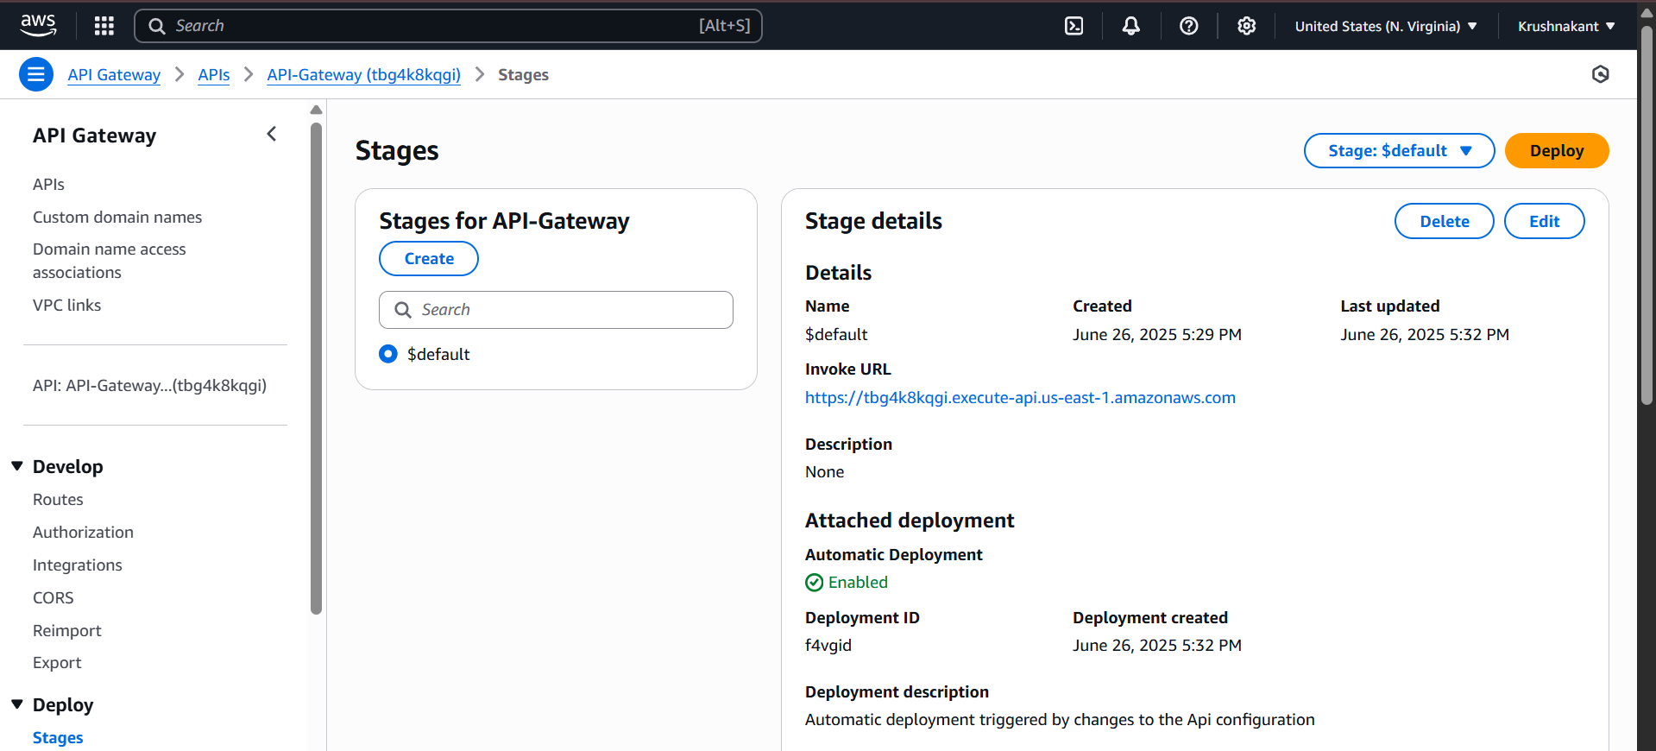

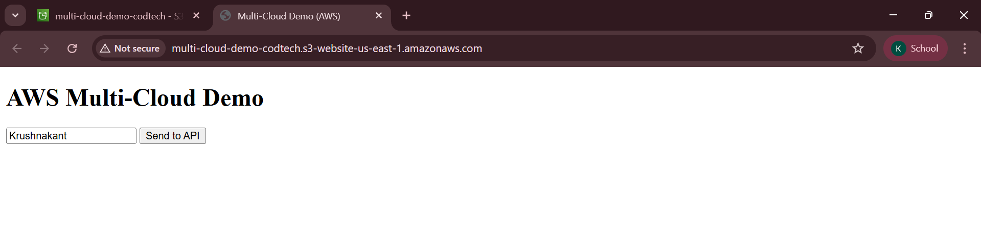

# 6. Conclusion

This project demonstrated how a multi-cloud architecture can be simulated within AWS using distributed services. It also showcased the ability to integrate, monitor, and automate cloud services effectively.